ORIENTATION FOR INCOMING PRESIDENTS

OF

NATIONAL HOTEL ASSOCIATIONS

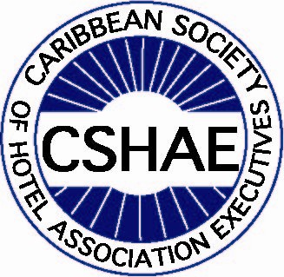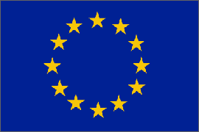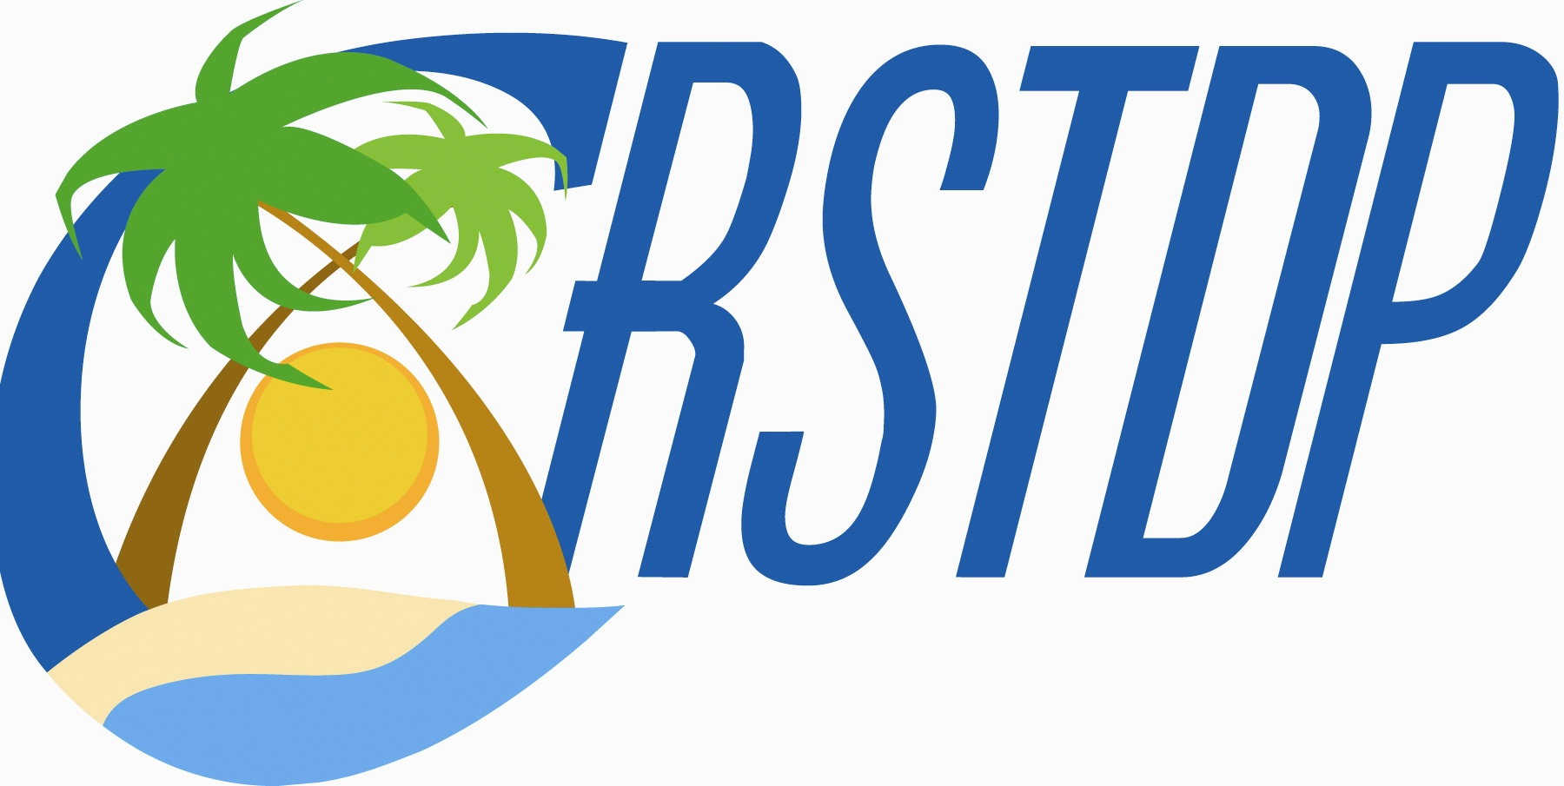

This tool was prepared under the European Union funded Caribbean Regional Sustainable Tourism Development Programme by PA Consulting Group for the Caribbean Hotel Association

ORIENTATION FOR INCOMING PRESIDENTS OF NATIONAL HOTEL ASSOCIATIONS

The Board of Directors (BOD) of National Hotel Associations (NHAs) is the elected executive that provides policy and direction in matters of concern to the association. The President and members of the BOD are usually elected to serve for a period of two years. The roles of the BOD, committees/councils, the Association Executive (AE) and the operational staff have been outlined in the Operational Manual for Executive Directors and Presidents of National Hotel Associations.

Even where the incoming President (hereafter referred to as the President) has been an active member and is aware of the activities of the Association, election to the top position in the NHA brings with it an increased level of responsibility and authority. The President shares joint responsibility with the AE for good governance of the Association and is the representative of the BOD who interacts most closely with the AE and operational staff of the Association.

Each president brings his/her style of management and, invariably, agenda of initiatives to be accomplished during his/her tenure of office. At the same time, NHAs have on-going initiatives which constitute part of the work programme of the operational staff. Therefore, the assumption of office by a president will involve a period of adjustment and accommodation both for the President and operational staff of the NHA, especially the Association Executive. This period of transition can vary in length and difficulty for all parties but can be made considerably easier by the AE, who has an important role in facilitating the President’s transition into office.

This template is primarily intended for AEs and outlines actions that should be taken to assist the President in becoming familiar with responsibilities of the position and the work programme of the association.

1 Acknowledge Election of President

As a courtesy, offer congratulations to the President at the time of his/her election to office. The AE should indicate that he/she and staff of the Association look forward to working with the President and making his/her tenure productive and successful. Arrangements for the first briefing meeting between the President and AE may be arranged at this time or as soon as possible after the elections as schedules permit.

2 Introduction of President to staff

At the outset, AE should take the President from office to office where each staff member should be introduced by name, job title and a brief description given of individual responsibilities. This enables the President not only to get a quick overview of “who does what” within the organisation but also allows the AE to highlight any issues regarding physical deficiencies in the working environment that are of concern to staff.

2 Prepare Briefing Package

Prior to their first meeting, the AE should prepare an informational Briefing Package for the President, which should contain are the following:

- Copy of the NHA Strategic Plan

- Copy of the Organisational Plan

- Work Programme and targets for the current year;

- Annual Reports, including financial reports for at least the last three years;

- Status Report on key operations of the Association. This should be no more than 2 pages and should include:

  - number and categories of members and any trends;

  - financial position of the Association and any trends;

  - Assessment of state of Government relations, on-going collaboration with other parties and issues to be addressed. Note: Government includes the Ministry of Tourism, tourism marketing entity and other ministries and entities that have portfolio items of interest to the association;

- Information in regard to the Association’s auditors, bankers, other service providers and their performance;

- Other important partnership arrangements;

3 Briefing Session for the President

The AE should arrange a briefing session (or if necessary more than one session) for the President using the Informational Package to guide discussions. Preparation for this session is important since this session is likely to be critical in establishing the modus operandi between the AE and the President. The briefing session is also useful in that it provides the AE with the opportunity to do the following:

- provide an assessment of the industry, the Association’s role and membership concerns and issues;

- highlight issues of concern for later discussion when the President is settled.;

- suggest new initiatives, concepts and ideas that can be included in the Association’s agenda e.g. social responsibility initiatives, training to list a few.

- find out if President has any new initiatives and or any concerns about the NHA that he/she would like to see addressed during his/her term in office.

- provide an overview of projects under implementation, planned, under negotiation and at the conceptual stage;

- provide an overview of status of the Association’s relationships with CHA and other partner organisations;

- highlight challenges and issues in need of attention, especially those that may require the President’s intervention or could have legal implications;

- arrange for the President to sign bank documents, papers and instruments commensurate with the exercise of authority of the position. .

The briefing meeting should not be used to deal with issues but rather to familiarise the President with the business of the Association. The substantive discussion of issues should be left for the Working Session(s)

3 Publicity for Incoming President

One of the first activities on which the AE and President should collaborate is the content of the PR release concerning the President’s election to office. The input and guidance of the NHAs public relations advisors may be useful in structuring the content and nature of the information that is released.

4 Working Session(s)

The Briefing Session should be followed by Working Session(s), the number of which will vary depending on the number of factors including time availability and range of issues receiving attention of the Association. As indicated in the Operational Manual, the Board of Directors should establish boundaries of responsibility and authority between the President and the AE and an agreed protocol regarding who speaks for the Association and when. This avoids fuzziness regarding who does what in these areas and remove them from being items to be negotiated with the assumption to office of each new president.

The AE has the option of including staff in the Working Session depending on the nature of the agenda issue and need for detail or clarification. The Working Session should allow for in-depth discussion and decision making in regard to the following:

- functioning of the association;

- issues raised during the briefing session; and

- other matters of concern and new initiatives.

Additional Recommended Reading: Operational Manual for Executive Directors and Presidents of National Hotel Associations:

Chapter 5 - Governance Structure (of a typical national hotel association).

Prepared by: Cecil A. Miller

for the

C a r i b b e a n H o t e l A s s o c i a t i o n

Head Office  1000 Ponce de León Ave., 5th Floor  San Juan, Puerto Rico 00907  Tel. 787-725-9139  Fax 787-725-9108 | Marketing Office  2655 Le Jeune Road,  Suite 910  Coral Gables, FL 33134  Tel. 305-443-3040  Fax 305-443-3005 | Project Office  BHTA Building  4th Avenue, Belleville  St. Michael, Barbados  Tel. 246-435-6847  Fax 246-435-0845

w w w . c a r i b b e a n h o t e l a s s o c i a t i o n . c o m

Operational Manual for Executive Directors and Presidents of National Hotel Association pp 16-20

