WHAT NANTIONAL HOTEL ASSOCIATIONS CAN DO TO RAISE REVENUE

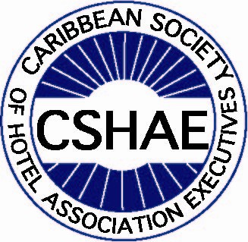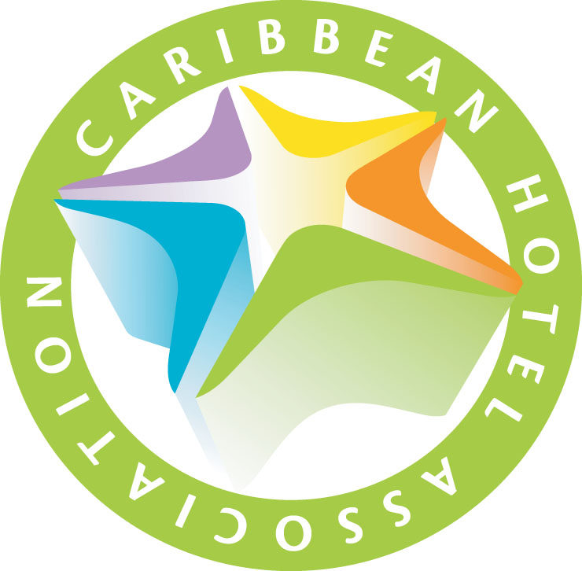

This tool was prepared under the European Union funded Caribbean Regional Sustainable Tourism Development Programme by PA Consulting Group for the Caribbean Hotel Association

WHAT NANTIONAL HOTEL ASSOCIATIONS CAN DO TO RAISE REVENUE


Introduction

The Caribbean hotel industry is operating in a challenging and dynamic external environment of increasing competition and regulatory requirements and rising internal expectations for the industry to replace export agriculture and manufacturing as a source of revenues to sustain and improve national economic development.

Given the structure of the industry, the burden of response to these external challenges and internal demands is increasingly being borne by the hotel segment. As a result, an effective institutional response structure requires strong and vibrant national hotel associations (NHAs) positioned to monitor internal and external industry dynamics, challenges and opportunities, undertake research and provide advice and technical support to their membership. However, against this background of a clearly perceived need for expansion in the secretariat responsibilities and functions performed by NHAs on behalf of their members is the reality that most NHAs have been forced to reduce the range of services delivered to members because of financial constraints.

In the short term, most NHAs have sought to maintain viability and boost revenues by expanding membership categories to include hotel allied services. However, over the medium to long-term, even this initiative has been insufficient to guarantee the long-term financial viability of most associations, which have been forced to look for ways to increase non-dues revenues.

Purpose of toolkit

The purpose of this toolkit is to provide NHAs with concepts that can be implemented to raise revenue from sources other than member dues, regardless of their level of maturity. Two categories of proposals are offered, namely:

- concepts that have been tried and tested by some NHAs and which can be implemented by less mature organizations with relative ease and even the assistance of NHAs which have already implemented them e.g. establishment of a Tourism Fund and earning revenue from advertising. (It makes no sense reinventing the wheel!!); and

- concepts that are more suitable for implementation by mature NHAs which have the experience and institutional capacity to manage the testing and experimentation inherent with innovative project concepts, especially those involving use of new processes and or technology.

Prerequisite for Change

Change in NHAs Operating Business Model

The long-term survivability and sustainability of NHAs will require them to change from operating primarily as membership secretariats to operating as businesses which concentrate on and develop core areas of potential revenue generating activity. Effective implementation of this new business model will necessitate fundamental changes in the staff composition of the typical NHA, with attention being given to recruiting persons with requisite skills to assist in developing identified revenue centres. As a result, the staff complement consistent with the new business model can be expected to include persons such as graphic artists, environmentalists, HRD specialists, marketing specialists, IT specialists and project managers, to list a few.

To a large extent, the success and pace of change in the NHA business model also will depend on the support for and participation of members in new initiatives of the NHA of which they are part.


REVENUE RAISING CONCEPTS

Advertising in Publications

Target publications as a source of revenue by:-

- Direct selling of advertising in destination guides, magazines and other publications owned or commissioned by the NHA.

- Negotiating with independent publishers for a commission on advertising revenue earned from NHA member properties and business.

- earning revenue on advertising sales in return for managing the production of brochures, discount coupons booklet and other promotional and marketing items for business across the range of categories of members.

- identifying opportunities for the sale of advertising space in publications of the NHA, including the Annual Report. Where the NHA produces printed material, the minimum target should be the sale of sufficient advertising to cover the cost of producing the material.

Auctions

- Encourage and facilitate the barter by members of in-kind contributions in lieu of cash payments for fees, services, training, voluntary contributions and the like.

Arrange for the auction of packages e.g. hotel rooms, shopping, dining, services, products contributed under (e) to generate cash for the NHA.

Brokering and Sale of Products, Services and Information

- Negotiate and broker for a fee, the supply of products, services and information to members and non-members.

Collaboration With Industry Partners/ Corporate Sponsorship

- Create productive and supportive corporate partner relations.
Seek sponsorship for all awards given at major functions

Negotiate corporate sponsorship programmes at three levels - platinum, gold and silver to support hosting of functions and awards programmes.

Increase funding for the implementation of initiatives by partnering with industry partners.

Creation of New Membership Categories

- Create new membership categories including
(i) villas, condos, luxury town houses
(ii) wider diversity of tourism-related businesses
(iii) tourism and hospitality professionals

Develop and Successfully Implement Donor-Funded Projects

- Prepare proposals seeking donor funding for projects and successfully manage and implement funded projects in order to demonstrate capacity for continued receipt and management of (donor) funds

Development and Rental of Property Assets

- For NHAs having undeveloped property assets, develop a business plan for the development of the property.

(i) aim to have sufficient space available for rental when the property is developed that rental income will significantly contribute towards mortgage payments.

Events – Major

- Organise formal events such as the Presidents Dinner, Presidents Ball or similar high end event as an event in the local social calendar with paid admission reflecting the quality of the event. Members should be invited to volunteer contributions in kind toward the hosting of the event

- Organise high level event such as golf or sailing tournament.

(i) develop proprietary materials and symbols for purposes of marketing the event, including the sale of items.

Events – Special Fundraising

- Arrange special fund raising events such as:
- marketing events
- culinary events, including food festivals
- arrange product exhibitions as part of the annual general meeting and rent space to exhibitors
- shows involving hotel industry workers
- other social events

Exclusivity - Sale of Rights

- In collaboration with hotel members grant certain suppliers exclusive right to supply specific locally produced products to hotels in return for a contribution to the NHA. For example, participating hotels agree to carry only one brand of water, juice mix, soap/cream/shampoo etc. and for every case sold, the supplier/distributor contributes $1.00 to the NHA ($ contribution negotiable).

The collaboration of member hotels is critical to the successful implementation of this initiative.

Facilitating Linkages Between the Hospitality Sub-sector and Other Sectors

- Champion and earn revenue by promoting linkages between the hospitality sub-sector on the one hand and agriculture, manufacturing and handicraft sectors on the other through the following activities:

Serving as a Clearing House for Supply and Demand Information

(i) Serve as a clearing house for information regarding production and demand for agricultural and agro-processed products;

(ii) Coordinate industry demand and facilitate delivery of products to members

Marketing

(v) Market agro products, especially bottled and packaged herbs and spices used in the preparation of local and Caribbean dishes, Caribbean cookbooks using recipes from annual competitions e.g. local competitions and Taste of the Caribbean, videos, cooking implements, Caribbean designed aprons, towels and mittens and other tools and items used for the preparation of local and Caribbean dishes.

National Food Festivals

(vi) Arrange national food festivals designed to focus the Region’s culinary products as events in the annual tourism calendar to showcase the culinary range and delights of individual countries and to stimulate interest in Caribbean cuisine.

Internet and Telecoms Generated Revenue

- Develop and engage in e-commerce by adding a booking engine to the Association’s website for purposes of booking business e.g. guest rooms, restaurants, attractions and other products and services.

Operation of a Commercial Enterprise

- Operate a subsidiary commercial business. Potential areas include rental of office space, rental of training room, rental of equipment e.g. audio visual equipment, offer of binding and publishing services, sale of destination branded products, creation of proprietary images for license to third parties.

Operation of a Tourism Fund

- Establish with the cooperation of member hotels, a fund for voluntary contributions of US$1.00 per day to be collected from guests and registered businesses. The $ charge is added automatically to hotel bills with guests having the option of not paying.

Participating hotels carry a certificate that is highly visible showing they are a legitimate part of the programme. The purpose for which the use of the funds collected is put should be stated (e.g. marketing, product development, educational, social and environmental programs, research) and examples given of some of the initiatives undertaken using the funds.

Hoteliers are encouraged to display prominently in their guest rooms or in their lobbies letters from the Association inviting a contribution of US $1 per night
Hotels collect the funds and send installments directly to the NHA.

- Continuously train front desk staff in order to ensure sustainability of the programme.

Partnering

- Where operational costs present a continuous challenge, examine the possibility of partnering with another national organisation such as the Chamber of Commerce or some other business cluster arrangement in order to reduce overheads and increase efficiencies.

It should be noted that Chambers of Commerce often provide for a hotel division as part of the membership structure.

Publishing

- Design, layout and print internal publications and materials.

Printing technology has become so inexpensive and user friendly that NHAs, with the assistance of a graphic artist can prepare and publish high quality publications with little effort.

Rental Income

- Use every opportunity to rent equipment such as audio visual equipment, binder, and occasionally used pieces of equipment and furniture.

Rent booth/table space at major CHA events including Annual General Meeting to suppliers who will be invited to display products.

Rights to Distribute Brochures/Materials to Members

- Seek the cooperation of members in the implementation of an arrangement that will allow the NHA to charge distributors a fee for the right to display magazines, brochures and other advertising material for the right to place such items in hotel rooms.

The distributor will pay the fee directly to the NHA based on volumes distributed.

Royalties

- Design and develop proprietary NHA items, brands, symbols, printed materials, clothing and other items and market them directly or license for use through third parties.

Sale of Items

- Provide items for sale directly or through third parties, items developed directly, through licensing or in collaboration with other entities, including training materials, clothing, publications to list a few.

Services

- Market and provide to members services for a fee, including environmental management services, training, on-line promotion and marketing, design, layout and printing.

Training

(aa) Organize seminars, workshops and training courses for a commission;

(bb) Deliver training directly for a fee;

(cc) Manage training programmes and training delivery for other entities for a Fee;

(dd) Arrange, coordinate and manage training focused on greater use of local food and beverage, including food handling and preparation as part of a wider linkage programme;

(ee) With the cooperation of members, coordinate cooking classes for visitors as part of the islands tourism product and in-country activities for visitors as part of a wider linkage programme;
.

Prepared by: Cecil A. Miller

for the

C a r i b b e a n H o t e l A s s o c i a t i o n

Head Office  1000 Ponce de León Ave., 5th Floor  San Juan, Puerto Rico 00907  Tel. 787-725-9139  Fax 787-725-9108 | Marketing Office  2655 Le Jeune Road,  Suite 910  Coral Gables, FL 33134  Tel. 305-443-3040  Fax 305-443-3005 | Project Office  BHTA Building  4th Avenue, Belleville  St. Michael, Barbados  Tel. 246-435-6847  Fax 246-435-0845

w w w . c a r i b b e a n h o t e l a s s o c i a t i o n . c o m

