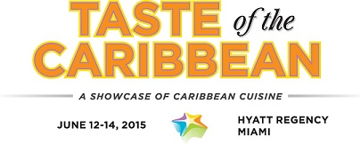

**MEDIA CONTACTS:**

KTCpr

Theresa M. Oakes / [T.Oakes@KTCpr.com](mailto:T.Oakes@KTCpr.com)

Leigh-Mary Hoffmann / [LM.Hoffmann@KTCpr.com](mailto:LM.Hoffmann@KTCpr.com)

Telephone: 516-594-4100

#1101

***\*\*high resolution images available\*\****

**BAHAMAS WINS TEAM, BARTENDER, PASTRY TOP HONORS; PUERTO RICO TAKES CHEF CATEGORY; ST. LUCIA EARNS**

**JUNIOR CHEF AWARD AT TASTE OF THE CARIBBEAN 2015**

MIAMI, FL (June 15, 2015) – The Bahamas National Culinary Team won three of the five top categories at the Taste of the Caribbean culinary competition this past weekend earning honors as ***Caribbean National Team of the Year*** and individual honors to **Marv Cunningham, Bahamas** for ***Caribbean Bartender of the Year*** and four-time winner **Sheldon Tracey Sweeting**, **Bahamas**, for ***Caribbean Pastry Chef of the Year***. **Jonathan Hernandez, Puerto Rico** was crowned ***Caribbean Chef of the Year* and Edna Butcher, St. Lucia, was named *Caribbean Junior Chef of the Year***.

"Congratulations to all of the Taste of the Caribbean participants, their national hotel associations, team managers and sponsors for developing 10 Caribbean national culinary teams to compete at our annual culinary event," said Frank Comito, director general and CEO of the Caribbean Hotel and Tourism Association (CHTA). "Your commitment to culinary excellence in our region is very much appreciated as we showcase the region’s culinary and beverage offerings. Congratulations to all of the winners for a job well-done," Comito added.

Presented by CHTA, Taste of the Caribbean featured cooking and bartending competitions between 10 Caribbean culinary teams from Anguilla, Bahamas, Barbados, Bonaire, British Virgin Islands, Jamaica, Puerto Rico, St. Lucia, Suriname and the U.S. Virgin Islands with the winners being named the "best of the best" throughout the region. This year’s event was held June 12-14 at the Hyatt Regency Miami.

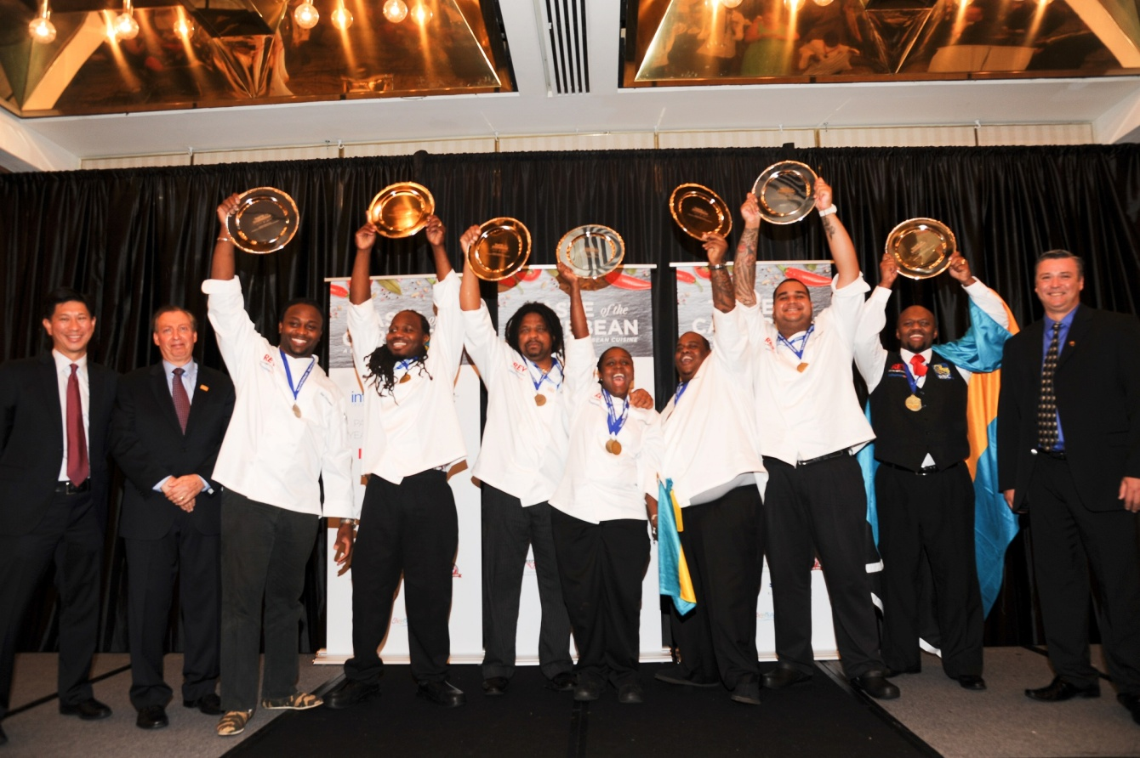

***Bahamas celebrates winning the coveted Caribbean National Culinary Team of the Year title***

**Caribbean National Team Medals**

* ***Winner: Bahamas***
* ***Gold Medals:*** Bahamas, Barbados, Bonaire, Jamaica and Puerto Rico
* ***Silver Medals:*** Anguilla, British Virgin Islands, St. Lucia, Suriname and the U.S. Virgin Islands

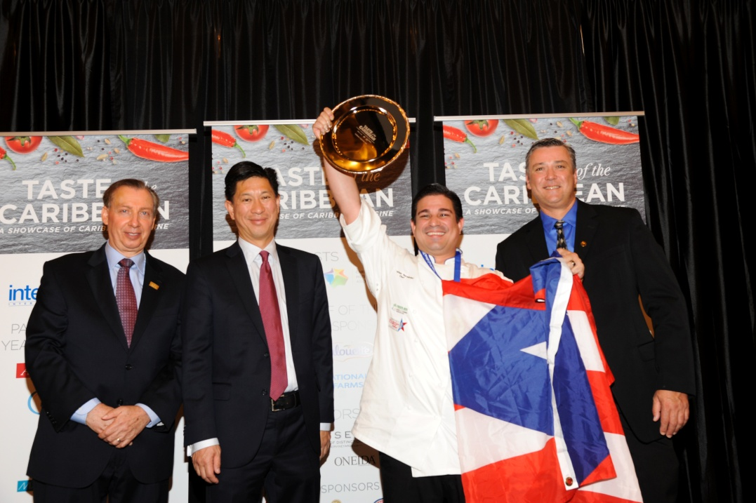

***Caribbean Chef of the Year presentation ceremony featuring (l-r) Frank Comito, director general and CEO, Caribbean Hotel & Tourism Association; Emil Lee, president of the Caribbean Hotel & Tourism Association, Caribbean Chef of the Year Johnathan Hernandez, Puerto Rico, and head judge* Peter Olsacher, Bahama Breeze.**

**Caribbean Chef of the Year Medals**

* ***Winner:* *Jonathan Hernandez, Puerto Rico***
* ***Gold Medals***: Rochelle Grindelle, Jamaica and Jonathan Hernandez, Puerto Rico
* ***Silver Medals***: Richmond Fowler II, Bahamas, Andre Nurse, Barbados, Channenton Jansen, Bonaire, Caswall Ponte, British Virgin Islands, and Refer Leon, St. Lucia
* ***Bronze Medals***: Johnathan Hughes, Anguilla, and Gilbert Wirjomoenawi, Suriname
* ***Honorable Mention****:* Michael Matthew, U.S. Virgin Islands

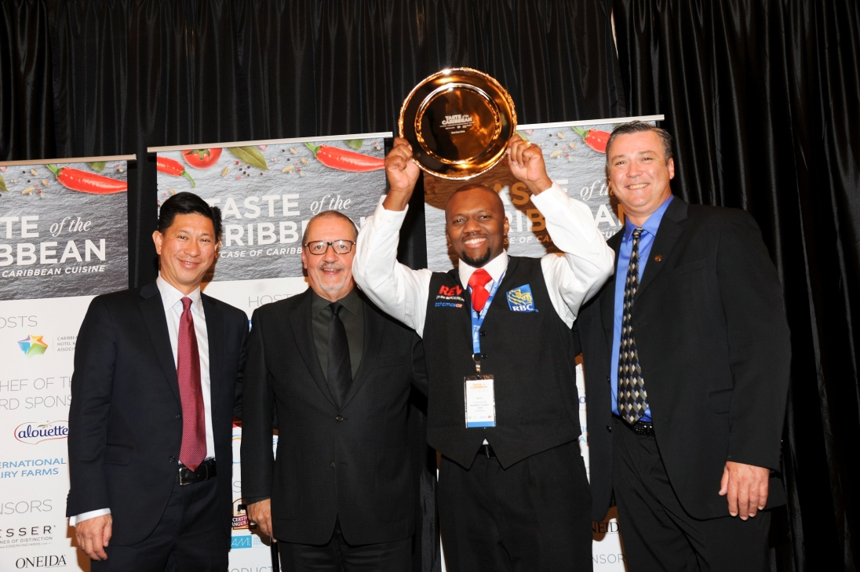

***Caribbean Bartender of the Year presentation pictured (l-r) Emil Lee, president, Caribbean Hotel & Tourism Association, Josue Merced Reyes, head bartender judge; Caribbean Bartender of the Year Marv Cunningham, Bahamas; and head judge* Peter Olsacher, Bahama Breeze.**

**Caribbean Bartender of the Year Medals**

* ***Winner:*** Marv Cunningham, Bahamas
* ***Gold Medal:*** Marv Cunningham, Bahamas, and Philip Antoine, Barbados
* ***Silver Medals:*** Jamal Hodge, Anguilla, Everson Rawlings, British Virgin Islands, Adrian Johnson, Jamaica, Jorge Olivera, Puerto Rico, Mario Alexander, St. Lucia, David Deul, Suriname, and Frank Robinson, U.S. Virgin Islands
* ***Bronze Medals***: Jay Frans, Bonaire

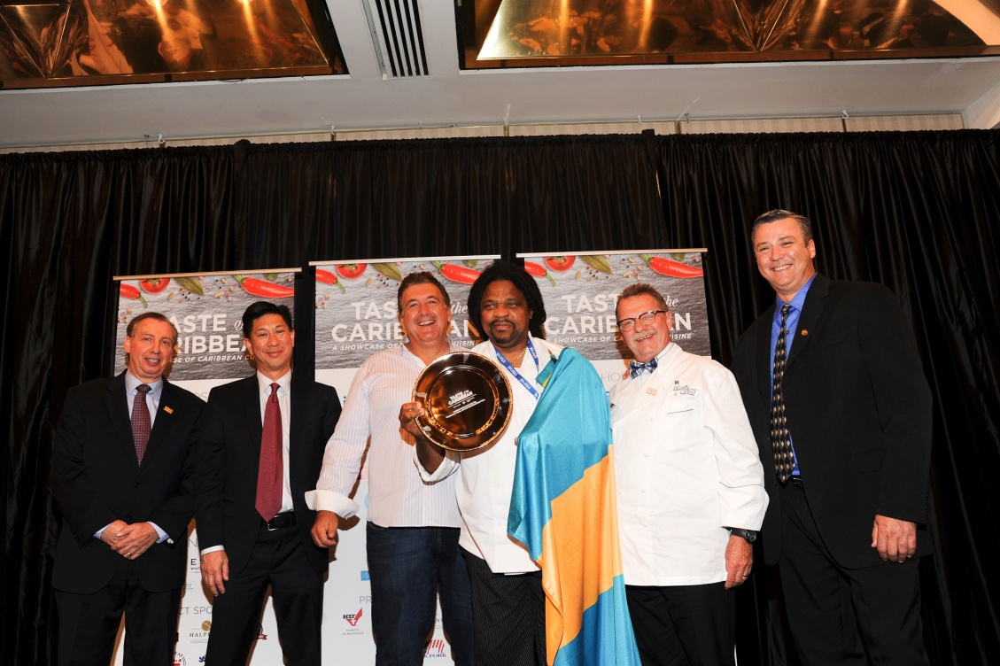

***Caribbean Pastry Chef of the Year presentation featuring (l-r) Frank Comito, director general and CEO, Caribbean Hotel & Tourism Association; Emil Lee, president of the Caribbean Hotel & Tourism Association,* Pierre DeAgostini, Anco, Aloutte and International Dairy Farms - sponsor Caribbean Pastry Chef Award; Caribbean Pastry Chef of the Year Sheldon Tracey Sweeting, Bahamas; Augusto Schreiner, head pastry judge; *and head judge* Peter Olsacher, Bahama Breeze.**

**Caribbean Pastry Chef of the Year Medals**

* ***Winner: Sheldon Tracey Sweeting, Bahamas***
* ***Gold Medals:*** Jimmie Matthews, Anguilla, and Sheldon Tracey Sweeting, Bahamas
* ***Silver Medals:*** Alberto Febo, Puerto Rico, and Gilroy Samuel, St. Lucia
* ***Bronze Medals:*** Javon Cummins, Barbados, Junior Janga, Bonaire, and Skehera Cassie, Jamaica
* ***Honorable Mention***: Neville Tucker, British Virgin Islands, Xaviera Mijnhijmer, Suriname, and Anthony Peets, U.S. Virgin Islands

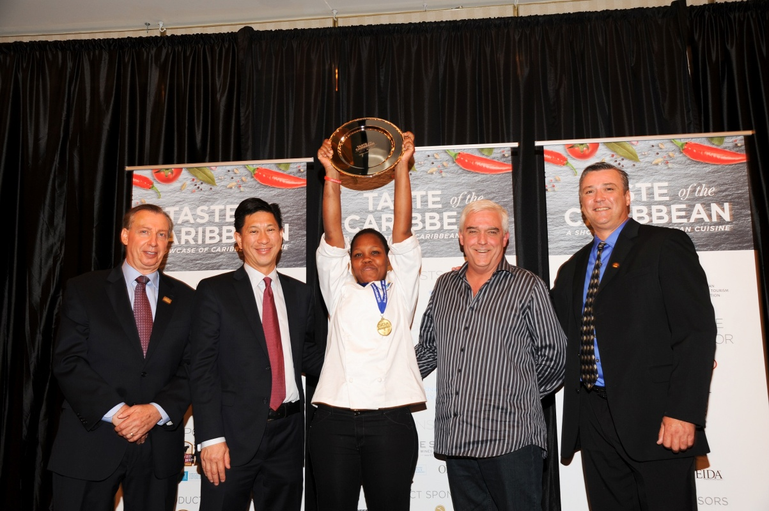

***Caribbean Junior Chef of the Year presentation featuring (l-r) Frank Comito, director general and CEO, Caribbean Hotel & Tourism Association; Emil Lee, president Caribbean Hotel & Tourism Association; Caribbean Junior Chef of the Year Edna Butcher, St. Lucia; Richard Doumeng, chairman, Caribbean Hotel & Tourism Association; and head judge* Peter Olsacher, Bahama Breeze.**

**Caribbean Junior Chef of the Year Medals**

* ***Winner: Edna Butcher, St. Lucia***
* ***Gold Medals:*** Crystal Morley, Bahamas, Suzette Diaz, Puerto Rico, and Edna Butcher, St. Lucia
* ***Silver Medals:*** Stephanie Sawyers, Barbados, Giovanie Veld, Bonaire, and Ariq Flaxe British Virgin Islands
* ***Bronze Medals:*** Theron Thompson, Anguilla, Marlon Brown, Jamaica, Svaenny Soekotaroeno, Suriname, and Anissa Rhymer, U.S. Virgin Islands

Taste of the Caribbean also featured individual competitions that took place during the event. Results are as follows:

**Best Beef / Seafood Competition**

* ***Winner Beef / Seafood Competition: Miguel Saragoza, Bonaire***
* ***Best Use of Beef, sponsored by Certified Angus Beef:*** Miguel Saragoza, Bonaire
* **Best Seafood**: Tatiana Connor, U.S. Virgin Islands
* ***Gold Medals***: Miguel Saragoza, Bonaire
* **S*ilver Medals:*** Lester Gumbs, Anguilla, Kenneth Molyneaux, British Virgin Islands, Gerald Lugo, Puerto Rico, Caron Jean, St. Lucia, and Tatiana Connor, U.S. Virgin Islands
* ***Bronze Medals:*** Charon McKenzie, Bahamas, Michael Thomas, Jamaica, and Lorenzo Harper, Suriname.
* **Honorable Mention**: Cristian Rebolledo, Turks and Caicos

**Cheesecake Competition, Sponsored by Anco, Aloutte and International Dairy Farms**

* ***Winner Cheesecake Competition:*** ***Martha Hippolyte, St. Lucia***
* ***Gold Medals:*** Alberto Febo, Puerto Rico, and Martha Hippolyte, St. Lucia
* ***Silver Medals***: Sheldon Tracey Sweeting, Bahamas, and Tiffany Grant, Jamaica
* ***Bronze Medals***: Ronald Gosepa, Bonaire, Tonya Malone, British Virgin Islands, and Sarah Meehan, U.S. Virgin Islands
* ***Honorable Mention***: Xaviera Mijnhijmer, Suriname

Following are the special awards that were bestowed at Taste of the Caribbean:

* ***Hans Schenk Commemorative Award for the Most Innovative Dish Utilizing Indigenous Ingredients***: Barbados
* ***Best Rum Drink*:** Marv Cunningham, Bahamas
* ***Best Vodka Drink*:** Frank Robinson, U.S. Virgin Islands
* ***Best Non Alcoholic Drink*:** Philip Antoine, Barbados
* ***Most Creative Bartender:*** Jamal Hodge, Anguilla
* ***Tony Mack Spirit of the Competition*:** Little Bill and the Backenders comprised of Daniel Schweizer, Eric Sywak, Michael Dannecker, Ravi Anne and Steve Sowa; and Junior Chefs Suzette Diaz, Puerto Rico, and Svaenny Soekotaroeno, Suriname.

**Sponsors**

Taste of the Caribbean is staged by CHTA in conjunction with *Caribbean Pastry Chef Sponsors: Anco, Aloutte and International Dairy Farms; Host Sponsor Interval International* and *Event Sponsors: Certified Angus Beef, Esser Wines, Greater Miami Convention & Visitors Bureau* and *Oneida.*

**For more information about Taste of the Caribbean visit** [**http://www.caribbeanhotelandtourism.com**](http://www.caribbeanhotelandtourism.com), **https://twitter.com/CHTAfeeds and** [**http://www.Facebook.com/CHTATasteoftheCaribbean**](http://www.Facebook.com/CHTATasteoftheCaribbean)**.**

**Caribbean Hotel & Tourism Association**

The Caribbean Hotel & Tourism Association (CHTA) facilitates the full potential of the Caribbean hotel and tourism industry by serving members’ needs and building partnerships in a socially responsible and sustainable manner. CHTA is the voice of the Caribbean hospitality industry for the development of the region in the highly competitive and sophisticated environment of international tourism. Today, tourism is widely recognized as a pivotal industry in the economy of the region – and CHTA functions as the common denominator for this industry in a region of diverse nationalities, languages and styles, identifying mutual problems and marshaling the resources of the active and allied members to devise solutions. CHTA represents all facets of the hospitality industry with more than 600 member hotels and over 300 allied members.

CHTA, including the events staged by the association, is supported by Strategic Partners Cable & Wireless, Interval International, HVS, MasterCard, OBM International, Tambourine and TravelZoo.

**For more information, visit** [**http://www.caribbeanhotelandtourism.com**](http://www.caribbeanhotelandtourism.com)**. Follow CHTA on Facebook** [**Facebook.com/CaribbeanHotelandTourismAssociation**](http://www.Facebook.com/CaribbeanHotelandTourismAssociation) **and Twitter** [**Twitter.com/CHTAFeeds**](http://www.Twitter.com/CHTAFeeds)**.**

###