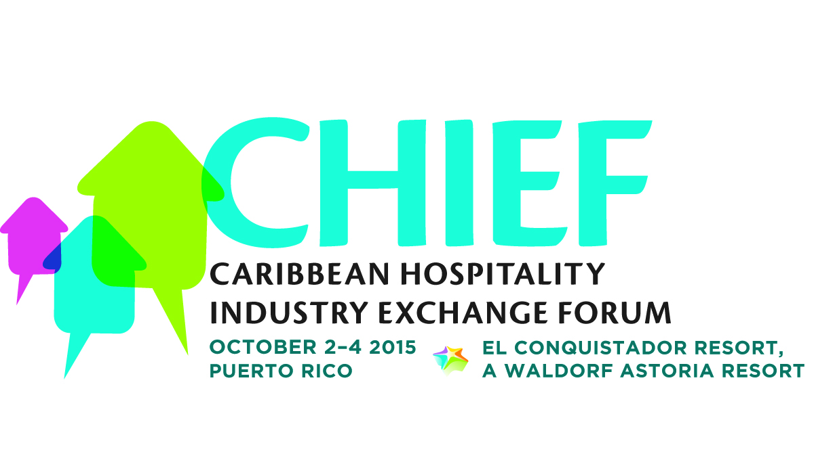

**MEDIA CONTACTS:**

KTCpr

Theresa M. Oakes / [T.Oakes@KTCpr.com](mailto:T.Oakes@KTCpr.com)

Richard Kahn / R.Kahn@KTCpr.com

Telephone: 516-594-4100

#1104

**TRAVEL + LEISURE EDITOR NATHAN LUMP TO DELIVER**

**KEYNOTE ADDRESS AT CHTA’S 'CHIEF' HOSPITALITY FORUM**

THE CARIBBEAN (June 25, 2015) - The Caribbean Hotel & Tourism Association (CHTA) has announced that *Travel + Leisure’s* Editor Nathan Lump will be the keynote speaker at the association’s Caribbean Hospitality Industry Exchange Forum (CHIEF), taking place Oct. 2-4, 2015 at El Conquistador Resort, A Waldorf Astoria Resort, in Puerto Rico. In his address, Lump will define the future of the hospitality and travel sector from the consumer’s perspective, particularly as it relates to leisure market visitors to the Caribbean.

"We look forward to Nathan Lump’s keynote address at CHIEF because his knowledge and wealth of information in consumer trends and travel habits will provide valuable insight for our members," said Frank Comito, director general and CEO of CHTA. "It’s important that our hotel and tourism business members understand and manage guest expectations while delivering a product and/or service that matches their vision. We also need to learn how to reach prospective guests and welcome the insight Lump will provide to event attendees," Comito added.

Lump leads the strategic and creative development of the *Travel + Leisure* brand across multi-platforms. Prior to joining Time Inc., parent company of *Travel + Leisure*, he spent nearly two years at Condé Nast, most recently as director of branded content, a role in which he established and led a new corporate branded content practice for the company. Lump also served as digital director at Condé Nast Traveler, where he oversaw the brand’s digital channels – CNTraveler.com and its mobile version, social media, and the tablet edition – spearheading a site redesign and leading it to 132% year-over-year organic growth.

Lump has created and led the content strategy and content marketing departments at two major advertising agencies, J. Walter Thompson and Hill Holliday, working with clients such as T. Rowe Price, Rolex, Johnson & Johnson, Liberty Mutual, and HSBC. He served as editor of the travel edition of *T: The New York Times Style* magazine from 2006 to 2009, following six years at *Travel + Leisure* and earlier editorial positions at *SmartMoney* and *Condé Nast Traveler*. His work has won Webby and OMMA Awards and has been nominated for multiple National Magazine Awards.

CHIEF offers three days of value-packed and engaging exchange sessions focused on helping businesses to generate revenue, reduce costs and become more relevant and efficient. CHIEF incorporates a variety of educational tracks so attendees can walk away with practical business tips. The educational tracks will be led by experts from a variety of travel, tourism and hospitality industry segments featuring roundtable panels with one-one-one discussions in Operations, Sales & Marketing, and Sustainability. An interactive tradeshow format, featuring an open floor plan, has been designed so participants and exhibitors can interact through live demonstrations of new products. Exhibitors will offer exclusive discounts on services and products to CHIEF attendees.

CHIEF encompasses the entire hospitality and tourism industry with educational opportunities for hotel owners and operators; chain resort management and executives; tourism and hospitality vendors/providers tourism industry entrepreneurs; hotel associations; public and private tourism and convention agencies.

**Registration and complete event details are available at www.chtachief.com. To register, email events@caribbeanhotelandtourism.com or call 786-476-8623.**

**Sponsorship**

CHIEF is staged with the assistance of **patron sponsors Interval International** and **MasterCard**; **platinum sponsor Travelzoo** and **gold sponsors Choice Hotels International, Expedia, OBMI, Sojern, STR**.

CHTA is accepting sponsors for specific programs at CHIEF. Companies interested in learning more about sponsorship opportunities should contact Matt Cooper, chief marketing officer, matt@caribbeanhotelandtourism.com or (305) 443-3040.

**Caribbean Hotel & Tourism Association**

The Caribbean Hotel & Tourism Association (CHTA) is a federation of 32 National Hotel Associations with more than 600 member hotels and over 300 allied members. CHTA is the largest representative of the private sector in the Caribbean hotel and tourism industry. We are the voice of the Caribbean hospitality industry for the development of the region in the highly competitive and sophisticated environment of international tourism. Today, tourism is widely recognized as a pivotal industry in the economy of the region – and CHTA functions as the common denominator for this industry in a region of diverse nationalities, languages and styles, identifying mutual problems and marshaling the resources of the active and allied members to devise solutions.

CHTA, including the events staged by the association, is supported by Strategic Partners Cable & Wireless, HVS, Interval International, MasterCard, OBM International, Tambourine and TravelZoo.

**For more information, visit** [**http://www.caribbeanhotelandtourism.com**](http://www.caribbeanhotelandtourism.com)**. Follow CHTA on Facebook** [**Facebook.com/CaribbeanHotelandTourismAssociation**](http://www.Facebook.com/CaribbeanHotelandTourismAssociation) **and Twitter** [**Twitter.com/CHTAFeeds**](http://www.Twitter.com/CHTAFeeds)**.**

###