

**MEDIA CONTACTS:**

KTCpr

Theresa M. Oakes / [T.Oakes@KTCpr.com](mailto:T.Oakes@KTCpr.com)

Richard Kahn / R.Kahn@KTCpr.com

Telephone: 516-594-4100

#1121

**CUBA GETTING U.S. VISITORS CONTINUES TO BE FOCUS AT**

**CARIBBEAN HOSPITALITY INDUSTRY EXCHANGE FORUM**

THE CARIBBEAN (Oct. 8, 2015) – Cuba: Opportunity or Threat? was the final General Session at the Caribbean Hospitality Industry Exchange Forum (CHIEF) in Puerto Rico over the weekend and the general consensus appeared to be cautious optimism based on expectations of diversion of visitors from other countries, but overall a chance to highlight the diversity of the culture of the region. There was also concurrence that the entire Caribbean can shine as the spotlight falls on Cuba, exposing more potential travelers to the rich diversity and culture of the region.

CHIEF was organized by the Caribbean Hotel & Tourism Association (CHTA) and held at El Conquistador Resort, A Waldorf Astoria Resort in Puerto Rico.

Cuba continued to be the focus of many conversations as the U.S. moves forward with the opening of relations which will eventually enable U.S. citizens to vacation there. There has been much speculation of what the impact will be including some dire predictions that similar destinations such as the Dominican Republic and those with a higher percentage of U.S. visitors will suffer the most.

Simon Suarez, president of ASONAHORES (the Dominican Republic hotel association), said, "We have been very vocal calling for the end of the embargo on Cuba and we expect the government of Cuba to become a viable partner in the tourism industry. We have been competing with Cuba in every other market except the United States for the past 30 years. However, the pie needs to be made larger."

Hugh Riley, Secretary General of the Caribbean Tourism Organization (CTO), noted that "Some people believe that the change is an opportunity. Will this magnet suck away visitors from others or will this magnet draw additional visitors. An optimist like me sees this as an opportunity to increase the slice of the pie."

Vincent Vanderpool-Wallace, Principal Partner, Bedford Baker Group, said, "Those countries relying on the U.S. as their primary market are going to have to pay close attention. Just as Donald Trump does not have to spend money to get into the news with his statements, Cuba will get a lot of news coverage when it opens up its doors to U.S. visitors."

Vanderpool-Wallace added: "A result of that is destinations will have to diversify source markets which will ultimately make the Caribbean stronger. And I suspect that other countries will pay more attention to promoting culture as a focus for visitor experiences."

A more cautious note was offered by Marla Dukharan, Group Economist, Caribbean Banking, Royal Bank of Canada, saying: "With occupancy levels of just over 55 percent, Cuba could accommodate nearly twice as many visitors." She also warned that "Less U.S. dollars will flow into other countries when more comes into Cuba and there will also be tax incentives offered to developers."

Riley suggested that "The Cuban situation has forced other countries to look into their own incentives to bring new business to their destinations."

This highly-anticipated session was moderated by Anton Edmunds, Principal, The Edmunds Group International. “The efforts towards the normalization of trade and travel between the United States and Cuba opens the door to a renewed focus on Caribbean tourism," said Edmunds. "Whether this presents an opportunity or a threat depends in large measure upon the region’s stakeholders,” he added.

The panelists expanded upon points raised in a paper released by CHTA this summer titled: *“Cuba: The Great Disruption for the Good of the Caribbean.”* The paper sparked debate within the region about the impact which the lifting of the U.S. trade and travel embargo would have on the industry. While the general consensus was to embrace full normalization, numerous concerns surfaced.

There is a consensus within CHTA and the region’s private sector that the Caribbean must do a better job at embracing tourism as its primary economic development and employment generation tool and a means to reduce the mounting debt of many jurisdictions.

"Our aim is to raise awareness about both the challenges and the opportunities to the region following the removal of travel barriers to Cuba," said Emil Lee, president of CHTA. “Now that the issue has had a few months to marinate, we have a clearer vision and look forward to sharing insider insight with attendees,” Lee added.

CHIEF was organized with the support of patron sponsors Interval International and MasterCard; platinum sponsors Cable and Wireless, JetBlue Getaways, Travelzoo and TripAdvisor, gold sponsors Adara, Aireko, AskMe, Best Doctors, Bonnier Corp, Cape Air, CaribbeanJobs.com, Choice Hotels International, Expedia, JackRabbit Systems Inc., Lutron Electronics, MobiManage, OBMI, Oracle, Sojern, STR, The New York Times, travAlliancemedia and World Media, wine sponsor Wines by Esser Wines and Education Partner Florida International University.

**Caribbean Hotel & Tourism Association**

The Caribbean Hotel & Tourism Association (CHTA) is a federation of 32 National Hotel Associations, with more than 600 member hotels and over 300 allied members. CHTA is the largest representative of the private sector in the Caribbean hotel and tourism industry. We are the voice of the Caribbean hospitality industry for the development of the region in the highly competitive and sophisticated environment of international tourism. Today, tourism is widely recognized as a pivotal industry in the economy of the region – and CHTA functions as the common denominator for this industry in a region of diverse nationalities, languages and styles, identifying mutual problems and marshaling the resources of the active and allied members to devise solutions. CHTA represents all facets of the hospitality industry with more than 600 member hotels and over 300 allied members.

CHTA, including the events staged by the association, is supported by Strategic Partners MasterCard, Cable & Wireless, HVS, Interval International, OBM International, Tambourine and TravelZoo.

**For more information, visit** [**http://www.caribbeanhotelandtourism.com**](http://www.caribbeanhotelandtourism.com)**. Follow CHTA on Facebook** [**Facebook.com/CaribbeanHotelandTourismAssociation**](http://www.Facebook.com/CaribbeanHotelandTourismAssociation) **and Twitter** [**Twitter.com/CHTAFeeds**](http://www.Twitter.com/CHTAFeeds)**.**

###

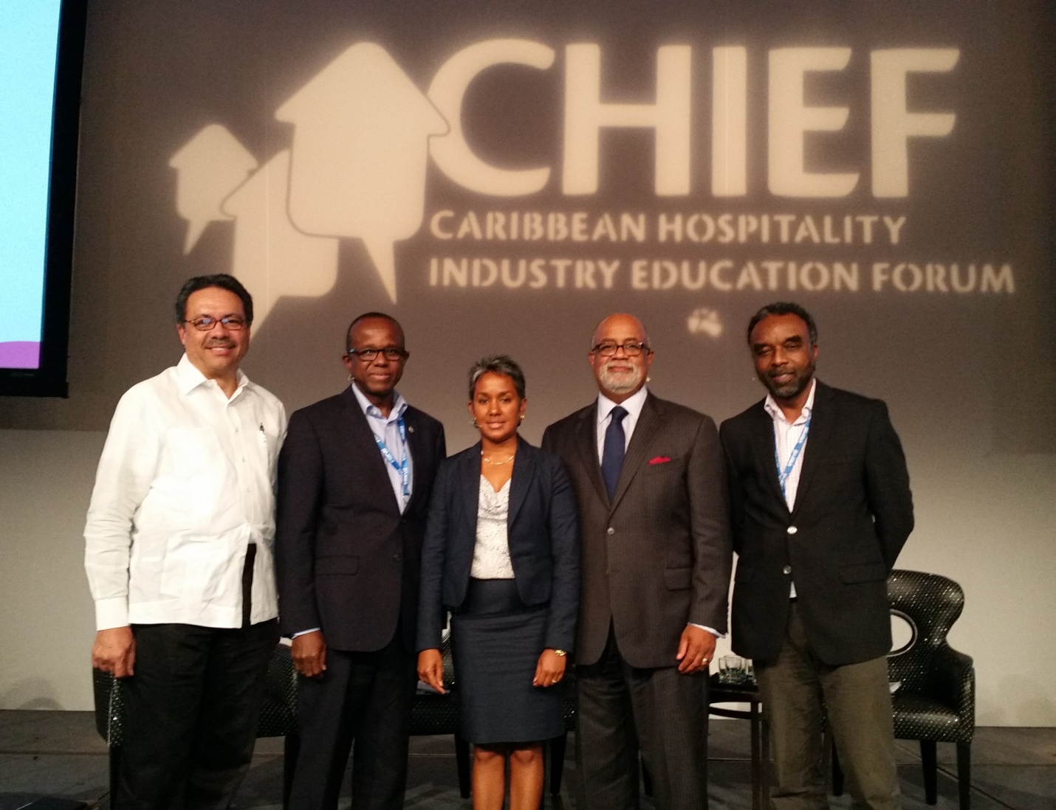

***Cuba: Opportunity or Threat? panel at the Caribbean Hospitality Industry Exchange Forum (CHIEF). Pictured (l-r) Simon Suarez, president of ASONAHORES; Hugh Riley, Secretary General of the Caribbean Tourism Organization (CTO); Marla Dukharan, Group Economist, Caribbean Banking, Royal Bank of Canada; Anton Edmunds, Principal, The Edmunds Group International; and Vincent Vanderpool-Wallace, Principal Partner, Bedford Baker Group.***