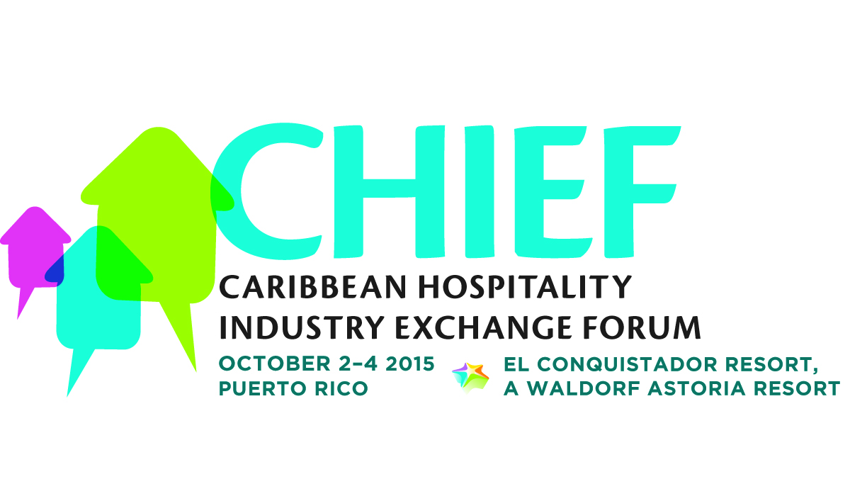

**MEDIA CONTACTS:**

KTCpr

Theresa M. Oakes / [T.Oakes@KTCpr.com](mailto:T.Oakes@KTCpr.com)

Richard Kahn / R.Kahn@KTCpr.com

Telephone: 516-594-4100

#1122

**'CHIEF AWARDS' PRESENTED FOR BUSINESS OPERATIONS,**

**SALES & MARKETING, SUSTAINABILITY**

THE CARIBBEAN (Oct. 14, 2015) – The Caribbean Hotel and Tourism Association (CHTA) has named the winners for the inaugural "CHIEF Awards" honoring member hotels and tourism-related enterprises for best practices in Business Operations, Sales & Marketing and Sustainable Practices. Awardees were announced at the Caribbean Hospitality Industry Exchange Forum (CHIEF) which took place Oct. 2 – 4, 2015 at El Conquistador Resort, A Waldorf Astoria Resort in Puerto Rico.

"We have witnessed extreme forward-thinking programs from each of the winning companies who rightfully earned top honors in these important categories,” said Emil Lee, president of CHTA.

The winner in the *Business Operations* category was presented to **Sandals Grand St. Lucian Spa & Beach Resort, St. Lucia.**

The resort’s entry focused on “Developing Strong, United, Team Working Towards the Goal of Consistently Providing an Outstanding Guest Experience.” To increase guest experiences, the resort implemented a program to strengthen the skills of its employees. Success was measured by increased guest service scores, strategic HR metrics focusing on productivity, recruitment, retention, employee relations and HR cost-saving as a percentage of total revenue.

**The Somerset on Grace Bay, Turks and Caicos,** took top honors in the *Sales & Marketing* category. The resort put in place an “Integrated Customer Relationship Marketing Initiative (iCRM).” After five years of occupancy and revenue declines, The Somerset on Grace Bay was able to mount a dramatic turnaround by implementing a concerted integrated Customer Relationship Marketing (iCRM) initiative which encourages all disciplines to communicate freely to develop creative, integrated, multi-disciplined programs that drive profitable revenue. Over the course of the first two years, revenue for the resort nearly doubled and is on pace to more than double in the third year of the program.

And finally, the resort which earned top honor for the *Sustainable Practices* category was **Rosalie Bay Resort, Dominica.** Their entry, “An All-Encompassing Approach to Sustainability,” highlights the resort’s initiative to build a sustainable, eco-friendly, wellness retreat dedicated to coexisting with nature, providing locals with a dependable livelihood through responsible tourism and to share its island home of Dominica with the world. Rosalie Bay has earned high accolades from leading organizations in sustainability.

CHTA members can view the finalists’ documents, submissions and lessons learned on the CHTA website [http://chtachiefawards.weebly.com](http://chtachiefawards.weebly.com/).

CHIEF offered peer-to-peer exchange sessions in Operations, Sales & Marketing, and Sustainability, which focused on helping businesses generate revenue, reduce costs and increase efficiency. Hoteliers attending walked away with practical business tips and learned of best practices for tackling operational and marketing challenges. The educational tracks were led by experts from a variety of travel, tourism and hospitality industry segments.

CHIEF was organized with the support of patron sponsors Interval International and MasterCard; platinum sponsors Cable and Wireless, JetBlue Getaways, Travelzoo and TripAdvisor, gold sponsors Adara, Aireko, AskMe, Best Doctors, Bonnier Corp, Cape Air, CaribbeanJobs.com, Choice Hotels International, Expedia, JackRabbit Systems Inc., Lutron Electronics, MobiManage, OBMI, Oracle, Sojern, STR, The New York Times, travAlliancemedia and World Media, wine sponsor Wines by Esser Wines and Education Partner Florida International University.

###