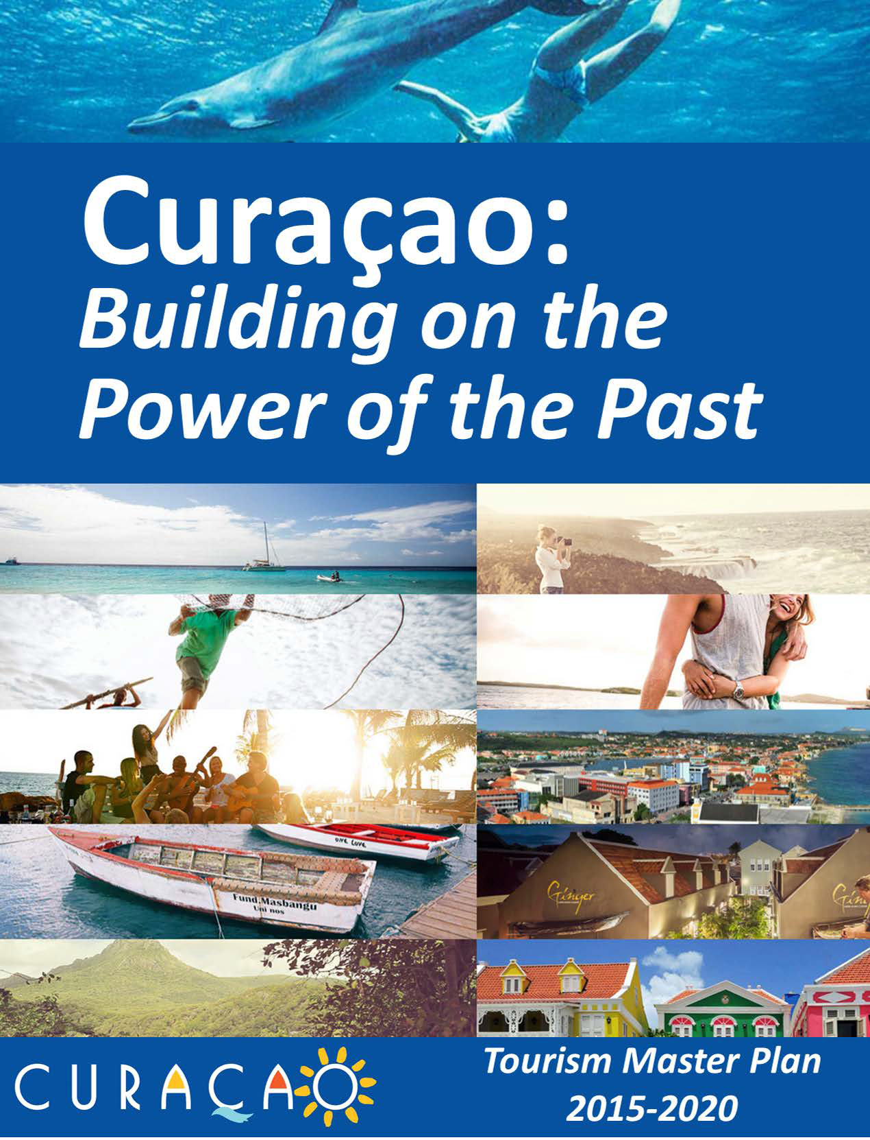

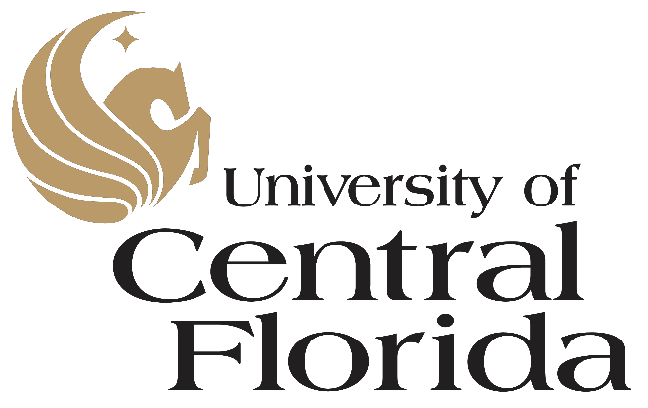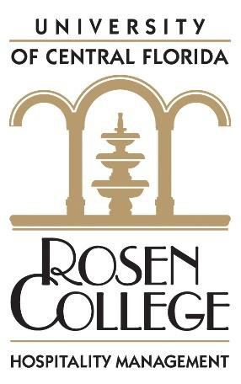

©2015

The Dick Pope Sr. Institute for Tourism Studies

Rosen College of Hospitality Management University of Central Florida

9907 Universal Boulevard

Orlando, Florida 32819

Main Investigators: Robertico Croes, Ph.D. Kelly Semrad, Ph.D. Manuel A. Rivera, Ph.D.

With the support of: Abraham Pizam, Ph.D. Asli Tasci, Ph.D.
Edwin Torres, Ph.D. Kevin Murphy, Ph.D. Murat Kizildag, Ph.D. Amy Gregory, Ph.D.

Valeriya Shapoval Jalayer Khalilzadeh Marissa Orlowski William Ingram Amanda Templeton

Acknowledgment:

The Dick Pope Sr. Institute for Tourism Studies would like to acknowledge the support of the Curaçao Tourism Board, in particular the valuable assistance of Ms. Christine Campagnard and her staff during the data collection and tabulation process. A special thank you to Dr. Jenna Lee.

Table of Contents

Executive Summary 1
The Rationale 1
Tourism is the Right Choice 1
Curaçao’s Opportunity 1
The Process 2
The What 2
The Value Proposition 2
The Goals of the Value Proposition 3
The How 3
When 4
The Role of the CTB 4
The Way Forward 4
Chapter 1: Strategic Tourism Master Plan Framework 6
Overview 6
Purpose of the plan 6
Development process 7
Chapter 2: Curaçao’s Opportunities for Forward Movement 10
Curaçao’s strong past 10
Curaçao’s tourism industry today 11
Curaçao’s destination image compared to other Caribbean competitors 13
Tourists’ perceptions after visiting Curaçao 15
Online reviews for Curaçao 16
Performance gap between tourists’ perceptions and Curaçao’s industry stakeholders 18
Local residents’ perceptions of the Curaçao tourism industry 19
Tourists’ future intentions to visit Curaçao 21
Perception Cruise Visitors 21
Tourism’s new promise 22
Chapter 3: The Economic Contribution of Tourism 23
Tourism spending 23
The spending impact in the local economy 23
The cruise business 28
The economic impact of tourism 29
Residents’ perceptions of tourism’s contribution 30
Employees’ perceptions of career opportunities in the tourism industry 31
Tourism works with misaligned local perceptions 32
Chapter 4: The Effectiveness of the Tourism Industry, Human Capital, and Institutional Support 33
The ROI of the tourism industry in Curaçao 33
Cause and effects of declining ROI in the tourism industry 35
The business environment and the low economic return 37
Human capital analysis 38
The CTB’s conundrum 41
Chapter 5: Challenges looming on the horizon 45
Tourism as best promise for the future 45
Tourism and the economic link 46
The soft component of tourism is under pressure 48
Direction needed 49
Curaçao’s competitive position 49
A need for change 51
Chapter 6: Profiling Curaçao’s Tourists, Satisfaction, and Intention to Return 52
Demographic tourist profile 52
Information search and booking behavior 52
Activities enjoyed while at the destination 55
From satisfaction to intention to return 57
Chapter 7 Solidifying the Tourist Experience 63
Paths toward collective prosperity 63
The strategic plan 63
Phase 1: Traction 65
Phase 2: Solidification 65
Phase 3: New horizons 66
Getting the American tourists to Curaçao 67
Curaçao’s American market competitors 68
Curaçao’s tourism strategy in the American market 71
Segmentation strategies conquering the American market 71
Innovative American tourist segment 72
Demographic and geographic traits 72
Psychographic traits 72
The quality, market maven American tourist 73
Demographic and geographic traits 73
Psychographic traits 73
“Curaçao, a different Dutch Caribbean” 74
The new CTB 75
Modifying the current tourism organization framework 75
The role of the CTB 76
Financial sustainability 77
Chapter 8: Traversing Tourisms’ Possibilities: kindling the economy and jobs 79
Introduction 79
The destination vision 79
The destination mission 80
The strategic framework 81
The underpinnings of the strategic map 82
Main goals: Economic and job growth 84
Strategy #1: Refocus demand structure 86
Strategy #2: Airlift and hotel optimization 88
Strategy #3: Human capital investment 88
Strategy #4: Investing in the future: Sustainable financial resources 90
Strategy #5: Punda/Otrabanda as Curaçao’s tourist rendezvous 91
Strategy #6: Oospunt as Curaçao’s wildcard 93
Strategic supporting actions 94
Actions to improve hotel productivity 94
Actions to enhance human capital 95
Embracing product staging at the mid-term: Acquiring sustainable products 96
The long-term perspective: Accountability and transparency 100
References 101

ANNEX A: ACKNOWLEDGEMENTS ................................................................................................................................ A
ANNEX B: SURVEY ......................................................................................................................................................... B
ANNEX C: RESULTS FACTOR ANALYSIS...........................................................................................................................C
ANNEX D: CRUISE CONJOINT ANALYSIS ........................................................................................................................ D

List of Tables
Table 1: Curaçao’s position in the 1960’s - 1970’s | 10
Table 2: Curaçao vs. St. Maarten’s tourism performance over time | 12
Table 3: Impressions about Curaçao | 14
Table 4: Tourists’ rating of Curaçao’s destination attributes | 15
Table 5: Tourists’ satisfaction and value for tourism-related products | 16
Table 6: “Curaçao” word correlations with other terms | 18
Table 7: Tourists’ perceptions vs. Curaçao stakeholders’ perceptions | 18
Table 8: Most important destination attributes that predict visits from potential tourists | 21
Table 9: Curacao’s Demand Accommodation mix | 24
Table 10: Distribution of hotel stays | 24
Table 11: Hotel vs. non-hotel tourists’ spending | 25
Table 12: Hotel tourists by country | 26
Table 13: Non-hotel tourists by country | 27
Table 14: Spending profile of the cruise industry | 29
Table 15: Tourism’s economic impact in Curaçao | 30
Table 16: Tourism’s economic spillover effect | 30
Table 17: Residents’ perceptions of tourism opportunities | 30
Table 18: Attitudes towards tourism and customer service | 31
Table 19: Total revenue gap | 34
Table 20: Comparison of corporate income tax rate | 35
Table 21: Panel A: Income from direct taxes (x mln NAf) | 35
Table 22: Panel B: Income from indirect taxes (x mln NAf) | 36
Table 23: Employee perspectives | 39
Table 24: Measurement items of job congeniality | 40
Table 25: Supervision in hospitality and tourism | 49
Table 26: Purpose of visit | 52
Table 27: Sources of information | 53
Table 28: Reservation and payment methods | 54
Table 29: Activities in Curaçao | 56
Table 30: Arrivals by country | 57
Table 31: Overall satisfaction | 58
Table 32: Overall quality | 59
Table 33: Overall value | 60
Table 34: Overall price | 60
Table 35: Overall satisfaction | 60
Table 36: Overall perceptions on loyalty | 61
Table 37: Overall tourist satisfaction | 61
Table 38: Additional tourists staying in hotels 2016-2020 | 65
Table 39: Additional tourists staying elsewhere 2016-2020 | 65
Table 40: Overall economic impact | 67
Table 41: Curaçao image in the US regions | 67
Table 42: Drives of intention to visit Curaçao | 68
Table 43: Curaçao’s US market competitors | 69
Table 44: Image perception of the competitive set | 70
Table 45: Factor analysis for beaches, duty-free and hospitality | 70
Table 46: Comparison of two suggested American markets | 75
Table 47: Loan Payment Structure for Budget | 78
Table 48: Total arrivals forecast 2016-2020 | 86
Table 49: Expected RevPAR from 2016-2020 | 87
Table 50: Attribute Preferences | A
Table 51: Utilities by Country | A
Table 52: Expectations by country | B
Table 53: Loyalty drivers | B
Table 54: Demographic information | B

List of Figures
Figure 1: Methodology used to construct the 2015-2020 Tourism Master Plan 8
Figure 2: Curaçao’s primary market segments overtime 10
Figure 3: Growth of Curaçao’s 11
Figure 4: Contributions of Curaçao’s economic sectors 11
Figure 5: Curaçao’s tourist arrivals 12
Figure 6: Curaçao’s tourist receipts 12
Figure 7: Curaçao tourism on TripAdvisor® 16
Figure 8: Curaçao’s word cloud 17
Figure 9: Curaçao’s tourism specialization 23
Figure 10: Length of stay of hotel vs. non-hotel tourists 26
Figure 11: Seasonality in occupancy rates 27
Figure 12: Curaçao’s cruise business over time 28
Figure 13: Increase in ports of call 28
Figure 14: Return on investment (ROI) 34
Figure 15: Relationship Marketing Budget (LRBUD) and Tourism Receipts (LRTOURREC) 36
Figure 16: Correlation Marketing Budget (LRBUD) and Tourism Receipts (LRTOURREC) 37
Figure 17: Job satisfaction and turnover intentions 40
Figure 18: Relationship between marketing budget and arrivals, 2002-2014 43
Figure 19: Marketing mindset for a market oriented organization 44
Figure 20: Growth of Curaçao’s economic sectors 2009-2013 45
Figure 21: Curaçao’s tourism receipts vs. economic growth 46
Figure 22: Moving correlations between real tourism expenditures and real economic growth 47
Figure 23: Curaçao’s competitive position 50
Figure 24: Parameters for Curaçao’s position 51
Figure 25: Booking behavior of Curaçao tourists 54
Figure 26: Food consumption patterns 57
Figure 27: Accommodation types selected by tourists from 2000-2013 64
Figure 28: The strategic focus of target audience 66
Figure 29: CTB’s two main areas of activities 77
Figure 30: Strategic framework 2015-2020 85
Figure 31: The new demand structure by 2020 86
Figure 32: US potential market 88
Figure 33: Punda/Otrabanda Map 91
Figure 34: Oostpunt 93
Figure 35: Objectives and strategic actions 99

The Rationale

Executive Summary

Curaçao faces hard choices in the upcoming years. High unemployment (especially among the youth), a stagnant economy, and low confidence levels may spiral the island into dangerous socio-economic waters. These domestic challenges are occurring in the midst of the global economic uncertainties that have been triggered by a shaky Chinese economy, a weakened European Union and Euro, and the deepening economic travails and budget problems of Brazil and Venezuela.

Yet, despite these challenges, Curaçao has made great strides in the tourism sector compared to other economic sectors on the island. The tourism sector demonstrated resilience against outside shocks and was able to steadily increase its prominence in Curaçao’s economy. In fact, today, its share of the island’s economy is nearly 18% of the total economy, impacting every economic sector on the island. In addition, the tourism sector has become a substantial source of employment on the island. Nearly 23% of jobs are created and sustained directly or indirectly by the tourism sector.

With its buoyant growth, the tourism sector has mushroomed in the past fifteen years. It is more mature, more desired by tourists, and discloses more promise for the future. Curaçao’s tourism product has changed significantly over time with regard to the product portfolio, market segment mix, and the industry’s overall contribution to the economy. So, fittingly, the current tourism product seems to possess a composition of experiences that are evaluated by tourists as favorable. This favorable evaluation is shared by both actual tourists: those who have visited Curaçao within one year, and those potential tourists who have not visited Curaçao but have visited the Caribbean within the last five years.

Tourism is the Right Choice
The timing is right to make a choice for tourism to become the strategic spearhead to catapult the island to new favorable horizons in the coming years. Moreover, there is ample evidence that small islands specializing in tourism grow faster than islands less specialized in tourism. Thus, tourism has the prowess and potential to facilitate the solutions to a stagnant economy and unemployment. In other words, tourism can propel economic growth and create the jobs that are so crucial to the welfare of Curaçao.

There are a number of factors that prompt optimism regarding the opportunity for Curaçao to continue moving forward. Despite the reigning global market growth uncertainty for destinations, a levered opportunity has surfaced for destinations located within the Caribbean. This opportunity may benefit Curaçao as Caribbean vacations are the most desired foreign vacations for US residents. Thus, given its resilience and impact, the tourism sector becomes a beacon that guides the island as it forages to capture more market factions – especially with regard to the US.

Curaçao’s Opportunity
Curaçao has a unique opportunity if the destination is willing to take up the challenge to reposition itself in a manner that could bring it once again to the forefront of small island destinations. Warm weather continues to be a strong draw for desired vacations, but hospitality factors (i.e., soft components of tourism) have emerged as the most important attribute for tourists in deciding which Caribbean destination they would like to visit. It is clear that visitors to Curacao view high quality service delivery and hospitality factors as characteristics necessary to desirable destinations. In addition, there is strong local support for tourism development amongst the local population. Therefore, Curaçao as a destination is logically positioned to grow and deliver strong economic and job growth from the tourism sector.

The Process
Recognizing this emerging opportunity, the Minister of Economic Development and the Curaçao Tourism Board commissioned (October, 2014) the Dick Pope Sr. Institute for Tourism Studies (DPITS) at the Rosen College of Hospitality Management at the University of Central Florida to develop a Strategic Tourism Master Plan 2015-2020. The purpose of the plan is to design a blueprint that guides and directs the destination to convert itself to one of the premiere Caribbean destinations by 2020.

This plan contains the rationale (why tourism), the tourism approach (what, how, and when the plan is implemented), and the timing of the plan (when it will be introduced). This master plan uses a bottom-up research approach in the construction of its suggested actions, solutions, and goals. This means that the plan is founded on empirically sound research that encompasses voices from a wide range of tourism stakeholders. Thus, stakeholders from all walks of life were consulted in the plan’s design.

Accordingly, the DPITS met face-to-face with more than 250 stakeholders. The purpose of the stakeholder meetings was to obtain feedback on the overall project, share ideas pertaining to Curaçao’s tourism challenges, provide informational sources of value to the DPITS research team, and actively involve a variety of different types of stakeholders in the drafting of the 2015-2020 Strategic Tourism Master Plan project. In addition, eleven surveys were created and nearly 7000 respondents completed the surveys, including stay-over tourists, cruise tourists, Caribbean tourists who had never visited the island, employees, and the local population at large.

The What
For the tourism sector to lead the island to new socio-economic horizons, the sector must attend to two critical foundational weaknesses. First, the current demand structure anchored in the Dutch and Venezuelan markets does not contain enough octane to power the island to higher levels of economic growth and jobs. The main reason is that approximately only half of the visitors from these two markets stay in hotels, resulting in low hotel performance, thereby imbuing the tourism sector with a high opportunity cost. Second, the soft component of the sector reveals deficiencies in service quality and delivery at the micro-level, and debilitating coordination and trust issues at the macro-level. The soft component refers to human capital development, education, service culture, service delivery, business climate, and institutional support. The consequence is that the tourism sector is not performing optimally. The plan recommends that strategic focus be placed on the reconfiguring of tourism demand to the island, as well as on improvement of the soft components of the tourism sector. Curaçao needs to restructure the foundation of its market segment mix by gravitating toward the American market. This implies creating a value proposition for the American market that is already familiar with the Caribbean region, but is unacquainted with Curaçao’s potential to provide meaningful and enjoyable experiences.

The Value Proposition
The proposition is anchored in “Curaçao: a Different Dutch Caribbean.” This proposition offers tourists a “new” destination brand, while still forwarding the Caribbean’s traditional SSS (sun, sand, and sea) seasoning, and while promoting its safety, stability, organizational prowess, and, finally, its character as a destination finely spiced with a unique blend of eclectic cultures. Curaçao: a Different Dutch Caribbean will provide the impetus to generate nearly 4000 jobs, will germinate 2% real annual economic growth in the first two years, and will close the RevPAR gap between Curaçao and the Caribbean region from the existing 35% to less than 10% by 2020.

The Goals of the Value Proposition
The goals of the plan are three-fold:

- Tourism must boost economic growth
- Tourism must spawn new jobs
- The performance of the lodging industry must improve

Curaçao should become the most desirable destination in the Caribbean. Becoming the most desirable destination in the Caribbean is directly associated with increased economic and job growth. The goal is to push real economic growth at an annual average of 2%, while spawning nearly 4000 jobs by year 5 of the plan. The increase in arrivals is crucial for job creation: each additional 44 arrivals will generate one job. In so doing, tourism would become a means to increase economic welfare and job growth through the industry’s connections with other economic sectors. The push for more arrivals will be realized through five main strategies.

The How
Strategy 1: Refocus demand structure
Refocus the demand structure toward the American market without replacing the Dutch and Venezuelan markets. The required additional arrivals from the US should increase to nearly 100,000, for total arrivals of 158,860 from the US market. The shift toward the American market responds to the need to quickly increase the hotel sector’s financial performance. The hotel sector has the most potent short-term economic impact for the tourism industry. The most efficient means by which to measure the aggregate performance of the hotel sector is via benchmarking Curaçao’s RevPAR value. It is expected that by year 5, Curaçao’s RevPAR will increase to US$128.13, which brings Curaçao closer to the regional RevPAR.

In addition to the shift toward the American market, the plan suggests a shift of marketing efforts from the uncertain Venezuelan market to the Colombian market. This is because, as of July 1, 2015, visa requirements for Colombian citizens coming to Curaçao had been eliminated. Finally, the plan also suggests the implementation of marketing efforts to convert 5% of cruise visitors to the destination into stay-over tourists.

The goal is to increase RevPAR at the end of year 2 by US$15.00. This means a 7.5% increase per year on average, which is the same regional RevPAR increase from 2012 to 2013. By year 5, the goal is to reach at least the 2014 RevPAR level of the Caribbean region at US$133. Achieving this objective implies significantly closing the RevPAR gap with the Caribbean region, thereby revealing a major stride with regard to Curaçao’s competitive position. This asserts that Curaçao must accomplish, from year 3 to 5, an average annual increase in RevPAR of 3.5%.

Strategy 2: Increase airlift
To provide accessibility to the required additional arrivals from the US, an increase in airlift is required. By 2017, the goal is to grow the current level of airlift by ten weekly flights from the 2015 baseline of twenty-four. The main priority region from the US is the Middle Atlantic region that covers New York, Pennsylvania, New Jersey, Maryland and Delaware (see Figure 32). By 2020, Curaçao will need twenty additional weekly flights from the US (above the 2015 baseline) in order to airlift 100,000 additional arrivals. The additional flights should depart from the Middle Atlantic, the Mid-West, and the South priority areas within the US continent.

Strategy 3: Human capital investment
The plan suggests a sharp focus on the enhancement of Curaçao’s human capital. Enhancing the quality of human capital is the core necessity of tourism’s soft components. Increasing the number of arrivals to Curaçao, as suggested in Strategy 1, will impact economic growth and job creation. However, the continued success of Strategy 1 is dependent upon the simultaneous increase in the quality of tourism experiences. The plan aims to certify 5000 employees in hospitality services by 2019, and on increasing the public perception of tourism’s value to 70% from the current level of 40% of favorable tourism perceptions. Of great value in securing positive perceptions of the destination are the experiences gained between interaction of Curacao’s people and tourists. Thus, the program

“Beautiful People” serves as an investment in increasing and sustaining tourist awareness of Curacao’s ability to offer far more than SSS.

Strategy 4: Sustainable financial resources
The plan foresees two funds. One fund is to support marketing efforts as well as increases in airlift and the soft components of the tourism product - according to Strategies 1, 2 and 3. This marketing fund consists of US$40 million to be acquired as a loan. The sources to finance the loan will stem from additional room tax, more effective room tax collection, and from other non-conventional sources (other economic sectors) that benefit from the increase in tourism revenues. It is imperative, however, that any room tax arrears be promptly collected in order to instill confidence in the banking system, that the law is to be respected, and that it will be enforced; and that the government means business when it comes to tourism development.
The second fund pertains to the collection of the room tax from short term rentals, such as apartments. This fund could be put to use for creating and sustaining product development in tourism offerings.

Strategy 5: Revamping the UNESCO heritage site Punda/Otrabanda
The Punda/Otrabanda area has a unique opportunity for combining cruise tourism and stay-over tourism in terms of opening hours, shopping mix, and food and beverage, as well as entertainment in general. This site is the most visited attraction on the island. As the American tourists prefer beach consumption, entertainment, and socializing opportunities, the development of the area would increase the likelihood of drawing this segment. Moreover, the American consumption pattern could fit well with what Curaçao has to offer in terms of its present everyday life mosaic, which is prevalent in the culture of the island. Additionally, this area will provide the residents with a district in which they might like to seek employment, as well as frequent during their leisure time.

When
The plan consists of three time cycles, which includes years 1 and 2 as the first cycle, years 3 and 4 as the second cycle, and finally, year 5 as the third cycle. Cycle 1 is traction and is crucial for the success of the plan as it is geared toward rapidly increasing demand and airlift, while strengthening the hotel sector. Cycle 2 is anchored in the consolidation of achievements, with special attention dedicated to improving human capital and other soft components of the tourism sector. During this cycle the UNESCO heritage site should have become a duty-free site. Cycle 3 addresses the expansion of the tourism sector. In particular, it speaks to the expansion of the hotel room inventory. Also, it attends to Oostpunt as the wild card in propelling the destination as a template for a “green” tourism development.

The Role of the CTB
The successful implementation of these five strategies relies on the effectiveness and efficiency of the Curaçao Tourism Board (CTB). The plan recommends a restructured CTB that involves inclusiveness, a business culture, and accountability as its most salient organizational values. The main role of the new CTB is to serve as an interface between market (consumer) demand and destination (industry) supply. The CTB should embrace a dual role as a tourism sales and marketing tool for the industry, and as the guarantor of coordination amongst stakeholders.

The new mission of the CTB is to increase the number of arrivals within an inclusive system, thus propelling economic growth and creating jobs through strong public/private partnerships. An inclusive system will ensure financial sustainability supporting this CTB mission. The main measure of success for the new CTB is the quality of the tourists’ experience. The overall tourist experience will be reflective of all of the separate tourist encounters within the travel chain. Hence, the quality of the experience is an outcome of the CTB’s efforts to sponsor coordination amongst stakeholders – something to be measured rather than directly managed. An audit of the quality of the destination experience along with tourist satisfaction surveys would be examples of initiatives that would support this activity.

The Way Forward
The road toward a breakthrough in the economy that the Strategic Tourism Master Plan 2015-2020 promises is paved with mundane, workaday tasks requiring patience, perseverance, discipline, and, above all, hope. There will

be daunting obstacles on the journey to prosperity, but it is necessary to stay the course without skepticism or uncertainty. The enemy of success is inaction and reluctance. There are two possible scenarios. On the one hand, Curacao may opt to do nothing. However, the price will be steep and irreversible with regards to impact rates on high unemployment, wasted talents, and increased pessimism amongst locals. On the other hand, Curacao may choose to operationalize the proposed plan which has the value proposition of an additional US$200 million in economic activities, 3,700 new jobs, and an annual average of real economic growth of 2% in the next five years. The return on investment of this plan is solid and significant: nearly 500% based on a maximum additional cost of US$40 million.

It is time to act, and to act decisively. There is no longer time for hemming and hawing about choice and direction. This plan provides a clear roadmap to a new and brighter future. The power of tourism may well be Curaçao’s greatest hope to free its people from the pain of unemployment, wasted talents, and pessimism. The success of this plan will be a reflection of the readiness of Curaçao’s people to aspire to a new and brighter future. Hope is the seed of accomplishment and success, and this plan is infused with hope - hope for new heights and prosperous tomorrows for all of Curaçao. The choice is clear.

Chapter 1: Strategic Tourism Master Plan Framework

Overview
The Curaçao Tourist Board (CTB) requested a Strategic Tourism Master Plan for the island of Curaçao for the years 2015-2020. The plan was to be designed by the Dick Pope Sr. Institute for Tourism Studies (DPITS) at the Rosen College of Hospitality Management at the University of Central Florida. The Minister of Economic Affairs and the CTB organized a Tourism Summit in January 2014, during which the Minister identified that a prominent goal for Curaçao should be to convert itself to one of the premiere Caribbean destinations by 2020. Thus, the DPITS developed a 2015-2020 Strategic Tourism Master Plan that focuses on launching Curaçao to the forefront of Caribbean destinations by way of reconfiguring its current demand structure.
A demand reconfiguration implies that the existing demand (market segments) will remain as primary destination market segments. However, a reordering of the primary, secondary, and tertiary markets will occur in order to align the existing tourism supply products with the demand necessary to move the industry forward. The historical performance of Curaçao’s tourism industry is deemed a logical and strategic spearhead for the island’s reconfiguration given the socioeconomic challenges that could jeopardize the vitality of other economic sectors of the island in/by 2019.1

Curacao’s previous tourism master plan drafts had primarily focused on supply orientation with regard to zoning and infrastructural development. The unapproved tourism master plan of 2010-2014 was primarily constructed from global trends and secondary data, as well as perceptions of key industry stakeholders in Curaçao.2 However, the previous tourism master plans did not directly consider the perceptions and experiences of the tourists visiting Curaçao, nor did these plans consider potential latent demand markets that could influx Curaçao’s tourist arrivals. Moreover, these plans did not take into consideration the residents’ openness regarding tourism development on the island. Therefore, the 2015-2020 Strategic Tourism Master Plan delineates itself from the past plans by its centric focus on customers and local people, – areas in which long-term destination attractiveness for tourists would be achieved.

The intention of the current plan is to operate within the confines of the existing tourism supply products and accelerate tourist demand through to the year, 2020. The 2015-2020 Strategic Tourism Master Plan deliberately includes a direct engagement with the existing market segments for Curaçao’s tourism industry. In order to establish a competitive advantage within the Caribbean region, policymakers and destination managers must identify and leverage those destination capabilities that are distinctive, as well as those that could increase its distinctiveness. Therefore, the current plan has intentionally and very carefully constructed strategies that will define and position Curaçao as a long-term attractive destination within the Caribbean.

The Strategic Tourism Master Plan 2015-2020 reflects the ambitions and possibilities of the various stakeholder groups in Curaçao. These stakeholder groups include: residents, government, business owners, associations, tourism and hospitality employees, as well as non-traditional groups that include cultural, social, educational, labor unions, and religious groups affiliated with and directly or collaterally impacted by the tourism sector.

Purpose of the plan
The purpose of the 2015-2020 Strategic Tourism Master Plan is to improve Curaçao’s competitive position in the Caribbean. Additionally, this plan will assist in generating sustainable growth in the tourism sector in a socially acceptable, environmentally sound, and economically viable manner. The current economic contribution of the tourism industry in Curaçao is approximately 18% of the total economy. Primary goals of this plan are to significantly increase the economic contribution within the next five years in order to secure the viability of the industry, and to improve Curacao’s living conditions via steady economic growth and job creation.

1 See the most recent UNDP Report.
2 See Halcrow, (2010). Strategic tourism master plan for the island of Curaçao: 2010-2014.

Development process
It is important to note that the central premise of the 2015-2020 Strategic Tourism Master Plan is not to suggest or advocate for further infrastructural development at this time. Rather, the central focus of this plan will be to improve upon, refresh, refine, and better align existing tourism supply and demand from a sustainable perspective. This focus is delved from longitudinal observations transpiring since the 1960’s, and from recent conversations with tourism stakeholders beginning in 2008 to current times. These observations and conversations have indicated that, in its current position, Curaçao does not possess a tourism core product that optimizes its performance in a manner that could best advance the island’s required sustained economic growth.
Therefore, the intention of the 2015-2020 Strategic Tourism Master Plan is not to duplicate the instigated efforts for infrastructural development that had been outlined in the 1995 tourism development plan and subsequently emphasized in the 2010-2014 draft plan. Instead, this plan will generate actions, solutions, and goals that will improve the core tourism product, and result in a stable revenue stream for the industry and society through job creation, profitability, and resources to the CTB. In order to accomplish this effort, it is necessary for this plan to centrally focus on aggressive market penetration, brand awareness, and positioning essentially within the American market.

The refocusing on the American market does not mean an abandonment of the Dutch and South American markets. Rather, the refocusing efforts on the American market is a shift in strategic emphasis from the existing tertiary target audience. This shift will allow for a stronger economic relationship among tourism expansion, economic growth, and job creation.

The Dutch and South American markets will remain within Curaçao’s primary target audiences. However, Curaçao already possesses a strong brand recognition with the Dutch and South American markets. Therefore, it is time for Curaçao to optimize the demand performance from the existing tertiary target audience, the USA. Juxtaposed to the aforementioned marketing initiatives, it is important for Curaçao to dedicate attention to the continued improvement of the soft components in the tourism service delivery, such as human capital development, education, service culture, service delivery, and institutional support. In so doing, the tactics and strategies associated with this plan could optimize the existing tourism product, thus optimizing future growth opportunities

A critical step in Curaçao’s ability to optimize the existing tourism product is the necessary improvement of the local business climate. In order for Curaçao’s tourism industry to maximize its future growth opportunities, the business climate on the island must facilitate future investments that would support the continued development of tourism offerings. In addition, to ensure a competitive advantage for the island, sharp consideration must be given to advancing Curaçao’s tourism soft components. This implies that human resources must undergo an upgrading process. It is necessary for the private sector to realize that it is, indeed, the private (not the public) sector that will “wow” tourists. It is the private sector in the tourism industry that will ultimately spur the job creation required to propel the island’s economy forward.

Once the core tourism product is improved and sustainable socioeconomic growth is stimulated, the necessary financial resources required to fund future tourism development will be readily available for future resource allocation. The outcome of the 2015-2020 Strategic Tourism Master Plan will enable the government and the private sector operators to work together in order to make clear policy choices and commit to the improvement of the core product (i.e. Curaçao as a destination) and job creation.

This comprehensive plan will be unique in several ways. First, the 2015-2020 Strategic Tourism Master Plan is distinct to Curaçao in that the perspective represents the integration of demand within the current supply product. This means that the efforts of this plan will reference international standards that represent the needs and wants of international tourist market segments that could then be reflected through the enhancement of the existing Curaçao tourism core product. The overall quality of the product, which includes the service delivery component, is essential to increasing demand.

Traditionally, most master plans concentrate on the supply side of tourism, thereby misaligning supply and demand functions, which stunts continued sustainable growth for destinations. Therefore, the suggested actions, solutions, and goals generated in the new plan will be rooted and positioned with the objective to generate demand for the existing tourism product portfolio.

Second, this master plan uses a bottom-up research approach in the construction of its suggested actions, solutions, and goals. This means that the plan is founded on empirically sound research that encompasses voices from a wide range of tourism stakeholders. Such stakeholders include: government, private business, tourism employees, entrepreneurs, social leaders, cultural organizations, labor unions, religious leaders, educational institutions, industry associations, local people, and the tourists. Figure 1 conceptualizes the bottom-up effort that was undertaken in the development of this plan in order to present a collective Curaçao voice on the topic of tourism.
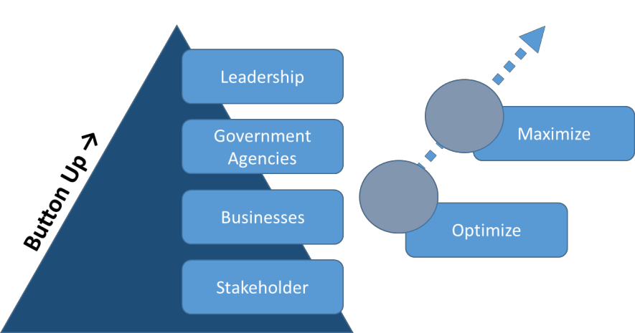

Figure 1: Methodology used to construct the 2015-2020 Tourism Master Plan

As part of the development process, the DPITS met face-to-face with more than 250 stakeholders. The purpose of the stakeholder meetings was to obtain feedback on the overall project, share ideas pertaining to Curaçao’s tourism challenges, provide informational sources of value to the DPITS research team, and actively involve a variety of different types of stakeholders in the drafting of the 2015-2020 Strategic Tourism Master Plan project.

The reason for this elaborate and time-consuming effort of the bottom-up research approach was to assess the meaning of Curaçao’s tourism system through the eyes of all society members, as well as to provide a voice to all stakeholders in the construction of the plan. This process quickly garnered the support and interest from Curaçao’s stakeholders in the development and successful implementation of the new tourism master plan. To date, the DPITS has interviewed a thorough sample of more than 250 people representing all types of Curacao’s tourism stakeholders.3

From the stakeholder meetings, various themes were depicted regarding the challenges that Curaçao faces in the development of the tourism industry. The themes included: need for product identity, coordination challenges between and within stakeholders’ groups, lack of trust, lack of vision, lack of know-how from service providers, lack of evaluation systems, need for attitudinal adjustments, need for open communication, need for collaborative processes, need for leadership, need for innovative product development, need for inclusion of the majority of stakeholders in the tourism system, need for transparent decision-making, and need for clear policies that benefit the industry.

From the stakeholder meetings and focus groups, a variety of surveys were designed, approved by Curaçao tourism officials, and administered in order to further understand the state of tourism in Curaçao. Eleven surveys were created and nearly 7,000 respondents completed the surveys, including stay-over tourists, cruise tourists, Caribbean tourists who had never visited the island, employees, and the local population at large.

3 See the list of stakeholders in Annex 1.

A variety of qualitative and quantitative techniques were used to analyze the data from the stakeholder meetings, focus groups, and surveys. Qualitative techniques included content analysis, domain analysis, quasi-statistics, analytic induction, typology and taxonomy, and organizational scanning. Quantitative techniques included regression analyses, cointegration analyses, unit root analyses, Granger causality analyses, factor analysis, cluster analyses, input-output analyses, ANOVA and MANOVA, discriminant analyses, and supply chain analyses.

Additionally, a formal literature review of all research regarding Curaçao and tourism development was performed. Sources for the literature review included: periodicals, journal articles, public documents, marketing materials, existing government and industry reports, photographs, and other relevant resources. Throughout the development process and in order to facilitate acceptance of, and commitment to, the final strategic tourism plan, the DPITS liaised with the public and private sector organizations that had an interest in tourism development. One of the highlights of this consulting process was the Tourism Summit organized on June 29-30, 2015 in the World Trade Center. The summit brought more than 200 Curaçao’s tourism stakeholders together in order to peruse the major findings from the research conducted for the 2015-2020 Tourism Master Plan.4 The Summit spawned insightful comments and concerns that were eventually integrated into the final draft of the tourism master plan.

The result of this process is this report, “Curaçao: Building on the Power of the Past.” The DPITS’ research revealed that Curaçao was a prominent destination in the past with a clear brand and a strong competitive position in the international market. Over time, it seems the destination lost its luster and its competitive position in the Caribbean region pushing the tourism industry and its development to the backburner of Curaçao’s economy. If the strategies of traction, consolidation, and new horizons that are suggested in this report are effectively implemented, Curaçao will be repositioned as a strong competitive destination in the Caribbean, thereby providing for healthy and prosperous living conditions for its residents.

The DPITS suggests positioning the island as, “Curaçao: A Different Dutch Caribbean.” This slogan offers tourists a “new” destination brand, while still forwarding the Caribbean’s traditional SSS (sun, sand, and sea) seasoning, and while promoting its safety, stability, organizational prowess, and, finally, its character as a destination finely spiced with a unique blend of eclectic cultures. Curaçao: A Different Dutch Caribbean will provide the impetus to generate nearly 4000 jobs, will germinate 2% real annual economic growth over five years, and will close the RevPAR gap between Curaçao and the Caribbean region from the existing 35% to less than 10% by 2020.

The future of Curaçao as a tourism destination is promising as stakeholders, agencies, businesses, policies, residents, tourism employees, labor unions, etc., work toward the optimization of all that Curaçao has to offer. To determine the processes and procedures involved in this collaborative venture, Curacao commissioned the DPITS to develop the 2015-2020 Strategic Tourism Master Plan. The 2015-2020 Strategic Tourism Master Plan has contributed rigorous study processes in determining Curacao’s strengths, its needs, its difficulties, and in identifying what made Curaçao a coveted destination in the past. The recommended plan is focused on optimization, thus requiring a strong focus on deliberate and instigated action, and on addressing factors that allowed Curaçao to fall from its past, supreme positioning in the tourism market. The plan intends to move what had become an ordinary state of affairs to the extraordinary. However, the willingness to achieve the extraordinary lies firmly in the hands of the people of Curaçao. Building on the power of the past, recognizing its current resources and strengths, and recognizing the power of its future will allow Curaçao to once again realize its full potential to seize and retain market segments, and, once again, become an apex destination.

4 For the complete set of presentations during the Strategic Tourism Master Plan Summit 2015, please visit http://www.curacao.com/en/directory/corporate/tourism-master-plan-2015/.

Chapter 2: Curaçao’s Opportunities for Forward Movement

Curaçao’s strong past
During the 1960’s-70’s the Netherland Antilles’ tourism industry occupied a top destination position in the Caribbean. In review of the Netherland Antilles’ total performance, Curaçao’s overall tourism industry performance was well above Aruba, Bonaire, and St. Maarten. The high performance of Curaçao’s tourism industry at that time seemed based on desirable weather factors, the success within the cruise industry, strong skills and network in retail business, and Curaçao’s investment in tourism’s infrastructure (e.g. airport, port, hotel construction). Additionally, Curaçao’s traditional commercial enterprises seemed more interested in tourism than in industrial diversification. Therefore, capital allocation was yielded toward the tourism sector for its continued improvement. Table 1 depicts the success of Curaçao’s tourism industry when compared to other Antilles’ destinations during the 1960’s and 1970’s.

Table 1: Curaçao’s position in the 1960’s - 1970’s
Development of Tourism in the Netherlands Antilles (‘000)
Country |  | Stay-over tourists |  | Cruise tourists
 | Absolute numbers |  | Nights |  | Absolute numbers
 | 1961 | 1976 | 1961 | 1976 | 1961 | 1976
Curaçao | 23 | 117 | 75 | 462 | 36 | 180
Aruba | 12 | 146 | 46 | 1023 | 2 | 68
Bonaire | 2 | 10 | 4 | 41 | - | 6
St. Maarten | 3 | 95 | 20 | 521 | 2 | 89
Total | 40 | 368 | 145 | 2047 | 40 | 343
Source: Van Soest (1978)

During the same time frame, the main demand segment for Curaçao was the American market which remained as such until 1976. At that point, the American market was substituted by the Venezuelan and Dutch markets.
In 1983, due to the Bolivar devaluation, the Venezuelan market plummeted.5 At that time, Curaçao opted to move further away from the American market and embraced the Dutch market as the primary demand segment to move the industry forward.6 Figure 2 conceptualizes the historic development of tourism in Curaçao.

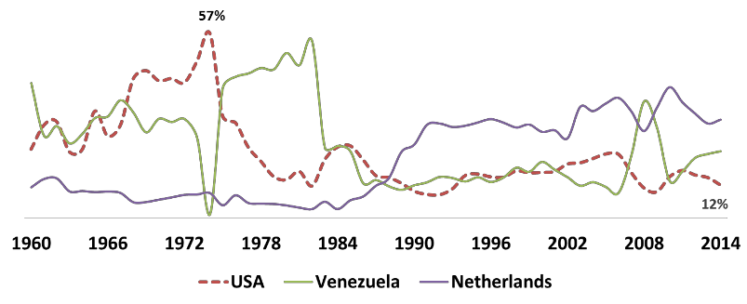

Figure 2: Curaçao’s primary market segments overtime

5 The observed volatility in the Venezuelan market is a cyclical pattern that has occurred several times in the past (e.g. 2008-2009).
6 Source: Soest Van, J. (1978). Trustee of the Netherlands Antilles.

Curaçao’s tourism industry today
Today, Curacao’s tourism industry boasts significant value to the island’s overall economic performance (see Figure 3). The tourism industry is the only sector that has steadily increased in foreign exchange when compared to the other economic sectors in Curacao. In addition, the tourism sector contributes over 1 billion NAF to the economy, which accounts for approximately 18% of the country’s GDP and 26% of the contribution to foreign exchange (see Figure 4).
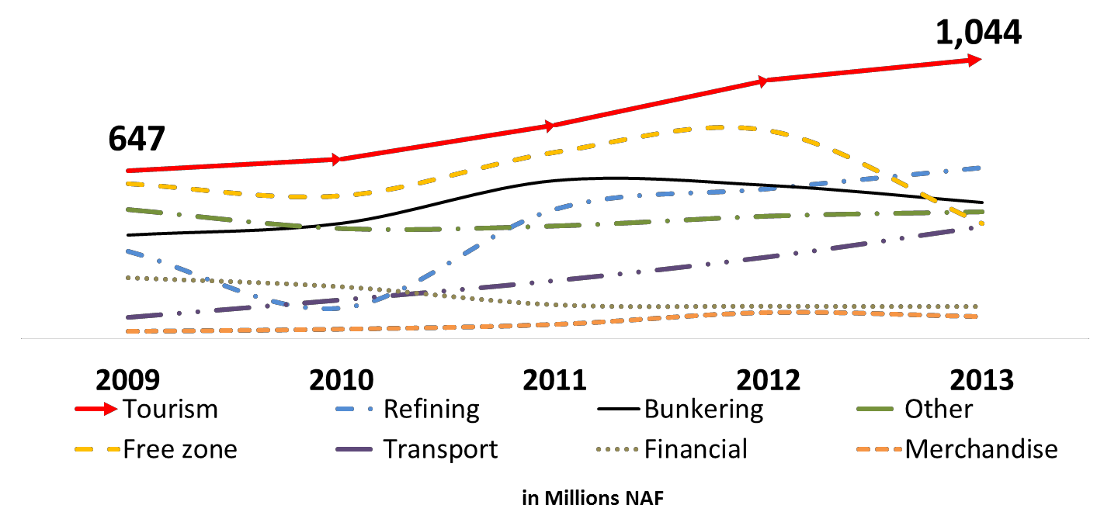

Figure 3: Growth of Curaçao’s

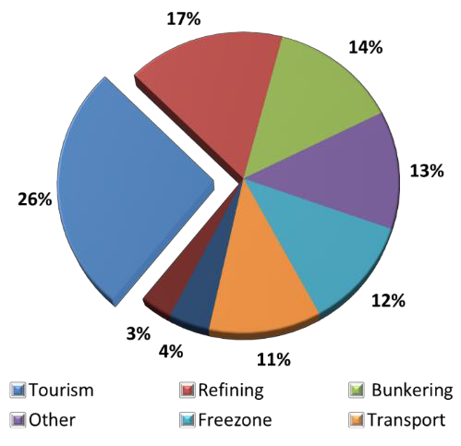

Figure 4: Contributions of Curaçao’s economic sectors

Figure 5 displays Curaçao’s tourist arrivals from 2000-2013. It is clear from the graph that tourism does work for Curaçao as the overall trend for tourist arrivals is positive. It is also evident that tourists’ receipts continue to increase over time (see Figure 6) making the tourism industry a potent contributor to the overall economy. Curaçao is home to a unique special event (i.e. Curaçao North Sea Jazz Festival), which attracts a profitable mix of tourists that spend approximately US$255.00 per day and stay an average of six days. The beauty of these tourists is that they indicate they would like to come back to Curaçao in the absence of the festival and would recommend the destination to others. Actually, the 2014 festival had more repeat attendees than first-timers, and the festival was instrumental in enhancing the image of the destination. For example, 80% of attendees reported that their image of the island had improved after attending the festival.7

7 See Rivera, M., Croes, R., & Semrad, K. (2014). The Curaçao North Sea Jazz Festival: A lustrum churning economic and promotional opportunities for Curaçao. Dick Pope Sr. Institute for Tourism Studies: Orlando, FL.

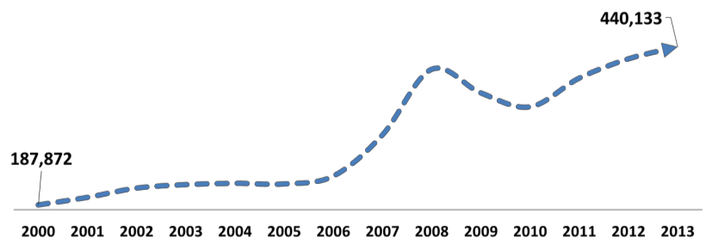

Figure 5: Curaçao’s tourist arrivals

Over time, Curaçao has closed the performance gap with one of its competitors, St. Maarten. Traditionally, St. Maarten had outperformed Curaçao in the past. However, since 2012, Curacao’s tourism industry has significantly decreased the performance gap in terms of arrivals between the two islands.
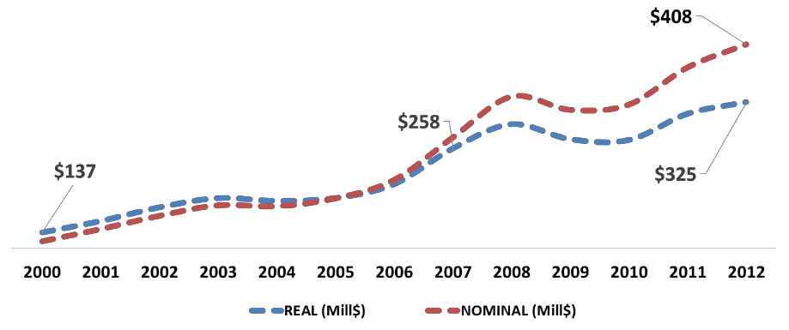

Figure 6: Curaçao’s tourist receipts

The annual average increase in international arrivals to Curaçao had increased by 6.9% from 2000-2014, while St. Maarten had only experienced an average annual increase of 1.2% over the same timespan (see Table 2). This means that Curaçao seems to be quickly catching up with St. Maarten in stay-over tourists, thereby implying that Curaçao’s competitive position seems to be improving when compared to St. Maarten.

Table 2: Curaçao vs. St. Maarten’s tourism performance over time8
Year | Curaçao | St. Maarten
2000 | 191,246 | 432,292
2001 | 204,603 | 402,649
2002 | 217,963 | 380,801
2003 | 221,395 | 427,587
2004 | 223,453 | 475,032
2005 | 222,099 | 467,861
2006 | 234,383 | 467,804
2007 | 299,730 | 469,424
2008 | 408,844 | 475,410
2009 | 366,703 | 440,185
2010 | 341,651 | 443,136
2011 | 390,282 | 424,340
2012 | 419,810 | 456,720
2013 | 440,714 | 466,955

8Source:http://www-
wds.worldbank.org/external/default/WDSContentServer/WDSP/IB/1986/08/26/000009265_3960926032140/Rendered/INDEX/multi0page.txt.

Curaçao’s destination image compared to other Caribbean competitors
Image is an important factor in the success of tourism development for a destination. Image includes the knowledge, thoughts, and opinions that tourists and potential tourists will have about a destination and its people. The image that tourists and potential tourists have concerning a destination could make those individuals feel a certain way toward the overall destination (i.e. Curaçao), and, in return, will influence their desire (or non-desire) to visit the destination for vacation purposes.

Destination image is a critical component of success for any tourism industry in that the image serves a vital role in influencing tourists’ behavior before, during, and after the consumption of a destination.9 Based on the tourists’ image, travelers may or may not choose a destination for their next vacation, may or may not revisit a destination, may or may not stay longer, may or may not spend more money than usual, and may or may not spread positive word-of-mouth advertising about the destination.

For these reasons, the DPITS felt it was important to gauge Curaçao’s image from both visitors and non-visitors’ perspectives. In other words, images were derived from those people who had been to Curaçao in the past and those people who had never been to Curaçao, but had been to other Caribbean destinations within the last five years. Measuring Curaçao’s destination image from both of these groups provides a comprehensive understanding of Curaçao’s potential strengths and weaknesses as viewed by visitors and non-visitors. Also, this data could be further decomposed into varying segments based on geography, gender, and other socio-demographic profiling traits, which will give clues regarding Curaçao’s position in the overall tourist market.

Table 3 shows the distribution of Curaçao’s destination attributes (e.g. climate, beach quality, etc.) in three categories: negative impression, neutral impression, and positive impression from the primary market segments that frequent Curaçao (USA, Dutch, Venezuela/Colombia). As can be seen from Table 3, the largest frequency lies within the positive impression category for all market segments except for the duty-free related items that are mostly neutral.

This table reveals important impression information for Curaçao. All market segments have a high impression regarding Curaçao’s climate, beach quality, and its variety of water activities. This seems to indicate that tourists have positive impressions of the Caribbean’s sun, sand, and sea destinations; thus, as Curaçao possesses strength in this area, it also adopts prominent positioning. The Venezuelan/Colombian markets are also pleased with the lodging quality and the food and beverage quality. Table 3 also suggests that tourists have a positive perception of Curaçao’s cultural component as revealed by service delivery, quality, and people.

An interesting wedge of information that emerges within the American market segment pertains to the amount of “neutral impressions” that exist regarding Curacao’s attributes. Table 3 reveals that these neutral impressions for most of Curacao’s destination attributes are almost always above those of the other two markets. From a positioning perspective, this implies that Curaçao is under positioned within the American market. That is, Americans who have not traveled to Curaçao are neutral in their impressions for each destination attribute because they do not know what they can expect from Curaçao.

If you compare this finding to the other two markets, it is evident that the Dutch and Venezuela/Colombia tourists who have not been to Curaçao have low neutral values. This means that, even though people from the Netherlands and Venezuela/Colombia have not been to Curaçao, they have a strong impression regarding what they can expect from Curaçao’s destination attributes. This implies that Curaçao has established a strong position within these two markets, but may be nearing a point of market saturation.

9 See the following sources for a review on the importance of destination image: Alhemoud and Armstrong 1996; Baloglu and Brinberg 1997; Chen and Hsu 2000; Chen and Kerstetter 1999; Court and Lupton 1997; Crompton 1979; Dadgostar and Isotalo 1992; Dann 1996; Fakeye and Crompton 1991; Gartner 1993; Goodrich 1977; Hunt 1975; MacKay and Fesenmaier 1997; Mayo 1973; Mayo and Jarvis 1981; Ross 1993; Schroeder 1996; Tapachai and Waryszak 2000; Tasci and Gartner, 2007; Tasci, Gartner and Cavusgil, 2007; Walmsley and Young 1998.

Table 3: Impressions about Curaçao
United States |  |  |  | Netherlands |  |  | Venezuela/Colombia
 | (-) | Neutral | (+) | (-) | Neutral | (+) | (-) | Neutral | (+)
Climate | 1.2% | 18.7% | 80.1% | 1.2% | 8.1% | 90.7% | 0.8% | 13.7% | 85.5%
Beaches’ Quality | 0.9% | 20.9% | 78.2% | 1.4% | 12.1% | 86.5% | 1.6% | 9.3% | 89.1%
Beaches’ Facilities | 1.2% | 35.8% | 63.0% | 1.4% | 26.5% | 72.1% | 2.0% | 23.8% | 74.2%
Water Activity Variety | 1.0% | 24.5% | 74.5% | 0.9% | 13.3% | 85.8% | 1.2% | 13.7% | 85.1%
Land-based Activity Variety | 1.5% | 29.1% | 69.5% | 2.8% | 29.8% | 67.4% | 4.0% | 33.1% | 62.9%
Cultural & Heritage Attractions Variety | 2.2% | 34.8% | 63.0% | 5.8% | 33.0% | 61.2% | 7.7% | 29.4% | 62.9%
Nightlife & Entertainment Variety | 1.6% | 32.7% | 65.6% | 2.6% | 27.7% | 69.8% | 2.8% | 12.9% | 84.3%
Gaming (Casino) | 4.0% | 41.4% | 54.6% | 4.0% | 43.5% | 52.6% | 2.4% | 23.8% | 73.8%
F&B Quality | 1.5% | 29.2% | 69.3% | 2.1% | 18.8% | 79.1% | 1.6% | 14.5% | 83.9%
Restaurants’ Prices | 4.1% | 36.9% | 59.0% | 7.0% | 40.9% | 52.1% | 4.4% | 40.7% | 54.8%
Accommodation Quality | 1.6% | 30.2% | 68.1% | 2.8% | 21.9% | 75.3% | 1.6% | 13.3% | 85.1%
Accommodation Prices | 3.7% | 36.7% | 59.6% | 10.5% | 36.0% | 53.5% | 6.0% | 31.0% | 62.9%
Shopping Opportunities | 2.8% | 31.3% | 65.9% | 2.8% | 36.5% | 60.7% | 3.2% | 23.4% | 73.4%
Shopping Prices | 3.8% | 37.6% | 58.6% | 7.2% | 46.7% | 46.0% | 9.7% | 34.3% | 56.0%
Info. Signage (Attractions) | 1.2% | 37.3% | 61.5% | 4.9% | 40.7% | 54.4% | 3.2% | 30.6% | 66.1%
Directional Signage (Roads) | 1.9% | 39.5% | 58.6% | 6.3% | 40.0% | 53.7% | 2.8% | 30.6% | 66.5%
Locals' Communication with Tourist Language | 2.8% | 34.5% | 62.7% | 3.5% | 20.0% | 76.5% | 9.3% | 25.4% | 65.3%
Overall Safety & Security | 3.8% | 33.9% | 62.2% | 13.5% | 40.5% | 46.0% | 2.4% | 21.8% | 75.8%
Locals’ Friendliness & Hospitality | 2.2% | 29.5% | 68.3% | 3.0% | 18.8% | 78.1% | 0.4% | 12.5% | 87.1%
Overall Cleanliness & Hygiene | 4.0% | 34.7% | 61.4% | 7.0% | 34.0% | 59.1% | 1.2% | 18.1% | 80.6%
Food & Water Safety | 4.3% | 37.5% | 58.3% | 4.7% | 34.7% | 60.7% | 1.2% | 20.2% | 78.6%
Destination Ease of Access | 4.4% | 31.4% | 64.2% | 1.9% | 19.5% | 78.6% | 3.2% | 14.5% | 82.3%
Transportation Cost to Destination | 7.4% | 36.7% | 55.9% | 11.9% | 38.4% | 49.8% | 10.1% | 29.4% | 60.5%
Local Food Taste | 1.9% | 33.2% | 64.9% | 2.1% | 22.6% | 75.3% | 1.6% | 21.8% | 76.6%
Social Mingling | 2.7% | 36.7% | 60.6% | 3.3% | 24.4% | 72.3% | 2.4% | 20.2% | 77.4%
High Prestige Product & Service | 3.8% | 34.5% | 61.7% | 2.6% | 37.9% | 59.5% | 1.6% | 22.6% | 75.8%
Ease of Mobility Within the Destination | 1.9% | 36.1% | 61.9% | 3.3% | 31.2% | 65.6% | 2.0% | 20.2% | 77.8%
Restaurants’ Service Quality | 1.9% | 34.4% | 63.7% | 2.6% | 26.3% | 71.2% | 0.8% | 13.7% | 85.5%
Accommodations’ Service Quality | 2.2% | 33.0% | 64.7% | 2.3% | 27.2% | 70.5% | 2.0% | 9.7% | 88.3%
Available Duty-free | 2.4% | 40.4% | 57.2% | 5.1% | 52.6% | 42.3% | 6.0% | 29.8% | 64.1%
Available Luxury Brands in Duty-free | 2.2% | 42.5% | 55.3% | 4.7% | 52.6% | 42.8% | 4.8% | 25.8% | 69.4%
Product Quality in Duty-free | 1.8% | 41.0% | 57.2% | 2.6% | 52.1% | 45.3% | 3.2% | 28.6% | 68.1%
Product Variety in Duty-free | 2.2% | 39.7% | 58.1% | 4.0% | 53.0% | 43.0% | 4.4% | 26.2% | 69.4%
Price in Duty-free | 2.7% | 40.9% | 56.5% | 5.8% | 56.3% | 37.9% | 4.8% | 35.1% | 60.1%

There is a low hanging fruit for Curaçao to increase the brand awareness of its destination attributes within the American segment. Nearly all Caribbean destinations that have enjoyed continued prosperity in tourism have possessed the American market as the foundation for demand. Currently, the American market has positive impressions for Curaçao, but the market requires more information from Curaçao regarding destination attributes in order to help form expectations prior to its consumption of Curaçao.

With regard to the Dutch and Venezuelan/Colombian market segments, the positive impression of Curaçao’s destination attributes is almost always higher than that of the American impression. This indicates that Curaçao has done a good job establishing a positive impression within these two markets. Curaçao should strive to keep its positive impression with these two market segments, but should also strive to decrease the neutral impression of the Americans. Also important is that there are very few negative impressions regarding Curaçao’s destination attributes from any of the three primary market segments.

For the entire sample, Curaçao’s top rated attributes from potential tourists and past tourists are climate, beach quality, and water activity variety, while the bottom rated attributes for the entire sample are duty- free prices, shopping prices, and transportation costs to the destination. The top rated attributes were the same for the USA and Dutch market segments (i.e., climate, water activity, and beach quality), whereas the Venezuelan/Colombian segment rated Curaçao’s beach quality the highest followed by accommodation service quality and food and beverage (F&B) quality.

This is interesting information in that, during qualitative interviews, the majority of stakeholders expressed that they did not feel tourists would have a positive impression of the quality of Curaçao’s beaches. The tourist data actually reveals the contrary.

Tourists’ perceptions after visiting Curaçao
A total of 1,701 tourists who had visited Curaçao were polled at either the Hato Airport while waiting for their departure flight, or via an online survey. Regardless of the data collection method, all tourist respondents had visited Curaçao within the last year. The survey gauged the tourists’ overall perception of Curaçao’s destination attributes by asking the respondents to rate each attribute (1 = low rating and 6 = high rating) (see Table 4).

Table 4: Tourists’ rating of Curaçao’s destination attributes
Island perceptions | Mean
Accommodation Staff Friendliness | 5.21
Accommodation Safety and Security | 5.12
Restaurant Staff Friendliness | 5.11
Accommodation & Restaurant Payment Options | 5.10
Local Friendliness | 5.10
Multi-lingual Locals | 5.07
Accommodation Cleanliness | 5.03
Accommodation Attractiveness | 5.02
Airport Safety and Security | 5.02
Restaurant Safety and Security | 5.02
Airport Cleanliness | 5.01
Drinking Water Quality | 5.01
Restaurant Cleanliness | 4.95
Restaurant Attractiveness | 4.89
Convenience Car Rental Facilities | 4.8S
Sites Accessibility | 4.78
Social Atmosphere | 4.73
Taxi Drivers’ Hospitableness | 4.71
Taxi Safety and Security | 4.69
Taxi Service Reliability | 4.63
Taxi Service Quality | 4.63
Taxi Cleanliness | 4.61
Hospitableness of Customs and Immigrations Personnel | 4.56
Island Safety and Security | 4.53
Signage & Directions Presence | 4.30
Clarity of Road Signage | 4.25
Island Cleanliness | 4.12
Roads Quality | 3.90

Table 4 shows that Curaçao ranks above average on those destination attributes that influence the overall perception of the island destination. For example, those attributes that are meaningful in shaping the overall tourists’ perception of Curaçao are ranked as performing high (e.g. accommodation staff friendliness, accommodation safety and security, restaurant staff friendliness, etc.). Those destination attributes that pertain to infrastructural development rank as performing low, but are not necessarily detractors in the overall island perception. However, island cleanliness and roads quality merit special attention due to their low scores compared to other destination attributes.

Therefore, there is an opportunity for Curaçao to reduce interest in large capital investments for infrastructural improvements and to instead concentrate on relatively low risk improvements for Curaçao’s soft tourism products (e.g. human capital development). This means that there is not an immediate need for Curaçao to concentrate on capital resource allocation to overhaul the existing tourism infrastructural supply. Instead, Curaçao should focus principally on aligning current supply with the existing primary markets.

In terms of tourists’ overall satisfaction and value perspectives pertaining to their consumption of tourism- related products, Curaçao performs relatively high (1 = low performance and 6 = high performance). Tourists ranked satisfaction and value high for the accommodations, restaurants, and entertainment available on the island. While shopping opportunities and transportation (taxis) ranked lower, the mean scores still rank above average. Therefore, it seems that tourists agree that the consumption of Curaçao’s tourism-related products fulfills their needs while creating value (see Table 5). These are important predictors for tourists’ future intentions (e.g. repeat visits and positive word-of-mouth recommendations for Curaçao).

Table 5: Tourists’ satisfaction and value for tourism-related products
Area | Satisfaction | Value
Accommodations | 4.95 | 4.51
Restaurants | 4.74 | 4.39
Entertainment | 4.52 | 4.30
Rental cars | 4.40 | 4.25
Airfare | 4.35 | 4.21
Shopping | 4.31 | 4.17
Taxis | 4.25 | 4.08

Online reviews for Curaçao
The DPITS also conducted an assessment of Curaçao’s online comments via TripAdvisor® (see Figure 7). Approximately 50,000 online comments were assessed regarding the different components of tourism in Curaçao. The information appeared in different subcategories that tourists frequently use to collect information regarding their upcoming trip to Curaçao. These subcategories included the following: hotels, vacation rentals, flights, attractions, restaurants, and forum.
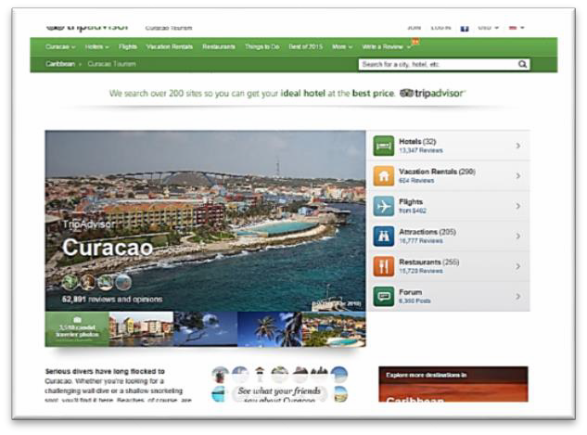

Figure 7: Curaçao tourism on TripAdvisor®

The “attraction” subcategory posted the most online reviews (16,777 comments), which includes 205 different items in four broad categories of attractions: beaches, activities, nightlife, and shopping/fashion. These categories are not mutually exclusive, and one attraction may appear in more than one category based on the type of activities the attraction offers. The water aspect of the destination is the most common review. Terms, such as diving, water, beach, cruise, ship, boat, swim, island, snorkeling, sea, and dolphin, compose 21.2% of the terms used in the attraction online reviews, which have an aggregated frequency of 14,928. The aggregated frequency represents 27.6% of all word frequencies used to describe the tourist experience in Curaçao. Figure 8 is a word cloud where the largest words represent the most common terms used to describe Curaçao.

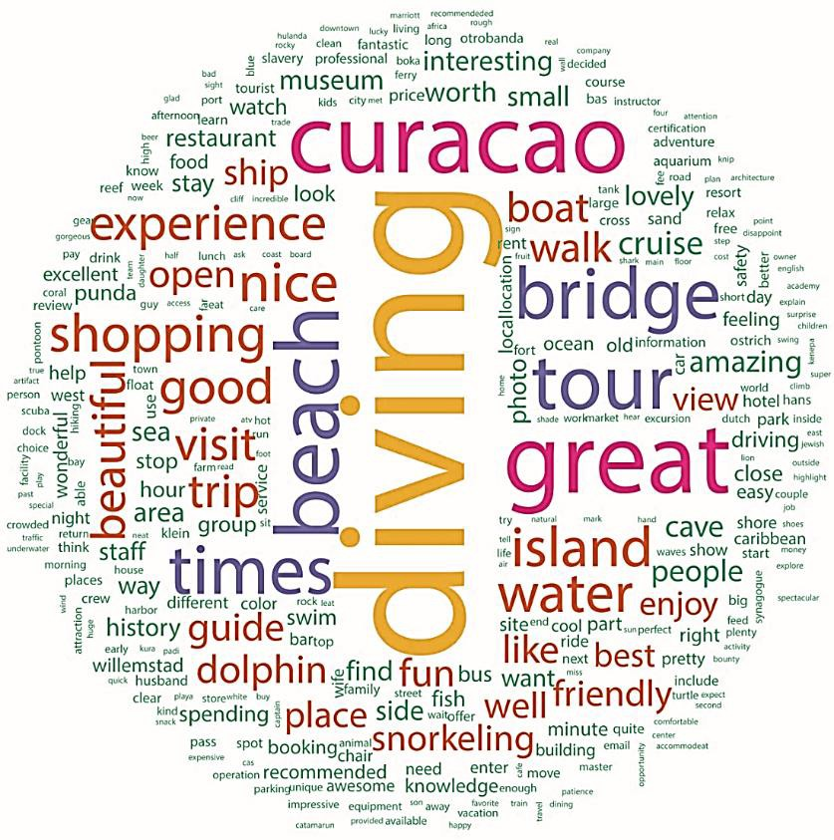

Figure 8: Curaçao’s word cloud
The word, Curaçao, has 17 words correlated with it that are higher than 0.75. The highest correlation with the word, Curaçao, is the term, great, with 86% appearing in combination with other descriptors. The other correlated terms are as follows: recommended (0.84), best (0.83), excellent (0.82), wonderful (0.82), fantastic (0.80), and so on. The word, beach, has an 88% correlation with the term, white, which can signify the white sandy beaches as a positive connotation in tourists’ beach reviews.

At the same time, the word, beach, shows a very high correlation of 94% with the word, crowded, which can signify a negative connotation. However, it should be considered that reviewers might comment that beaches are “not” crowded, and due to data transformations conducted in this analysis, the terms “are” and “not” are dropped from the analysis (which is unlikely in this case due to the high correlation). Nevertheless, both scenarios may be possible, and the need for a carrying capacity evaluation and management of Curaçao beaches should be investigated.
The word, times, is associated with the terms: great, fun, wonderful, amazing, lovely, awesome, enjoy, excellent, and right, among other words in 0.75 correlation level. Another interesting finding is the descriptors used for the quality of water. The most common words to describe Curaçao’s water were: clear, calm, crystal, gorgeous, beautiful, and perfect (see Table 6).

The current market segments that visit Curaçao view the island as a traditional SSS destination. The word frequency analysis reveals that the majority of these tourists seem satisfied with Curaçao’s current tourism product and offerings.

Table 6: “Curaçao” word correlations with other terms
Terms | Curaçao
great | 0.86
recommended | 0.84
best | 0.83
excellent | 0.82
wonderful | 0.82
fantastic | 0.80
friendly | 0.80
review | 0.80
times | 0.80
trip | 0.80
arrive | 0.79
care | 0.79
vacation | 0.78
want | 0.77
wife | 0.77
spending | 0.76
week | 0.76

Performance gap between tourists’ perceptions and Curaçao’s industry stakeholders
In 2014, the DPITS found some inconsistencies with regard to tourists’ perceptions of Curaçao and Curaçao’s industry stakeholders’ perceptions of Curaçao. The inconsistency is that industry stakeholders feel Curaçao performs worse than what tourists think and feel about Curaçao.10 This finding was again confirmed during the qualitative data collection phase for the 2015-2020 Strategic Tourism Master Plan. It seems that tourism managers/employees and locals believe that they are underperforming in most of the soft components of a tourism product (e.g. service delivery). However, when tourists were asked how Curaçao was performing in service delivery aspects, the tourists felt as though service delivery employees were performing above average. Tourists felt that service delivery employees were welcoming, friendly, polite, trustworthy, and consistent. However, managers/employees, locals, and industry stakeholders felt as though they were underperforming in all of these skills (see Table 7).

Table 7: Tourists’ perceptions vs. Curaçao stakeholders’ perceptions
Tourist  Ranking | Items | Managers/  Employees | Residents | Audience
1st | Welcoming | ↓ | ↓ | ↓
2nd | Friendly | ↓ | ↓ | ↓
3rd | Polite | ↓ | ↓ | ↓
4th | Smiling | ↓ | ↓ | ↓
5th | Trustworthy | ↓ | ↓ | ↓
6th | Consistent | ↓ | ↓ | ↓
7th | Dedicated | ↓ | ↓ | ↓
8th | Professional | ↓ | ↓ | ↓
9th | Knowledgeable | ↓ | ↓ | ↓
10th | Organized | ↓ | ↓ | ↓

10 See Croes, R., Rivera, R., Semrad, K, Dickson, D., Pizam, A., Shapoval, V., and Orlowski, M. (2014). From attribute orientation to experiential consumption: the future of tourism in Curaçao. Curaçao Tourism Board.

Table 7 shows the soft component skills of service delivery that are most important to tourists. It ranks them in order of how well tourists feel Curaçao’s tourism employees are performing. The managers/employees and locals ranked every performance skill in service delivery below the tourists impressions of the service employees in Curaçao.

It is important for Curaçao tourism stakeholders to believe that the industry is valued and does satisfy the tourists that are frequenting the island. Stakeholders must learn not to be so hard on themselves, and compare Curaçao’s performance to that of other island destinations. Through the eyes of the tourists, Curaçao is providing a satisfactory and valued product.

It is essential for Curaçao tourism stakeholders to realize the following: the Caribbean’s SSS product is not perceived differently by Curaçao’s tourists from that of other island destinations; Curaçao’s service delivery is performing at an average mean; tourists are satisfied and value the core Curaçao tourism product; and, infrastructural investments to increase the tourism supply do not seem necessary at this time as these attributes are not detracting from tourists’ value or satisfaction ratings of the overall Curaçao tourism product.

This means that Curaçao has a low risk opportunity to concentrate on improving tourism’s soft components to above an average mean at a relatively low cost investment to enhance its competitive position in the Caribbean (e.g. improved training of service delivery employees).

Local residents’ perceptions of the Curaçao tourism industry
Additionally, when the local population residing in Curaçao was queried regarding their level of agreement that Curaçao’s tourism industry holds potential, the overwhelming majority of locals felt that tourism holds great promise for Curaçao’s economy. This perception is shared across multiple generations (i.e. Baby Boomers, Generation X, Generation Y, and Generation Z). Combined, these perceptions represent more than half (54%) of the population’s approval. Generation Z is age 18 years and less; Generation Y is between ages 19 and 38; Generation X is between ages 39 and 54, while Boomers are 55 years and older.11

Generation Z (66%) followed by the Baby Boomers (60%), and Generation X (52.2%) had the most favorable opinion regarding this statement, “Tourism holds great promise for Curaçao’s economic future.” Generation Y had the lowest score with less than half (46.5%) of the respondents indicating that they held the least positive perception about tourism’s promise in Curaçao.

There is also a significant portion of Curaçao people (exceeding one-third of the population) that does not have an opinion regarding tourism’s benefits for Curaçao. Based on descriptive statistics, there is an obvious opportunity for Curaçao to promote tourism’s potential to the local population.12

While the overall local perception regarding tourism’s promise is positive, there does exist a potential danger looming on the horizon. The overwhelming majority of the population held a negative view regarding the following statement, “Income opportunities from tourism development are evenly distributed to all.” Only 19% of the respondents agreed with this statement. Respondents discerned that only a few on the island benefited from tourism. With regard to the statement, “A few residents benefit economically from tourism,” only 17% of the respondents disagreed with the statement.

The negative perception that tourism income opportunities are not evenly distributed amongst the local population was found across all four generations. This perception was also expressed in the interviews with stakeholders. In particular, the social, cultural, educational, labor unions, and religious groups reported consistent views with the

11 The list of generations alluded to are referenced as follows: Baby Boomers - 1946 -1964: Generation X - 1975 -1985: Generation Y - 1978 - 1990: and Generation Z - 1995 -2007 (Glass, 2007).
12 This finding is in line with a report from the University of Curaçao (UoC). See UoC (2015), Attitude of local residents towards sustainable tourism. Curaçao, February.

overall local population’s perception, which was that tourism’s income opportunities are not equally distributed amongst the local population.

In order to circumvent this negative perception, it is necessary for the industry to be restructured in an open system. This means that the local population and independently owned businesses will have equal opportunities and access to advancement within the system. Additionally, jobs spawned by the industry should be communicated to the population at large on a regular basis in order to educate the local population about the distributive benefits of tourism.

The findings also reveal that Curaçao’s residents are happy people. Happiness, in this context, means that people are joyful, cheerful, and content.13 Overall, seventy-eight percent (78%) of the respondents indicated they were happy. This average happiness score is similar to what was found in Aruba, the USA, and the Netherlands.14 However, happiness is not equally felt amongst residents. For example, Generation Z had the lowest happiness score (64.8%), followed by much higher happiness scores for Boomers (78.7%), Generation X (79.5%), and Generation Y (79.7%). When asked about their happiness compared to others, the overall mean score was 72.2%. In other words, seven out of ten respondents felt they were happier compared to their peers and friends. The scores amongst generations were almost evenly distributed with Generation Z, again, having the lowest score (69.3%), followed by Boomers (70.2%), Generation X (71.5%), and Generation Y (75.4%). Overall, when respondents were comparing themselves to others, they felt less happy.

It is noteworthy to mention that nearly 100% of Curaçao’s stakeholders indicated, in the qualitative data collection phase, that there is a need for change in the tourism industry; and that, in order for the sector to reveal its strength, change must occur. The majority of these stakeholders also revealed that they had doubt if the local population would further support tourism expansion. However, after reviewing the data and learning that the overwhelming majority of the local population agreed that the tourism industry holds great promise for Curaçao’s economy, it seems that the stakeholders’ concern could be laid to rest.

In reviewing all data pertaining to locals’ perception of the current tourism industry and the potential of this sector, an extraordinary circumstance arises for Curaçao. The stakeholders are in consensus that the current state of the tourism industry is not optimally working. The stakeholders are also in consensus regarding a need for change, and that they are willing to support that change. However, the majority of the stakeholders were in doubt about the willingness of other residents to stand behind the efforts required to boost the industry’s performance to higher levels.

The quantitative data revealed that the island’s residents do stand behind the tourism industry and do believe that the sector can lead Curaçao forward. Therefore, this is a virtuous circle that will allow for a smooth transition toward converting tourism as a strategic spearhead for the economic and social well-being of the island.
It is necessary for Curaçao to capitalize on this rare consensus opportunity, especially when considering that there is evidence of distrust on the island, as well as a disbelief that stakeholders are able to join forces to move Curaçao forward.15 If stakeholders are able to come together and use tourism as a strategic spearhead for economic and social well-being, local pride and cultural cohesion will make great strides on the island.

13 Happiness as used in this plan refers to the meaning (emotions) ascribed to it in the subjective well-being literature. See, for example, Kenny,
- (2005). Does development make you happy? Subjective well-being and economic growth in developing countries. Social Indicators Research
73, 199-219; Layard, R. (2005). Happiness: lessons from a new science. Penguin: New York.
14 For the Aruba case, see DPITS (2011). Winning the Future. Oranjestad, Aruba. For the American and Dutch cases, see Kapteyn, A., Smith, J. and Soest, A. (2010). Life satisfaction. In Diener, E. Kahneman, D., and Helliwell, J. International differences in well-being. Published to Oxford Scholarship Online: May 2010, pp.70-104.
15 The sentiment of distrust and fear were apparent time and again during our conversations with multiple stakeholders. The TAC and the UNDP reports reference distrust and fear as main areas of concern for the development of Curaçao.

Tourists’ future intentions to visit Curaçao
In predicting visits of potential tourists (those tourists who have not been to Curaçao but have been to the Caribbean), Curaçao possesses all of the key destination attributes that would envisage a vacation choice destination. Table 8 reveals that there is a difference among market segments (i.e. USA, Netherlands, Venezuela/Colombia) with the destination attributes that seem to predict a visit from potential tourists. Table 8 ranks the top five destination attributes that have a significant impact on determining if a potential tourist will visit Curaçao. For example, for the USA market, the destination attributes that were the most impactful were price and familiarity whereas the Netherlands most important destination attributes were the price and the activities and the Venezuela/Colombia market was the safety and the attractions. This information is useful to Curaçao for developing product mix as well as crafting the marketing message.

Table 8: Most important destination attributes that predict visits from potential tourists16
Items | USA | Netherlands | Ven\Col
 | Rank | Rank | Rank
A trip to Curaçao is worth the money I spend. | 1** | 1*** | -
I am familiar with Curaçao. | 2*** | 3** | -
Curaçao has a good image for me. | 3** | 4* | 4*
Quality of services is high in Curaçao. | 4** | - | -
(R) A trip to Curaçao is too expensive. | 5* | - | 5*
Curaçao is safe and secure. | - | - | 1**
Curaçao offers attractions that I look for on a vacation. | - | - | 2*
Curaçao has high-quality tourist products. | - | - | 3*
Curaçao offers activities that I look for on a vacation. | - | 2** | -

Perception Cruise Visitors
Curaçao has experienced strong growth in its cruise business in the past fifteen years. Growth in passengers’ arrivals averaged 6% per year, following the positive trend of the cruise industry in the Caribbean. Passenger production projection from North America alone is poised to increase from 16.7 million in 2015 to 19.8 million in 2020, underlying the cruise industry potential for Curaçao.17 Given the prominence of this industry subsector, the DPITS conducted a survey among cruise passengers and crew members in the months of January to March, 2015. The survey aimed to estimate the economic impact of the subsector, the level of satisfaction and intention to return to the island. A total of 897 cruise surveys were collected at the harbor.
Of the 897 cruise survey respondents, the majority of passengers who visited Curaçao were experienced cruise travelers. Three out of four respondents had been on a cruise before, enjoy a high income (60% had an annual income of more than US$75,000), and the majority of respondents were familiar with Curaçao. Two-thirds of the respondents had previously visited Curaçao via a cruise. Four out of ten respondents were from the United States, while 11% were from Latin American countries (i.e. Argentina, Brazil, Colombia and Venezuela). Nearly 8% of respondents were from Europe with the majority being from Germany.
Cruise passengers seem satisfied with their experience while on the island. The drivers of the satisfaction level are variety in shopping (p=0.017) and friendliness of the local people (p=0.025). The recommendation to visit Curaçao depends on the amount of time visitors spend on the island (p=0.011). In other words, the longer cruise visitors spend on the island, the more likely they are to recommend Curaçao as a vacation destination. One of five respondents indicated that they were extremely likely to return to Curaçao for a non-cruise vacation within the next three years. And, more than 25% of respondents indicated that a non-cruise vacation to Curaçao is worth the time and money. Cruise visitors are impressed by the variety of offerings (things to do), and the opportunity to shop duty

16 Note: *=p<.10, **=p<.05, ***=p<.01
17 For the passenger production projection, see The World Cruise Shipping Industry to 2020.

free. Focusing on the conversion of cruise passengers to stay-over tourists is a great marketing opportunity for the destination.

Tourism’s new promise
In summary, although Curaçao’s tourism product has changed significantly over time with regard to the product portfolio, market segment mix, and the industry’s overall contribution to the economy, the current tourism product seems to possess a composition of experiences that are evaluated by tourists as favorable. This favorable evaluation is shared by both actual tourists: those who have visited Curaçao within one year, and those potential tourists who have not visited Curaçao but have visited the Caribbean within the last five years.

This information is an indicator that the potential strategic position for Curaçao within the Caribbean region is promising. Based on the performance evaluation by tourists and potential tourists, Curaçao’s existing destination attributes (tourism supply) seem to be in line with tourists’ needs and wants. Therefore, an opportunity exists for Curaçao to concert efforts toward aligning new demand with existing products. The local population supports tourism as an important economic pillar for the future - and that promises hope. Consensus exists amongst the local population and industry stakeholders that a change is necessary to move the sector forward. The majority of people indicated that they are willing to work for that change in order for Curaçao to reap the socioeconomic benefits that tourism could afford.

In order for Curaçao to materialize the benefits afforded by tourism, it is necessary for Curaçao to examine its current market segment mix and optimize tourism supply utilization from underserved markets that exist within the confines of the current demand structure. This means that Curaçao will need to restructure the foundation of its market segment mix. This does not imply a market segment displacement. This implies creating a value proposition for the American market that is familiar with the Caribbean region but is unacquainted with Curaçao’s potential.

The Dutch and Venezuela/Colombia markets will remain within the top three market segments frequenting Curaçao and will not be displaced. This means that Curaçao will maintain the current market share from the Dutch and Venezuela/Colombia markets that enter the Caribbean region. The suggested restructuring of the demand structure is based on quantitative results that reveal that Curaçao possesses a strong product identity within the Dutch and Venezuela/Colombia markets but has not yet fully penetrated its tertiary market segment (i.e., the USA). This suggestion is a relatively simplistic market reconfiguration.

Chapter 3: The Economic Contribution of Tourism

Tourism spending
The previous chapter indicated that tourism has potential in Curaçao with tourists revealing more favorable perceptions about the delivery of the tourism product compared to Curaçao’s stakeholders (managers, employees, business owners, locals). Tourists’ favorable perceptions resulted in significant spending while on the island. This spending reveals a sizeable contribution to the island’s economy. For example, tourist receipts in 2013 amounted to US$618 million, which is a 6% increase compared to the year before.

Tourism spending has significantly increased over the past 15 years by an annual average of 4.5% in nominal terms. When compared to the Caribbean region, Curaçao has outperformed other destinations within the Caribbean. For example, the annual average increase in tourism receipts from 2012-2013 was 14% in Curaçao, while the entire Caribbean region only scored an increase of 2.1% during the same time span. Over time, Curaçao has deepened its tourism specialization to the point where 18.5% of the economy in 2013 relied on the tourism sector (see Figure 9).

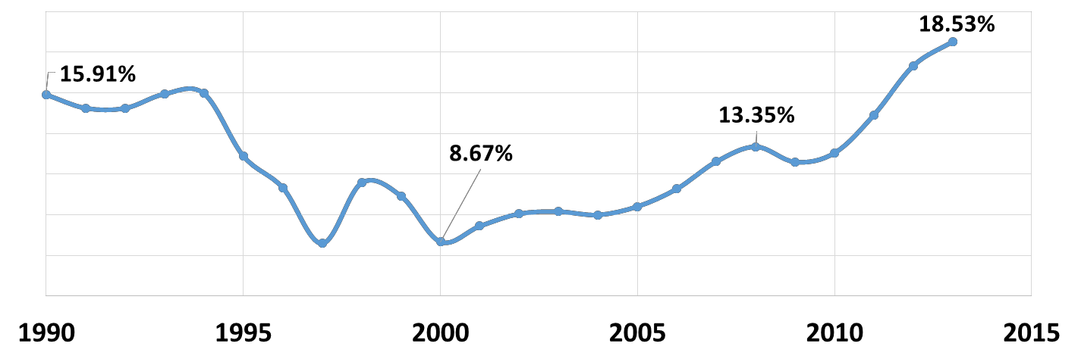

Figure 9: Curaçao’s tourism specialization

The spending per tourist arrival in Curaçao amounted to US$925.5 in 2014. In 2013, the spending per arrival was US$911, which is an increase of 1.6%. When compared to the year 2000, the spending per arrival has increased from US$664.5 to US$925.5. Curaçao’s average annual receipt increase per arrival is 2.5% which compares favorably to that of Aruba,18 a competing island destination. The increase in spending per arrival over time suggests a strong performance by the Curaçao tourism sector.

The spending impact in the local economy
The direct spending from tourists patronizing Curaçao touches conventional tourism suppliers, such as hotels, restaurants, and transportation, as well as other less conventional suppliers, such as banks, utilities, and manufacturing. It is important to note that the amount of tourist spending that occurs in Curaçao is directly dependent upon the tourists’ stay in hotels. This is because hotels have the largest multiplier in the economy. In the case of Curaçao, the estimates reveal that the multiplier for hotels is 1.92.

Interestingly, a large proportion of those tourists frequenting Curaçao (nearly 43%) stay outside of the traditional accommodation sector, such as renting private homes and apartments, or staying with friends and relatives.19 The shift towards other types of accommodations rather than the transient hotels are clearly exposed in Table 9. Tourists staying in hotels only increased on average by 5% per year, which is below the 7% annual average increase of arrivals.

18 See the report authored by the DPITS, Croes et al. (2011). Winning the Future: Strategic Plan for the development of Tourism.
19 This proportion is substantially higher than, for example, Aruba where 80% of the tourists stay in hotel accommodations. See Croes et al. (2011). Winning the Future.

On the other hand, private homes, apartments and bungalows increased by an annual average of 318%, 20%, and 16%, respectively.20 The choice accommodation selection of tourists directly affects their spending as well as the tourism industry’s overall contribution to the wider economy.

In reviewing Curacao’s tourism data, it is determined that accommodation receipts represent approximately 43% of the total tourism spending in Curaçao. However, approximately 42% of the 2014 tourism receipts did not include hotel stays. Due to the high opportunity costs in direct spending, as well as multiplier effects, the large amount of tourists that do not stay in hotels should raise concern for Curaçao.

Table 9: Curacao’s Demand Accommodation mix

Guest House |  |  | Others |  | Apartments |  | Bungalows |  | Small Hotels |  | Friends & Family |  | Large Hotels |  | Arrivals
Year | Tourists | ∆% | Tourists | ∆% | Tourists | ∆% | Tourists | ∆% | Tourists | ∆% | Tourists | ∆% | Tourists | ∆% | Tourists | ∆%
2000 | 1,830 |  | 2,255 |  | 3,745 |  | 10,134 |  | 35,844 |  | 57,668 |  | 76,056 |  | 187,532
2001 | 2,768 | 51% | 5,726 | 154% | 4,687 | 25% | 10,178 | 0% | 44,399 | 24% | 58,312 | 1% | 73,298 | -4% | 199,368 | 6%
2002 | 2,946 | 6% | 6,850 | 20% | 4,194 | -11% | 13,193 | 30% | 45,093 | 2% | 66,450 | 14% | 75,630 | 3% | 214,356 | 8%
2003 | 2,392 | -19% | 7,488 | 9% | 4,256 | 1% | 19,710 | 49% | 41,744 | -7% | 65,779 | -1% | 78,612 | 4% | 219,981 | 3%
2004 | 1,948 | -19% | 6,112 | -18% | 3,534 | -17% | 23,079 | 17% | 41,737 | 0% | 65,400 | -1% | 80,357 | 2% | 222,167 | 1%
2005 | 1,672 | -14% | 2,797 | -54% | 3,252 | -8% | 25,488 | 10% | 40,057 | -4% | 59,361 | -9% | 88,511 | 10% | 221,138 | 0%
2006 | 1,970 | 18% | 2,134 | -24% | 3,707 | 14% | 27,693 | 9% | 41,510 | 4% | 66,095 | 11% | 90,382 | 2% | 233,491 | 6%
2007 | 3,513 | 78% | 2,157 | 1% | 4,629 | 25% | 34,025 | 23% | 64,270 | 55% | 82,483 | 25% | 107,995 | 19% | 299,072 | 28%
2008 | 3,626 | 3% | 87,994 | 3979% | 6,307 | 36% | 35,339 | 4% | 86,383 | 34% | 80,400 | -3% | 103,763 | -4% | 403,812 | 35%
2009 | 3,589 | -1% | 80,434 | -9% | 11,864 | 88% | 43,658 | 24% | 69,104 | -20% | 40,960 | -49% | 117,070 | 13% | 366,679 | -9%
2010 | 3,290 | -8% | 75,207 | -6% | 9,192 | -23% | 45,688 | 5% | 39,103 | -43% | 46,050 | 12% | 125,766 | 7% | 344,296 | -6%
2011 | 2,010 | -39% | 88,338 | 17% | 9,161 | 0% | 49,100 | 7% | 46,439 | 19% | 52,866 | 15% | 142,117 | 13% | 390,031 | 13%
2012 | 1,990 | -1% | 167,168 | 89% | 11,512 | 26% | 47,556 | -3% | 47,784 | 3% | 23,145 | -56% | 121,158 | -15% | 420,313 | 8%
2013 | 4,037 | 103% | 119,606 | -28% | 23,703 | 106% | 61,033 | 28% | 62,155 | 30% | 27,230 | 18% | 142,329 | 17% | 440,093 | 5%

The DPITS conducted an exit survey during the months of January – April, 2015 at the Hato Airport in Curaçao. A total of 1,701 exit surveys were collected. The respondents indicated that 58% stayed in hotels, while 42% stayed in non-hotels (i.e., with friends and relatives, in apartments, or in private homes). Table 10 displays the distribution of hotel stays versus non-hotel stays for each primary market segment (Netherlands, Venezuela/Colombia, and USA). According to the distribution in Table 10, the American tourists demonstrate a clear preference for staying in hotels (i.e., approximately eight of every ten American tourists) compared to, for example, less than five out of ten Dutch tourists who stay in hotels. This result is similar to what the DPITS found in a study conducted in 2010 for Curaçao, where nearly nine out of ten American tourists stayed in hotels.21

Table 10: Distribution of hotel stays
Country | Stay in Hotels
Netherlands | 46%
Venezuela/Colombia | 52%
USA | 79%
Others | 81%

An important observation needs to be made from the information displayed in Tables 11 and 12. That is, tourists staying in hotels are likely to spend more money per day when compared to tourists who stay in non-hotels. This spending behavior was also revealed in the DPITS study for Curaçao in 2010.22 This information has also been

20 In our conversations with multiple stakeholders it became clear that “others” should be defined as private homes. Anecdotal evidence suggests that 30% of arrivals find accommodation in private homes and apartments. We found 239 offerings on only one website, retrieved on August 13, 2015. https://www.airbnb.com/s/curacao?guests=2&checkin=08%2F13%2F2015&checkout=08%2F20%2F2015&ss_id=et7nkwmb&source=bb.
21 See Croes, R., Rivera, M. & Semrad, K. (2010). Economic Impact Study, Curaçao Tourist Board.
22 See Croes, R., Rivera, M. & Semrad, K. (2010). Economic Impact Study, Curaçao Tourist Board.

revealed time and time again in multiple studies covering The Curaçao North Sea Jazz Festival.23 Tourists staying in hotels spend US$99.00 per day per person compared to US$74.00 for those who stay in non-hotels, which is nearly 34% more spending. The difference in spending potential between those tourists that stay in hotels and those who do not is a significant opportunity cost for the destination.

Table 11: Hotel vs. non-hotel tourists’ spending
Spending | Hotel | Non-Hotel
Spending US$-Lodging (only room expenses) | $286 | $262
Spending US$-Food/beverage (inside hotel) | $72 | $30
Spending US$-Food/beverage (outside hotel) | $112 | $150
Spending US$-Car rental | $52 | $80
Spending US$-Gasoline | $12 | $17
Spending US$-Taxi | $12 | $7
Spending US$-Public transportation | $3 | $5
Spending US$-Local arts/cultural events | $9 | $8
Spending US$-Shopping | $135 | $148
Spending US$-Internet/telephone | $5 | $5
Spending US$-Groceries/sundries | $23 | $58
Spending US$-Entertainment/nightlife/casino | $28 | $20
Spending US$-Water activities/recreation | $40 | $32
Spending US$-Other expenses | $33 | $36
Total Per Trip | $822 | $858
Total Per Day | $99 | $74

In review of Table 12, it appears that the difference in the overall trip expense is relatively the same between those tourists who stay in hotels (US$823 per trip) and those tourists who do not stay in hotels (US$857 per trip). However, a critical point must be made to call attention to the variation in the length of stay for both of these groups. Those tourists who stay in hotels stay an average of 8.3 nights, whereas those tourists who do not stay in hotels spend an average of 11.6 nights (see Figure 10). This means that while non-hotel tourists stay longer, they spend less money. The length of stay (LOS) for the Netherlands is significantly larger than that of all other groups (F=23.22, p<.0001). The implication is that those tourists staying in hotels have a significantly different spending behavior than those staying in non-hotel accommodations. The key consideration is the unit of analysis in the length of stay. Consider the following information to elucidate this point: a non-hotel guest spends US$25 more in groceries per trip than a tourist who stays in a hotel. When considering that raw food products account for 1/3 of a meal price in the restaurant industry, this could represent an opportunity cost of US$83 per person per trip. The total annual amount of tourists who do not stay in a hotel is 42% of the tourist arrivals in 2014. Thus, the opportunity cost of US$83 per person per trip directly effects the restaurant sector in the amount of US$15.8 million.

23 See, for example, Rivera, M., Croes, R., & Semrad, K. (2014). The Curaçao North Sea Jazz Festival: A lustrum churning economic and promotional opportunities for Curaçao. Dick Pope Sr. Institute for Tourism Studies: Orlando, FL.

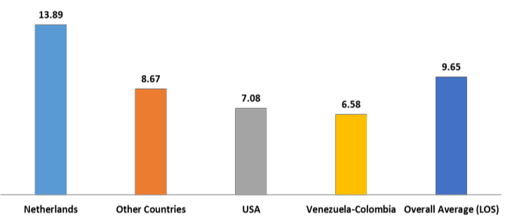

Figure 10: Length of stay of hotel vs. non-hotel tourists24

In other words, tourists staying in hotels are more likely to eat in the hotels in which they stay compared to those staying in non-hotel accommodations. In reference to actual consumption, tourists who stay in hotels spend US$112 plus US$72 in restaurants per trip per person compared to US$150 plus US$30 in restaurants per trip per person for those tourists staying in non-hotels. The total amount per trip per person seems about the same. However, when considering the variation in the length of stay, tourists staying in a hotel spend US$22.16 per person per day in restaurants compared to US$15.50 per person per day in restaurants for those tourists not staying in hotels. This again represents the aforementioned loss of $15.8 million in the restaurant sector.

This is not to say that tourists who do not stay in hotels do not make other economic contributions to the island. For example, those tourists staying at non-hotel accommodations spend more money on groceries (US$58) compared to tourists staying in hotels who spend less than half (US$23). However, when considering that hotels have the largest multiplier within the economy, it is important to concentrate on creating an influx of those tourists who would prefer to stay in hotels, as opposed to those that prefer non-hotel accommodations.

Table 12: Hotel tourists by country
Spending | The  Netherlands | USA | Venezuela/  Colombia | Others
Spending US$-Lodging (only room expenses) | $302 | $402 | $222 | $273
Spending US$-Food/beverage (inside hotel) | $80 | $116 | $48 | $64
Spending US$-Food/beverage (outside hotel) | $174 | $128 | $81 | $81
Spending US$-Car rental | $79 | $47 | $29 | $55
Spending US$-Gasoline | $19 | $9 | $6 | $13
Spending US$-Taxi | $8 | $23 | $10 | $10
Spending US$-Public transportation | $1 | $3 | $7 | $2
Spending US$-Local arts/cultural events | $11 | $14 | $6 | $9
Spending US$-Shopping | $115 | $100 | $172 | $133
Spending US$-Internet/telephone | $6 | $3 | $6 | $5
Spending US$-Groceries/sundries | $38 | $23 | $18 | $16
Spending US$-Entertainment/nightlife/casino | $17 | $43 | $35 | $23
Spending US$-Water activities/recreation | $40 | $74 | $19 | $45
Spending US$-Other expenses | $45 | $35 | $29 | $25
Total Per Trip | $935 | $1,020 | $688 | $754
Total Per Day | $73 | $159 | $136 | $91

Next, the data was further filtered according to the spending behavior by country of origin as follows: the Netherlands, USA, Venezuela/Colombia, and others. Table 13 reveals that the American segment has the highest spending per person per day at US$159.00, followed by Venezuela/Colombia at US$136.00, and the Dutch segment at US$73.00. The “Others” category, which included a number of countries grouped together, accounted for

24 (8.33 nights vs. 11.57 nights F=13.20 P<.001)

US$91.00 per person per day. It is important to note that the American market is spending more than twice as much per day per person than the Dutch.

It is also important to note that while the Venezuelan and Colombian market is performing as expected, the past volatility in this market segment has prompted concern. Seasonality from this market segment is highly pronounced in terms of hotel occupancy rates, as well as in the level of arrivals. The highest seasonal point regarding stay-over tourists occurs in the month of December, while the lowest point happens in May of each year (see Figure 11). Seasonality propagates volatility affecting the planning capacity of the destination as well as individual firms. Therefore, it is necessary for Curaçao to secure tourist markets that demonstrate lower levels of seasonality than that of the Venezuelan market.
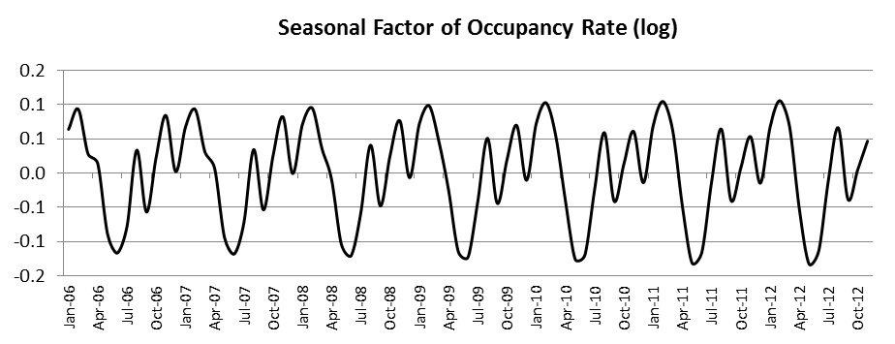

Figure 11: Seasonality in occupancy rates Table 13: Non-hotel tourists by country
Spending | Netherlands | USA | Venezuela/  Colombia | Others
Spending US$-Lodging (only room expenses) | $339 | $432 | $119 | $406
Spending US$-Food/beverage (inside hotel) | $32 | $43 | $24 | $40
Spending US$-Food/beverage (outside hotel) | $228 | $185 | $66 | $122
Spending US$-Car rental | $125 | $95 | $27 | $80
Spending US$-Gasoline | $25 | $19 | $8 | $20
Spending US$-Taxi | $3 | $13 | $10 | $8
Spending US$-Public transportation | $1 | $2 | $10 | $2
Spending US$-Local arts/cultural events | $12 | $10 | $3 | $7
Spending US$-Shopping | $70 | $76 | $237 | $179
Spending US$-Internet/telephone | $5 | $2 | $4 | $8
Spending US$-Groceries/sundries | $92 | $70 | $20 | $44
Spending US$-Entertainment/nightlife/casino | $17 | $22 | $23 | $24
Spending US$-Water activities/recreation | $38 | $45 | $20 | $43
Spending US$-Other expenses | $46 | $49 | $23 | $37
Total Per Trip | $1,033 | $1,063 | $594 | $1,020
Total Per Day | $70 | $113 | $73 | $99

The USA market spends the most per day per person at US$148.4 compared to the Venezuelan/Colombian market (US$105.8), and Dutch market (US$71.4). As evidenced in Table 13, the American non-hotel tourists are again displayed as the largest spending per day per person at US$113, followed by Venezuela/Colombia (US$73), the Dutch segment (US$70), and Others (US$99).

In 2014, the accommodations sector observed a 21.9% room tax collection increase. This means that given the increase in tourist arrivals, the room tax increased from US$5.5 in 2013 to US$7.7. However, it is not known if this

increase in room tax collection is due to an increase in the accommodations sector’s performance as evidenced by improved hotel occupancy and RevPAR values, or if the increase is due to improvements in the tax collection process.

The cruise business
Curaçao’s tourism sector also includes cruise businesses. Curaçao’s cruise businesses have been thriving in the past few years. In 2013, Curaçao experienced a significant growth of 41% in cruise passengers compared to the year before. Figure 12 depicts the evolution of Curaçao’s cruise businesses over time. The increase in cruise passengers is a direct result of increased ports of call to Curaçao (see Figure 13). Consequently, for the first time, Curaçao was ranked in the “World’s Top 50 Ports” by Cruise Insight magazine’s 2013 autumn issue.
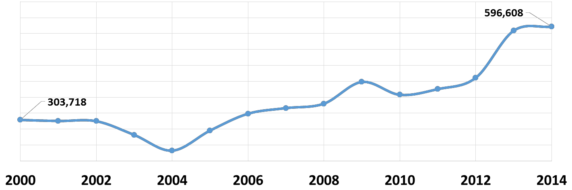

Figure 12: Curaçao’s cruise business over time

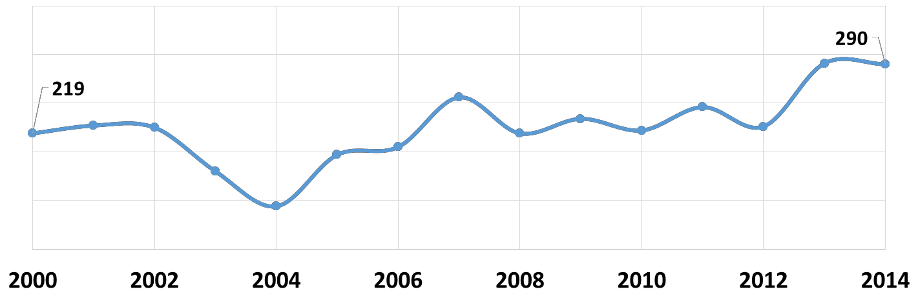

Figure 13: Increase in ports of call

Cruise visitation has clearly made inroads in Curaçao’s tourism industry over the past fifteen years. Cruise passengers increased on average 6% per year, while cruise calls increased on average by 3.4% per year over the same time span. Cruise business at the destination reveals two important characteristics, i.e., arrivals have been growing faster than calls while the destination has displayed one of the strongest cruise passenger increases in the region.

Given the prominence of this industry subsector, the DPITS conducted a survey among cruise passengers and crew members in the months of January to March, 2015. The survey aimed to estimate the economic impact of the subsector, the level of visitor satisfaction, and the cruise passengers’ intention to return to the island. A total of 897 cruise surveys were collected at the harbor.25 Cruise survey respondents’ spending behavior is revealed in Table 14. The spending per passenger amounted to US$71.19, while the spending per crew member accounted for US$100.38.26 The total cruise business contribution to the local economy amounted to US$41.6 million based on

25 The DPITS is indebted to the Curaçao Port Authority (CPA) staff for their valuable assistance in the administration of the data collection.
26 The BREA report confirms that crew members spend more money on the island of Curaçao.

583,994 cruise passengers in 2013. The US$41.6 million excludes crewmembers’ economic contribution and cruise line expenditures.27 The total direct cruise spending (including crew members) equates to 8.1% of the total tourism receipts benefiting retail, restaurant, and transportation industries.

An interesting piece of information extracted from Table 14 is that the crew members are spending more money on the island of Curaçao than the actual cruise passengers. This information reveals that the subsector is not optimally performing. An examination of the data reveals that cruise passengers spend more money on watches and jewelry, clothing, restaurants, and tours. An interesting note is that crew members spend more money in restaurants (almost five times more) than passengers. In addition, crew members spend nearly four times as much on perfumes when compared to cruise passengers.

Table 14: Spending profile of the cruise industry
Spending | Passengers | Crew
Food and Beverage at Restaurants and Bars (In US$) | $10.67 | $50.61
Sightseeing Tour (In US$) | $10.13 | $4.31
Taxis/Ground Transportation (In US$) | $2.89 | $5.29
Retail Purchases of Watches & Jewelry (In US$) | $16.43 | $4.59
Retail Purchases of Clothing (incl. T-shirts) (In US$) | $14.22 | $6.85
Entertainment Venues/Nightclubs/Casinos (In US$) | $0.48 | $1.28
Retail Purchases of Perfumes & Cosmetics (In US$) | $2.71 | $9.82
Telephone & Internet Communications (In US$) | $0.11 | $1.65
Local Crafts and Souvenirs (In US$) | $5.73 | $7.52
Retail Purchases of Liquor (In US$) | $2.21 | $1.83
Retail Purchases of Electronics (In US$) | - | $2.25
Any Other Purchases (In US$) | $5.62 | $4.36
Total | $71.20 | $100.36

The results of the survey indicate that cruise passengers display a spending capacity as well as a potential source of stay-over tourists. Twenty-one percent of cruise passengers indicated that they are willing to return to Curaçao as a stay-over tourist, stressing a conversion opportunity for the destination. This conversion opportunity represents a considerable potential economic impact for the destination. Consider the following example: if only 5% of cruise passengers decide to return to the destination as a stay-over tourist, this would mean an additional 30,000 tourists (29,831 based on 2014 cruise passenger arrival). Assuming these additional tourists would spend the same as the average stay-over tourists in the amount of US925.5 per trip, the direct spending would add to US$27.6 million. This is clearly a significant opportunity cost the destination would not pursue a tourist stay-over conversion policy.

The economic impact of tourism
The economic contribution of tourism goes beyond the direct tourists’ spending. The economic impact analysis is based on the I-O model calibrated in the Tourism Economic Impact reported by the DPITS in 2010.28 The direct spending was based on the information the DPITS received from the CTB and includes tourist spending in the magnitude of US$625.5 million. A leakage factor was included in the economic impact. The analysis made the assumption that a portion of the spending would be lost to other economies outside of Curaçao. Therefore, a leakage factor of 0.308 subtracted this fraction from the total direct spending of tourists to the island.29
The indirect economic impact was estimated at US$437.7 million, while the total economic contribution to the economy amounted to US$971.6 million (see Table 15). The multiplier effect is estimated at 1.82. The total amount of jobs spawned by this economic impact is 16,503, which includes 9,946 direct jobs and 6,557 indirect jobs. The

27 If the same amount of crew visits is used as reported by BREA, the crew expenditures would amount to US$6.8 million, which would bring the total value of the cruise business to US$49.3 million. See BREA (2012). Economic contribution of cruise tourism to the destination economies. Volume 1. Report prepared for Florida-Caribbean Cruise Association.
28 See Croes, R., Rivera, M. and Semrad, K. (2010). Curaçao Tourism Economic Impact 2007-2008, prepared for the Curaçao Tourist Board, DPITS, Orlando, September 15.
29 The leakage factor was estimated based on a Keynesian model.

total amount of jobs is equivalent to 22.6% of the total labor force in Curaçao. For every 44 tourists, one direct job is generated; whereas, one direct job as well as indirect jobs are generated for every 27 tourists.30

Table 15: Tourism’s economic impact in Curaçao
Economic Impact | Totals
Direct Impact | $533,940,224.00
Indirect Impact | $437,692,945
Total Impact | $971,633,168.66
Multiplier Effect | 1.82

Table 16: Tourism’s economic spillover effect
Sector | Direct and Indirect |  | Direct Jobs | Indirect Jobs
Agriculture, fishing, mining | $28,291,163 | 2.9% | 0 | 188
Manufacturing | $102,447,290 | 10.5% | 0 | 2,122
Electricity, gas, and water supply | $44,777,159 | 4.6% | 0 | 114
Construction | $8,391,525 | 0.9% | 0 | 92
Wholesale/Retail/Trade | $141,102,926 | 14.5% | 4,641 | 0
HORECA | $348,431,191 | 35.9% | 4,591 | 236
Transport and communication | $105,354,262 | 10.8% | 714 | 511
Financial Intermediation | $103,294,583 | 10.6% | 0 | 1,404
Other real estate activities | $44,668,442 | 4.6% | 0 | 824
Education | $1,433,091 | 0.1% | 0 | 13
Health | $1,264,905 | 0.1% | 0 | 21
Other services | $42,176,633 | 4.5% | 0 | 1,033
Total | $971,633,170 | 100% | 9,946 | 6,558

The economic benefits accruing to the local economy go beyond the conventional tourist industry and spread to the banks, utilities, telecommunications, and manufacturing sectors. For example, for every US$100 spent by tourists visiting the island, manufacturing receives US$19.19, utilities obtain US$8.39, and the banking sector accumulates US$19.35. It seems logical that these sectors should have the incentives to participate in any tourism funding system that would be used to permit the allocation of tourism financial resources over time (Table 16).

Residents’ perceptions of tourism’s contribution
Residents may entertain feelings and emotions that do not align with the objective reality previously discussed. Therefore, it is imperative to detect and understand residents’ perceptions regarding tourism development. While it is clear that the tourism sector made enormous strides in its economic contribution according to all of the previous economic analyses, the DPITS also gauged whether the economic contribution of tourism was positively perceived by island residents. For this purpose, a quality of life survey during the months of March and April, 2015 was conducted in different barrios and according to the island census. A total of 1,054 surveys were collected, of which 1,024 were considered usable.

Table 17: Residents’ perceptions of tourism opportunities
 | Completely Disagree | Disagree | Neither  Agree nor  Disagree | Agree | Completely Agree
Employment opportunities | 8% | 13% | 33% | 26% | 20%
Increase the standards of living | 10% | 14% | 38% | 20% | 18%

Table 17 shows that about half (46%) of the local respondents agree that the tourism sector provides employment opportunities; whereas, 21% of the respondents did not agree that tourism provides employment opportunities.

30 The economic effects should be larger if induced effects are considered in the I-O model. However, the induced effects were not included in the estimation due to the lack of household income data.

The interesting value is that 33% of the respondents could not agree, nor disagree, if the tourism sector would provide employment opportunities. This means that the island residents are not aware of tourism’s impact on job opportunities in Curaçao. Therefore, Curaçao must make valiant efforts to educate the local population regarding perspective jobs and employment options within the tourism sector.

With regard to tourism’s ability to contribute to increasing residents’ standards of living, again nearly half (48%) of the respondents indicated that they agree that tourism can increase the standards of living on the island. Twenty- four percent of the respondents did not agree that tourism could enhance the standards of living in Curaçao; and more than 1/3 of the respondents (38%) were unaware of tourism’s ability to contribute to the increase in the standards of living in Curaçao.

Again, Curaçao must make valiant efforts to educate the local population on employment opportunities and tourism’s overall ability to increase the standards of living in Curaçao. The educational efforts could be conducted through public relations and advertising campaigns that teach the public about the socioeconomic contributions that tourism will make to Curaçao.

In order to further understand the differences between those respondents who agreed or disagreed that tourism could make positive contributions to the socioeconomic conditions in Curaçao, the data was further segregated into generational cohorts (i.e. Baby Boomers, Generation X, Generation Y, and Generation Z). Analysis of variance (ANOVA) tests were used to determine statistical differences between the generations.

According to the results, those local residents who responded to the survey that were from Generation Z (age 20 years and less) were significantly different than Generation Y (ages 21-37) when asked if they felt that tourism provides many good employment opportunities for residents. This is an interesting finding in that Curaçao’s Generation Y currently possesses the highest level of unemployment on the island and seems to believe that there may not be employment opportunities available/desirable in any sector. However, the new upcoming Generation Z does have a favorable outlook on the tourism sector’s ability to provide many good employment opportunities for residents.

Employees’ perceptions of career opportunities in the tourism industry
Tourism economic impact is also potentially correlated with the perception of career opportunities. The DPITS examined a sample of 518 workers from different hospitality and tourism- related occupations to determine their perceptions of the availability of career opportunities in the tourism industry. A survey was distributed and a total of 518 responses were received. The individuals who responded to the survey worked in the hotel industry (55%), restaurants (16%), transportation (8%), tour operators (4%), and retail (7%), among other tourism-related industries. Males represented 40% of those surveyed, whereas females comprised 60% of the sample. Most individuals were single (56%), followed by married individuals (28%) and divorced individuals (5%), with 48% of the respondents having children. The average respondent was 35 years old and worked an average of 38 hours per week.

Table 18: Attitudes towards tourism and customer service
Statement | Mean
I think my personality fits a career in the tourism industry | 4.08
At work, I consider myself a hospitable person | 4.34
I can use my skills and abilities in the tourism industry | 4.29
I get pleasure working in the tourism industry | 4.24
I take pride in seeing satisfied customers | 4.50
I like a job that allows me to interact with people from various backgrounds | 4.44

Employees in the tourism industry had a favorable perception of the tourism industry. For example, the mean scores for, “A job in the tourism industry is creative and meaningful.” and, “A job in the tourism industry is challenging.” were 4.11 on a 5-point Likert scale. Similarly, respondents were favorably disposed to, “I am proud to work in the tourism industry.” with a mean score of 4.19, as well as, “A job in the tourism industry is important.” with a mean

score of 4.03. Overall, the attitudes toward tourism and customer service were highly favorable as attested in Table 18.

Tourism works with misaligned local perceptions
In summary, Chapter 3 reveals that tourism spending has increased significantly over the past 15 years and is outperforming other destinations within the Caribbean. The spending per arrival was US$925.5 in 2014; and the steady increase in tourist receipts over time suggests strong performance in Curaçao’s tourism sector. Data reveals that the spending per tourist touches a multitude of different suppliers that includes conventional tourism businesses, as well as non-conventional businesses, such as banks, utilities, and manufacturing.

A note of concern is that there is a growing trend in the data from those tourists who arrive to Curaçao but do not stay in hotels (approximately 42% of the 2014 tourism receipts did not include hotel accommodations). This shift in hotel expenditures has had a direct negative implication on the disbursement of revenues earned via tourist receipts. The revenues earned by nearly half of the tourism receipts is filtered through less potent economic multipliers than that of the hotel industry. Additionally, the data reveals that while the Dutch segment has a comparable per trip expenditure to other market segments, their length of stay is longer, thereby reducing the daily amount spent on the island.

The American market reveals a clear preference to stay in hotels where 8 out of 10 Americans stay in hotels versus less than 5 out of 10 Dutch tourists who stay in hotels. The American preference to stay in hotels directly effects the economic multiplier for Curaçao. Of all the market segments frequenting Curaçao, the American market spends the most per day.

Therefore, a concerted effort should be made toward the acquisition of the American market that spends more money per day, stays for less time, but spends about the same per trip as the Dutch market. This recommendation also takes into consideration that the less time a tourist stays on the island, the less amount of attractions are required to entertain those tourists; whereas, the markets that have longer lengths of stay require more attractions to keep them entertained during their holiday/vacation.

The cruise industry has flourished over time and Curaçao has enjoyed the introduction into the World’s Top 50 Ports because of its rapid growth. However, the DPITS has confirmed the BREA report findings that the crewmembers spend more money on the island of Curaçao than the actual cruise passengers, thereby indicating that this subsector is underperforming. This underperformance is exposed in two areas, i.e., the relatively low spending of cruise passengers while at the destination, and the missed conversion opportunity of cruise visitors to stay-over tourists. The DPITS research does reveal that there is an opportunity to convert cruise passengers into stay-over tourists.

Last, the residents’ perception of the tourism industry’s economic contribution to the island indicates that the majority of the population agrees that the tourism sector will provide employment opportunities in Curaçao, and will increase residents’ standards of living. A generational analysis reveals that Generation Z is statistically higher in their perceptions of the tourism industry’s opportunities than that of Generation Y (Curaçao’s highest unemployed generation). However, the local population can be made cognizant of the vast career opportunities available in tourism, thus impacting locals’ perception about tourism opportunities.

Chapter 4: The Effectiveness of the Tourism Industry, Human Capital, and Institutional Support

The ROI of the tourism industry in Curaçao
A challenging situation that stems from Curacao’s current business environment and stresses the advancement of Curacao’s tourism industry has been identified. High transaction costs combined with increasing frictions in the marketplace are hindering the infusion of the capital that is necessary to sustain a high-quality tourism product. As a result, this business environment is hampering the necessary sustained investment that might otherwise keep the industry competitive. The result, as witnessed in the hotel sector, is that the ability of the local hospitality industry to move forward is then diminished.

Data analysis alludes to the dire financial situation of a number of hotels on the island that prevents these properties from maintaining international standard rooms. The lack of international standard quality rooms on the island is problematic. First, those hotels not capable of maintaining international standards are not able to justify higher room rate charges; and low room quality jeopardizes the hotels’ ability to have a steady increase in occupancy rates. Currently, many of the island’s hotels are courting financial jeopardy as is evidenced by key performance indicators, such as low island RevPAR, ADRs, and occupancy rates.

The gravity of the business challenges is reflected in the return on investment (ROI) of the tourism industry to the economy as a whole. One way to assess the macro-economic ROI of the industry is by examining how tourism receipts and expenditures evolve over time. Curaçao’s dependence on exports and rising government expenditures has created significant budget deficits and imbalances of payments (especially after 2010).31

For the tourism sector, this pattern prevents creating and allocating funds for tourism marketing purposes, and encourages a weak external position in terms of tourism activities in both neighboring and international regions, such as South and North America, and Europe. This puts the island in financial jeopardy at both macro (current account deficit of 19.5% of GDP in 2012, Central Bank of Curaçao) and micro levels (i.e., declining ROI from tourism receipts from travel, import, and transport activities vs. total tourism expenditures).

Figure 14 and Table 19 show the comparison of the total international tourism receipts and expenditures as generated by passenger transport and travel items from 2007 to 2012.32 Total receipts represent 13% of the gross national product, and when multiplier effects are considered, the tourism industry accounts for nearly one (23%) of every four dollars generated by the economy. Indeed, the data indicates that total international tourism receipts are increasing at an annual average rate of 15.9%.

On the other hand, tourism expenditures (spent by the government for the island’s international brand awareness, total imports, and travel items) have also been increasing by an annual average rate of 10%, albeit at a lesser pace than receipts. Prima facie, this positive comparison could be construed as a sign of the vitality and overall competitiveness of the industry. However, this comparison provides only a partial picture of tourism vitality and its impact on the economy. Actually, this comparison could be misleading in terms of the overall performance of the industry.

One rigorous way to assess the real strength of the tourism industry is to simultaneously integrate receipts and expenditures into an index. This index, the ROI of the industry, may be estimated by examining the ratio between these two variables. By employing this index, it becomes clear that the ROI figures have been declining since 2009. The change in ROI reveals a steep decline when the years from 2009 to 2012 are considered (see Figure 14). If the

31 See, for example, the TAC report.
32 Obtaining data about the tourism industry in Curaçao has been nearly futile. The DPITS was only able to obtain data from those years revealed in the text.

2009 ROI is used as the benchmark for the change analysis, then it can be concluded that lost revenues were over NAf110 million.

Thus, raising the pattern in historical tourism receipts and revenue could mislead the authorities since, based on the benchmark, there are not sufficient receipts generated to compensate for lost revenues. That is, although receipts have been increasing since 2009, the required return is not satisfactory, thereby increasing the revenue gap in the revenue pattern of tourism performance. Table 20 reveals the total revenue gap over the time span reviewed, which equals almost US$63 million or more than NAf110 million over the time span of four years. Clearly, tourism receipts have to increase at a much faster pace if the benchmark of 2009 is to be achieved and surpassed. The decreasing ROI is an indication of the weak fundamentals in the tourism sector on the island.

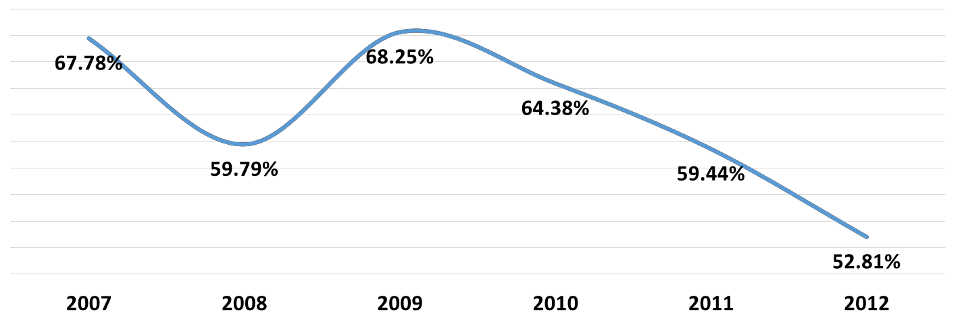

Figure 14: Return on investment (ROI)33

Table 19: Total revenue gap

Years | Total International Tourism Receipts | Total International  Tourism Expenditures | Δ Total Receipts | Δ Total Expenditures
2007 | $658,000,000 | $446,000,000 | - | -
2008 | $766,000,000 | $458,000,000 | $108,000 | $12,000,000
2009 | $756,000,000 | $516,000,000 | ($10,000,000) | $58,000,000
2010 | $876,000,000 | $564,000,000 | $120,000,000 | $48,000,000
2011 | $1,080,000,000 | $642,000,000 | $204,000,000 | $78,000,000
2012 | $1,352,000,000 | $714,000,000 | $272,000,000 | $72,000,000
Years | ROI | Δ ROI (%) vs.  Benchmark | Δ ROI ($) vs. Benchmark | GAP in Total Receipts
2007 | 67.78% | - | - | -
2008 | 59.79% | - | - | -
2009 | 68.25% | - | - | -
2010 | 64.38% | -3.87% | $124,644,000 | ($4,644,000)
2011 | 59.44% | -8.81% | $221,972,400 | ($17,972,400)
2012 | 52.81% | -15.44% | $313,996,800 | ($41,996,800)

33 Note: ROI = Tourism Expenditures / Tourism Receipts

Cause and effects of declining ROI in the tourism industry
What seems to be influencing the fundamental function of the tourism sector in Curaçao is the lack of financial discipline and regulation. This unfortunate situation is yielding low economic returns, volatile economic growth, and financial constraints and challenges that negatively influence economic expansion driven via public and private investments, as well as external demand (i.e., international tourists). The institutional capacity which is required to support the tourism industry, its expansion, and its impact on the economy as a whole, is currently needing, wanting, and requiring attention.

Table 20: Comparison of corporate income tax rate34
Country | Corporate Income Tax Rate (%)
Aruba | 25.00
Barbados | 28.00
Mauritius | 15.00
U.S. Virgin Islands | 38.50
Puerto Rico | 30.00
Jamaica | 33.50

The institutional weakness is revealed in the significant amount of the existing gross tax gap (the difference between the taxes owed and what is actually paid in taxes). For example, anecdotal evidence suggests that the tourism room tax gap is in the order of US$50 million. This gap could either be the result of lack of enforcement by the corresponding agencies, or is a reflection of the tax burden imposed on businesses. Tables 21 and 22 indicate a decreasing trend in the collection of both direct and indirect taxes. Curaçao has a relatively high corporate tax compared to the region. The current corporate income tax rate for the island is 27.50%.

The confluence of fiscal and law enforcement forces are shaping the marketing capacity of the destination. The marketing capacity of the destination has remained practically stagnant from 2002 to 2015. The marketing dollars in 2015 are equivalent and also display significant volatility during this time period. Marketing dollars over that time have increased by less than a 1% annual average, and its volatility is disquieting with a coefficient of variation (CV) of 12.46. This volatility in marketing dollars is pervasive in several markets during this time span. For example, the South American and Caribbean markets have experienced the largest fluctuations in their marketing budgets. The European marketing budget has increased by an annual average of 12%, while the American marketing budget increased by an annual average of 7.6%.

Table 21: Panel A: Income from direct taxes (x mln NAf)35
 | 2010 | 2011 | 2012 | 2013
Taxes on Income | 739.3 | 701.3 | 712.8 | 673.6
Wage Tax | 500 | 504.4 | 499.8 | 494.9
Income Tax | 1.1 | -1.6 | 10.2 | 5.1
Profit Tax | 238.3 | 198.5 | 202.8 | 173.6
Other Current Taxes | 29.1 | 31.4 | 31 | 29.3
Total Current Taxes on Income | 768.4 | 732.8 | 743.8 | 702.9

34 Note: The Corporate Income Tax Rate Schedule is taken from Ernst & Young’s Worldwide Corporate Tax Guide 2013. Source: http://www.ey.com/Publication/vwLUAssets/Worldwide_corporate_tax_guide_2013/$FILE/Worldwide_corporate_tax_guide_2013.pdf 35 Note: Taxes on Income = Wage Tax + Income Tax + Profit Tax. Total Current Taxes on Income = Taxes on income + Other Current Taxes. Source: Government Budgets, Central Bank of Curaçao. Available at Curaçao Central Bureau of Statistics Webpage: http://www.cbs.cw/cbs/themes/Economy/DataEconomy-2014062794434.pdf

Table 22: Panel B: Income from indirect taxes (x mln NAf)36
 | 2010 | 2011 | 2012 | 2013
Motor-vehicle Tax | 36.3 | 39.3 | 38.8 | 36.6
Land Tax | 27.8 | 26.1 | 26.1 | 27.3
Lodging Tax | 8 | 9 | 10.2 | 10.1
Usage Tax | 0.3 | 0.2 | 0.2 | 0
License Tax | 6.6 | 15.5 | 16.5 | 11.3
Other | 5.7 | 10.5 | 10.5 | 9.2
Total | 84.7 | 100.5 | 102.3 | 94.5

The volatility in the availability of marketing dollars has had its impact on market performance with regard to international tourists. For example, the number of international tourists from the Caribbean region shows a decline of 3% in the number of visitor nights.37

Similarly, the American market remained stagnant or revealed some decline during the period under review. Overall, there seems to be little resemblance with regard to the trends between marketing dollars and tourism receipts as revealed in Figure 15. The lack of resemblance suggests that the marketing dollars are not targeting the right type of customers, or building the right type of relationships with customers.

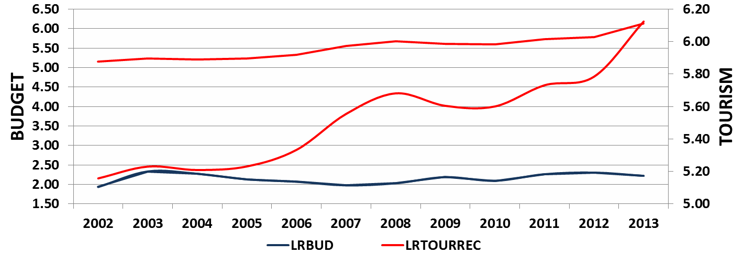

Figure 15: Relationship Marketing Budget (LRBUD) and Tourism Receipts (LRTOURREC)

Similarly, a three year moving correlation analysis between the logarithm of the marketing budget and tourism receipts reveals a large positive linear relationship for 2001, 2004, and 2013. The remaining years display a negative linear relationship (see Figure 16).

The high volatility in marketing dollars adds to the uncertainty of local and international providers and international distribution channels in terms of the importance of the tourism industry for the government. Additionally, uncertainty stunts needed investments to expand and sustain tourist offerings at the destination. Providing more certainty in the allocation of marketing dollars is an important component of change for key tourism source markets. Moreover, certainty in the availability of marketing dollars may fuel confidence in the markets regarding new capacities and capabilities in tourism management and sector development. This is vital, not only if an economy is to become more resilient against disruptive events, but if it is to prepare for long term stability. Multiple conversations with stakeholders suggested that, because the tourism industry requires a priority policy role in order to secure its growth, the government should clearly state its support and advocacy regarding that role.

36 Source: Government Budgets, Central Bank of Curaçao. Available at Curaçao Central Bureau of Statistics Webpage: http://www.cbs.cw/cbs/themes/Economy/DataEconomy-2014062794515.pdf
37 (17.802 nights –Source: The Curaçao Chronicle. Available at: http://www.caribbeannewsdigital.com/en/noticia/tourism-generated-352- million-Curaçao-economy-january-2014).

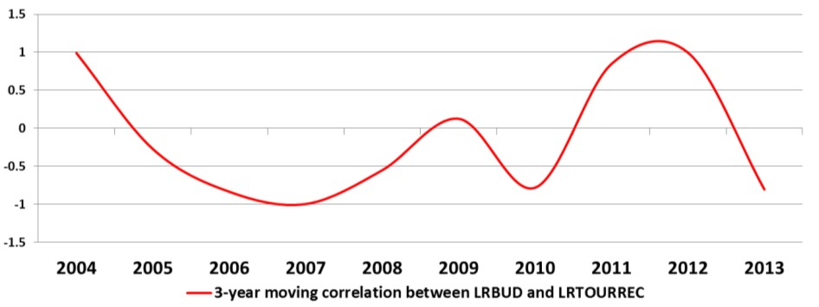

Figure 16: Correlation Marketing Budget (LRBUD) and Tourism Receipts (LRTOURREC)

The business environment and the low economic return
Tourism’s ability to provoke economic growth and social prosperity depends upon an attractive investment and business climate. Businesses create jobs; and if the business climate is not conducive to investment, jobs will be wasted or lost. Further, sustainable economic growth could suffer under the condition of a rigid business climate. In order to achieve sustainable economic recovery, the business environment should improve the quality of regulation, promote external competitiveness, and systematically introduce better regulatory procedures and practices. The evolving business environment on the island, then, affects productivity, performance, and profitability of the tourism industry.
The report entitled, “Strategies for sustainable long-term economic development in Curaçao,” (May, 2013) documents how the current institutional and regulatory framework in Curaçao is impinging upon the business environment on the island.38 That is, the current environment is curtailing business initiatives and investments. Consequently, the investment level in the tourism and hospitality industries on the island is low when compared to that of the Caribbean region.39 Hence, the low level of investment flows to low levels of tourists’ spending. Tourists average daily spending is about US$100.00 and the ADR of local hotels is less than US$100.00 according to the hotel industry.
In its multiple conversations with stakeholders, the DPITS has also noticed the growing frustration with the institutional and regulatory environment. The labor market and regulations seem to hamper productivity, frustrate the hiring of qualified staff, and hamper labor competitive processes. In addition, the recommended 80/20 rule, which requires a minimum of 80% local workers in local companies, has posed a threat to the competitiveness of tourism businesses. The lengthy and complex regulatory process to hire skillful and experienced management and staff is hindering the adequate training and skill transfer to the locals employed in the industry.
This situation is affecting the island in areas in which the island needs the most attention: the human resource necessary to move the industry into the 21st century. Although appearing to recognize its shortcomings in the delivery of quality service, the tourism industry struggles with implanting the workforce development that is necessary to enhance service delivery. This is because the process for hiring expatriates is inefficient. If the process were expeditious, the ability to train locals via the transfer of expatriates’ service delivery skills would be introduced into Curacao’s tourism sector; and the result could provide for quality service.

38 See the TAC (2013) report.
39 The President of the Central Bank alluded to the low level of investment in the hospitality industry in his speech at the 2015 CHATA annual general meeting. How can we shape a better future for the Curaçao tourism industry? Keynote speech delivered by Dr. Emsley Tromp, President of the Central Bank of Curaçao and St. Maarten, On the occasion of the annual general meeting organized by the Curaçao Hospitality and Tourism Association, March 25th, 2015.

Along with the rigid regulatory environment are the high operational costs for tourism and hospitality businesses. The utilities in Curaçao (i.e. electricity and water) are 40% higher than the island of Aruba, estimated at 0.42US$/kwh. Additionally, the cost of hiring quality management staff from abroad is significant, reaching by some account of US$500,000.00 per year due to the tax code, the lengthy permit process, and high costs of living on the island. Combined with the difficulty in finding qualified local staff and the resulting low productivity, it seems that doing business in Curaçao’s tourism and hospitality industry is not an attractive economic activity. Anecdotal evidence suggests that, because of the regulatory environment and high operational costs, the majority of hotels are either losing money or have an operational profit of less than 5%. This level of operational profit is significantly below the market standards of 10-15%.
The high operational costs are also affecting the quality of service delivery that is required to make the destination more attractive and competitive. The low economic return of tourism and hospitality business in Curaçao is affecting the physical maintenance level of many hotels. Consequently, many of the hotel facilities are clearly in need of upkeep. Unless the regulatory environment issues are alleviated in the short-term, the island will waste opportunities that will affect its ability to create the amount of jobs that are needed to improve the standard of living for the local population.
Curaçao’s hospitality businesses have a difficult time in obtaining the required financial resources necessary to invest in new products and/or to reinvest in existing products. The overall low level of investment is mainly due to the local banks’ perception that tourism and hospitality business endeavors are high risk. This perception has placed the hotel sector under duress due to the local bank’s unwillingness to provide the financial resources required to maintain existing hotels, or to construct new hotels.

Human capital analysis
The DPITS has been involved in a series of assessments regarding human capital in the tourism industry. A preliminary human capital analysis reveals that the Curaçao restaurant and hotel operators seem to indicate that the assembling of a high-quality workforce in the hospitality and tourism segment is a significant challenge. Qualitative data analysis suggests three separate but related concerns regarding the workforce in the tourism industry:
  - Disinterest in service
  - Education and training
  - Local employment laws

The first concern, disinterest in service, was evidenced in commentary related to a lack of service-mindedness and a lack of desire for service and hospitality jobs among local workers. Managers expressed concerns that most hourly hotel and restaurant employees do not project the approachable and engaging body language, mannerisms, or communication that is expected of service employees. A consensus opinion seems to be that there is a distinct difference in the mindsets of local workers and foreign workers regarding acceptable levels of service, with foreign workers possessing a stronger service mentality. Also, most managers provide commentary that indicates that service and hospitality jobs are perceived as short-term employment of last resort, rather than as promising, long- term career paths. Some group members attributed this to cultural perceptions among local workers that service is somehow akin to servitude, and is therefore neither desirable nor respectable employment.

The second concern, education and training, reflects the comments from managers with regard to the unpreparedness of workers who are entering the industry via local hospitality and tourism schools and training programs. Managers indicate that these programs focus primarily on specific technical skills, which can often be taught or trained on the job, rather than broad competencies that are applicable across a variety of service jobs. Competencies, such as language/communication, service, and professionalism (both on-the-job and during the application/interview process) were specifically highlighted as areas in which the local workforce is lacking. Managers also indicated that trainees lack a general understanding of the industry and its demands.

The third and final concern was related to local employment laws on the island. There was a perception among managers that local workers are protected by employment laws which make it difficult to terminate employees. Managers indicated a willingness to hire local workers, but also indicated a preference for foreign workers because foreign workers were considered better educated in hospitality and service, and possessed more diverse language skills. However, the consensus opinion was that the time for foreign work permits to be processed was excessive, making it challenging to complete the hiring process and bring foreign workers to Curaçao.

The culminating theme that emerged in the preliminary human capital analysis is that there is a need among local workers to foster a service mindset and a positive attitude toward service jobs. However, as revealed in Chapter 2 (see Table 7), this may prove a challenging task as there seems to be a disconnect between managers’ experience and employee attitudes toward tourism and customer service. Employees seem to have favorable perceptions of the tourism industry and its opportunities, whereas managers have a hard outlook on the service quality abilities and tourism’s overall potential impact on the island. To understand this disconnect, the DPITS team did a formal analysis of the relationship between quality of work life and productivity.

A survey was conducted among hospitality employees with 518 respondents. The survey used a Likert scale with 1 being completely disagree and 5 being completely agree. Table 23 indicates that hospitality employees’ turnover intentions are low with mean scores of 2.97 and 2.48. A low turnover intention could mean that there is high motivation and productivity in the industry. However, in an environment of high unemployment, like that of Curaçao, a low turnover intention could also mean a lack of opportunities. The low productivity number in Curaçao seems to suggest the lack of opportunities. According to the findings, the employees seem relatively satisfied with their tourism jobs. Because job satisfaction can beam productivity, this relationship was further explored.

Table 23: Employee perspectives
Factor | Item | Mean
 | Supervisors provide employees instruction on how to improve their job | 3.47
Supervisor | Supervisors provide employees with assistance to solve job problems | 3.47
 | Supervisors acknowledge employees if they perform their job well | 3.46
 | Supervisors recognize challenges that might affect employees’ ability to perform | 3.36
 | I consider benefits (holidays, meals, bonuses, etc.) in tourism jobs adequate | 2.98
Benefits | The tourism industry provides an above average starting salary | 2.73
 | The tourism industry provides job security and stability | 3.09
 | The advantages of working in the tourism industry outweigh the disadvantages | 3.13
 | A job in the tourism industry is creative and meaningful | 4.16
Promotion | A job in the tourism industry is challenging | 4.15
 | A job in the tourism industry offers opportunities for promotions | 3.78
 | A job in the tourism industry provides employees with adequate training | 3.61
Quality of Work Life | Working in the tourism industry allows residents to care for their family | 3.32
 | The workload of a tourism job is reasonable | 3.41
 | A tourism job ensures balance between work and life | 2.91
 | I am satisfied with my working conditions | 3.56
 | I am satisfied with my tourism job | 3.89
 | I am satisfied with the amount of spare time that I have | 3.35
Job Satisfaction | In most ways my life is close to my ideal | 3.38
 | The conditions of my life are excellent | 3.50
 | I am satisfied with life | 4.04
 | So far, I have gotten the important things I want in life | 3.71
 | If I could live my life over, I would change almost nothing | 3.33
 | In general I consider myself (1=Less Happy; 5=More Happy) | 4.26
Happiness | Compared with peers, I am (1=Less Happy; 5=More Happy) | 4.11
 | People are generally very happy. Do you fit into this category? (1=Not At All; 5=A Great Deal) | 3.98
Turnover | I have thought of seeking employment in another industry | 2.97
 | I will probably look for a new job in the next year | 2.48

Quality of work life is defined as a multi-dimensional concept that includes measurement of the quality of supervisors, job benefits, and promotion opportunities. As was expected, job benefits tend to influence the perception of quality of work life the most (the standardized B=0.55). However, besides job benefits, promotion opportunities and supervisors’ support also seem to have a relatively high bearing on the perception of quality of work life. A positive perception of the quality of work life positively affects job satisfaction and explains 66% of overall job satisfaction. This means that there is only 34% of variance that accounts for a tourism employee’s job satisfaction in Curaçao. As was expected, job satisfaction is negatively correlated to employee turnover intentions as is explained by the 44% of the variation in the latter (see Figure 17).40

Because the perception of quality of work life could be influenced by employees’ personality traits, a further analysis in understanding this relationship was conducted. Personality traits were measured by the concept of congeniality,
  - traits that are amenable to working in the hospitality industry. A composite score of congeniality was subsequently developed consisting of two levels – that of high and low congeniality. The structural model previously alluded to in Figure 17 was then tested for the moderation effect of congeniality on the relationship between variables. The variables consisted of supervisor, job benefits, promotion opportunities, and turnover intentions. Table 24 below provides an overview of measurement items used in defining congeniality.

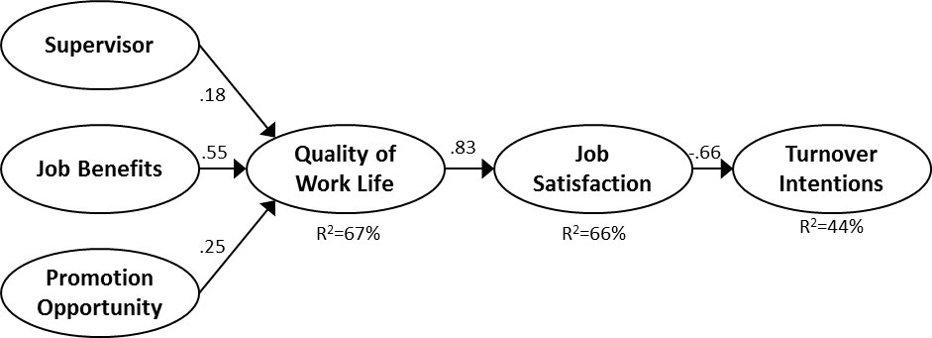

Figure 17: Job satisfaction and turnover intentions

Table 24: Measurement items of job congeniality
Tourism/Hospitality Congeniality | Mean | Std.  Deviation
I think my personality fits a career in the tourism industry | 4.08 | 0.98
At work, I consider myself a hospitable person | 4.34 | 0.81
I can use my skills and abilities in the tourism industry | 4.29 | 0.88
I get pleasure working in the tourism industry | 4.24 | 0.84
I take pride in seeing satisfied customers | 4.50 | 0.81
I like a job that allows me to interact with people from various backgrounds | 4.44 | 0.82

The results indicate that for employees with low congeniality, the supervisor is not a significant predictor of their quality of work life. Also, promotion is more important for workers with low congeniality compared to high congeniality workers. In other words, workers with high congeniality evaluate their quality of work life more based on their relationship with their supervisor, rather than the job benefits and promotional opportunities.

In addition, unlike workers with low congeniality (whose job benefits and promotions explain the majority of their perceived work life quality (R2=71%), for workers with high congeniality, supervisor relationships and job benefits explain a lower amount of variability of their perceived work life quality (R2=64%). Finally, for high congeniality employees, job satisfaction is the major predictor of their turnover intention (R2=60%) compared to low congeniality employees. In other words, high congeniality employees make their decision to quit based on their job satisfaction, while for low congeniality employees’ job satisfaction only explains 25% of their turnover intention.

40 Model Fit: Chi2=1,058; df=477; p<.000; CFI=.93;TLI=.916; RMSEA=.039

Nurturing human capital requires attending to the whole job satisfaction process; however, in the case of Curaçao, the hiring process (the input aspect of the job satisfaction) seems to require the greatest amount of attention. What is clear from the survey is that the hiring process should be directed by determining the self-esteem level of the potential employee as well as ensuring that job title and personality match. Human resource management in the hospitality industry should engage in a pro-active practice which includes the following:

    - Low self-esteem means focus on benefits and promotion
    - High self-esteem means focus on direction and guidance
    - Attention should be paid to supervisors on the work floor
    - It is imperative that supervisor skills should include encouragement, motivation, empowerment, problem- solving, and team building.
Tourism has grown over the last two decades presenting a need for professional skills within the industry. However, students at the high learning institutions are not acquiring those skills. The educational institutions seem lacking in providing the required skills and attitudes to move the industry forward. There is a widespread idea that the only career opportunities available in the tourism industry are to become a waiter, a maid, or a bellman. While there is nothing wrong with these jobs, there are plenty more lucrative opportunities for persons to exploit, such as legal experts in tourism, health and safety experts, and experts in management positions – all of which are available in hotels, restaurants, attractions, and transportation sectors.

The CTB’s conundrum
A destination management organization (DMO) is a catalyst and facilitator for the realization of tourism development with the aim of making the destination competitive and sustainable. The CTB organization, structure and organizational culture are assessed through the competitiveness and sustainability lens as required by the competitive global environment. Consequently, a DMO engages in two main activities, i.e., marketing (external) and coordination (internal) activities. The latter references the activities necessary to connect all stakeholders in the supply of the tourism experience.41 The assessment is based on extensive conversations with the leadership and staff of the CTB, as well as in the reading of relevant policy documents. The DPITS has observed the CTB staff members’ commitment, dedication, and passion to see the tourism industry succeed. These observations were made through lengthy conversations and working with staff members.
As an organization, the CTB is faced with three tactical challenges.

- Lack of Curaçao’s brand position
- Multiple tasks that extend beyond the core activities of a DMO
- Lack of sufficient financial resources to carry out a DMO’s primary tasks
The first challenge is that the CTB has not been able to portray a clear product identity for the destination in the international market. For quite some time the destination does not seem to enjoy a clear brand position, therefore affecting the optimal return of the tourism industry.42 For example, the 2014 CTB business plan reveals some interesting notions regarding the acquisition of a new market segment that may enhance the destination’s demand. This new segment is referenced as the ‘cultural explorer’.43 While the notion to procure this market segment is interesting, not all of the unit actions are directly related to the objectives of the CTB. In other words, not all of the

41 For a discussion on the challenges facing small destinations in this regard, see Croes, R. (2011). The Small Island Paradox. Tourism Specialization as a Potential Solution, Lambert Academic Publishing: Saarbrucken, German; and Candela, G., Figini, P. and Scorcu, A. E. (2008). The Economics of Local Tourist Systems, in R. Brau, A. Lanza, and S. Usai (eds.), Tourism and Sustainable Economic Development: Macroeconomic Models and Empirical Methods, Cheltenham: Edward Elgar.
42 The lack of product identity was referenced in many conversations with stakeholders including the meeting with Parliament in December, 2014.
43 The analysis of the ‘cultural explorer’ is based on the definition drawn from the framework suggested by McKercher and du Cros (2003), Testing a Cultural Tourism Typology. The use of the term cultural explorer has a recognized definition. Therefore, when we reviewed the CTB’s efforts to acquire this market segment there seemed to be some disconnect based on the formal definition. However, we now know that the CTB is functioning from their own definition of this term which combines several different forms of market segments. Nevertheless, the concern in deviating from the formal definition is that it allows for a subjective interpretation of “who” the actual cultural explorers may be.

marketing strategies and actions are aligned with the overall aim to procure and nurture the cultural explorer segment.

In review of the CTB’s action plans to acquire this new market segment, most of the strategies and tactics that are outlined in the plan are normative and do not provide operational based strategies that would implement marketing initiatives to attract this target segment. In addition, there are no clear targets in order to promote any type of accountability to any specific unit directly related to the CTB. Moreover, outside of the CTB, not all of the tourism industry stakeholders are aware of the CTB’s efforts to attract the cultural explorer market segment. Most hotel properties possess their own yield management tactics to attract other market segments that exclude the CTB’s initiatives. The overall evaluation regarding the CTB’s initiative to attract the cultural explorer is that the idea may be worthwhile; however, there are no direct means to attract or acquire this market. In other words, the CTB’s strategies to attract this segment are deficient.

The second tactical challenge is that while the CTB is involved with what its core business should be, marketing the destination, it is also involved in product development, human capital enhancement, cleaning the beaches, safety and security, managing the Hotel Academy, protecting Willemstad on the UNESCO heritage list, etc. Most of these activities are undertaken by the CTB because other agencies or organizations are either not performing according to their administrative responsibilities, or they are functioning poorly. Under these circumstances, the CTB was compelled to take over the task from others in order to keep the destination, attractive, safe, and clean.
A clear example of this situation is the CTB’s involvement in cleaning up and providing security to several beaches on the island. In another case, the CTB took the initiative of setting up a project that would identify job openings/positions available in the tourism industry. The project was then handed over to the Department of Labor to manage. However, the project never came to fruition. Thus, substantial resources were wasted on a project that was well intended to align supply and demand. Further, to date, an accurate account for employment openings in the hospitality industry does not exist.

The CTB’s continued involvement in so many activities affects its overall performance and success. For example, the CTB is in charge of collecting room tax. The result of that activity is that the CTB is only able to collect about 60% of the total amount of the annual room tax due. According to anecdotal evidence, there is approximately US$50 million that is not collected by the CTB. The consequence of this is that the CTB does not have the appropriate funding to support its core business, which is that of marketing the destination. It is clear that while the CTB has good intentions, the agency does not possess the capabilities, the institutional prowess, or the resources to accomplish all these complex tasks. This results in occasions where assignments are not completed, thus wasting valuable resources.44

The lack of optimal outcomes in providing for all these tasks has resulted in frustration, exhaustion, burn- out, and apathy within the organization, as well as waste of valuable resources. The absence of a clear focus regarding the CTB core business has led to confusion with regard to the vision, mission and expectations of what the activities initiated, managed, and implemented by the CTB should be. At the present time, the CTB lacks an organizational vision and mission that could direct its actions and measure the level of the CTB’s success.
The CTB’s lack of vision and mission have been compounded by the absence of a CEO to direct the assignment and tasks of the organization. The Interim CEO is stretched thin with multiple tasks (managing the organization, leading Latin American promotions, coordinating with local and international stakeholders, remaining abreast of the CTB Board requirements and policies, and directing the tourism master plan process – each of which is a challenging

44 Another example is the creation of the vacancy data bank in the hospitality industry. The Human Resources Infrastructure System project (HRIS) was created to realize three main objectives: (1) to reduce gaps in supply and demand of human resources that are willing to work in tourism in Curaçao, (2) to provide information on human resources availability and (3) to gather historical information about labor markets for the future projections. Eventually, the project was abandoned by the Department of Labor resulting in the non-existence of a databank. At present, no one on the island knows the exact amount of vacancies and the skills required to fill these vacancies in the hospitality industry.
A similar fate was bestowed on the Curaçao Hospitality Training, a project initiated in 2008 and terminated in 2014 without accomplishing its objectives. For a more detailed analysis of the project, see NASCI (2014). Project Horecatraining Werkzoekenden. CTB.

responsibility in itself. Additionally, the blurred responsibilities between the CTB Board and the Interim CEO create confusion in the direction and management of the institution.

In its current position (as expressed in the 2014 business plan) the CTB appears to be an organization that is a, ‘Jack of all trades’. An organization that acts as a Jack of all trades in an industry that requires speed and accuracy to optimize the sales of perishable products cannot be the driving force for that industry. Either by convention or by circumstances, the amount of tasks and assignments that the CTB is currently engaged in is preventing the organization from having a clear focus on its core business.

The third tactical challenge for the CTB is its struggle with a deficient budget to carry out its tasks. A quick analysis of the budget spanning 2002 to 2014 reveals that the allocation of budget resources has been intermittent and unstable. This has resulted in marketing cuts that have an adverse effect on driving demand. An assessment of the relationship between marketing budget allocations and arrivals suggests a very weak relationship as depicted in Figure 18.45 Current figures indicate that CTB marketing productivity is relatively low. According to the 2015 budget, the marketing costs for acquiring one tourist is approximately US$38.00. However, the return on investment for the US$38.00 equates to an average US$925.50 per person. This brings a ratio acquisition-spending of one (1) to twenty- four (24) (1:24). In addition, marketing hard dollars spent is only equivalent to 38% of the total CTB budget.46

All of this information regarding the effective use of the marketing budget implies two things. First, the marketing dollars spent to acquire tourists is ineffective and second, the markets that are arriving to Curacao are not spending enough money on the island.
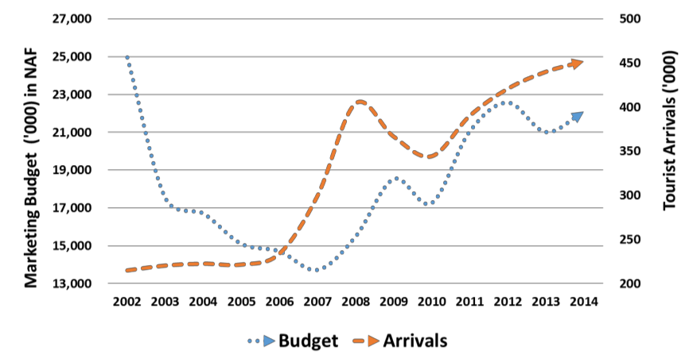

Figure 18: Relationship between marketing budget and arrivals, 2002-2014 in NAF

Yet, even if it was awarded the appropriate funds to support its core business, the CTB lacks the direction, focus, and expertise to develop a marketing position that would create sufficient awareness and brand equity to move the destination forward. The CTB is at risk of generating a negative cycle where demand is deficient and the economic performance of tourism businesses (e.g. hotels) is negatively affected because of lack of revenue. Without revenue, maintenance becomes inadequate, continued investment is reduced, and the likelihood of acquiring the right type of customers who are willing to pay a profitable price diminishes. This negative cycle will disable the destination’s efforts to increase its competitive position in the region.

The organizational culture of the CTB is enshrined in a government framework and mindset. This framework and mindset prevents the alignment of the tourism stakeholders’ needs with the overall objectives of the destination. In order to circumvent this challenge, it is necessary for the CTB to develop and maintain a culture that embraces a

45 The result was derived from a two stage least squares using real tourism expenditures as the instrument variable. Estimations were done both as I(0) as well as I(1) but the results were not significant. A cautionary note is warranted due to the limited data available.
46 For example, 60% of the Aruba Tourism Authority budget is allocated to marketing hard dollars. The acquisition cost per arrival is less than US$30 and the ratio cost per spending is 1:51.

marketing mindset. This means that the CTB should produce business intelligence (in a timely manner), and steer or steward decisions based on data driven considerations.

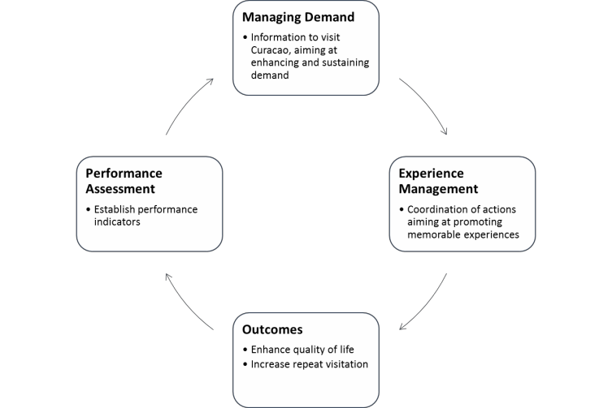

Figure 19: Marketing mindset for a market oriented organization

While the CTB is data rich, the CTB is information poor. This situation is the result of a very small research unit that while doing its utmost in providing data, does not have the necessary staff to comply thoroughly with its core assignment. Moreover, the research staff is required to undertake tasks beyond the scope of its core assignment. This stunts the ability of the research unit to gather and assess data that would provide information regarding status performance and emerging trends.

In the DPITS’ view, the CTB core business is twofold: marketing of the destination, and optimizing coordination amongst stakeholders – both of which would create memorable experiences for tourists. Figure 19 represents a mindset for a market orientated organization. In addition, the organization should build and nurture a business culture where the staff understands and shares the values of the organization. These values should be anchored in business driven parameters for choice making. These parameters should reveal clear business benchmarks in attracting and sustaining market segments in a cost effective way as well as supporting the overall objectives of the destination.

Chapter 5: Challenges looming on the horizon

Tourism as best promise for the future
Curaçao faces enormous challenges. These challenges run the gamut of a weak economy (very low growth), debt repayment in 2019, the continuation of the oil refinery (2019), the uncertain future of the financial sector due to the end of grandfathering provisions of the offshore financing legislation (2019), high unemployment (15%), reported poverty incidence of above 15%, and an explosive youth unemployment in the range of 35%.47
Compounding these socioeconomic problems that are spawned by unemployment and poverty, is the phenomenon of the brain drain (the loss of well-educated, human capital) resulting from the lack of job opportunities, as well as the growing level of uncertainty about the economic future of the island.48 If these challenges are not faced aggressively, all the strides toward progress that the tourism sector has made in the last few years will be jeopardized.
Tourism is one of the few economic sectors that has revealed steady and strong growth in the last decade (see Figure 20). The tourism industry has provided the island with thousands of jobs. Indeed, tourism generates 16,503 jobs and already represents 18% of the local economy. Clearly, tourism represents a unique opportunity for the island to confront the future with economic and social opportunities. Social opportunities pertain to the resources available to residents. These resources stem either from jobs or economic growth.

Figure 20: Growth of Curaçao’s economic sectors 2009-2013

Currently, tourism serves as Curaçao’s largest source of foreign exchange (26%), and has strong backward economic linkages to other sectors, thereby providing multiple business and job opportunities. Thus, the tourism sector and its informal components provide a vast number of jobs that range from upper level executive positions to positions that require little or no formal training. For example, there are a broad range of career opportunities in hotels and resorts, restaurants and commercial food service, meeting and event planning, tourism destinations and attractions, leisure, recreation, sports management, airlines, cruises, and other transportation, cultural tourism development, spa and wellness management, and the entertainment industry. Further, for those individuals facing social and skill

47 See TAC report.
48 See TAC report.

disadvantages, the tourism industry will provide a range of employment opportunities in a manner that is not always offered by other industries.
At this time, the tourism sector has emerged as the only sector that represents steady and sustained economic growth that could move Curaçao forward. Therefore, in order to optimize the output from the tourism industry, it is critical to thoroughly assess the strength of the sector. In so doing, the DPITS has revealed through rigorous statistical assessment that Curaçao’s tourism growth is:
- Not well-aligned with the economy as a whole, thus revealing weak relationships
- The soft component of tourism (e.g. service delivery component) is deficient in several ways.
- The tourism industry reveals a lack of direction and competitiveness.

Tourism and the economic link
According to the DPITS investigation, tourism development and economic growth is weakly related to Curaçao’s greater economy. This means that the growth of tourism weakly corresponds to economic growth on the island. The weak relationship is demonstrated in Figure 21 where real tourism expenditures and real economic growth seem to be drifting apart (especially since 2006). The three year moving correlations between tourism expenditures and economic growth also show a decreasing trend over time as is revealed in Figure 22.

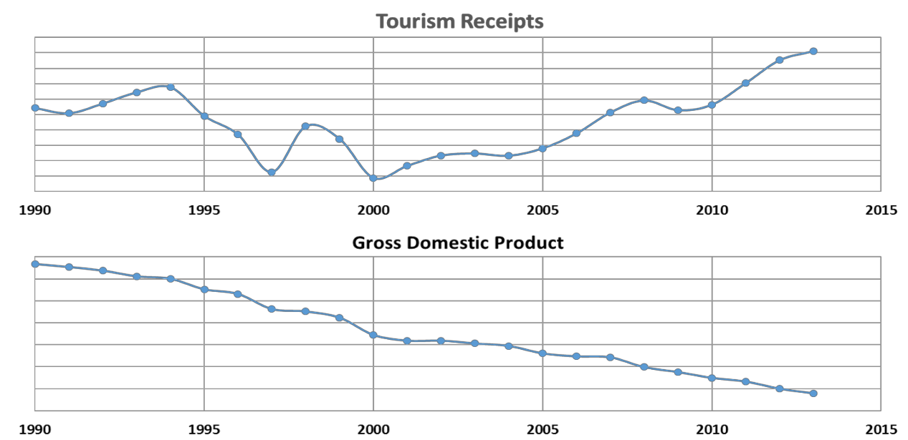

Figure 21: Curaçao’s tourism receipts vs. economic growth

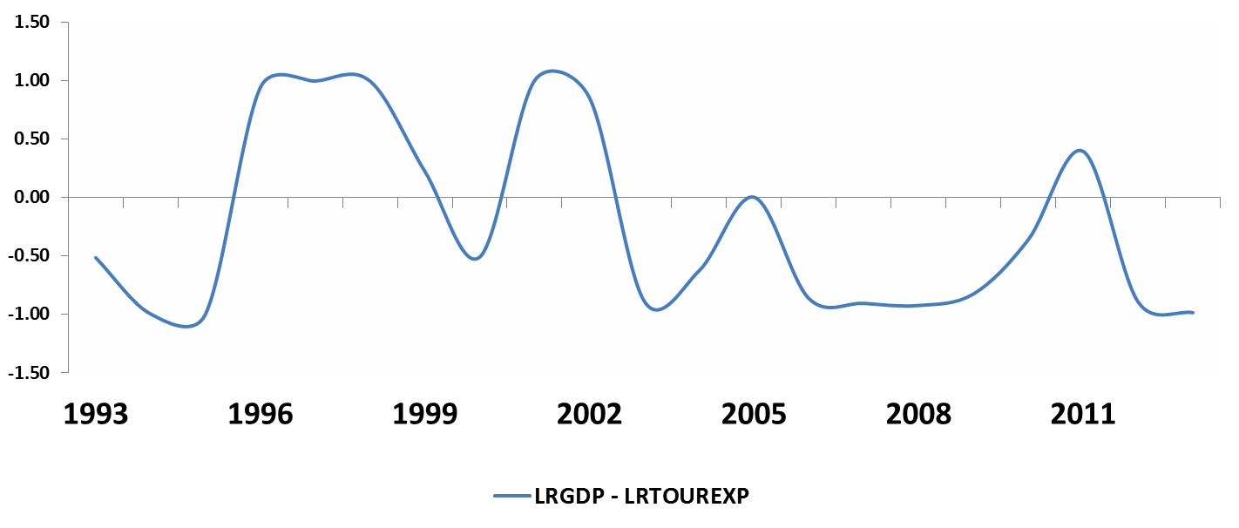

Figure 22: Moving correlations between real tourism expenditures and real economic growth

A more rigorous investigation of the relationship between GDP and tourism expenditures reveals that there is a weak cointegration relationship at the 10% significance level running from real GDP and expenditures to arrivals. Granger causality tests reveal no short-term causality, while the long-term causality is strong and indicates a bi-directional relationship between the economy and tourism expenditures.49 50 This means that tourism seems to lack the strength to affect the island’s overall economy in the short-term. However, it is clear that tourism has the potential for sustained economic growth in the future. In addition, the bi-directional relationship between tourism development and economic growth implies that tourism development and economic growth entertain a virtuous relationship. In other words, the one leads into the other. More tourism receipts mean more economic growth and more economic growth means more resources available to support tourism development.
The spending per day per person equals US$96 (based on the average length of stay of 9.65 days) in 2014, which is substantially lower than what the destination could acquire if compared to the spending per day of CNSJF attendees at US$255. In addition, an analysis of the evolution of tourism receipts reveal clear presence of high persistence of shocks.51 In other words, if positive shock accumulates, it can result in a high level of tourist activity, while the accumulation of negative shocks could give rise to prolonged decadence of the destination. This situation predicts high volatility in the industry’s performance as attested by high coefficients of variation in arrivals and receipts over time.
This volatile circumstance requires an active destination management intervention in order to confront negative cycles and seize opportunities during positive cycles. All the shocks that affect this tourist area will have both temporary and permanent effects. These shocks include policy measures adopted by policy makers (public investments in tourist infrastructure, subsidies to develop new tourist products, etc.). Consequently, if the destination begins showing signs of stagnation, local destination managers must act quickly and strongly if they want to maintain the growth of the tourism industry. “Wait and see” policies could be costly to the industry. A pro-active CTB is required to have sufficient knowledge that would allow its staff to dedicate attention to address cyclical movements in source countries. This pro-active behavior should be anchored in timely business intelligence to support decisions and choices.

49 Long run causality error correction term for LRGDP= 3.23 (p<.0001); Long run causality error correction term for LRTOUREXP=3.81(p<.0001)
50 Granger results for LRGDP=5.95(p<.0001); Granger results for LRTOUREXP=7.44(p<.0001)
51 The study conducted a number of unit root tests to determine whether shocks are transitory or persist over time. The results of these tests indicate high persistence of shocks.

The soft component of tourism is under pressure
There is clear indication that Curaçao’s soft components in the tourism sector are under pressure. Soft components of a tourism product are defined as the intangible aspects of a tourism delivery process (the non-tactile aspects of the product). For example, the service levels, product identity, institutional support, public/private partnership, etc. The DPITS’ field work has revealed that there is confusion regarding Curaçao’s product identity. Heritage, colonial past, slavery, diversity, sun, sand, and sea are all touched upon as components of the overall product identity; yet, there is no firm identity or position established for the destination. Thus, Curaçao’s ability to establish a firm brand has been compromised. It is the strong brand recognition for the Caribbean region that has carried Curaçao thus far in its positioning strategies.
A central question lingers amongst stakeholders as to, “What is Curaçao, and why should a tourist visit Curaçao?” This question is commonly expressed by stakeholders and resonates an overall sentiment that the island has a lack of a clear product identity. In numerous discussions with tourism stakeholders, there has been reference to the old glory of the downtown area as a UNESCO heritage site. These discussions have been a prominent source of contention amongst stakeholders regarding how to revive the area. Some stakeholders expressed an interest in positioning Curaçao as a heritage destination, while others have identified weather as being the most important characteristic of all Caribbean destinations. Stakeholders were not able to provide clear answers regarding how to combine the heritage components of Curaçao’s past, its geographical positioning as part of the Caribbean, and reference to a SSS (i.e., sun, sand, and sea) destination into a clear product identity/position.
Unfortunately, when probed for further information regarding the challenges/issues that confronted Curacao with regard to advancing the soft components of the tourism product, most interviewees shared a negative perspective. They indicated that the major problem for Curacao lies in deficient expertise to move the industry forward. Hence, this lack seems to support the need to employ skillful expatriates that might facilitate the necessary soft component skills in locals in order to launch Curacao’s tourism industry.
The DPITS research also revealed that within this lack of “know-how,” education, language, and attitude may be major barriers in terms of improving the soft components of the tourism product. The main thrust of the educational concern is that the system is failing at producing high-quality level employee applicants. Compounded with educational challenges is the aforementioned “brain drain” problem. The brain drain was referenced by many stakeholders, and was explained as the exportation of talent where the most educated and skilled applicants are educated abroad and do not return to work in Curaçao.
The qualitative interviews also revealed that the language proficiency that Curaçao people once possessed seems to be deteriorating. In the past, the local population was mostly fluent in speaking Dutch, Spanish, Papiamento, and English. However, this skill set is not as well-developed as it was in the past. Consequently, according to the qualitative interviews, the service delivery process in the tourism industry is compromised due to language barriers between the locals/employees and tourists.
Finally, most of the interviewed participants made reference to a common cultural thread that pertains to the overall attitude to become engaged within the tourism industry. There was an inherent undertone in the qualitative data that reflected a lack of interest in contributing to the current tourism industry because the jobs and the benefits affiliated with working in the industry are low and lack social status.
However, the quality of life survey that was previously mentioned provides quantitative data that explains this “lack of interest.” As previously discussed, approximately 1/3 of the population is unaware of the potential jobs that the tourism industry could offer, and of tourism’s ability to increase the standard of living for Curaçao’s residents. Therefore, it is necessary for Curaçao to educate the public on the potential socioeconomic benefits that the tourism industry could contribute to the island.

The quantitative analysis conducted among hospitality employees reveals average supervisory direction to employees, as indicated in Table 25. The average supervision may negatively affect job satisfaction, thereby potentially affecting service delivery and customer satisfaction. Supervision is a strong driver of job satisfaction (R- square = .485, F = 79.31, P-Value = .00).

Table 25: Supervision in hospitality and tourism
Statement | Mean
Supervisors provide employees with assistance to solve job problems | 3.41
Supervisors provide employees instruction on how to improve their job | 3.39
Supervisors acknowledge employees if they perform their job well | 3.37
Supervisors recognize challenges that might affect employees’ ability to perform | 3.31
In the tourism industry, it is difficult to meet managers' level of expectations | 3.06

Direction needed
Interview respondents emphasized a frustration regarding Curaçao’s historical efforts to change the focus of the tourism industry. Many of the participants voiced a nonchalant view regarding new opportunities that could emerge through the tourism industry. This apathetic view has been due to continued broken promises that were made in the past. A consensus opinion was expressed that “someone” needs to lead the process of change in the tourism industry.
The majority of people expressed that, at this time, they do not know who that leader should be (e.g., public vs. private). The majority also expressed that they do not care who that leader is affiliated with - as long as the leader represents the voice of the majority, and does not harbor self-interests or a personal agenda for themselves or specific shareholders in the industry. It is clear from the qualitative data collection phase that, without the identification of a leader or a leadership group that can facilitate trust and guarantee change amongst stakeholders, the industry and all its players will remain fragmented and stagnant in their efforts to stimulate and increase economic growth.

Curaçao’s competitive position
In order to assess/benchmark Curaçao’s tourism potential within the Caribbean competitive set, a tourism competitive index for small island destinations (Croes, 2011) was used to assess the competitive position of Curaçao. The tourism competitive index consists of three factors: 1) the size of the industrial base, 2) performance over time, and 3) productivity growth. The first factor (size of industrial base) is measured by the proportion of real tourism receipts to the total population. The second factor (performance over time) is measured by real tourism receipts over time. The third factor (productivity growth) is measured by the value added of tourism receipts over time (tourism value added ratio of GDP).
Taking these three factors into consideration, Curaçao ranks second to last (number 16 out of 17) of island destinations in the Caribbean. On all three measures, Curaçao has poor performance, but performs the worst in value added. This means that the tourism industry’s contribution to the island’s economy is minimal and quite weak. See Figure 23 for reference to this competitive index.52
This information is confirmed when looking at common industry performance benchmark indicators (e.g., occupancy rates, RevPAR, and ADR). A recent report from Smith Travel Research (STR) indicates that the Caribbean competitive set is performing at the following levels:

52 The index is drawn from Croes, R. (2011). The Small Island Paradox. Tourism Specialization as a Potential Solution, Lambert Academic Publishing: Saarbrucken, Germany.

- ADR for the region is up 7.9% through September 2014 and RevPAR is in the midst of a fifth consecutive year of growth (3.1% in 2010, 10.5% in 2011, 8.1% in 2012, 3.5% in 2013, and 9.6% YTD 2014)
- The growth in RevPAR has been driven by ADR, rather than ancillaries
- Key markets showing impressive RevPAR growth in 2014 include:

  - Jamaica +24.5% to $156
o Aruba +14.7% to $181
  - Dominican Republic +12.7% to $92
  - Bahamas +11.6% o $181
  - Puerto Rico +5.7% to $150
  - Cayman Islands +4.4% to $250

Curaçao is nearly 35% below the average RevPAR for the Caribbean region. This indicates the island’s relatively low competitive position in the Caribbean competitive set. When compared to Curaçao’s relative performance, it is evident that the competitive position of Curaçao is simply not competitive. The Caribbean competitive set demonstrates a constant increase in ADR for the region, yet Curaçao demonstrates characteristics of lost market share. When analyzing the data, it appears that Curaçao competes with the Dominican Republic in terms of RevPAR values. However, the Dominican Republic competes on sheer volume numbers in room supply. At the current time, it is not possible for Curaçao (as a small island) to compete on room supply.

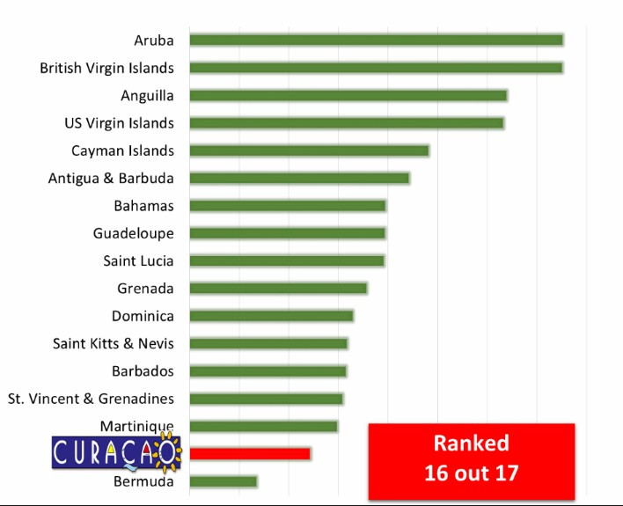

Figure 23: Curaçao’s competitive position

Therefore, it is clear that the most viable means of competing in the Caribbean competitive set for Curaçao is through aligning the current supply with a demand structure that optimizes tourists’ receipts and increases the industry’s economic multiplier. In order to optimize demand, it is necessary for Curaçao to restructure the current markets and improve the soft components of the core tourism product that increase spending.

This is the major message of the 2015-2020 Strategic Tourism Master Plan. Conceptually speaking, the DPITS research team has identified three key areas that seem to provide the parameters of a demand orientated framework that will enhance Curaçao’s position. The parameters are defined in Figure 24 and will be discussed in detail in the next chapters.

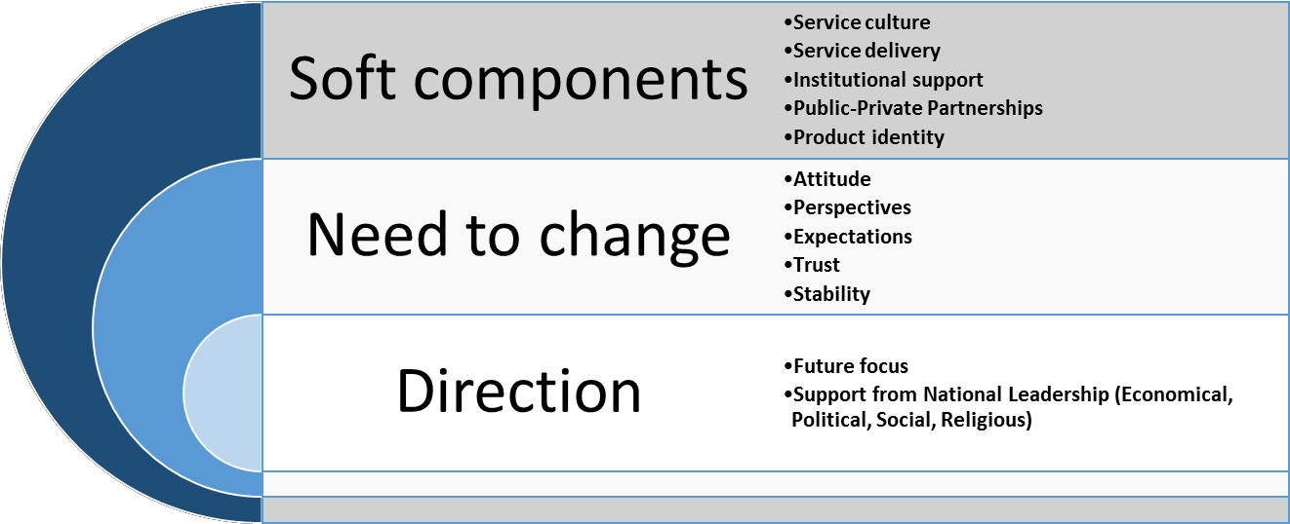

A need for change

Figure 24: Parameters for Curaçao’s position

A consensus opinion was reached in all interviews and focus groups where participants expressed that there is an absolute need for change in order for the tourism industry to continue to grow. The need for change was specifically expressed as required improvements to education, service culture, collaboration, and coordination amongst all stakeholders. There is observable tension between various stakeholder groups that requires modifications that would facilitate stakeholder cooperation. For example, there is tension between the hotel groups and rental properties, tension between Dutch owned hotel properties and American owned hotel properties, tension between locally owned tourism businesses and foreign owned businesses, etc.
Additionally, there is exclusion from the decision-making process of planning and policy development for several important industry sectors (e.g. transportation services unrelated to airlift and cruise). There is also a growing rift amongst social groups that heavily criticize themselves regarding the need for a “mental paradigm shift” that would increase trust and self-confidence. While the tourism product requires healthy internal competition to elevate the standard and quality of various tourism-related product offerings, it also requires trust and collaboration among stakeholders in order for the macro destination to be sustainable.
A major strength of the 2015-2020 Strategic Tourism Master Plan is that all stakeholders agree that there is a need for change, and they are all willing to work for that change. Thus, firm guidance and steps must be provided in order to keep all stakeholders on the same page and looking forward.

Chapter 6: Profiling Curaçao’s Tourists, Satisfaction, and Intention to Return

Demographic tourist profile
The average tourist visiting Curaçao is 43 years old, 37% of whom enjoy an income of over US$50,000. The tourist is relatively well educated with 79% having a college degree (including professional formation, bachelor, and graduate degrees). Approximately, 40% are married with kids, and have visited Curaçao multiple times. Sixty percent are repeat visitors and 39.7% visited Curaçao for the first time.

There are some significant differences among age groups and income brackets. Hence, 22.2% of the age group between 18 and 38 years old have an income of less than US$25,000; 21.5% of the group between 39 and 54 years old have an income of over US$100,000; while the age group older than 55 years has the highest income level with 22.1% being over US$100,000. In terms of spending, there is no significant difference between Generation X (39 to 54 years old) which spent US$1,135.86 per person while in Curaçao when compared to Baby Boomers (older than 55 years old) with US$1,208.14 per person. However, a significant difference lies when compared to the younger Generation Y (18 to 38 years old) which only spent US$887.63 per person during the timespan of their visit.

The destination has a large contingency of representatives of Gen Y consuming the Curaçao product. For example, more than one-third of Dutch visitors arriving to Curacao belong to Generation Y. This large presence of the younger generation that is spending less while in Curacao is affecting the total tourist spending on the island.

In terms of purpose of visit (Table 26), 86.4% said they came to Curaçao on a vacation or pleasure trip, 3.4% said they came specifically for shopping, 6.9% for cultural tourism, 3.9% for wedding and anniversaries, 1.4% for a special event, 9% visiting friends and families, and 6.1% for business. The overwhelming majority, 61.8%, came specifically for the warm weather and beaches. Although sun and beach tourism is the dominant purpose of the trip for both those who had at least one previous experience on the island and those who traveled to Curaçao for the first time, only 57% of repeat visitors said that they came for this purpose, while 68.8% of first-timers came for sun and beach tourism.

Table 26: Purpose of visit

%
Business | 4.70%
Conference | .60%
Shopping | 3.40%
Cultural tourism | 6.90%
Sun and beach tourism | 61.80%
Wedding/honeymoon | 3.90%
Events | 1.40%
Incentive travel | .80%
Visiting friends and family | 9.0%
Other | 7.5%

Eight of 10 visitors went to downtown Punda/Otrabanda. The other most popular activities were beaches (77.7% of all visitors) followed closely by bars and cafés (73.8%), and snorkeling (44.5%).

Information search and booking behavior
Tourism consists of intangible products, making measurement of product quality difficult. In order to mitigate this difficulty, tourists engage in information searches to cope with uncertainty when purchasing services from a destination, such as booking a hotel in advance of the destination visit. Timing and sources of information about the

quality and image of a destination plays an important role in determining destination choice. Nearly one out of three tourists (31.3%) who visited Curaçao began their information search about Curaçao between one to three months prior to their actual visit. One out of four (23.8%) initiated their search for information about Curaçao more than six months prior to their visit to the island.

The two most preferred sources of information are friends and family and online sources, including company websites, online rating websites, and online travel agents. Three out of four tourists (75.6%) used online sources (including company websites) as their main source of information followed by 51.6% friends and family, and 21.2% travel agencies. Nearly 17% consulted social media, including Facebook, YouTube, Instagram, and Twitter, regarding information about Curaçao. Approximately, one out of ten tourists (11.2%) visiting Curaçao used the Curaçao Tourist Board as their source of information.53 See Table 27 for an overview of the sources of information used by tourists who visited Curaçao.

Table 27: Sources of information
Communication Channel | % of Cases
Friends/ Family | 51.6
Company website (hotels, airlines) | 26.9
Online rating website (e.g. TripAdvisor) | 23.9
Travel Agent | 21.2
Travel Guides | 16.0
Curaçao Tourist Board | 11.2
Newspaper/ Magazines | 9.3
Online Travel Agent (e.g. Travelocity) | 8.1
Others | 7.9
Facebook | 7.4
Television | 6.5
Tour Operator Brochure | 6.5
Youtube | 5.9
Instagram | 2.8
Twitter | 0.6

It seems that tourists bought their flight to Curaçao via three main channels, i.e., travel agent, airline website, or via Internet through electronic distribution channels, such as Travelocity. Travel agents remain the main provider for purchasing a flight to Curaçao. It is incumbent upon the CTB to know who these travel agents are, and to forge strong partnerships with these travel agents. Tourists have a different purchasing behavior when it comes to buying a hotel room in Curaçao. Travel agents remain slightly as the largest provider for room bookings followed by electronic distribution channels and hotel websites. Tourists’ purchasing behavior seems to suggest that tourists visiting Curaçao have a perceived risk in dealing with local providers/suppliers and, therefore, are less likely to book with local small companies.

The payment method used by tourists is almost evenly distributed between credit cards and cash (49.2% and 41.4%). The large proportion of cash in buying these services, especially lodging, requires closer scrutiny because of the potential effects on economic growth. Often, cash is hoarded and is not put in the economy immediately, thereby potentially affecting the level of economic growth. Table 28 provides an overview of booking and payment methods.

Unlike the case of the tourists’ planning behaviors, age seems to play a significant role in terms of buying behavior. For example, Generation Y seems more likely to wait for last moment booking. One out of four tourists (26.4%) made their reservation less than one month prior to their trip, compared to the Boomers generation. Only 17.6% of

53 The CTB website seems to increase in popularity over time. Compared to 2015, only 4% of tourists consulted the website in 2008. See Croes, R., Rivera, M. and Semrad, K. (2010). Curaçao Tourism Economic Impact 2007-2008, prepared for the Curaçao Tourist Board, DPITS, Orlando, September 15.

the latter booked less than one month prior to their visit to the island. Almost 70% of repeat tourists planned their visits more than 6 months in advance to their arrival on the island, compared to 18% of first-timers.

Table 28: Reservation and payment methods
Lodging Distribution Channel | %
Travel agent | 29.95%
Internet (e.g. Travelocity.com) | 28.97%
Hotel website | 18.02%
Hotel telephone reservation | 14.27%
Apartment rental company | 7.38%
Airbnb.com | 1.41%
Flight Distribution Channel | %
Travel agent | 46.31%
Airline website | 27.63%
Internet (e.g. Travelocity.com) | 16.58%
Airline telephone reservations | 5.24%
Other | 4.25%
Payment Method | %
Credit Card | 49.20%
Cash | 41.40%
Debit Card | 6.90%
Other | 2.50%

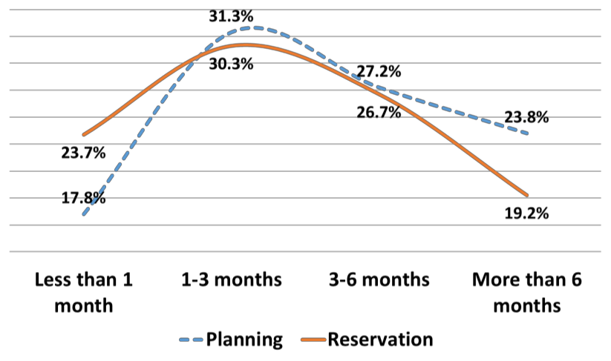

Figure 25: Booking behavior of Curaçao tourists

Overall, the search and booking behaviors pose two challenges, especially for the local hotels. Searching for information about the destination began at a relatively early stage of their vacation planning (more than 6 months), but the booking in general only occurred within months 1-3, indicating that booking is slower than the search. Typically, it is preferred to have bookings closer to the search time; because the longer the booking advance time is, the greater the uncertainty for hotel managers in terms of realizing their price points without running the danger of engaging in discounting behavior.

The other challenge is that nearly one out of four tourists (23.7%) buy less than one month prior to their visit to Curaçao. The data suggest that this group is predominantly from Venezuela. With low occupancy rate levels on the island, this last minute buy could trigger unnecessary price squabbles among the local hotels, thereby negatively impacting their RevPAR. Figure 25 below exhibits the booking behavior of the Curaçao tourists.

Activities enjoyed while at the destination
The average tourists' length of stay exceeded 9 nights. A little more than half of tourists stayed in hotels, while about the same amount of tourist visiting the island ate in a restaurant during their seven-day stay in Curaçao. The travel size of the groups arriving to Curaçao is approximately 2.5 persons.
The mobility of the tourist around the island is limited with the most popular attractions, by far, consisting of the downtown area and the beaches. Not engaging in other types of activities could be an indication of either a low level of tourist awareness of the existence of attractions on the island, the lack of appeal of those attractions, or deficiencies in the packaging of the attractions. Regardless of the reason, the result appears to be a low level of tourist interest/appreciation for Curaçao's heritage assets.

Tourists’ life in Curaçao is tied to beaches, entertainment, cultural and shopping activities. Outdoor activities are a distant fourth after these three main activities.54 Beaches and water activities as well as entertainment, cultural, and shopping activities are almost evenly distributed with beaches ranking at the top of the activities. Nearly eight out of ten (77.7%) visited the beaches as well as the downtown area (77.2%). Nearly three out of four (73.8%) visited bars and cafés, indicating a strong tendency towards entertainment activities.
Entertainment has become an important draw in the vacation decision-making process, particularly in the realm of music festivals and events as attested by the growing popularity and prominence of the Curaçao North Sea Jazz Festival.

With regard to cultural activities, tourists seem to enjoy or seem interested in the historic city core of the downtown area. Harnessing cultural resources and combining these resources with livable activities have proven to be a successful recipe to rebuild and reuse the area. The recently held BlueSeas Festival in the Pietermaai area attests to this opportunity to draw tourists and the local population by providing a platform for an eclectic atmosphere that is conducive to cultural interaction. Events, such as music concerts and festivals follow nightclubbing, which is the most appealing activity while on the island.

Tourists also enjoyed water activities while in Curaçao. This is no surprise as Curaçao is considered a SSS product. Besides beaches, tourists were involved in snorkeling (44.5%), Sea Aquarium (37%), Dolphin Academy (22.6%), sailing to Klein Curaçao (14.4%), boating (13.7%), and scuba diving (13.2%).

Tourists mostly visited Hato Caves 39.9%), Christoffel Park (37.5%), the Ostrich Park (27.7%), and the Aloe Farm (19.4%) as part of their land activities. The specific activities that were enjoyed the most by tourists in the order of desired activities are: guided wildlife tours, viewing decks, rock climbing, bird watching biking, exercise trails, art exhibits, and meditation stations. Forty-six percent of those visiting parks were between 25 and 44 years old. One out of three park visitors were from the Netherlands, while only 17% were from the United States.

Tourists seem to roam the island in search of products, offerings, and adventure as revealed in Table 29. The tourist activities reveal the type of product line on the island. However, it seems there is a lack of information promoting and directing tourists thereby potentially stunting tourists’ spending while at the destination. The low level of spending on activities as well as the feeling of boredom the longer tourists stay on the island are clear indications of the lack of product bundling.

54 See, Perceptions, behaviors & economic impact of tourism in Curaçao.

Table 29: Activities in Curaçao
Land Activities | %
Hato Caves | 39.9
Others | 37.7
Christoffel Park | 37.5
Ostrich Farm | 27.7
Aloe Farm | 19.4
Herb Garden | 10.3
ATV Quad Tour | 8.9
Butterfly Farm | 6.9
Parrot Paradise | 4.8
Water Activities | %
Beaches | 77.7
Snorkeling | 44.5
Sea Aquarium | 37.0
Dolphin Academy | 22.6
Sailing to Klein Curaçao | 14.4
Boating | 13.7
Scuba Diving | 13.2
Others | 7.6
Kayaking | 4.6
Water Ski /Jet Ski | 3.2
Deep Sea Fishing | 2.5
Kite Surfing | 1.1
Entertainment Activities | %
Bars and Cafe's | 73.8
Nightclub/Dancing | 25.6
Music/Concert/Festival | 23.7
Others | 11.8
Folkloric/Cultural Show | 9.9
Carnival | 7.2
Cultural Activities | %
Downtown Area | 77.2
Kura Hulanda Museum | 22.3
Fort Nassau | 21.7
Fort Amsterdam | 19.5
Maritime Museum | 16.9
Curaçao Museum | 16.4
Landhuis Kenepa | 16.0
Landhuis Brievengat | 11.1
Others | 10.1
Jewish Cultural Museum | 9.3
Landhuis Bloemhof | 6.0
Postal Museum | 5.1
Fort Church Museum | 4.8
Tele Museum | 4.4
Landhuis Rooi Catootje | 3.6

Tourists visiting Curaçao displayed different food consumption patterns. The DPITS investigated the time and place of food consumption of the tourists. Figure 26 reveals three interesting consumption patterns: those preparing their own meals, those eating in their hotels, and those eating in restaurants. With regards to the consumption of breakfast, the majority of people (65%) eat breakfast in hotels, 18% eat breakfast in restaurants, and 17% prepare their own breakfast. With regards to lunch consumption, it is observed that tourists venture outside of their hotels where the majority (65%) consume lunch in restaurants and 34% eat lunch in hotels. As for dinner consumption, almost three out four tourists eat dinner at restaurants whereas only 1 out of 4 tourists eat in dinner in the hotel. The data reveals that as the day progresses, tourists seem to become more adventurous and explore the various gastronomic offerings on the island.
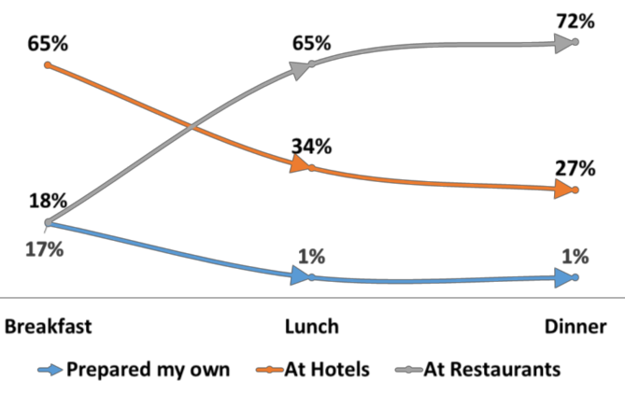

Figure 26: Food consumption patterns
The three main source markets are as follows: The Netherlands (35%), Venezuela (27%), and USA (13%). Together, these three markets account for 65% of total arrivals to Curaçao. Tourists from the Netherlands stay longer (13.89 nights) than tourists from the other two countries (6.78 and 7.08 nights).

Canada, Colombia and Brazil should be kept in consideration as they appear to be emerging complementary markets (see Table 30). Colombia is a market to promote, especially after the abolition of the visa requirement on July 1, 2015. The elimination of the visa requirement will certainly boost demand from Colombia to Curaçao.55 Preliminary market numbers already indicate that demand from Colombia to the destination has increased.

Table 30: Arrivals by country

Country | Frequency
The Netherlands | 35%
Venezuela | 27%
United States | 13%
Canada | 7%
Colombia | 5%
Brazil | 4%
Other | 9%

From satisfaction to intention to return
Nearly three out of four tourists indicated that their “Overall satisfaction of the island” was high with their experience in Curaçao, and nearly one out of four reported being satisfied with their level of experience. This equates to a total of nine out of ten persons (97.7%) indicating that they were satisfied with their visit to Curaçao. The main

55 The elasticity of demand due to the visa requirement for Colombian citizens was significant in the case of, for example Aruba, The estimated impact in 2003 was negative (-0.224) and significant at the 1% level of confidence (See Vanegas, 2009). The suspicion is that a similar negative effect occurred in the case of Curaçao.

driver of overall satisfaction is the accommodation sector, followed by restaurants, and entertainment activities as revealed in Table 31. The satisfaction level of the accommodation sector is very high where 97.1% of respondents being satisfied with their experience of the product.

Table 31: Overall satisfaction
Independent Variable | Mean | (SD) | Std. β
Accommodation Satisfaction | 4.95 | (1.060) | 0.276**
Restaurant Satisfaction | 4.74 | (1.002) | 0.148**
Taxis Satisfaction | 4.25 | (1.099) | -0.042
Entertainment Satisfaction | 4.52 | (1.058) | 0.213**
Shopping Satisfaction | 4.31 | (1.163) | 0.166**
Rental Car Satisfaction | 4.40 | (1.120) | 0.065**
Airfare Satisfaction | 4.35 | (1.105) | 0.129**
Cronbach's α=0.893; F-value345.412**; R2=0.581

First-timers and repeat tourists had different satisfaction levels pertaining to their experience while in Curaçao. The mean satisfaction for repeat visitors (M=5.07, SD=0.969) is significantly (t (1728) = -3.74, ρ < 0.01) higher than satisfaction of the first-timers (M=4.88, SD=1.004). Moreover, there is no significant relationship between the number of past visits and overall satisfaction levels for repeat tourists. The number of past visits to Curaçao have a positive impact on behavioral intentions (loyalty).

There is no significant difference in terms of overall satisfaction scores for repeat visitors (M=4.94, SD=0.1.162) and first-timers from the USA (M=4.86, SD=1.218) (t (211) = -0.520, ρ = 0.604), and repeat visitors (M=4.90, SD=0.962) and first-timers (M=4.85, SD=0.908) from other parts of the world (t (435) = -0.542, ρ = 0.588). However, first-timers (M=4.85, SD=0.888) from the Netherlands show significantly (t (609) = -2.004, ρ = 0.046) lower satisfaction scores compared to repeat visitors from the Netherlands (M=5.00, SD=0.871).

In the case of Venezuela, first-timers (M=4.99, SD=1.121) show significantly (t (467) = -3.038, ρ = 0.003) lower satisfaction scores compared to Venezuelan repeat visitors (M=5.30, SD=0.980). The take away here is that, whether or not they had previously visited Curaçao , American tourists do not have significant differences in terms of their overall satisfaction evaluation of Curaçao. However, both Dutch and Venezuelan first-time tourists have a significantly lower overall satisfaction score of Curaçao.

The socioeconomic status is a latent construct reflected in income level (β=0.13, ρ<0.001) and education degree (β=0.11, ρ<0.001) of the visitor. Socioeconomic status shows a negative impact (β=-0.49, ρ<0.001) on behavioral intentions. This means that people with high socioeconomic status (high income and higher education degrees) are less likely to come back to Curaçao, or spread positive word-of-mouth about it. Simply, the current brand image says, “Curaçao is not a place for high-class people in the society.” Similarly, age shows a slightly negative impact (β=-0.08, ρ<0.001) on behavioral intentions. This is intuitive as older customers have less connection to the social networks in the society, especially if they are retired; so, spreading the positive word-of-mouth is usually weak for elders.
The number of nights spent in Curaçao shows a negative impact (β=-0.07, ρ<0.01) on behavioral intentions. This finding suggests that the island does not have enough to offer to tourists (or at least tourists think so) for longer stays. They simply seem to get bored the longer they stay on the island.56 Finally, gender also plays a role in shaping satisfaction levels. Males (β=-0.04, ρ<0.04) are less satisfied compared to females.

56 The typical length of stay in the Caribbean is a one-week stay, according to the Caribbean Tourism Organization (2010). This typical one week stay corresponds to the quantity and quality of tourist offerings in the Caribbean.

On the other hand, past visit frequency has a positive impact (β=0.22, ρ<0.001) on behavioral intentions. In other words, visitors with more previous visits are more likely to speak positively and return to the island. These are loyal customers who, by word-of-mouth, act as emissaries for Curaçao. Tourists traveling in groups tend to be more satisfied with their experience compared to solo travelers. In fact, their satisfaction level was positive and significant (β=0.07, ρ<0.01).

The overall perceived quality of the Curaçao experience is driven by the accommodation sector, followed by shopping, entertainment, and airfare quality. Restaurant quality is the second to last item that influences the overall quality perception of the island. Taxis’ quality (while not significant at ρ >0.05) and rental cars have the lowest scores in influencing quality perception as revealed in Table 32.
Again, socioeconomic status shows a very strong negative impact (β=-0.82, ρ<0.001) on perceived quality. In other words, only those people with high levels of income and education consider the Curaçao tourism product to be of quality. The service problems, infrastructure, and lack of luxury could be one reason for this low perception that others harbor.

Age also shows a negative impact (β=-0.08, ρ<0.001) on the quality perception of the tourism product. Older people need more comfortable services, which Curaçao does not seem to adequately provide. As a result, age has a negative impact (β=-0.06, ρ<0.01) on satisfaction. Finally, the number of nights spent on the island shows a negative impact (β=-0.10, ρ<0.001) on the quality perception of the tourism product. The more offerings tourists consume on the island, the more a negative attitude is formed toward the quality of the consumption.

Table 32: Overall quality
Independent Variable | Mean | (SD) | Std. β
Accommodation Quality | 4.73 | (0.987) | 0.230**
Restaurant Quality | 4.61 | (0.942) | 0.131**
Taxis Quality | 4.21 | (1.015) | 0.043
Entertainment Quality | 4.45 | (0.988) | 0.151**
Shopping Quality | 4.25 | (1.102) | 0.158**
Rental Car Quality | 4.34 | (1.050) | 0.101**
Airfare Quality | 4.32 | (1.045) | 0.141**
Cronbach's α=0.891; F-value=317.482**; R2=0.56

The overall value of the experience of Curaçao is impacted by shopping and accommodations, as well as airfare. While the destination has control over the first two items, airfare is something beyond the control of the destination. The only way to address the item of airfare is by increasing competition through steady increase in demand. Entertainment has a weak influence on value perception, while taxis have no influence on value. Ground transportation on the island does not seem to resonate with the value perception of respondents (Table 33). Taxis received the lowest scores from respondents when defining the image of Curaçao (See Chapter 2).

Socioeconomic status shows a very strong negative impact on both perceived value (β=-0.74, ρ<0.001) and satisfaction (β=-0.74, ρ<0.001) of the visitors. Similarly, the number of nights spent on the island has a negative impact (β=-0.07, ρ<0.01) on perceived value of the island. On the other hand, those tourists traveling in groups or accompanied by only a few have a positive perceived value (β=0.06, ρ<0.01) of the experience while in Curaçao.

Table 33: Overall value

Independent Variable | Mean | (SD) | Std. β
Accommodation Value | 4.51 | (0.990) | 0.226**
Restaurant Value | 4.39 | (0.981) | 0.153**
Taxis Value | 4.08 | (1.021) | 0.029
Entertainment Value | 4.30 | (0.961) | 0.075**
Shopping Value | 4.17 | (1.060) | 0.237**
Rental Car Value | 4.25 | (1.007) | 0.058**
Airfare Value | 4.21 | (1.025) | 0.205**
Cronbach's α=0.913; F-value=438.157**; R2=0.638

The overall price perceptions are driven by shopping and restaurants. The large influence of these two items on the overall price perception is due to the frequency of transactions occurring in shopping and restaurants compared to, for example, mainly one transaction at the hotel (see Table 34). Females have a better perception of price fairness compared to males (β=-0.07, ρ<0.01). Married couples with children (β=0.05, ρ<0.03) seem to perceive prices as fair compared to other types of marital status.

Table 34: Overall price
Independent Variable | Mean | (SD) | Std. β
Accommodation Price | 4.17 | (0.943) | 0.123**
Restaurant Price | 4.18 | (0.988) | 0.201**
Taxis Price | 4.12 | (1.035) | 0.020
Entertainment Price | 4.06 | (0.962) | 0.038
Shopping Price | 4.11 | (1.019) | 0.357**
Rental Car Price | 4.03 | (1.018) | 0.108**
Airfare Price | 4.27 | (1.053) | 0.175**
Cronbach's α=0.84; F-value=328.682**; R2=0.569

However, when considering price, quality, and value, it is noteworthy to report that tourists who have visited Curaçao do not seem to be price sensitive. Price in Table 35 has the correct sign (negative) but was not significant in determining overall satisfaction.57 This means that what drives overall tourist satisfaction for the Curaçao product is quality (B=0.444) and value (B=0.289). The justification for understanding satisfaction and for monitoring the satisfaction level as it pertains to the tourist experience is satisfaction’s impact on the intention of the tourist to return to Curaçao. Repeat visitation is well known for its economic benefits to destinations. According to Table 37, satisfaction explains nearly 32% of the intention to return to Curaçao, and has a high β coefficient of 0.360 (ρ<0.01). Within satisfaction, accommodation and entertainment have the highest impact on shaping repeat visitation, explaining 22% of the variance in intention to return. Restaurants, accommodations, and shopping (in order of importance) explain 20%, 19%, and 18%, respectively, of the variance in intention to return to Curaçao (see Table 37).

Table 35: Overall satisfaction

Independent Variable | Mean | (SD) | Std. β
Overall Price Perception | 4.23 | (0.927) | -0.031
Overall Quality Perception | 4.70 | (0.952) | 0.444**
Overall Value Perception | 4.39 | (0.969) | 0.289**
F-value=461.606**; R2=0.443

57 Price inelasticities have been found in multiple studies in tourism demand. In the case of Curaçao, see Berkhout, E., (2007). An econometric analysis of tourism inflow in Curaçao: Can tourism price indices help us out? SEO Economisch Onderzoek. Paper presented on the 1st Conference of the International Association for Tourism Economics, Mallorca, October 25-27, 2007.

Table 36: Overall perceptions on loyalty

Predictor | Std. β | F-value | R2
Overall Satisfaction | 0.360** | 203.246** | 31.80%
Overall Quality Perception | 0.234**
Overall Perceived Value | 0.033
Overall Price | -0.052**

Table 37 reveals the relevance of satisfaction and quality on loyalty. Again, price has the right sign but is not significant, implying the inelastic nature of price in shaping repeat visitation to Curaçao. Perceived value of the island has a positive impact on behavioral intentions. However, since the impact of satisfaction from the island is dominant, the positive impact of satisfaction (β=0.20, ρ<0.001) on behavioral intentions suppresses the effect of perceived value on behavioral intention. In other words, no matter what customers believe the value of the island is, satisfied customers will continue to speak positively about the island, and will return to the island.

In the case of Curaçao, the hotel sector represents 43% of tourists’ spending. Moreover, the hotel sector has a large and powerful multiplier effect of 1.92 in the overall economy. Finally, when compared to other sectors, the hotel sector has the greatest bearing on overall tourist satisfaction (see Table 38). Note that consistent with other findings, taxis again have a negative influence on tourist satisfaction albeit not significant.

Table 37: Overall tourist satisfaction
Independent Variable | Mean | (SD) | Std. β
Accommodation Satisfaction | 4.95 | (1.060) | 0.276**
Restaurant Satisfaction | 4.74 | (1.002) | 0.148**
Taxis Satisfaction | 4.25 | (1.099) | -0.042
Entertainment Satisfaction | 4.52 | (1.058) | 0.213**
Shopping Satisfaction | 4.31 | (1.163) | 0.166**
Rental Car Satisfaction | 4.40 | (1.120) | 0.065**
Airfare Satisfaction | 4.35 | (1.105) | 0.129**
Cronbach's α=0.893; F-value345.412**; R2=0.581

This discussion regarding tourists’ profiling and their behavioral intentions has important implications in terms of matching the right type of tourists with the supply of Curaçao’s offerings. This matching is crucial particularly when a destination has embarked on optimizing use of its inventory and offerings. A quick look at the spending behaviors indicates that the more tourists stay on the island, the more they spend (β=0.26, ρ<0.001). However, the interesting point is that the strength of the relationship, 0.26, is a rather weak coefficient for this kind of relationship. This weak relationship indicates that it is easier to stay longer and pay less, suggesting that a high portion of the costs are related to initial costs. Designing the tourism product in a way that convinces the tourists to spend more will lead to an increase in income as the result of extended stays. Finally, on average, older tourists spend more compared to younger tourists (β=0.11, ρ<0.001); and, single tourists average less spending than other marital status groups (β=- 0.07, ρ<0.01); while married couples without children spend the most compared to others (β=0.07, ρ<0.01).
The DPITS collected demographic and geographic tourist information via standard survey questions pertaining to: income levels, gender, age, country of residence, length of stay, expenditures, etc. (See Annex 2 for sample survey). Additionally, the DPITS included questions that queried the tourists’ future behavioral intentions with Curaçao, such as: likelihood to return to Curaçao, recommendations for Curaçao, sharing their experiences in Curaçao on social media sites, etc.

The DPITS focused on developing tourist cohorts via socio-demographic segmentation strategies (i.e., demographic, geographic, and psychographic segmentation strategies combined), as well as behavioral segmentation. When

comprising these cohorts, the DPITS heavily focused on the psychographic characteristics in order to determine the specific tourist personality traits that could influence consumption of travel-related products. The DPITS then infiltrated the psychographic results with demographic and geographic segmentation characteristics in order to generate the most fertile form of segmentation data – socio-demographic tourists’ profiles.
The socio-demographic information that was collected on Curaçao’s tourists’ profiles will provide the CTB with valuable insight for the construction of promotions and advertising materials for the destination. A series of Likert scale questions depicting especially American tourists’ profiles were included in the tourist exit survey.
The psychographic scale was anchored from 1 being a personality trait that a tourist never possesses to 6 being a personality trait that the tourist always possesses.

The personality traits that were assessed included tourists’ preferences pertaining to:

- Market mavenism (tourists that must have a high level of consumption related information)
- Quality consciousness (tourists who prefer high-quality products)
- Time constraints (tourists who chronically feel pressed for time)
- Innovativeness (tourists who desire trying new things)
- Brand loyalty (tourists who consume specific brands)
- Enjoyment (tourists who enjoy shopping)
- Price (tourists who may be price conscious)
- Variety (tourists who like to try new brands)

All of these personality traits directly relate to some facet of tourists’ personalities that may influence the consumption level of Curaçao’s tourism products.

Chapter 7 Solidifying the Tourist Experience

Paths toward collective prosperity
The previous chapters indicate that the current tourism industry performance has shortcomings that need to be addressed in order for tourism to carry the local economy to new heights. The new heights are required to address the serious socioeconomic challenges facing the island in the near future. The shortcomings in Curaçao’s tourism industry are mainly related to the soft component of the industry (service oriented skills) which does not require significant investment. While this situation reveals a low hanging fruit for the island, the focus on nurturing human capital requires creative management, as well as a government willing to take non-traditional risks.

The research findings reveal the ways in which perceptions about Curaçao are formed as a destination. We learned that these perceptions may be influenced by managers through branding and the way the destination is presented and packaged to target markets. Thus, prior information or association with the destination and the ways in which the experience is presented by destination managers is crucial in making Curaçao more competitive in the region. The tourists who acquire information about Curaçao prior to their visit and who confirm that prior knowledge with the actual Curaçao tourist experience, will establish a relational value and commitment to the island. In order for Curaçao to improve its competitive position within the region, this coordination process is a necessity to make Curaçao unique and distinct from other Caribbean islands.58

It is absolutely necessary that Curaçao’s tourism industry create a path toward collective prosperity with the economic growth and job creation required to propel the island forward. In a speech to CHATA in March, 2015, the President of the Central Bank of Curaçao and St. Maarten alluded to the tourism industry’s potential prowess. During this speech, it was conveyed that one single hotel project (luxury brand) may lead to an additional 0.2% real economic growth per year, and create 180 jobs during construction. Once constructed, the hotel will add 1.7% to the GDP, will create 450 direct and indirect jobs, and will generate NAf62 million in foreign exchange per year. The return on investment is huge according to the President of the Central Bank.59 The President advocated for Curaçao’s government to take risks by furnishing the required financial resources to support the growth of the tourism industry.

Previous chapters revealed that the intervention of destination managers, including the government, is crucial in moving the industry forward. Our findings indicate that there is no deterministic path for tourism, but the path depends on managers’ intervention - which entails risk-taking. We argued that the unique experience can be mediated and controlled via destination managers by aligning tourists’ perceptions and experiences at the destination. However, while the government should take risks, hazarding the risks, particularly in funding risk capital for investments, is not enough. Strong collaboration and partnership with the private sector is required. Fortunately, Curaçao has witnessed that a strong public-private partnership can yield immediate success, such as in the case of JetBlue (more airlift). If these parameters are met, Curaçao’s tourism industry will have a bright future.

The strategic plan
The main premise of the plan is to proceed in a smarter, cost-effective and focused way that realizes set objectives. Working from this premise is crucial for the success of the plan in the context of a constrained and restrained environment. Constrained by resources, and restrained by an institutional framework that is not yet lubricated to act decisively, take risks and seize quick market opportunities. The plan is built on small steps wrapped around a business approach and quick successes to rapidly increase credibility and trust. The business focus is defined by a

58 The CNSJF attests to this reality by its fast growing number of repeat attendees. See, Rivera et al. (2014)

59 How can we shape a better future for the Curaçao’s tourism industry? Keynote speech delivered by Dr. Emsley Tromp, President of the Central Bank of Curaçao and St. Maarten, On the occasion of the annual general meeting organized by the Curaçao Hospitality and Tourism Association, March 25th, 2015.

specific ratio of cost to acquire a tourist compared to revenues and jobs spawned by the tourists. In addition, it is crucial that both government and the CTB can show quick success in order to build up the required trust and credibility from stakeholders, which seem to be lacking at the moment.

The plan consists of optimizing the existing supply: in particular, the hotel sector which is currently under financial duress. Because the hotel sector is the engine of growth for any destination, it behooves the destination to promote demand with respect to hotels in order to make the sector profitable and strong. However, the hotel sector has experienced a decline in occupancy rates as more tourists are staying in untraditional lodging accommodations (see Figure 27). In other words, while Curacao’s tourist arrivals have been increasing over time, hotel occupancy has been decreasing.

Non-hotel accommodation stays have been increasing as evidenced in Figure 27. More people are staying with family and friends and in rental units. Higher demand for these accommodation types have triggered an increase in their real estate development, thereby mitigating larger spillover effects to the economy. By attracting more tourists who stay in hotels, the demand for apartments will slowly subside, thereby reaching a healthy balance between rental units and the accommodation sector. A stronger accommodation sector will provide more stimulus to the local economy, thus achieving the goals of stronger economic growth and job creation.

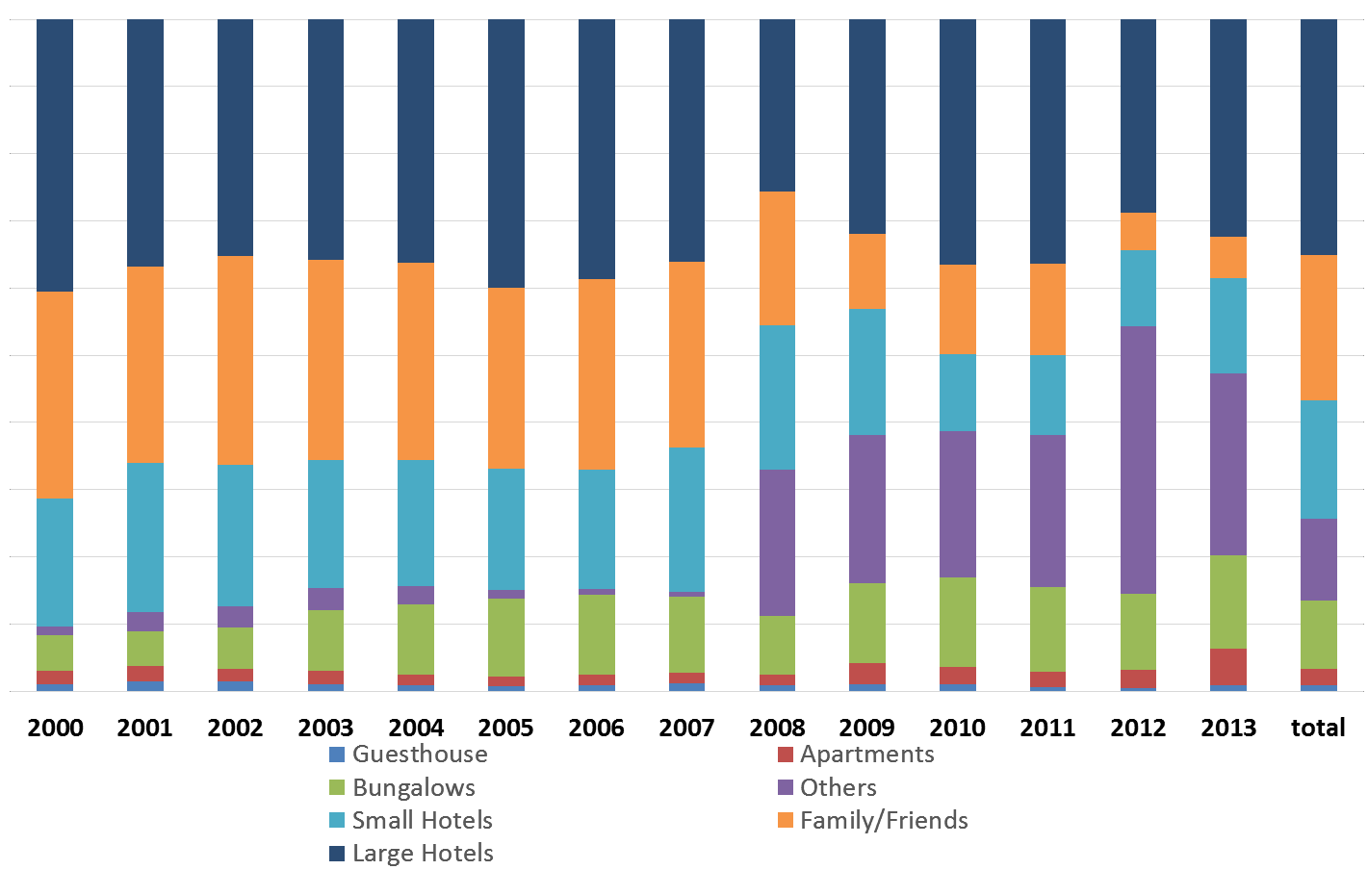

Figure 27: Accommodation types selected by tourists from 2000-2013

The 2015-2020 Strategic Tourism Master Plan consists of three goals:
- To boost economic growth
- To create accelerated jobs
- To consolidate hospitality business
Tables 38 and 39 indicate the numbers of arrivals needed to achieve these three goals. The forecasted arrivals per the tourists’ country of residence are derived from the distribution of hotel stays and non-hotel stays that were previously analyzed. The impact of the forecast spans three strategic phases:

- Traction
- Solidification
- New horizons

Table 38: Additional tourists staying in hotels 2016-2020
Year | USA | Netherlands | Venezuela | Others | Total
2016 | 26,200 | 2,134 | 4,493 | 3,157 | 35,984
2017 | 26,200 | 1,600 | 3,370 | 4,736 | 35,906
2018 | 8,957 | 354 | 887 | 1,407 | 11,604
2019 | 8,895 | 236 | 591 | 1,790 | 11,512
2020 | 9,145 | 118 | 296 | 1,961 | 11,519
Total | 79,396 | 4,442 | 9,636 | 13,051 | 106,525

Table 39: Additional tourists staying elsewhere 2016-2020
Year | USA | Netherlands | Venezuela | Others | Total
2016 | 7,390 | 2,505 | 4,148 | 741 | 14,782
2017 | 7,390 | 1,878 | 3,111 | 1,111 | 13,490
2018 | 2,526 | 415 | 818 | 330 | 4,090
2019 | 2,509 | 277 | 546 | 420 | 3,751
2020 | 2,579 | 138 | 273 | 460 | 3,451
Total | 22,394 | 5,214 | 8,895 | 3,061 | 39,564

Phase 1: Traction

The traction phase suggests a 10% increase in hotel occupancy rates by year 2. This means that, in the next two years, hotels will need to achieve an 80% occupancy rate, which will increase RevPAR by US$15, thus making RevPAR approximately US$114 in two years. This increase of US$15 in RevPAR means an additional US$133 million in foreign exchange, which will lead to an additional 1.8% real economic growth per year, and 1,918 direct and indirect jobs. These numbers do not include the multiplier effects of tourism in the local economy.60

The increased occupancy rate of 5% for each year in the first two years of the strategic plan may seem aggressive. This statistic is based on the information from the distribution of hotel stays that was previously alluded to in Table 11 of Chapter 3. When considering that the historic growth of arrivals to Curaçao has increased by 7% on average each year for the last 15 years, a 10% increase in two years is not only feasible, but necessary. The necessity is based on the precarious situation in Venezuela, which is the main trade partner for Curaçao, and is the second largest tourist market for the island. The Venezuelan market is already showing signs of decline. Therefore, it behooves destination managers to quickly consider and act upon the opportunities in the Colombian market stemming from the visa elimination applied to Colombian citizens on July 1, 2015.

Phase 2: Solidification

The solidification phase includes years 3 and 4. During years 3 and 4, the plan foresees a slowing of the arrivals growth rate of 4% in year 3, and 2% in year 4. In actual numbers, tourist arrivals are expected to drop from 50,000 in both years 1 and 2 to 15,000 in both years 3 and 4. The anticipated decrease in arrivals is based on the Venezuelan situation, as well as the expectation that the plan will work, thereby accomplishing the 10% increase in hotel occupancy rates in years 1 and 2, but reaching a level of 85% occupancy rates in years 3 and 4. According to anecdotal evidence, the increased level of hotel occupancy rates (85%) in years 3 and 4 may show signs of diminishing returns. The economic impact of this solidification phase means US$943.9 million by 2018 and US$989.1 by 2019.

60 The DPITS is indebted to the Ministry of Economic Development of Curaçao in facilitating the estimation of the impact of the forecast on economic growth and taxes.

Phase 3: New horizons

The new horizons phase differs from the first two phases. During the first two phases, the concentration has primarily fallen on aligning the existing supply with a necessary demand surge Moving into year 5 (new horizons phase), it will become necessary for Curaçao to increase the island’s room inventory. This means that Curaçao will need to incorporate additional high-quality hotel rooms that are accompanied with additional high-quality supporting products. For example, if Curaçao is successful in recruiting luxury brand hotels, then other supporting products (e.g. restaurants and attractions) must cater to the clientele that would consume the luxury hotel.

By year 5, the plan expects that Curaçao will increase its competitive position within the Caribbean region. The increase in competitive position will be measured by Curaçao’s RevPAR value in relation to its competitive set. The expectation is that Curaçao’s RevPAR must be at the same level, or above the rest of the Caribbean region. This plan requires an additional demand of 100,000 arrivals. Because the USA market has the largest proportion of arrivals staying in hotels (eight of every ten American tourists stay in hotels compared to four of every ten Dutch tourists), and the American segment spends the most per day, the plan suggests a strategic refocus of the demand structure for the Curaçao tourism industry, which means aggressive market penetration, brand awareness, and positioning essentially within the American market.

The refocusing on the American market does not mean an abandonment of the Dutch and South American markets. Rather, the refocusing efforts on the American market is a shift in strategic emphasis from the existing tertiary target audience. This shift will allow for a stronger economic relationship between tourism expansion, economic growth and job creation. The Dutch and South American markets will remain within Curaçao’s primary target audiences (see Figure 28). Additional marketing resources beyond the resource level supporting these two markets as primary target audiences should be guided by their direct impact on the occupancy level and RevPAR of the hotel sector.

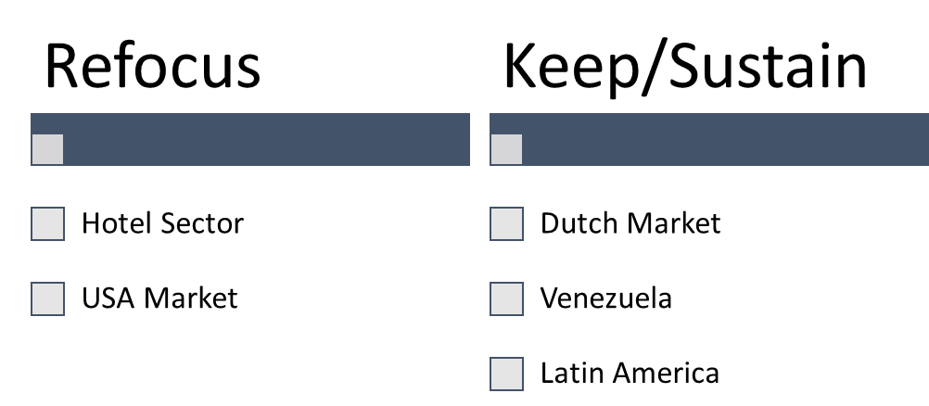

Figure 28: The strategic focus of target audience

While the first two years of the strategic plan are oriented toward the optimization of the current room inventory (the efforts are not geared to add more rooms), current airlift from the USA market seems deficient. The amount of USA tourists required to realize the goals of the plan are 67,180 additional arrivals, which is the equivalent to double the amount of current USA arrivals. This amount of arrivals entails an additional 1,500 seats per week to Curaçao. The current airlift from the JFK gateway with JetBlue is near full capacity (92%), while the Miami gateway with American Airlines is 76% and Charlotte with InselAir is 67%. Based on the current load factor level, Curaçao would need five additional flights per week in the first year, and six flights per week in the second year of the traction phase. Then, to continue accelerating demand, Curaçao would need another five flights per week in the consolidation phase.

The total economic impact of the plan is revealed in Table 40 and represents the change relative to the baseline. This representation signifies the economic impact of the yearly additional tourist nights during 2016-2020. As

evidenced in Table 40, the additional tourist nights are expected to have a positive impact on the economy through the additional consumption, job opportunities, exports, and investments. The expected increase in these domestic economic activities results in an average increase of the Real GDP growth of 1.2 percentage points during the 2016- 2020 period.

The expected increase in tourism exports will result in higher employment, private consumption and investments, thus resulting in higher imports. An additional 3,700 jobs are projected in 5 years. These jobs are expected to positively impact the locals’ disposable income. The projected increase in domestic spending will increase prices (export price and wage rate among others), resulting in a higher inflation level. The increase in the total tourism exports has a positive effect on the foreign reserves of US$83.2 million in 5 years. The foreign reserves’ inflow from tourism exports fully exceeds the reserves’ outflow which is used for the required imports of goods. The higher tourism exports also have a positive effect on government revenues through an expected increase in indirect taxes as well as direct taxes, summing to US$58.5 million in five years.61

Table 40: Overall economic impact
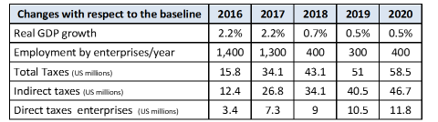

Getting the American tourists to Curaçao
The USA continent was divided into six regions: New England, South, Southwest, Middle Atlantic, West and Midwest. The map in the Annex reveals which states belong to each of the six regions. Through a factor analysis (see Annex 3) four constructs were identified, i.e., positive attitudes, value and variety of attractions, shopping quality, and hospitality-related services. In addition, an ANOVA technique was conducted to compare differences among the regions in terms of these four constructs.

Table 41 reveals the position of Curaçao in each one of the regions according to each one of the four constructs. For example, Curaçao reveals a lower positive attitude in the New England region (3.09) compared to the Midwest and West regions (3.36 and 3.32). Based on this analysis, Curaçao would have the greatest potential to attract tourists from the West and Midwest regions. However, it is crucial to connect positive attitudes with the intention to visit Curaçao in order to gauge more precisely which regions possess the highest likelihood of patronizing Curaçao.

Table 41: Curaçao image in the US regions
Construct | New England | South | Southwest | Middle Atlantic | West | Midwest
Positive Attitudes | Low (3.09) | Low (3.10) | No-Diff (3.25) | No-Diff (3.25) | High (3.32) | High (3.36)
Value & Variety of Attractions | Low (3.34) | No-Diff (3.36) | No-Diff (3.37) | No-Diff (3.50) | High (3.54) | No-Diff (3.25)
Shopping Quality | Low (3.51) | No-Diff (3.55) | No-Diff (3.57) | No-Diff (3.69) | No-Diff (3.74) | High (3.75)
Hospitality | Low (3.38) | Med-Low (3.43) | No-Diff (3.47) | Med-High (3.61) | High (3.63) | Med-High (3.60)

The four constructs were used as predictors of intention to visit Curaçao. Among the four constructs, positive attitudes was shown to be the strongest predictor of the intention to visit Curaçao (R-square=0.433 with F=518.686; t=22.775). Positive attitudes refer to safety, good image, quality services and tourism products, and value, as well

61 We are indebted to the team within the Ministry of Economic Development of Curacao for their assistance regarding the sectorial economic impact analysis done with the application of the Turistika model and the macro economic impact analysis done with the application of the Curalyse model.

as activities and attractions that tourists enjoy. These dimensions are related to the human element (soft component of tourism) in the creation of the Curaçao product, again stressing the centrality of human capital in the consumption experience of the destination.

Finally, a regression was conducted for each one of the six regions in the sample. The results are displayed in Table
43. Positive attitude was the strongest predictor in the New England (B=0.702) region followed by the Middle Atlantic (B=0.671), the South (B=0.667) and the Midwest (B=0.665). All the other predictors were non-significant except for shopping quality, which was significant only in the West region. It seems clear from the previous analysis that Curaçao should focus on positive attitudes (human dimension) in the regions of New England, the Middle Atlantic, the South, and the Midwest.

Table 42: Drives of intention to visit Curaçao
 | R2 (F-value) | Positive Attitude (t-value) | Shopping Quality (t-value)
New England | 0.479 (35.900) | 0.702 (5.992) | NA
Middle Atlantic | 0.446 (135.655) | 0.671 (11.647) | NA
South | 0.441 (123.167) | 0.667 (11.098) | NA
Midwest | 0.437(81.819) | 0.665 (9.045) | NA
Southwest | 0.384 (36.522) | 0.628 (6.043) | NA
West | 0.423 (56.236) | 0.523 (6.642) | 0.188 (2.392)

Curaçao’s American market competitors
It is critical at this juncture to examine Curaçao’s competitors in each one of the potential regions identified. Table 43 shows Curaçao’s competitors within the region, and reveals the ranking of Caribbean destinations. The arrows in the table and the horizontal sign represent positive, negative, or neutral movements from each of the six regions with regard to tourists’ impressions about destinations they enjoyed in the Caribbean. An up arrow means that the impression has improved, while a down arrow means that the positive impression has deteriorated. A horizontal line means that the impression has remained the same. For example, in New England, the impression about Mexico’s Caribbean coast has decreased, the Bahamas has improved, and Aruba has remained the same.

Table 44 deciphers impressions about the top destinations in the potential four regions where Curaçao should seek a more prominent competitive position. The table reveals the competitors of Curaçao in each one of the four regions. In the New England region: the Bahamas, Bermuda, Cayman Islands, St. Maarten and Aruba are Curaçao’s competitors, while for the Middle Atlantic region: the Bahamas, Aruba, and US Virgin Islands are the competitors. For the South region: the Bahamas, US Virgin Islands, and Jamaica are competitors, while in the Midwest region: the Bahamas and US Virgin Islands are Curaçao’s competitors.

Table 43: Curaçao’s US market competitors
Rank in US Regions
Destination | New England | Middle Atlantic | South | Midwest | Southwest | West
Mexico’s Caribbean coast | 7 | 2 | 2 | 2 | 1 | 2
Bahamas | 1 | 1 | 1 | 1 | 2 | 1
Aruba | 3 | 3 | 7 | 4 | 6 | 8
Dominican Republic | 8 | 8 | 10 | 9 | 9 | 9
Jamaica | 8 | 5 | 4 | 7 | 5 | 5
US Virgin Islands | 6 | 4 | 2 | 3 | 4 | 3
Cuba | 15 | 16 | 15 | 13 | 13 | 12
Puerto Rico | 10 | 5 | 6 | 5 | 7 | 4
Cayman Islands | 3 | 9 | 5 | 5 | 3 | 6
Saint Martin/St. Maarten | 3 | 12 | 8 | 7 | 13 | 7
Barbados | 13 | 11 | 10 | 11 | 9 | 10
Bermuda | 2 | 7 | 9 | 14 | 9 | 14
Turks and Caicos Islands | 13 | 9 | 13 | 12 | 12 | 10
Saint Lucia | 11 | 13 | 12 | 10 | 8 | 15
Haiti | 12 | 14 | 15 | 15 | 17 | 12
Trinidad and Tobago | NA | 14 | 13 | 17 | 15 | 16
Martinique | 15 | 17 | 17 | 15 | 16 | 16
Guadeloupe | NA | 18 | 18 | 17 | NA | 16

Table 44 shows that, in general, people expect that the Caribbean islands will have nice beaches. This means that most people expect and do not see a large difference in the quality of Caribbean beaches. It seems that the Caribbean has successfully positioned the island destinations, in the minds of tourists, as a region that has beautiful weather, beaches, and access to the sea. With the exception of Cuba, which placed very low when compared to other Caribbean destinations, the data reveals that there are no prominent differences with regard to people’s perceptions of beaches and duty-free areas in the Caribbean region. This means that tourists arriving to the Caribbean islands expect that duty-free shopping will be available, and that the beaches will be nice.

The practical implication here is that the Caribbean islands must promote and maintain their beaches, and it behooves the island destinations to offer duty-free areas in order to align with the tourists’ expectations. Nice beaches and duty-free areas for shopping are necessary components of the overall tourist experience in the Caribbean region; however, it does not seem that these two components (by themselves) will provide a Caribbean destination with a competitive advantage.

An interesting finding was revealed during the data assessment that there was a distinct difference in people’s perceptions regarding the hospitality or the service delivery quality (soft components of tourism) that is available in the Caribbean region. Therefore, Curaçao should take great strides to emulate or exceed the level of service and hospitality that is available in Bermuda and Mexico’s Caribbean Coast. According to tourists, these two locations have a very high level of hospitality.

The DPITS further investigated the data to determine the weight that each of these components (i.e. beaches, duty- free shopping, and hospitality) had in determining a tourist’s level of satisfaction with their overall experience. According to the data, the soft component of tourism, which is hospitality, accounts for 45% of the variance, whereas duty-free shopping and beaches accounted for 7.5% and 4%, respectively (See Table 45). The remaining variance within the model cannot be accounted for and is due to statistical limitations of measurement error that exists in all models.

This means that the most important factor to consider in delivering a superior tourist experience is the soft components factor of tourism, which is mainly the service delivery. This information presents a unique opportunity for Curaçao to improve its competitive position within the region via focusing on human capital development, as opposed to capital investments in infrastructural development.

Table 44: Image perception of the competitive set62
Construct | Beaches | Duty-Free Shop | Hospitality
Aruba | No-Diff | High | High-Med
Bahamas | No-Diff | High | No-Diff
Barbados | Low-Med | High | Low
Bermuda | High-Med | High | High
Cayman Islands | No-Diff | High | No-Diff
Cuba | Low-Med | Low | Low-Med
Dominican Republic | High-Med | High | No-Diff
Guadeloupe | No-Diff | High | No-Diff
Haiti | No-Diff | High | Low-Med
Jamaica | No-Diff | High | No-Diff
Martinique | No-Diff | High | No-Diff
Mexico’s Caribbean coast | No-Diff | High | High-Med
Puerto Rico | No-Diff | High | No-Diff
Saint Lucia | No-Diff | High | No-Diff
Saint Martin/St. Maarten | High-Med | High | No-Diff
Trinidad and Tobago | Low | High | No-Diff
Turks and Caicos Islands | High | High | No-Diff
US Virgin Islands | No-Diff | High | No-Diff

Table 45: Factor analysis for beaches, duty-free and hospitality
Hospitality (variance explained=45.4%) | 45.4%
Restaurant Service Quality | 0.89
Accommodation Service Quality | 0.85
Locals' Friendliness & Hospitality | 0.81
Local Food Taste | 0.72
F&B Quality | 0.71
Accommodation Quality | 0.68
Social Mingle | 0.67
Food & Water Safety | 0.64
Overall Cleanliness & Hygiene | 0.64
Ease of Mobility in Destination | 0.63
High Prestige Product & Service | 0.63
Overall Safety & Security | 0.61
Nightlife & Entertainment | 0.59
Accommodation Price | 0.56
Restaurant Price | 0.54
Destination Ease of Access | 0.50
Duty-Free (variance explained=7.5%) | 7.5%
Product Quality in Duty-free | 0.90
Available Luxury Brand in Duty-free | 0.88
Product Variety in Duty-free | 0.86
Available Duty-free | 0.77
Price in Duty-free | 0.76
Beaches (variance explained=3.9%) | 3.9%
Beaches Quality | 0.94
Climate | 0.78
Available Facilities Beaches | 0.61

62 In order to gauge the factors that influence the ranking of the islands as depicted in Table 45, the DPITS applied an ANOVA test to investigate potential differences among image impression factors for each island destination. The variable “island” was used as the independent variable and the image impression factors (i.e., Beaches, Duty-Free, and Hospitality) were used as dependent variables. The scores were categorized as: High, Med-High, Med-Low, Low, and No-Difference.

Curaçao’s tourism strategy in the American market
Two US regions from the sample reveal a strong presence in the Dutch Caribbean islands. St. Maarten and Aruba are strong in the New England region, while Aruba is strong in the Middle Atlantic region. Because the Dutch Caribbean island image is already prominent in those two regions, Curaçao has a unique opportunity in both regions to display its Dutch Caribbean heritage. By making its heritage obvious, Curaçao is able to piggy back on the success of Aruba and St. Maarten in an effective and smart way.

What is required from Curaçao is a fourfold strategy. First, Curaçao must aggressively promote to the New England and Middle Atlantic regions that the island’s people are friendly, unique, provide excellent service, and welcome tourists. Second, Curaçao must identify itself as a different Dutch Caribbean island in order to distinguish itself from Aruba and St. Maarten. Third, it is a necessity to increase the airlift capacity from the New England and Middle Atlantic regions. Last, it is necessary for Curaçao to increase airlift from other regions that have good connectivity with gateways from the aforementioned regions.

The final message here regarding this fourfold strategy is that Curaçao must position itself as a different Dutch Caribbean. This message implies that Curaçao will reference the strong brand of the Dutch Caribbean that is alluring to so many Americans, but will entice the American market to sample a newly emerging destination - Curaçao. “Curaçao, A different Dutch Caribbean” is an appropriate tagline for Curaçao in that it captures many elements that the American tourist looks to consume while on vacation.63 The “Caribbean” component of the tagline represents the “sun, sand, and sea” that is preset and desired in the American consumer mind. The “Dutch” component of the tagline represents the stability, safety, and organization that is appealing to American tourists. And, the “different” component in the tagline represents the emergence of a new destination that possesses the eclectic culture and charm that is unique to Curaçao.

The plan therefore suggests that the region where Curaçao has its best chances to attract more American tourists is the Middle Atlantic States. If this suggestion holds, airlift should be increased from JFK gateway with JetBlue from two weekly flights to daily flights.

The second priority area (year 2) should be from the Midwest area suggesting Midway Chicago as the departure points with two weekly flights (Southwest is the suggested carrier). And, in year 3, three weekly flights departing from Houston (again Southwest seems the suggested partner).

Curaçao should engage in aggressive financial incentives to convince these carriers to consider flights to the destination. In today’s competitive environment, developing airlift capacity air service incentive programs has become a requirement to bolster a competitive island destination. It is therefore crucial to create a permanent airlift fund to support the air service incentive program.

Segmentation strategies conquering the American market
Given the DPITS suggestion for Curaçao to refocus its attention toward the acquisition of the American market, two primary tourist segments were selected from the segmentation evaluation (i.e. cluster analysis) for Curaçao to consider in the future construction of advertisement and promotions.

63 The DPITS suggests to test this tagline through focus groups and other instruments to validate its potential.

Innovative American tourist segment

Demographic and geographic traits
The innovative American tourist segment is comprised of 55% males who are close to 50 years old and are married with children. A large portion of the segment (44%) possesses a college degree and 100% of the segment makes over US$75,000 on an annual basis. Nearly half of the tourists in this segment are from the USA (43%) with 27% from Canada, 19% from the Netherlands, and 11% being from “other.” This means that 70% of this segment arrive to Curaçao from North America.

More than half of the members in this market segment have previously been to Curaçao (54%), have an average length of stay of 7.59 nights, and an average trip expenditure of $1, 038.80. The majority of these tourists booked their travel (i.e. airline ticket and lodging) through a travel agent (46%) and 25% of this market segment booked their travel via the Internet.

On a Likert scale of 1-6, the segment possesses a mean satisfaction score of 4.75. This means that the tourists in this segment are highly satisfied with Curaçao’s overall tourism product. These tourists also perceive the quality of Curaçao’s tourism product as high with a mean score of 4.44 and perceive the value (i.e. price and quality) as also high with a mean score of 4.28. The major reason tourists in this segment chose to travel to Curaçao was primarily for the sun and beach (76%). It is appropriate to assume, given the high satisfaction, quality, and value scores for Curaçao’s overall tourism product and the tourists’ major reason for travel, that this segment is satisfied with the traditional Caribbean product – sun, sand, and sea amenities found in Curaçao.

It is important to note, that nearly 100% of the tourists in this market segment prefer to stay in a traditional lodging accommodation (99%) with 66% staying in hotels and 35% staying in all-inclusive resorts. As previously discussed, hotels serve as the most potent economic link in Curaçao’s tourism system. Therefore, acquiring a market segment that prefers and uses hotel accommodations is of utmost importance for Curaçao to maximize the impact of the industry for the island.

Psychographic traits
The psychographic traits of this market segment reveal that the tourists possess a relatively low level of brand loyalty with a mean of 2.93 (1 being the lowest and 6 being the highest form of brand loyalty). This is valuable information for the CTB to learn regarding this market segment’s brand preferences. Curaçao does not currently boast a large brand portfolio for tourism-related products. However, this market segment does not favor branded products over that of others.

The goal for the 2015-2020 Strategic Tourism Master Plan is for Curaçao to optimize the existing supply. With this goal in mind, and from the perspective of this market segment, it is not necessary for the existing tourism supply to contain a large amount of branded products in order for this segment to consume the destination.

With regard to the level of price sensitivity, this market contains tourists who are not a price sensitive group of travelers. The mean score for price sensitivity was 3.35, with 1 being not price sensitive at all and 6 being very price sensitive. As previously mentioned, this market segment was satisfied with the overall Curaçao tourism product and felt that the value of the product was high. This implies that this market segment may have a more tolerant price threshold for hotel rooms than that of other segments.

An interesting psychographic trait that emerged within this market was their willingness to try and experience new things. The group was deemed an innovative form of traveler with a mean score of 4.01. This means that this market segment is willing, able, and ready to consume travel-related products that are different and perhaps fall off the beaten path of other travelers. This may be a primary reason why this group of tourists selected to vacation in Curaçao. The DPITS feels that the suggested slogan, “Curaçao, a different Dutch Caribbean,” may entice more travelers like those from this segment to sample the island.

In terms of future behavioral intentions with tourists from this segment, a large amount of them would like to return to Curaçao (4.53 mean). The majority of these tourists would also provide Curaçao with a good reference (4.99 mean).

The quality, market maven American tourist

Demographic and geographic traits
The market maven segment is comprised of 54% males who are also close to 50 years old and are married with children. This segment is more educated than the previous segment with nearly 40% having an undergraduate college degree and approximately 36% possessing a masters or doctorate degree. Again, a 100% of this market segment makes over US$75,000 on an annual basis. Approximately, 37% come from the USA, 23% from Canada, and 17% from the Netherlands, with the remaining 23% arriving to Curaçao from “other” countries. This means that approximately 60% of this segment arrive to Curaçao from North America.

Fifty four percent of the tourists in this market segment had a previous trip to Curaçao with the average length of stay of 7.19 nights and an average trip expenditure of $1,485.43. Contrary to the previously discussed market segment, the majority of these tourists (73%) did not use a travel agent to book their travel (i.e. airline ticket and lodging). Forty two percent used an airline website and 31% percent used the Internet for an airline ticket. One third of the tourists from this segment used a travel agency to book lodging and another one third used hotel websites to book accommodations.

On a Likert scale of 1-6 the segment possesses a mean satisfaction score of 5.03. This means that the tourists in this segment are highly satisfied with Curaçao’s overall tourism product and this segment is more satisfied with the island than the previously discussed segment. These tourists also perceive the quality of Curaçao’s tourism product as high with a mean score of 4.67, and perceive the value (i.e. price and quality) as also being high with a mean score of
  - Although a smaller percentage of tourists in this segment chose to travel to Curaçao for the sun and beach than in the first segment (76%), the majority of 69% still come for a sun, sand, and sea destination.

It is appropriate to assume that, given the even higher satisfaction, quality, and value scores for Curaçao’s overall tourism product, this segment is also highly satisfied with the beach and weather in Curaçao. Nearly 90% of the tourists in this segment also prefer to stay in and use traditional lodging accommodations with 80% staying in hotels and 10% staying in all-inclusive resorts. Again, this is a valid segment for Curaçao to target in order to increase the economic impact of tourism through the hotel sector.
Psychographic traits
The psychographic traits of this market segment reveal that, although statistically different than the first segment, these tourists also possess a relatively low level of brand loyalty with a mean of 3.37 (1 being the lowest and 6 being the highest form of brand loyalty). While this segment may seem to tentatively trend towards branded products, this consumption style may be due to this market’s high-quality consciousness (mean 4.86 out of 6).

The previously discussed market segment possessed a mean score of 3.57 for quality consciousness. Therefore, the current market segment may be slightly more skewed toward branded products that guarantee a higher level of quality. The DPITS feels that Curaçao may replace this market segment’s interest in brands with high-quality, non- branded products. In order to do this, non-branded properties would need to carefully craft advertising materials that reference extremely high-quality standards and performance. This market segment is slightly more price sensitive with a mean score of 3.43, albeit still low, with 1 being not price sensitive and 6 being very price sensitive. This market again revealed its willingness to try and experience new events and features. This group was also deemed an innovative form of traveler with a mean score of 4.6, which is significantly higher than the previous market segment at 4.01.

The most interesting psychographic trait that emerged for this market segment was its need for market information prior to their consumption of travel-related experiences. Market mavens are considered to be persons that require

a large amount of information to educate themselves prior to the consumption of any product. After the consumption of the product, mavens enjoy sharing their “expert opinion” with others.
This market segment seems to possess a large amount of market mavens. They construct what they feel are expert opinions from the information they find on the destination pre-consumption, followed by their post-consumption evaluations of the destination. This group also revealed that they had more of a likelihood to share their experience on social media sites (mean score 4.14 compared to 3.87 for the previous market segment).

Based on the need for this market segment to acquire a vast amount of pre-consumption information, it may behoove the CTB to concert efforts on improving the available information on the CTB site. This recommendation was also documented in a previous DPITS monthly report that referenced the CTB websites’ shortcomings.64 Building and maintaining an up to date website and strong presence on social media platforms is imperative for the destination to nurture the interests and willingness of the market segments (especially the maven tourist) to visit the destination. Additionally, it is necessary for Curaçao’s tourism businesses to provide up to date, reliable, meaningful, and trustworthy information to positively influence the perception of this segment. The CTB may play a key role in furnishing the private sector with guidance in formulating this type of information.

In terms of future behavioral intentions with tourists from this segment, an even larger amount of them would like to return to Curaçao (5.01 mean). They would also provide Curaçao with a good reference (5.23), would consider Curaçao as a first destination (4.1 compared to 3.76), and would encourage friends and families to visit Curaçao (4.87 compared to 4.5).

“Curaçao, a different Dutch Caribbean”
The two identified market segments, innovative American tourists and quality, market maven American tourists, reveal that these tourists do not have complaints pertaining to the overall value and quality of the Curaçao tourism product. The market segments also reveal that, overall, they were satisfied with the destination and the Caribbean experience they received in Curaçao. The majority of the tourists from both segments came to Curaçao for the Caribbean experience of great weather and the beach.

Both of the market segments were deemed as innovative travelers that desire to try new and different activities/destinations/products (See Table 46). This is fortuitous information for Curaçao in that the destination is not well known in the American market. Therefore, the destination is qualified as “different.” Hence, the slogan, “Curaçao, a different Dutch Caribbean.” The slogan represents the desire of both of these markets to sample new products, but also captures the Caribbean that is branded as sun, sand, and sea destinations. The use of “Dutch” affords Curaçao the safety and high-quality perspectives that are associated with other Dutch islands.

With regard to the construction of future advertising materials for these two segments, it is important to remember that the markets seem to have a higher price threshold than other markets that Curaçao currently services. Therefore, as long as the tourism products represent a high-quality product, these groups will appreciate the value of different, non-branded, high-quality products.

It is also very important for the CTB to identify the particular needs of one of the segments that included market mavens. This market segment has a high need and desire to acquire large amounts of information regarding the destination prior to their consumption of the island. This group also has a high propensity to recommend the island via social media and other forms of word-of-mouth recommendations post consumption of Curaçao. Therefore, the CTB needs to streamline a process for types of travelers like this to have efficient access to in-depth information.
See Table 46 for a comparison between the two market segments.

64 In our monthly report 5, we performed a descriptive comparative analysis of different dimensions of website design. The report shares some knowledge about status quo and potential improvement areas for the Curaçao Tourism official website. Four principal dimensions were used to assess the website. These dimensions included: “attributes”, “interactive”, “informative”, and “technical.”
Eleven destinations’ websites in the Caribbean were carefully analyzed to prepare the analysis. The destinations are as follows: St. Lucia, Barbados, Bahamas, Cayman Islands, Aruba, Bonaire, Surinam, St. Martin, St. Thomas, Jamaica, and Dominican Republic.

Table 46: Comparison of two suggested American markets
 | Innovative American  Tourist | Quality, Market Maven  American Tourist
Market Maven | -----
Quality Conscious | -----
Pressed for Time | ----- | -----
Innovative
Brand Loyalty | -----
Price Sensitive | ----- | ------
Satisfied with Curaçao
Perceived Quality Level of Curaçao ’s Tourism Product
Perceived Value Level of Curaçao ’s Tourism Product
Share Experience on Social Media | -----
Return to Curaçao
Give Curaçao a Good Reference
Consider Curaçao as a 1st Choice Destination | -----
Encourage Family/Friends to Visit Curaçao
Recommend Curaçao to Anyone Who Asks Me

The new CTB

For Curaçao to capture the American market as described in the aforementioned two main segments, the destination must meet two conditions. First, the present CTB should be reengineered toward a flexible and market oriented organization. This new CTB will need to have a different governance structure that would make it more agile and ready to engage in a new type of conversation with stakeholders.

Second, the financial resources must be present from the immediate implementation of the strategic plan to conquer the American market, as well as to irradiate credibility in the plan from the start. The discussion below is to provide and define the parameters of this new CTB, and to gain credibility in the sustainability of the plan.
The CTB is a component of the Curaҫao Tourism Development Foundation which was founded in 1989. The foundation consists of a Supervisory Board of 7 members, including a chairperson, appointed by the Minister of Economic Affairs. The organization is funded by the government and managed by a director and deputy director under the articles of association. The bylaws of the Foundation were amended in 2012.65

CTB has a pivotal role in realizing the plan. The current organizational structure of the CTB does not seem conducive to provide effective direction to the plan through to its successful completion. Several important modifications to the organizational structure should take place.

Modifying the current tourism organization framework
Organizational framework assumes that policy coordination will occur and that a strong collaboration will exist between the public and private sectors. Moreover, the framework assumes that policies, actions and projects will be regularly monitored, evaluated, and adjusted. The new tourism framework consists of the Minister of Economic Development, the new CTB Board, and the restructured CTB. Each one will have their own responsibilities and tasks. The Minister of Economic Development is in charge of the tourism policy design and formulation, while the new CTB is in charge of the implementation of those policies. For this purpose, a special tourism unit should be included in the Ministry to support the Minister with responsibilities and tasks. The unit should consist of highly qualified professionals that can perform high quality analyses to support sound decision-making and choices. The unit should

65 See Curaçao Tourism Development Foundation, 2014 Business Plan.

be headed by a person who will be directly in charge of the implementation and updating of the Tourism Master Plan.
The Minister of Economic development should expeditiously take a decision on two areas:
    - To appoint in consultation with The CTB Board a new CTB CEO in the short term. The CTB CEO should have a clear profile revealing these competencies along with those skills and competencies required to manage a DMO organization and destination. Expertise and experience in these areas, as well as strong leadership skills, are required to direct the new CTB.
    - To select in consultation with the CTB Board expeditiously hire a marketing agency in the USA market to support the strategic plan. Currently, the CTB does not have such representations in the USA.
The current CTB Board structure should be modified to reveal the public/private partnership. Both instances (public and private) should have parity in membership and decision-making power. Neither the government nor the private sector should have the upper hand in the decision-making process. The board should function at arm’s length from the political process. The board should be inclusive to all sectors participating in and benefiting from the tourism industry. The government should appoint three members representing a broad spectrum of the industry, while the private sector should appoint three members. The six members should appoint a president to the board. The new composition of the CTB board facilitates the integration of stakeholders other than those directly involved with the tourism industry. In addition, the inclusion of these stakeholders facilitates the support of branding and marketing efforts of the CTB. The board will have a supervisory role in the CTB decision-making process.

The role of the CTB
The main role of the new CTB is to serve as an interface between market (consumer) demand and destination (industry) supply. The CTB should embrace a dual role as a tourism sales and marketing tool for the industry, as well as coordination amongst stakeholder. This main role should be supported by a smart communication program consisting of two aspects. The first aspect is to inform visitors in a quick and efficient way about the products and services available on the island (visitor servicing). The second aspect is to provide research/information that enables the CTB to have the necessary business intelligence required to function and understand emerging market demands, current industry supply, and the gaps that need to be addressed through planning and development. Product development should be a task of the new CTB only with reference to supporting the alignment between demand and supply. In this context, product development should mainly become a tool for business intelligence in supporting the creation of innovative and high-quality offerings. In order for the CTB to achieve the second aspect, it is necessary for the CTB’s research unit to be expanded.

In addition, the CTB should be engaged in active coordination of concerted efforts of all stakeholders to support its sales and marketing activities. An important assessment of the DMO ability to foster coordination will be directly related to the number and quality of relationships with tourism stakeholders. In this regard, network analyses might be applied to determine the strength of the DMO’s position (centrality) in the network vis-à-vis the density of the network.

The CTB must craft a sales pitch that is conducive to selling Curaҫao “a different Dutch Caribbean” experiential product. The driving force of this experience is the local people. The product or experience may be summarized as genuine, eclectic, exciting, and inviting. In order to sell this product, the new CTB should focus on the anticipatory, consumptive, and reflective stages of the experience with the Curaçao product. CTB should empower stakeholders to assist in realizing this plan by increasing awareness of Curaçao, increasing value of the product during consumption of the experience while in Curaçao, and increasing tourist spending and loyalty.

The new mission of the CTB is to increase the number of arrivals within an inclusive system, thus propelling economic growth and creating jobs through strong public/private partnerships. An inclusive system will ensure financial sustainability supporting this CTB mission. The main measure of success for the new CTB is the quality of the tourists’ experience. The overall tourist experience will be reflective of all of the separate experiences within the travel experience chain. For this reason, the quality of the experience is an outcome of all of the CTB’s efforts in stakeholders’ coordination – something to be measured rather than directly managed. An audit of the quality of the

destination experience along with tourist satisfaction surveys would be examples of initiatives that would support this activity.

Figure 29 depicts the structure of CTB’s areas of activities. The tactical marketing activities should occur only after the CTB (together with stakeholders) has been able to define the strategic marketing activities of image identity, branding, and positioning. The new CTB should work closely with the Ministry of Economic Development in the implementation of the 2015-2020 Strategic Tourism Master Plan.
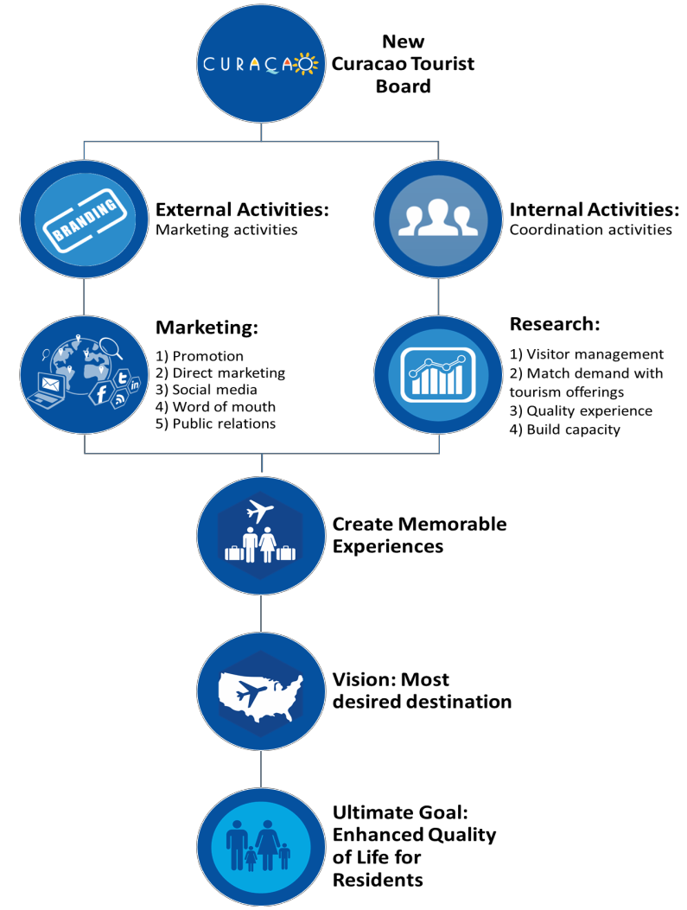

Figure 29: CTB’s two main areas of activities

Financial sustainability
The ROI of the strategic plan is substantial and justifies the investment of US$40 million over a time span of five years. This investment will be allocated to support an aggressive marketing program and an air service incentive program in the USA market.

The investment will be procured by borrowing from the local financial intermediaries which have sufficient cash to provide for this strategic plan. The investment borrowed will be paid by an aggressive and efficient room tax collection, an additional room tax of US$3 million per year due to the increased RevPAR, and by the participation of non-conventional instances which benefit from the increased tourism transactions on the island, and resulting from the strategic plan. The aggressive and efficient room tax collection also include those private dwellings that engage

in short time rentals. The revenues from this source could eventually be put in a separate fund earmarked for research and product development.

However, the loan magnitude depends on how successful the CTB is in collecting outstanding arrears in room tax. It seems unrealistic to expect that the CTB would be able to collect all outstanding arrears. Therefore, the suggestion is for the CTB to develop a plan that provides a forgiveness period of five years (from 2000-2005), the payment in full of the arrears in two months (no financial accommodation granted to any hotel) spanning 2006-2014, and the prompt compliance since January, 2015. Any misbehavior from any hotel should bear the full consequence of existing laws, including putting a lean on the property.

The CTB should also instate strict enforcement to any short-term rental property. A similar approach for short-term rental properties may be used like that of the hotels. It is important to again stress the need for strict adherence to the plan in order to achieve quick credibility of the earnestness in the law enforcement as it pertains to room tax collection. The loan payment schedule below shows that the risks involved in the investment are minimal when compared with return on investment over the timespan of five years.

Table 47: Loan Payment Structure for Budget
Loan Payment Structure ($40 Mil) 5-year payment schedule
7.00% interest rate 6.50% interest rate 6.00% interest rate 5.50% interest rate 5.00% interest rate
N= | 5 |  | N= | 5 |  | N= | 5 |  | N= | 5 |  | N= | 5
I/Y= | 7.00% |  | I/Y= | 6.50% |  | I/Y= | 6.00% |  | I/Y= | 5.50% |  | I/Y= | 5.00%
PV= | -$40,000,000 |  | PV= | -$40,000,000 |  | PV= | -$40,000,000 |  | PV= | -$40,000,000 |  | PV= | -$40,000,000
FV= | $0.00 |  | FV= | $0.00 |  | FV= | $0.00 |  | FV= | $0.00 |  | FV= | $0.00
PMT= | $9,755,627.78 |  | PMT= | $9,625,381.50 |  | PMT= | $9,495,856.02 |  | PMT= | $9,367,057.45 |  | PMT= | $9,238,991.93
10-year payment schedule
7.00% interest rate 6.50% interest rate 6.00% interest rate 5.50% interest rate 5.00% interest rate
N= 10 N= 10 N= 10 N= 10 N= 10
I/Y= 7.00% I/Y= 6.50% I/Y= 6.00% I/Y= 5.50% I/Y= 5.00% PV= -$40,000,000 PV= -$40,000,000 PV= -$40,000,000 PV= -$40,000,000 PV= -$40,000,000 FV= $0.00 FV= $0.00 FV= $0.00 FV= $0.00 FV= $0.00
PMT= $5,695,100.11
PMT= $5,564,187.60
PMT= $5,434,718.33
PMT= $5,306,710.75
PMT= $5,180,183.00
15-year payment schedule
7.00% interest rate 6.50% interest rate 6.00% interest rate 5.50% interest rate 5.00% interest rate
N= 15 N= 15 N= 15 N= 15 N= 15
I/Y= 7.00% I/Y= 6.50% I/Y= 6.00% I/Y= 5.50% I/Y= 5.00% PV= -$40,000,000 PV= -$40,000,000 PV= -$40,000,000 PV= -$40,000,000 PV= -$40,000,000 FV= $0.00 FV= $0.00 FV= $0.00 FV= $0.00 FV= $0.00
PMT= $4,391,784.99
PMT= $4,254,111.32
PMT= $4,118,510.56
PMT= $3,985,023.90
PMT= $3,853,691.50

20-year payment schedule
7.00% interest rate 6.50% interest rate 6.00% interest rate
5.50% interest rate 5.00% interest rate

N= 20 N= 20 N= 20 N= 20 N= 20
I/Y= 7.00% I/Y= 6.50% I/Y= 6.00% I/Y= 5.50% I/Y= 5.00% PV= -$40,000,000 PV= -$40,000,000 PV= -$40,000,000 PV= -$40,000,000 PV= -$40,000,000 FV= $0.00 FV= $0.00 FV= $0.00 FV= $0.00 FV= $0.00
PMT= $3,775,717.03
PMT= $3,630,255.81
PMT= $3,487,382.28
PMT= $3,347,173.20
PMT= $3,209,703.49
- year payment schedule
7.00% interest rate 6.50% interest rate 6.00% interest rate 5.50% interest rate 5.00% interest rate
N= 25 N= 25 N= 25 N= 25 N= 25
I/Y= 7.00% I/Y= 6.50% I/Y= 6.00% I/Y= 5.50% I/Y= 5.00% PV= -$40,000,000 PV= -$40,000,000 PV= -$40,000,000 PV= -$40,000,000 PV= -$40,000,000 FV= $0.00 FV= $0.00 FV= $0.00 FV= $0.00 FV= $0.00
PMT= $3,432,420.69
PMT= $3,279,259.24
PMT= $3,129,068.73
PMT= $2,981,974.12
PMT= $2,838,098.29

Chapter 8: Traversing Tourisms’ Possibilities: kindling the economy and jobs

Introduction
Chapter 7 presents the 2015-2020 Strategic Tourism Master Plan’s vision, mission, and primary goal for Curaçao to become the premiere Caribbean destination by 2020. Note that the vision, mission, and primary goal that are provided serve the purposes of the 2015-2020 Strategic Tourism Master Plan. The plan’s vision, mission, and primary goal are representative of short, mid, and long-term supply and demand strategies that highlight the actions required by Curaçao to reconfigure its current demand structure with the existing product supply. The vision, mission, and primary goal of the 2015-2020 Strategic Tourism Master Plan are not intended to be used, nor are they recommended to be used as the CTB’s vision, mission, and primary goal.
The short, mid, and long-term supply and demand strategies are data driven strategies. The short-term objectives are defined as years 1 and 2. The mid-term objectives are defined as years 3 and 4. And, the long-term objectives are defined as year 5. If executed correctly, the 2015-2020 Strategic Tourism Master Plan will optimize the existing tourism supply, stimulate demand, and create a tourism core product that generates a stable revenue stream for the industry and society through job creation, profitability, and resources to the CTB.

The destination vision
“To make the island the most desirable destination within the Caribbean”
The long-term vision (5 years) of the 2015-2020 Strategic Tourism Master Plan is to make Curaçao the most desirable destination within the Caribbean. This means that Curaçao will emerge as the Caribbean’s newest, freshest, and strongest island with regard to its brand awareness and market position. In order to benchmark Curaçao’s progress toward this vision, specific measures will need to be assessed over the lifespan of this plan. These measures include:
  - Tourist arrivals
  - Tourist receipts
  - Hotel occupancy rates
  - RevPAR
  - Airline load factors
  - Electronic word-of-mouth comments (e.g. TripAdvisor ©)
The main measurement of Curaçao’s competitive position in the Caribbean is the closing of the RevPAR gap between Curaçao and the rest of the Caribbean. Curaçao’s historic success with the Dutch and Venezuelan markets has compelled stakeholders to stay vested within these markets. At this time, it is necessary for Curaçao to sustain its market share with the Dutch and Venezuelans while actively reaching for and acquiring American tourists. Keeping the Venezuelan market seems a daunting task under the current economic situation in that country. Consequently, the plan suggests a shift within the Latin America market towards Colombia. Colombia has become a market opportunity due to the elimination of the visa requirement for Colombian citizens. Finally, the plan suggests to focus on converting cruise passengers into stay-over tourists.
In order for Curaçao to become the most desirable destination within the Caribbean region, it is necessary for the American market to emerge as the primary tourist foundation. Currently, American tourists serve as Curaçao’s tertiary (3rd) target audience. As previously discussed throughout this plan, this recommendation is based on American tourists’ inherent interest to stay for less time on the island, spend more money on the island, and stay in the hotels; thus, making a potent market penetration justification.

The destination mission

“To collectively provide a memorable experience for the tourist”
The mission for the 2015-2020 Strategic Tourism Master Plan is for Curaçao to collectively provide a memorable experience for tourists. Most island destinations, as well as mainland destinations, strive to guarantee that all tourists will leave with a positive, memorable experience. Curaçao will strive to do the same; however, the memorable experience will be associated with the total tourist experience that includes the social interaction between people (locals and tourists).

While every island in the Caribbean is considered different, most Caribbean islands have already been infiltrated by the American segment. Curaçao has not adequately been discovered by American tourists and must take strides to come into its own. In essence, Curaçao is a late comer with regard to penetrating the American market. However, being late in this instance will serve to benefit Curaçao. This is because the majority of Caribbean island destinations have slanted the destinations’ product portfolio to represent tourists’ tastes and preferences from yesteryear. The data driven strategies provided in this plan will allow for Curaçao to carve and create products that will satisfy newly emerging tastes and preferences from the American market.

For example, the data reveals that the American market is largely interested in interacting and socializing with the local population. American tourists would like to have access to the beach and water activities during the day and would like to shop, dine, socialize, and engage in entertainment activities at night where they may interact and mingle with locals. Curaçao has the opportunity to create the atmosphere currently desired by tourists; whereas other island destinations have gone to great lengths and have incurred a sunk cost to create tourist districts that are removed from the local population. Tourist districts like those that do not incorporate a local crowd are often criticized for not being authentic to the island culture.

This information regarding Americans’ desire to socialize with the locals reveals a unique facet that Curaçao possesses and that other destinations do not, which is that of the direct ease of access to a very colorful culture. Curaçao’s local people are eclectic with a rich history that is anchored in deep Dutch roots, but is vibrantly expressed in Caribbean style in everyday life. The typical tourism Caribbean product has been configured in a fashion that intentionally disengages tourists’ interactions with those of the local people. Curaçao now has the foresight and the ability to craft a tourism product that provides these socializing activities and opportunities for tourists.

In order for Curaçao to realize its prescribed mission statement, which is to collectively provide a memorable experience to the tourists, it is necessary to consider how Curaçao may best provide that experience. The data reveals that Curaçao’s “memorable experience” forte is the ability of tourists to freely encounter locals and interact with Curaçao’s culture. Because of the nature of the tourism industry, many of these tourist encounters with locals are made through service-based employees. Therefore, if Curacao is to achieve the proposed mission, the human component in the delivery of services is one of the most critical elements requiring improvement. Again, because the hotel sector has the largest impact on the overall tourist’s satisfaction level, this sector should receive priority in terms of training opportunities.

The supply side of the tourism sector must take great heed regarding its investment in human capital. This investment must be more than monetary with respect to developing service-based skill sets that meet the needs of American tourists. This investment must also be stringently focused on enhancing the emotional aspect of service- based employees. This means that time and attention must be dedicated to lifting the self-efficacy of the local population. After all, if Curaçao is to realize its mission statement, it must be considered that memorable experiences are highly driven through the consumption of encounters that are filled with emotions and feelings. These encounters require that both tourists and locals be emotionally fulfilled in their interaction. The only way to achieve this bi-directional emotional fulfillment is when both parties leave the experience feeling positive about the encounter. In other words, the departure between a local and a tourist must be as rewarding an experience for the local as it is the tourist.

Generally speaking, tourists leave feeling positive when their expectations have been met or exceeded. What is known from the data assessment in Curaçao is that, on one hand, American tourists currently seem satisfied with their overall experience in Curaçao. On the other hand, tourism employees (although pleased with interacting with tourists in general) do not currently feel as though they are appropriately compensated, nor fairly supervised in the industry. For example, 527 people working in Curaçao’s tourism industry were surveyed and had an average score of 2.97 out of 5.00 when asked if a tourism job ensures balance between work and life.

The negative employee connotations of feeling underpaid, overworked, and unfairly treated are not in keeping with an environment that will improve the self-efficacy of the local population. These feelings are also not in keeping with preserving and improving the level of human capital within the industry. If this perception from service-based employees does not improve, it can be expected that turnover rates will increase and interest in working in tourism will decrease throughout the local population. In this case, Curaçao will lose the capacity to provide positive memorable experiences to the tourist through service encounters. Therefore, Curaçao tourism officials must develop ways to invest in tourism employees, and circumvent the negative feelings expressed throughout the industry.

The data assessment also reveals that American tourists arrive to Curaçao of what Curaçao has to offer beyond SSS. The lack of expectations is due to the lack of brand awareness and information that American tourists receive from Curaçao prior to their arrival on the island. With regard to establishing strong positive memories with the tourists, it behooves Curaçao to create a foundation for those positive memorable experiences. That foundation could then breed greater tourist expectations of Curacao. In other words, if tourists have some notion regarding what they may expect from Curaçao (other than being a SSS destination) the strength of positive memorable experiences would be increased.

Therefore, it is necessary for Curacao to provide more information to American tourists so that that segment might form expectations prior to its arrival on the island. Receiving this information may result in more meaningful experiences, which may lead to more spending, repeat visitations, word-of-mouth, and social media referrals from the American market.

The strategic framework
The 2015-2020 Strategic Tourism Master Plan is directed by two core principles. These core principles consist of:
- A demand orientated approach, rather than a supply orientated approach,
- Focus on the tourism industry’s soft component (human capital) development as opposed to infrastructure developments (hard components)

In order for Curaçao to shift its focus from a supply orientation to that of a demand-driven model, it is necessary that both the tourists and the residents assume a central role in the tourism system. This means that, in this new framework, more attention will be given to: the extent to which tourists enjoy their experience (i.e. focus on satisfaction and value), tourists’ specific needs and wants, understanding tourists’ motivations, and the measurement of residents’ quality of life.
Aggressive improvements must be made in the soft component of the tourism delivery product, such as:
  - Human capital development
  - Education
  - Service culture
  - Service delivery
  - Institutional support
The priority should be to revamp the lodging industry productivity measured in terms of increasing RevPAR. The lodging industry has the largest impact on economic growth and job creation due to its substantial multiplier effect. Destination managers should work alongside hotel managers in order to give priority to employee training. This

training should make employees astutely aware that the quality of their interaction with guests is a driver of satisfaction that leads to an increase with tourists’ intention to revisit and recommend Curacao.
Additionally, the destination demand portfolio should be recalibrated to significantly increasing the American segment to the island. In so doing, the tactics and strategies associated within this plan will optimize the existing tourism product through a refocus to the American market, a convergence approach to the cruise business, as well as a shift towards the Colombian market within South America. This optimization will ensure maximum future growth opportunities for Curaçao’s residents. Curaçao should intend to disseminate benefits amassed via tourism’s growth across all socioeconomic classes.

The stated core principles frame guidelines for how Curaçao is to approach, design, steer, and monitor the plan in order to realize the new tourism vision for Curaçao. The application of these core principles includes a policy and planning process that is directed by a bottom-up approach. The bottom-up approach empowers all stakeholders to own and create innovative tourism offerings. Using this method means that all suggested actions, solutions, and goals enlisted within this plan originated from the majority stakeholder voice. This approach builds an inclusive tourism system as the foundation for the next development stage of Curaçao’s tourism sector. An inclusive system integrates all stakeholders who hold a direct interest in tourism, as opposed to an exclusive system that represents only a few stakeholders.

An inclusive tourism system is necessary in order to ensure and improve the level of trust and collaboration required to move the industry forward and into the realization of its proposed vision. Thus, it must be considered that, while the tourism product requires healthy, internal competition to elevate continued quality standards, it also requires trust and collaboration amongst stakeholders if the destination is to be sustainable.

For this reason, the guidelines associated within this plan focus on developing small win strategies for stakeholders. These small wins will address some of the intrinsic social and economic problems that Curaçao currently faces (e.g. high unemployment rates, declining productivity, languished human capital, stagnated economic growth, etc.). While these social problems may not all directly involve the tourism industry, the success of the industry is intertwined with finding methods to overcome these larger societal problems. Therefore, the construction of strategies used in the 2015-2020 Strategic Tourism Master Plan will provide a means to achieve small wins for the local population, thereby influencing and assisting with the resolution of larger societal issues. In turn, small wins will garnish continued support in the implementation of the 2015-2020 Strategic Tourism Master Plan.

Because Curaçao’s tourism supply is not being optimized, the plan views small wins as the actions required to first optimize the existing supply, and then to maximize revenue earnings. The actions in this plan are data driven. This means that the recommendations and decisions made are derived from rigorous statistical assessments that generate solutions to address business challenges and operations in Curaçao. The data used in this plan provide insight into Curaçao’s tourists, business operations, organizational structure, and the welfare of the local residents. The map anchored in this framework is described below.

The underpinnings of the strategic map
The tourism industry has emerged as a vital economic pillar for the island of Curaçao by providing direct economic growth, essential jobs, educational opportunities, and large amounts of income that have circulated throughout other industries on the island. While the tourism industry does feed the local economy and has developed links to other economic sectors prevalent on the island, Curaçao has not reached its full potential as a tourism destination. The strategic map depicting the path to a stronger and more rewarding tourism industry that emotionally connects to the tourists is in Figure 30. In order for Curaçao to become the most desirable destination in the Caribbean, a strategic map has been developed to guide stakeholders. The strategic map highlights the authenticity of the Curaçao people as its hallmark, while also reflecting the principles driving the vision and mission of Curaçao. The map provides opportunities for stakeholders to stimulate collaboration and coordination within the tourism system. The strategic map is derived from five key findings.

First, at a time when a number of global economic factors contribute to market growth uncertainty for destinations abroad, an esteemed opportunity has surfaced for destinations located within the Caribbean. This opportunity may benefit all Caribbean destinations given that the region is recognized as a more prominent source of vacations for Americans as opposed to Europe. According to MMGY Global, Caribbean vacations are the most desired foreign vacations for US residents.

Second, Curaçao has a unique opportunity if the destination is willing to take up the challenge to reposition itself. Warm weather continues to be a strong draw for desired vacations,66 but hospitality factors (i.e., soft components of tourism) have emerged as the most important for tourists in deciding which Caribbean destination they would like to visit. The data assessment reveals that Curaçao is recognized as a Caribbean destination that (like all others) has warm weather. Curaçao’s visitors also rate the service delivery and hospitality factors more positively than those tourists that indicate they are interested in visiting Curaçao but have never been to Curaçao. This means that the hospitality factors that may influence a traveler’s decision in destination selection are not hampering Curaçao.
Third, the data also reveals that there is strong local support for tourism development amongst the local population. This information is contrary to what was seemingly believed by most of Curaçao’s tourism stakeholders who felt that locals would not be in support of the tourism industry. Therefore, Curaçao as a destination is logically positioned to grow and deliver strong economic and job growth from the tourism sector.

Fourth, the US market is poised to grow if Curaçao is able to connect with that market. The Curaçao tourism product is highly income elastic, as well as price inelastic.67 The income elasticity means that the propensity of the American market to visit Curaçao increases with the economic swell in the USA. Therefore, as the economic situation in the USA steadily improves, Curaçao has greater opportunities to attract larger tourist contingencies from the American segment. In addition, the American tourist does not seem price sensitive.

In other words, the price factor does not seem to play a significant role in determining the competitiveness of the Curaçao product in the American market. Perceptually, price may seem relevant, but its weight in the total tourists’ overall satisfaction is relatively low. This means that hotels and other tourist offerings are able to increase their prices, but only if two conditions are present:

- Curaçao must have stronger quality standards than other islands within its competitive set.
- Curaçao must offer more value to its tourists than other islands within its competitive set.
This is important information for tourism officials to retain in order to entice American tourists to select Curaçao as their choice vacation destination. This is especially true when considering the volatile nature of Curaçao’s main trading partner and secondary tourist market, the Venezuelans. Curaçao cannot make itself vulnerable to the uncertain situation in Venezuela that results in undesirable shifts in tourism demand. Therefore, the income elasticity that is observed within the American market provides Curaçao’s tourism industry a firm foundation and stable demand.

And, fifth, it is necessary for Curaçao to emotionally connect with American tourists. As previously indicated, the consumption of tourism-related experiences should be constructed in a manner that creates memorable experiences through emotional connections. The consumption of tourism-related products include the emotional connection amongst tourists and local residents. The data reveals that tourists are more positive about the service delivery of tourist offerings and the hospitality provided by local service employees than that of the local people. The local people view their own service standards, capabilities, and interactions with visitors more negatively than do the tourists.

66 See MasterCard http://www.mastercard.com/assetfile/nc/1003/MCA/MCA/142/AssetViewServlet13.pdf.
67 The OLS results are based on a second order difference estimation that reveals an income elasticity of 7.1735 at 10% level of significance. The R-square was 0.4018; a DW= 1.643393; F-stat=2.492428 (p=0.0777); Breusch–Godfrey LM test =3.7021 (p=0.1571); and Breusch–Pagan/Cook– Weisberg test=6.4957 (p=0.6895).

The take away here is that Curaçao residents reflect poorly upon themselves with regard to the quality of the tourism services they are able to offer tourists; yet, the tourists indicate they are satisfied with the service. That the locals do not possess the confidence in their ability to deliver high service quality is an unfortunate circumstance. Eventually, if locals continue to believe that they perform poorly, the overall service quality will erode and lead to less emotional connections between residents and tourists. Thus, the result equates to less memorable experiences for Curaçao’s tourists.

Main goals: Economic and job growth
The strategic map (Figure 30) provides pathways to accomplish the three main goals that (if achieved) will convert Curaçao into the most desired island in the Caribbean. As discussed in the previous chapter, those three goals are as follows:
- Tourism must boost economic growth,

- Tourism must spawn new jobs and accelerate job creation,

- Consolidation of the lodging industry must occur.

Curaçao should become the most desirable destination in the Caribbean. Becoming the most desirable destination in the Caribbean is directly associated with increased economic and job growth. The goal is to push real economic growth at an annual average of 2%, while spawning nearly 4,000 jobs by year 5 of the plan. In so doing, tourism would become a means to increase economic welfare and job growth through the industry’s connections with other economic sectors.

Currently, tourism has a weak relationship with economic growth. Therefore, higher receipts should provide the necessary lubrication for economic growth. This could be attained by establishing a growth model that focuses on increasing receipts at a higher rate than arrivals. A quick way to achieve and monitor this goal is to increase RevPAR. A major component in the increase of tourism receipts is derived from spending in hotels. The hotel sector should increase the rate of growth of real RevPAR.
Strategies to become the most desired Caribbean destination
The plan forwards six strategies to realize the suggested goals: refocus the demand structure, airlift and hotel optimization, human capital investment, developing sustainable financial resources, renovating the downtown area, and planning for Oostpunt development.
To optimize existing tourism supply within years 1 and 2, the DPITS recommends that Curaçao centrally concert efforts in the following areas:
- Increase RevPAR
- Procure more airlift
- Increase service quality in the lodging industry
- Enhance domestic awareness about the importance of tourism development

In years 3 and 4 the DPITS suggests that Curaçao focus on:
- Achieving an enhanced product image
- Developing experiential tourism clusters
- Increasing human capital
- Creating opportunities to recognize cultural pride

In year 5, Curaçao should achieve the goals of:
- Establishing strategic partnerships
- Developing plans for continued product development
- Securing opportunities for capital investment
- Increasing the quality of life for Curaçao’s residents

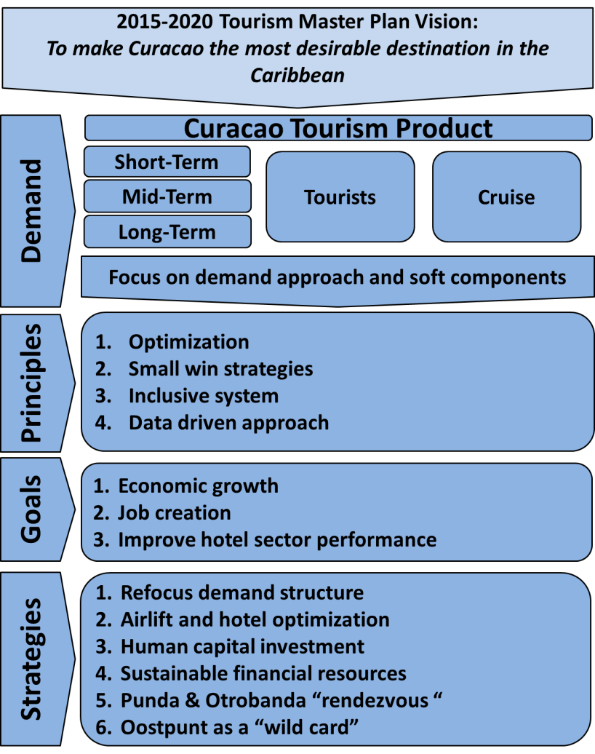

Figure 30: Strategic framework 2015-2020

Strategy #1: Refocus demand structure
In order for Curaçao’s RevPAR value to increase to a level that would create economic and job growth, it is necessary to refocus the current demand structure towards the American market. The relationship between tourism receipts and Curaçao’s economic growth is weak. Increasing arrivals under the current demand structure would only suggest marginal improvements on receipts given the lack of hotel consumption from the primary Dutch market.68

Refocusing the demand structure toward the American market without replacing the Dutch and Venezuelan markets, while sustaining the Latin American market through a shift towards the Colombian market, entails an additional influx of American tourists by year 2 of nearly 50,000 arrivals. This means that Curaçao must aim to double the amount of American tourists in two years. By year 5, the additional arrivals from the USA should increase to nearly 100,000, for total arrivals of 158,860 from the USA market (see Table 48). It is expected, that in the short- term, the Venezuelan market will decline due to the uncertain economic situation in the country. However, it is imperative that Curaçao moves to quickly penetrate the Colombian market in order to compensate as much as possible the potential loss of a portion of the Venezuelan market. Thus, by year 5, Curaçao’s tourism demand structure will shift toward 24.1% arrivals from the USA, 24.5% from the Netherlands, and 18.5% from Venezuela (see Figure 31).69

Table 48: Total arrivals forecast 2016-2020
Year | USA | Netherlands | Venezuela | Others | Total
2016 | 90,660 | 155,779 | 100,000 | 178,500 | 524,939
2017 | 124,249 | 159,258 | 105,000 | 187,425 | 575,932
2018 | 135,733 | 160,027 | 110,250 | 196,796 | 602,806
2019 | 147,136 | 160,540 | 115,763 | 206,636 | 630,075
2020 | 158,860 | 160,796 | 121,551 | 216,968 | 658,175

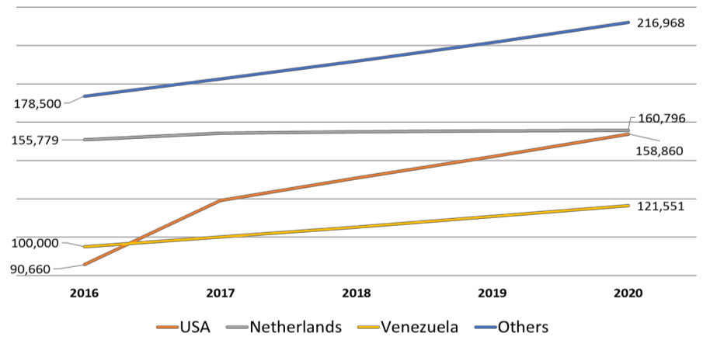

Figure 31: The new demand structure by 2020

It is important to emphasize that the refocused demand toward the American market is suggested because it is mandatory for Curaçao to increase the hotel sector’s financial performance. The hotel sector has the most potent short-term economic impact for the tourism industry. The most efficient means by which to measure the aggregate

68 Less than half of Dutch arrivals stay in hotel accommodations on the island.
69 This table reveals the scenario that will prompt the destination to the desired productivity. For the purpose of this report, a scenario is a Hypothetical case relying on a number of assumptions. The Venezuelan situation has deteriorated so rapidly that several adjustments were made during the course of the Tourism Master Plan. By now, it seems clear that the Venezuelan situation can prompt a similar market condition experienced by the destination in the second part of the first decade of the 21st century. That is why the remedial actions suggested in an alternative scenario is to work towards the penetration of the Colombian market to compensate for the potential Venezuelan loss. The strategic focus however is to keep the market share of the Latin American market at its current levels.

performance of the hotel sector is via benchmarking Curaçao’s RevPAR value. It is expected that by year 5, Curaçao’s RevPAR will increase to US$128.13, which brings Curaçao closer to the regional RevPAR (see Table 49).70

Table 49: Expected RevPAR from 2016-2020
Year | Rooms Sold | Occupancy | ∆ in Rooms  Occupied | ∆ in Rooms  Nights | RevPAR (%, $)
2016 | 4,500 | 75.0% | 300 | 109,500 | 7.50% | $107.50
2017 | 4,800 | 80.0% | 300 | 109,500 | 7.50% | $115.56
2018 | 4,890 | 81.5% | 90 | 32,850 | 3.50% | $119.61
2019 | 4,980 | 83.0% | 90 | 32,850 | 3.50% | $123.79
2020 | 5,070 | 84.5% | 90 | 32,850 | 3.50% | $128.13

The goal is to increase RevPAR at the end of year 2 by US$15.00. This means a 7.5% increase per year on average, which is the same regional RevPAR increase from 2012 to 2013. By year 5, the goal is to reach at least the 2014 RevPAR level of the Caribbean region at US$133.71 Achieving this objective implies significantly closing the RevPAR gap with the Caribbean region, thereby revealing a major stride with regard to Curaçao’s competitive position. This means that Curaçao must accomplish, from year 3 to 5, an average annual increase in RevPAR of 3.5%. The increase in RevPAR by year 2 will generate 1.9% real economic growth and will generate nearly 2,000 direct and indirect jobs. By year 5, the expected increase in these domestic economic activities will result in an average increase of the Real GDP growth of 1.2 percentage points during the 2015-2020 span. This increase will spawn an estimated 3,700 jobs (direct and indirect jobs).
The plan assumes that the closer Curaçao’s RevPAR value is to the regional RevPAR, the more competitive the destination will become. Also, if, Curaçao is able to achieve a higher RevPAR at a faster speed than that of the region, Curaçao will outperform its competitive set. The forecasted Caribbean RevPAR by 2020 is US$144. This means that the RevPAR would be moved from 35% to a little over 12%.72
In order to increase Curaçao’s RevPAR, the current room inventory must be optimized before adding to the supply mix. The expectations are to increase hotel occupancy rates to 84.5% by year 5. In order to maximize the current room inventory and increase RevPAR by 28% in 5 years, Curaçao needs to increase arrivals by 145,000 tourists in 5 years. Of those 145,000, 100,000 should stay in hotels. The number of tourists is estimated by allocating the available room inventory by market share based on the tourists’ potential and travel profile (party size and length of stay). In addition, there is an opportunity to convert cruise visitors into stay-over tourists. In order for this to occur, the CTB and the Curaçao Port Authority (CPA) should collaborate on marketing efforts to target cruise visitors while there are in the destination.
It is also of utmost importance that Curaçao’s tourism officials recognize that the seasonality that influences tourism demand must be addressed. This means that the seasonal influx between low and high tourist arrivals must be distributed more evenly throughout the year. For example, the Curaçao North Sea Jazz Festival occurs within a relatively low demand month for Curaçao. Due to the festival’s success, the hotel occupancy rates are increased during a normally low month. Curaçao must look for other creative opportunities like that of the festival to boost arrivals during low demand seasons.73

70 By 2014 the regional RevPAR was nearly US$133. See Integra Realty Resources-Caribbean (2015). IRR Viewpoint, Caribbean Market Update- 2015 Annual Report.
71 See Integra Realty Resources-Caribbean (2015). IRR Viewpoint, Caribbean Market Update-2015 Annual Report.
72 The forecast is based on STR time series from 1993-2014, employing a step-wise regression.
73 According to the 2014 CNSJF’ report: ”The RevPar of August, 2013 was US$98.41 which exceeds the RevPar of all months, except the months from January to April with more than 40% of the revenues of the hotel industry stemming from the festival.” See Rivera et al. (2014). The Curaçao North Sea Jazz Festival: A lustrum churning economic and promotional opportunities for Curaçao.

Strategy #2: Airlift and hotel optimization
A lack of accessibility will restrict the number of arrivals. A review of successful destinations in the Caribbean region suggests that, generally speaking, the islands that are more accessible have more visitors. Curaçao will need to increase its airlift to compete with other destinations in the region.

As arrivals increase due to the increased accessibility to Curaçao, and assuming that the hotel room supply is inelastic (number of rooms are fixed), hotel prices will increase. Small island destinations typically witness this phenomenon during the high season (November to April) in the Caribbean region. Based on this logic, the DPITS recommends aggressive outreach to American carriers to increase airlift to the island.

In order to meet the suggested demand increase from the US market, an increase in airlift will be required. The increase in airlift from the US is vital for the tourism industry in Curaçao.74 By 2017, the goal is to increase the current level of airlift by ten weekly flights from the 2015 baseline. The main priority region from the US is the Middle Atlantic region that covers New York, Pennsylvania, New Jersey, Maryland and Delaware (see Figure 32). By 2020, Curaçao will need twenty additional weekly flights from the USA (above the 2015 baseline) in order to airlift 100,000 additional arrivals. The additional flights should depart from the Middle Atlantic, the Mid-West and South priority areas within the USA continent.

It is clear from the data that the destinations that have the most airlifts will deliver the most returns. Therefore, because Curaçao needs to find a means to fill the current inventory of rooms (optimize), it will need to partner with airlines to ensure affordable airfares. Also, destination officials and hotel managers should work together to embrace social media platforms. Findings suggest that the most profitable segment (the mavens) are information “omnivores” requiring constant interaction on social media platforms. Effectively managing social media has shown to be a critical pathway to increase RevPAR. Therefore, hotels and the destination should ensure that they are in good (great) standing with regards to reputation categories such as rating, thumbs up, and class, for example, in TripAdvsior.
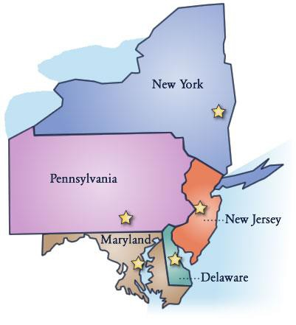

Figure 32: US potential market

Strategy #3: Human capital investment
The plan suggests a sharp focus on the enhancement of Curaçao ’s human capital. Enhancing the quality of human capital is the core necessity of tourism’s soft component. Increasing the number of arrivals to Curaçao, as suggested in strategy #1, will impact economic growth and job creation. However, the continued success of strategy #1 is dependent upon the simultaneous increase in the quality of tourism experiences. One form of tourism experience that is a low risk but high return on investment is the drastic improvement in the soft component. Empirical evidence

74 Airlift remains a significant hurdle to increase the number of arrivals and to fill hotel rooms in the Caribbean region, according to a survey conducted by KPMG in 2012 among hotel properties in the region. See KPMG (2014). 2013 Caribbean Hotel Benchmarking Survey.

shows that overall quality perception has the largest impact on overall satisfaction of tourists visiting Curaçao (Beta=0.444, p<0.01).75

In order to deliver high-quality tourism experiences, greater attention must be paid to the quality of products and services which includes: sustainable development, superior work in tourism, and highly qualified management that is capable of developing the human capital skills that will satisfy tourists. Curaçao must see an aggressive conversion from the status quo service skills and attitudes to a service- based industry mindset. This conversion requires a rapid increase in the amount of available human capital with the right types of skills.

Developing the readily available human capital is directly associated with configuring a positive attitude amongst tourism employees, increasing the manpower in the industry, improving negotiation skills, enhancing technical skills, and increasing work effectiveness. Education and training are at the core of accomplishing these objectives. In order for Curaçao to create real value, businesses are advised to leverage human capital by developing large numbers of employees into better-educated workers who will be able to create more high-value-added products and services at low costs. However, it is important for managers to realize that it may be difficult to recruit and retain qualified staff in Curaçao, thus resulting in high search costs for employers and employees.

In order to achieve the quality and quantity of human resources needed, it is imperative that the Human Resources Infrastructure System be reinstated. This system was intended to list job openings that were available on the island. However, to the best of knowledge, the system has failed. In order for tourism and hospitality businesses to reduce the costs involved in recruiting qualified individuals, and for potential employees to locate viable job opportunities, a databank that includes all available tourism jobs on the island must be created.

One of the primary challenges related to human resource development in the hospitality and tourism industry is how to forecast the future skills required to meet the changing needs and preferences of tourists and the sector. In order to meet these changing needs, it is necessary for Curaçao to embrace a human resource manpower program that is specifically designed for the tourism sector. This program should identify employment opportunities, required skills, and the talents necessary to move the industry forward. It is important to incorporate within this program a creative detection mechanism that would match the needs of the industry with the skillset of the employees. Collaboration between academia (university), the industry, and the government are all necessary to support this program.

The DPITS recommends that the CTB implement an investigation on the career opportunities available in the industry, as well as tourism employees’ compensation and benefits. The information should then be shared with the public at large. If the data reveals that the industry does not bolster adequate compensation and benefits worthy of talented individuals, the industry will not prevail. A survey on compensation, benefits, and employment opportunities should be done annually in order to create a strong data bank that can guide employers and potential employees in the hospitality industry. The annual survey can shed light on the industry’s wages and salaries, employee benefits packages, pay increases, and merit and incentive plans, as well as corresponding performance measures, and recruiting sources.

The degree to which tourism businesses invest in employee training and development will significantly influence the businesses’ long-term economic impact. Because the hospitality industry in Curaçao consists of multiple small businesses, and in order to make training costs more affordable, the private sector can support industry-wide efforts to train young people and support schools and universities. For example, the private sector can contribute their knowledge or scholarship money to college courses and training centers so that training is provided for large numbers of people, thus strengthening the talent pool and saving themselves the direct cost of training. A model, such as the Ensenanza pa Empleo in Aruba, that has successfully facilitated the transition from an industrial to a service/hospitality mindset, could serve as a model.

75 Quality is defined in terms of service delivery and product offerings.

Several different approaches can be adopted to shift the collective mindset in the tourism industry toward high- quality service standards. This shift is necessary in order to achieve the desired end goal of a high-quality workforce capable of providing excellent service.

These approaches include:
  - Large hotels may be required to have a significant share of their employees in training, incentivized by tax reductions
- Advocacy for the benefits and career opportunities available within the hospitality industry at a young age (e.g. middle school and early high school)
- Incorporation of an “industry overview” into hospitality and training programs that includes discussion of job demands, typical working hours, and service expectations
- Incorporation of “interview readiness” into hospitality and training programs to discover the right job attitudes
  - Expansion of current education and training programs to include competency development in areas such as professionalism, communication, language, relationship building, service, and teamwork
  - Holding employees accountable to service standards, and documenting positive and constructive feedback/coaching

Training programs and their execution should go together with a national awareness campaign that promotes tourism development as a key vehicle for the enhancement of the residents’ quality of life. The report already documented that a large portion of the local population does not understand tourism and its potential to positively affect their daily lives. Local residents have a huge influence on how the ultimate tourist experience is defined and felt. This role should be clearly understood in order to spawn memorable experiences. The program “Beautiful People” is a good start to reach this goal in the short/medium term.

Strategy #4: Investing in the future: Sustainable financial resources
In order to infiltrate the necessary amount of arrivals that is required to increase the RevPAR value to the level of the Caribbean region by 2020 (US$128/US$130), a sustainable fund should be available. The fund is suggested to be in the amount of US$40 million over five years. A substantial amount of this fund will be allocated to bring the American market up to nearly an equal level with that of the Dutch and Venezuelan markets by 2020.

A significant portion of the fund will be allocated for marketing and airlift, especially in the first two years of this plan. Luckily for Curaçao, the data demonstrates that the destination does not require significant investment in its hard components of tourism (infrastructure) within the lifespan of the 2015-2020 Strategic Tourism Master Plan. The data actually reveals the contrary, which is that Curaçao should invest financial capital mainly in marketing, airlift, and aggressively improving the soft component (human capital). The luck of the draw for Curaçao is that the investment required to dramatically improve tourism’s soft components is much less expensive than sinking investments into infrastructural design and development.

The goal is to raise the money for the fund via a loan in year 1. The sources to finance the loan will stem from additional room tax, more effective room tax collection, and from other non-conventional sources (other economic sectors) that benefit from the increase in tourism revenues. It is expected that the additional tourists visiting the destination will have a positive effect on the foreign reserves of US$83.2 million in 5 years, and will completely exceeds the reserves’ outflow that is used for the required imports of goods.76 The additional forecasted tourism demand will generate an estimated 3,700 jobs as well.

76 The demand forecasting model is based on a decomposed trend and cycle data using the Hodrick Prescot filter. Prior to decomposition, the variable was first transformed into logarithm. Subsequently, both the trend and cycle components were estimated backwards and forwards using their lagged values (up to 12 years), applying a combinatorial regression technique. The latter determines combinations of lagged trend and cycle variables that are significant to the regression. The forecasts are adjusted with part of the errors found in the backcast of the period

Another aspect that needs to be addressed is the cost of doing business in Curaçao. Currently, that cost is not an attractive proposition for investors. The efficiency with which the investment process is handled in Curaçao is time consuming, frustrating, and risky for investors. Therefore, the process must be improved if investment in the tourism industry is to increase. The following steps should be accomplished in years 1 and 2:
  - Streamline permitting
  - Increase efficiency in utilities in order to lower utility costs, thereby lowering direct costs to production (especially in hotels)
  - Reduce market distortions by easing or liberalizing the hiring of expatriates to provide quick and affordable skills that are missing on the island.
  - Accelerate knowledge transfer in order to increase the quality of the service delivery

Strategy #5: Punda/Otrabanda as Curaçao’s tourist rendezvous
The DPITS findings indicate that Punda/Otrabanda have become important attractions for the stay-over tourists as well as the cruise visitors. The mid-term goal (years 3 and 4) is to transform the UNESCO World Heritage site, Punda/Otrabanda, into a vibrant rendezvous area for tourists (see Figure 33). The largest component required to sustain tourist demand in today’s market is to provide destination product platforms that display a destination’s raw and untouched cultural authenticity. These platforms should make locals proud. The history and the heritage represented should give reason and cause for locals to celebrate. And, if the locals are willing to create a platform that invites tourists to share and feel the local Curaçao culture, the experiences will be memorable for all involved.

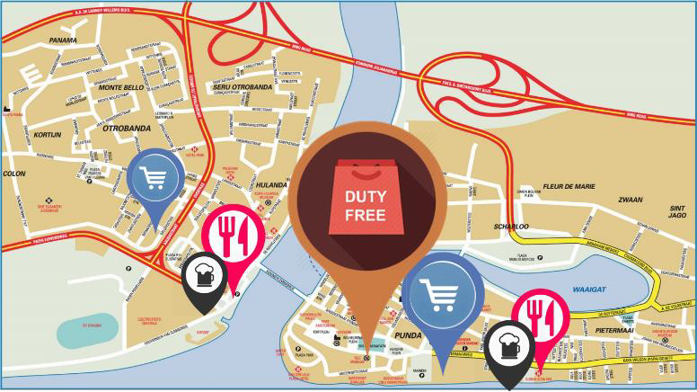

Figure 33: Punda/Otrabanda Map

Many island destinations have created tourist districts that intentionally separate the island people’s everyday life from the historic monuments that the tourists would like to see. This practice, more or less, degrades the cultural authenticity of a destination. It becomes difficult to infiltrate tourists into areas away from tourist districts since island destinations have already sunk cost into the tourist districts that had separated authentic culture from historic attractions. Curaçao is not in this position. Curaçao has the opportunity to create experiential tourist clusters which include heritage sites that locals enjoy alongside the tourists every day.

2004-2013. The forecasts are based on the assumption of unchanged policy. The economic impact is derived from the Turistika and Curalyse models. We are indebted to the team within the Ministry of Economic Development of Curacao for their assistance regarding the sectorial economic impact analysis done with the application of the Turistika model and the macro economic impact analysis done with the application of the Curalyse model.

Tourism offers opportunities for continuation, rejuvenation, and enhancement of traditions and a way of life.77 The investment in heritage for livability, job creation, and local economic development is beneficial to Curaçao. The attraction of the Punda/Otrabanda area is that the historic core differentiates this location from other locations in Curaçao, branding it nationally and internationally.

In order to convert the Punda/Otrabanda site into a vibrant experiential cluster that highlights its clear historic identity, there should be a balance between rules, regulations, and incentives. Rules and regulations compel all businesses to implement similar practices that do not take into account the cost of doing business. Designating a venue as a UNESCO heritage site is accompanied by a set of regulations that limit what an owner can do with the property. For example, these regulations prohibit the demolition of the building, require specific materials for building upkeep, and require a special approval process for building permits. However, these regulations may stifle investment and commercially viable activities, thereby hampering job creation and the generation of income. Therefore, the introduction of incentives for business owners may balance or reward those people willing to invest in the heritage site.

It costs money and the government’s institutional capacity to cope with preservation management activities while simultaneously addressing multiple social and economic challenges of a small island destination. Our conversations with local stakeholders suggest that the local government lacks funds and institutional capacity to keep Punda/Otrabanda on the UNESCO heritage list.78 Therefore, regulations should go hand in hand with incentives (tax reduction, grants, designation of duty-free area) in order to convert this asset into an economic powerhouse.

If Curaçao is to maintain a UNESCO World Heritage site, then Punda/Otrabanda should become a place where people like to go, meet, live, work, and invest in, thereby linking heritage conservation and local economic development. This site should become a lifestyle site, which is defined as energetic public spaces that encourage lounging via free Wi-Fi, creative food and beverage outlets that are easily accessed, excellent shopping opportunities, innovative entertainment products, and engaged exposure of the island’s history and culture.

Ideas that may be considered to encapsulate a lifestyle site may include location-specific technologies and data communication systems. A tourist could benefit from information about the heritage site, including audio and printed maps/directions, listings of restaurants and shops, and even recommendations and reviews from other users. Another idea is to allow a two-minute, free telephone conversation with friends/family around the world during the day for cruise passengers, and in the early evening for tourists. These conversations would be viewed on large screens in strategic locations in the heritage site. This is a way to ensure a constant flow of people in the historic city core.

In order to achieve this, the use of incentives should be based on market instruments rather than “command and control” measures. This means that mandated rules and regulations that monitor business practices and operations are costly endeavors. In other words, the laws that protect the UNESCO World Heritage site are necessary from a cultural perspective, but a cultural perspective does not propel the necessary investment in the area that would maintain and keep the site on the UNESCO list. The DPITS suggests that incentives must be put into place in order to leverage heritage for jobs by incorporating a cultural dimension into the development framework.

Data suggest that this Punda/Otrabanda area has a unique opportunity for combining cruise tourism and stay-over tourism in terms of opening hours, shopping mix, and food and beverage, as well as entertainment in general. As the American tourists prefer beach consumption, entertainment, and socializing opportunities, the development of

77 See Licciardi, G. and Amirtahmasebi (eds.) (2012). The Economics of Uniqueness. World Bank, Washington DC.
78 This view also resonated in our encounters with Parliament in December, 2014 and May 2015. For a discussion on the relevance of heritage sites as assets for economic development in small island destinations, see UNESCO (2014). Culture & Development, World Heritage in the Caribbean. Regional Office for Culture in Latin America and the Caribbean. Havana, Cuba.

the area would increase the likelihood of drawing this segment. Moreover, the American consumption pattern could fit well with what Curacao has to offer in terms of its present everyday life mosaic, which is prevalent in the culture of the island. Additionally, this area will provide the residents with a district in which they may like to seek employment, as well as frequent during their leisure time.

Strategy #6: Oospunt as Curaçao’s wildcard
Ultimately, Curaçao should consider the quality and size of its hotel inventory. By year 4, it is assumed that, should the plan work, hotels’ occupancy levels should reach their optimal use (around 85%). At this point, destination managers should have brought quality brand hotels to the island in preparation for their 2020 inauguration date. Moreover, at the conclusion of the 2015-2020 Strategic Tourism Master Plan’s lifespan, current room supply will be optimized and revenue earnings maximized. Therefore, additional high-quality room inventory, as well as tourism offerings, will be required to sustain the path of prosperity.

In order for tourists to pay premium hotel prices, assurance of quality and reduction of perceived risk in consuming an intangible good must be present. Therefore, recognizable or strong brand equity reduces the perceived monetary, social, or safety risk in buying services: or in visiting destinations that are difficult to assess prior to purchase. As potential tourists spend significant amounts of time in searches for information related to their vacation, a distinct destination brand awareness reduces the search cost, thus facilitating the selection of the destination. Therefore, Curaçao should evolve steadily toward a reliable and quality brand destination.

While the anchor toward the path of prosperity is premised on enhancing and nurturing human capital and its consequential externalities (soft component) in the short and mid-term, the distinguishing element in the destination’s long-term viability as a superior brand destination is the development of Oostpunt. Oostpunt could be the final distinguishing signature of the future Curaçao product. The region, due to its unspoiled nature and its sheer size (the size of St. Maarten), is poised to become the hallmark of sustainability through the most pristine form of green tourism (see Figure 34).

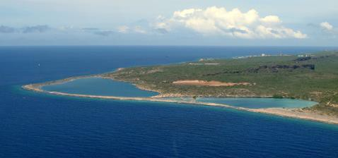

Figure 34: Oostpunt

As more tourist organizations view sustainability not only as “the right thing to do” but as a prominent marketing strategy, Curaçao could create a creative sustainability program. That program design and development could be the apex standard of green wise management. Indeed, Oostpunt provides a unique opportunity for generating a story line about Curaçao’s efforts to become a champion of green practice among small island destinations in the world. Again, a strict balance between rules, regulations, and incentives has to be created in order not to stifle development and restrict activities. The plan recommends that the development of Oostpunt follow the guidelines expressed in the UNEP document of 2011. 79

79 See UNEP (2011). Tourism: Investing in energy and resource efficiency.

Surely, for Curaçao to be branded as a sustainable destination, the CTB together with stakeholders should establish a rating system that encourages hotels, attractions, and restaurants to optimize environmental performance and reduce environmental impact. This rating system, according to international standards, should encompass five main categories: energy, water efficiency, sustainable purchasing, waste management, and occupant health/comfort. However, if Curaçao meets and exceeds international green standards, then it befits the destination to develop a rating system that is unparalleled to those of any other existing green standards’ pursuits.

Strategic supporting actions

Actions to improve hotel productivity
Three main markets support Curaçao:
- The Dutch segment currently comprising 30% of the market
- The Venezuelan segment comprising 25% of the market
- The American segment accounting for 12% of the market.
While all three segments are similar in their preferences for beach and water activities, data reveals that the segments do reveal different tastes and preferences. The American segment is attracted by high-level hospitality and positive attitudes; the Dutch segment gravitates toward safety and accommodation quality, while the Venezuelan and Colombian segments seek variety in restaurants and hotels. Understanding these nuances in tastes and preferences are important for brand awareness and product development. Visitors from these three segments rated safety, accommodation, restaurant quality, ease of mobility, familiarity, and value for the money as important factors defining their experience on the island. Figure 35 depicts the nuances among the three segments.

Clearly, the first two years of the plan are embedded in enhancing the product image in all three markets, and in emphasizing the previous tastes and preferences - with particular aggressive marketing efforts toward the American market. The marketing efforts go in tandem with hotel room optimization, increased service quality, and airlift optimization and connectivity. The slogan, “Curaçao, a different Dutch Caribbean,” could be emphasized using words displayed in Figure 8 of this plan, (e.g. excellent, great, wonderful, and fantastic). These words could embellish the slogan in all promotional material.80

The CTB should constantly assess and update the motivation structure for each one of the segments. In particular, ample attention should be dedicated towards the maven segment which appears to be the most promising segment to support the plan’s goals.

In order for the CTB to lead this process of major market penetration in the American market, shifting away from the Venezuelan to the Colombian market, and to convert a portion of cruise passengers to stay-over tourists, the CTB should undertake the following actions in the short term:

- Create the new CTB structure
- Hire a new CEO
- Hire a new marketing agency in the USA
- The CTB and hotels should develop together an aggressive social media program
- Secure the US$40 million loan
- Secure additional airlift from the USA
All these actions require a high level of coordination. Coordination, trust, and collaboration are vital elements in a coherent, effective, and inclusive policy environment. More coherence in terms of targets (market segments, positioning, revamping of the hotel portfolio), management (institutional coordination, impact analysis studies), and

80 Curaçao should make use of its Major League baseball players as spokespersons to the American public. The NYT recently published an extensive article about Andrelton Simmons and Didi Gregorius referencing their birthplace of Curaçao on several occasions. This article is an example of how the island can be promoted in the American market. See Witz, B. (2015). Two Shortstops Share Journey: Small Island to Big Leagues. New York Times, August 30, p. 3 (Sports).

incentives (effectiveness, cost-benefit, and adequacy) is required to maintain sound competitive advantages. All these tasks require high doses of creative and experienced talents. Institutions that can nurture, discover, and provide room to implement these tasks and practices are necessary to sustain a competitive advantage.

Actions to enhance human capital
Enhancing service quality requires the continuous adoption and updating of skills and competencies, as well as attaining the right attitude from the hospitality industry. The existing training programs are not properly designed to face the organizational challenges of the local businesses, nor are they designed to discover the required talents to move the industry forward. Supervisory direction seems lacking in hospitality organizations, thereby compromising a hospitality organizational culture that is attuned to enhancing the service delivery quality. For example, the existing program at the Academy Hotel is not providing students with the experiential learning to excite them to work in the industry. The public education system’s curriculum is failing with high dropout rates and graduates that lack the knowledge and knowhow to even enter the market, much less enhance and move the tourism industry forward.

The existing UNDP draft document extensively elaborates on how to improve the educational and training programs in Curaçao in order to imbue the local human capital with the required skills, competencies, and attitudes that the global market requires. In addition, this strategic plan recommends applying an institutional learning framework that could resemble the Ensenanza pa Empleo that has successfully facilitated the transition from an industrial to a service/hospitality mindset. The plan also recommends that the CTB and the Department of Labor organize a number of short seminars to upgrade the knowledge and skills - especially of leaders and supervisors. The series of seminars could assume a kind of “train the trainers” where managers and supervisors who possess the specific skill sets, characteristics, exemplary service standards, and management styles that are required to move the tourism industry forward will train other managers and supervisors that do not possess these specific traits. Finally, in order to quickly accelerate knowledge and skill transfer, the plan suggests the elimination of the 80/20 rule.
Specifically, the 2015-2020 Strategic Tourism Master Plan envisions a program that:

  - Certifies 5,000 employees in hospitality services by year 4
  - Increases the public perception of tourism’s value to 70% of the population by year 4
  - Places 70% of graduates from university and professional programs in jobs
Additionally, the 2015-2020 Strategic Tourism Master Plan advocates for the people of Curaçao. This plan intends to bring the tourism industry to the forefront of all economic sectors on the island. The tourism industry will serve the people via improving their quality of life. In order for this to occur, it is necessary for the people of Curaçao to understand, respect, and appreciate their heritage. Certainly, this means that the people of Curaçao must look within their island life to learn why the rest of the world would travel great distances to experience Curaçao’s culture. Whereas the canvassed data revealed that close to 75% of tourists would consider returning to Curacao after their experience on the island, most of the qualitative data indicated that locals do not understand why a tourist would want to come to Curaçao. Thus, while the rest of the world sees the island of Curaçao, its people, and its culture as beautiful, sadly, to the people of Curaçao, there seems to be nothing that is appealing for tourists.

If the people of Curaçao cannot fathom the beauty of the natural resources that Curaçao possesses, or the eclectic culture that has emerged from an ethnicity fusion that is so rare – then, the DPITS is concerned that Curaçao may never emerge as the tourism powerhouse that it is capable of becoming. Therefore, the 2015-2020 Strategic Tourism Master Plan emphasizes the importance of supporting the public relations campaign, “Beautiful People,” commissioned by the CTB.

The tourism public relations campaign should also include documenting and reporting tourism benefits in terms of job creation on a regular basis. A campaign should be designed called tourism works, which refers to one job for every 44 new arrivals. There should be a major screen in the downtown area and other public areas announcing every 44 new arrivals to the island.

Finally, a special training program should be designed to guide and direct optimal performance of ground transportation, in particular the taxis service delivery. Tourists perceived taxi service as being low quality and even negative in terms of influencing their overall satisfaction with their experience with the destination. It is important for taxi drivers to become aware of the critical role they play in reaching and getting around the island. A tourist’s first encounter with a destination often takes place during the first taxi ride after leaving the airport. Therefore, it is recommended that quick attention should be given in cycle one to train taxi drivers to improve their customer service and interaction skills when dealing with tourists while on the island. It is suggested that all taxi drivers- without exception- should enroll in the program. The program will focus on transforming driver behavior and attitude, with the aim of enhancing their skills to offer better service to tourists. Upon the successful completion of the program, it is necessary to provide the taxi drivers with either a tax incentive or compensation for the hours that they served in the program.

Embracing product staging at the mid-term: Acquiring sustainable products
After the optimization years (1 and 2), the plan suggests changing gears and prioritizing the creation of sustainable tourism products. Creating tourism products are vital to the consolidation of businesses in terms of operations, practices, and profitability. The focus of this timeframe is to accelerate, enhance, and innovate product development on the island. This timeframe references product image, experiential clusters, and further enhancement of human capital.
Product image pertains to the appearance of physical attributes, attractions, facilities, information dissemination and hospitableness. There are several sites on the island that look unappealing and require infrastructural attention to make them aesthetically alluring. Further, there are many attractions that need to be cleaned, polished, maintained, and promoted for better development on the island. According to the CTB’s record, there are more than 101 accommodation facilities, more than 150 attractions, and more than 200 restaurants - all establishing a strong base for captivating tourists.
Product image also entails providing information directly to tourists in order to minimize their search cost while on the island. For example, data indicates that tourists do not seem to be aware of the existence of Curaçao’s attractions. More than 75% of the existing attractions are patronized by less than 20% of visitors. The poor patronage of the attractions implies that either they are unattractive in their current configuration, or visitors are unaware of their existence. Attractive promotional plans could be developed for these attractions.
Data also indicate that the longer tourists stay on the island the more bored they become, and the less likely they are to return to the island, or recommend the island to others. The reason for boredom seems to be the lack of sufficient attractive product offerings. The plan recommends a two-pronged approach to confront this issue:
- Shift away from the current Dutch tourist profile that incurs a length of stay of more than nine days. Ideally, Curaçao should work toward product offerings of eight nights.
- Accelerate the creation, or reinvention, of attractive product offerings in response to the tastes and preferences of specific markets.
Tourist offerings should be presented, packaged, and tailored in the types of creative approaches that will result in strong emotional engagements, as well as high-quality visitor experiences and memories that lead to revisits and referrals. To facilitate an environment that engages in creative offerings, provisions for financial assistance and access to venture capital is crucial. Therefore, the CTB must provide regular business intelligence and future growth insight to give lenders and providers more confidence in tourism investment. Further, to meet guests’ wants and needs in this changing world, it is necessary to ensure that focus remains on the customer as the industry consistently moves forward.

Thus, in developing creative and innovative offerings, the destination may no longer define tourists in its own terms. This means that destination providers and suppliers must take the time to understand and converse with tourists in their own language in order to build a deeper understanding of precisely what it is that tourists want while on the island. This would allow for building social relationships with guests at a deep level – a vital step for the future success of local hospitality businesses.
An example of product development is the revitalization of the Punda/Otrabanda UNESCO Heritage site. The revitalization of buildings and open spaces for contemporary purposes provides opportunities for sustaining traditional and contemporary Curaçao cultural values. Historic buildings and open spaces that are left abandoned are at risk of physical decay, and represent a loss of opportunity to revitalize structures that contribute to the identity of Curaçao and its social traditions. The inclusion of hotels, restaurants, offices, and shopping could complement art galleries, museums, and performance venues for their re-use; and the revitalization of heritage places as creative and attractive venues for tourists and local residents are prime examples of beneficial product development.
Data indicates that revitalization of this unique UNESCO site should consist of the following elements:81
  - By year 2, declare the UNESCO heritage site as a duty-free area.
  - Make flexible opening hours to accommodate cruises and stay-over demand. Data shows that cruise passengers prefer opening hours in the day, while stay-over tourists prefer opening hours in the late afternoon and evening.
  - Both segments are interested in shopping, food and beverage, and entertainment.
  - The preferred shopping mix consists of (in order of preference): clothing, shoes and accessories, perfumes and cosmetics, jewelry, electronics, alcohol, and tobacco.
  - With regard to the preferred types of restaurants, preferences are ranked in the following order: fine dining, pub bar, gourmet and bistro, and gourmet café.
Another example of product development is cruise packages. The most preferred cruise package according to respondents sampled from cruise visitors involves a time duration of 4.5 hours followed by 3.5 hours. The cruise passengers indicated that they prefer tour packages that include the following, in order of preference: historical attractions, beaches, entertainment, shopping, and wellness activities. With regard to the type of service visitors favored on their cruise tours, they indicated a preference for full meals rather than only beverages, or beverages and snacks. The first preferred price point isUS$89 followed by a price point of US$69.82
Curaçao has a bundle of unique and successful events (e.g. Curaçao North Sea Jazz Festival, the film festival, and BlueSeas Festival). It behooves destination managers, as well as other stakeholders, to join forces in supporting such events as well as creating new events (e.g., music festivals of similar caliber). Events such as these reveal the real character of Curaçao and its unique hospitality features. These events have revealed that blending entertainment with socialization opportunities is a recipe for tourism success. Curaçao is frequented by two popular types of tourists. Those traveling with their family to create enduring family ties, and those tourists who search for cultural

81 Preferences are ranked according to a conjoint analysis to estimate tourists and cruise visitors’ preferences in terms of shopping, types of restaurants, time of day, and type of shopping experience. Tourists and Cruise visitors’ preferences are almost homogenous with the exception of perfumes, cosmetics, tobacco, and alcohol. The conjoint analysis is based on a survey consisting of 301 respondents, cruise (n=130) and tourists (n=171). See the complete results in Annex 4.
82 The sample size was 127 respondents, which complies with the validity requirements for a conjoint analysis. The complete results of the analyses are revealed in ANNEX 4.

interaction and entertainment.83 The previously mentioned events provide opportunities for both types of these tourists.
In order to accelerate creative and innovative product development, policy intervention is required to facilitate consolidation of profitable and sustainable business practices (e.g. trust and collaboration). Policy intervention should range from direct incentives, duty-free status in the UNESCO site area (Punda/Otrabanda), and risk-taking by the government. Risk-taking for the government could include the creative tax incentive packages to induce businesses to invest in new products, offerings, and upkeep.
The current plan suggests that by year 3, the government should provide a tax-free window for import duties so hotels could engage in upkeep activities of the facilities. By year 1, the government should announce this import duty-free opportunity as earmarked for the upkeep of hotels; and, it should broadcast that the tax window will repeat every four years. The tax window should generate in year 3 at least US$30 million in investment in upkeep of the facilities.
The destination should also consider the proper accommodation mix in order to mitigate the high volatility of arrivals and spending. Diversifying the hotel portfolio by including timeshare properties can help mitigate volatility and would complement the diversification strategy towards the USA market.
The specific actions are as follows:

- Create a tourism development fund nurtured mainly by room taxes collected from short-term rentals (apartments)
- Establish a tax free window to promote the refurbishing of current hotels
- Establish the UNESCO ascribed heritage area as a duty free area
- Increase airlift from the USA
- Increase RevPAR
- Certify 5000 employees
- Realize a cruise conversion rate of 5%
- Increase cruise visitation in the summer by 30%

The objectives and implementation cycles of the five year plan are displayed in Figure 35.

83 For a discussion on the purpose of taken vacations, see Lehto, X., Choi, S., Lin, Y. & MacDermid, S. (2009). Vacation and family functioning. Annals of Tourism Research, 36 (3), 459–479. A recent AAA survey reported that the two most important drivers of American tourists to travel in the summer is warm weather and entertainment.

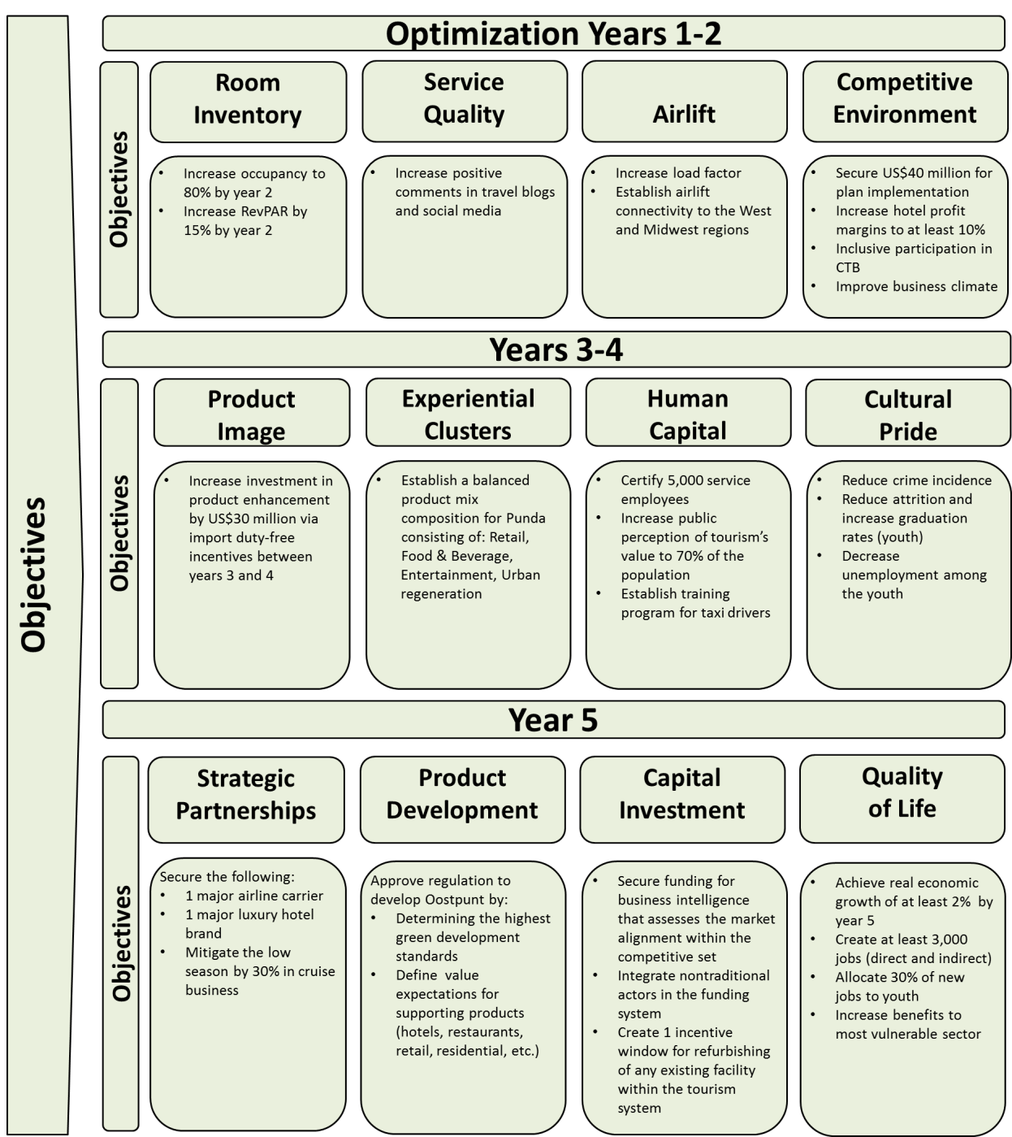

Figure 35: Objectives and strategic actions

The long-term perspective: Accountability and transparency
In order to evaluate the effectiveness of these recommendations, the plan suggests putting a monitoring system in place by year 5. The monitoring system includes the organizational environment, support, and the expertise that can provide sophisticated analysis to stakeholders. The monitoring system should be housed in the newly converted CTB and should concern itself in marketing, sales, and business intelligence as well as in updating monitoring mechanisms. Staff with required expertise and experience should populate this special monitoring unit within the new CTB. This unit is not only tasked with the constant monitoring of the implementation of the plan, but with the timely reporting of results to all stakeholders as well.

The monitoring framework consists of a number of connected metrics to help achieve the objectives set forth in this plan. These metrics include RevPAR to meet the objectives of economic growth and job creation; they would also measure the destination’s level of competitiveness with regard to Curaçao’s competitors in the Caribbean region. A number of certified employees will measure training achievement and skill progress. Quality of life is measured through the amount of jobs, and the numbers of youth attaining those jobs. Quality of university and professional programs will be assessed through the extent of placement in the job market.

Obtaining timely intelligence and operational feedback with which to fine tune or change a course of action is required and crucial for the successful implementation of the plan. In addition, this timely information feedback is also intended to promote stakeholder buy-in when needed, and to increase the credibility and reputation of the 2015-2020 Strategic Tourism Master Plan. Making sure that a form of social license is validated and upheld is vital for the advancement and progress of the plan. In other words, the constant support of all stakeholders is not only critical but absolutely necessary. For without constant support from all stakeholders the ability of the 2015-2020 Tourism Master Plan to deliver a promise to carve a better future for the industry and for the island as a whole could be in jeopardy.

There is a need to conduct periodic evaluations and impact analysis of tourism incentives due to the phenomenon of free-riding observed on the island. Free-riding is pervasive in many small destinations and should be avoided with an effective performance monitoring and impact evaluation mechanism. By steering the direction of policy and spearheading product development efforts, government authorities can motivate and influence other stakeholders—both public and private—to engage in behavior that bolsters a destination’s competitive advantage.

References
Aaker, D.A. (1996). Building strong brands. New York: Free Press.
Alhemoud, A. and Armstrong, E. (1996). Image of tourism attractions in Kuwait. Journal of Travel Research.
34(Spring), 76-80.
Baloglu, S., and Brinberg, D. (1997). Affective images of tourism destinations. Journal of Travel Research, 35(4), 11- 15.
Berkhout, E., (2007). An econometric analysis of tourism inflow in Curaçao: Can tourism price indices help us out? SEO Economisch Onderzoek. Paper presented on the 1st Contference of the International Association for Tourism Economics, Mallorca, October 25-27, 2007.
Caribbean Tourism Organization (2014) Caribbean tourism Review 2013. Retrieved from: www.onecaribbean.org/wp.../Caribbean-Tourism-Review-2014.docx
Chen, J. S., and Hsu, C. H. C. (2000). Measurement of Korean tourists’ perceived images of overseas destinations.
Journal of Travel Research, 38(3), 411-416.
Chen, P. J., and Kerstetter, D. L. (1999). International students’ image of rural Pennsylvania as a travel destination.
Journal of Travel Research 37(2), 256-266.
Court, B. and Lupton, R. A. (1997). Customer portfolio development: Modeling destination adapters, inactives, and rejecters. Journal of Travel Research 36(1), 35-43.
Croes, R., Rivera, M. & Semrad, K. (2010). Economic Impact Study, Curacao Tourist Board. Dick Pope Sr. Institute for Tourism Studies: Orlando, FL.
Croes, R., Rivera, M. & Semrad, K. (2010). Economic Impact Study, Curacao Tourist Board.
Croes, R., Rivera, M. and Semrad, K. (2010). Curacao Tourism Economic Impact 2007-2008, prepared for the Curacao Tourist Board, DPITS, Orlando, September 15.
Croes, R., Rivera, M., Pizam, A., Lee, S. H., Zhong, Y. Y., (2011) Winning the future: Strategic Plan for the development of Tourism. Retrieved from digital library UCF website: http://digital.library.ucf.edu/cdm/ref/collection/DPI/id/17
Croes, R., Rivera, R., Semrad, K., Dickson, D., Pizam, A., Shapoval, V., and Orlowski, M. (2014). From Attribute orientation to experiential consumption: the future of tourism in Curacao. Curacao Tourism Board.
Crompton, J. L. (1979). An assessment of the image of Mexico as a vacation destination and the influence of geographical location upon that image. Journal of Travel Research 17(1):18-23.
Curacao Central Bureau of Statistics (2002). Income from direct taxes. Retrieved from http://www.cbs.cw/cbs/themes/Economy/DataEconomy-2014062794434.pdf
Curacao Central Bureau of Statistics (2014). Income from direct taxes. Retrieved from http://www.cbs.cw/cbs/themes/Economy/DataEconomy-2014062794515.pdf
Dadgostar, B. and Isotalo, R. M. (1992). Factors affecting time spent by near-home tourists in city destinations.
Journal of Travel Research 30 (Fall), 34-39.
Dann, G. M. S. (1996). Tourists’ images of a destination-An alternative analysis. Recent Advances in Tourism Marketing Research 5(1/2):41-55.
Ernest & Young (2013). World Corporate Tax Guide. Retrieved from http://www.ey.com/Publication/vwLUAssets/Worldwide_corporate_tax_guide_2013/$FILE/Worldwide_c orporate_tax_guide_2013.pdf
Fakeye, P. C. and Crompton, J. L. (1991). Image differences between prospective, first-time, and repeat visitors to the Lower Rio Grande Valley. Journal of Travel Research. 30(Fall):10-16.
Gartner, W. C. (1993). Image formation process. Journal of Travel and Tourism Marketing, 2(2/3), 191-215.
Glass, A. (2007). Understanding generational differences for competitive success. Industrial and Commercial Training, 39(2), 98-103.
Integra Reality Resources. Caribbean Market Update – Annual Report (2015). Repost of IRR on Caribbean Market.
Retrieved from
http://www.irr.com/_FileLibrary/Office/M1509/IRR_Caribbean_Market_Update_2015_Annual_With_Cou ntry_Reports_LR.pdf
International Monetary Fund (2014). Article IV Consultation Discussions –Stuff Report and Press Release (IMF Country Report No. 14/239). Retrieved from: http://www.imf.org/external/pubs/ft/scr/2014/cr14239.pdf

Kapteyn, A., Smith, J. and Soest, A. (2010). Life satisfaction. In Diener, E. Kahneman, D., and Helliwell, J. (Eds.),
International differences in well-being. Published to Oxford Scholarship Online: May 2010, pp.70-104.
KPMG (2014). 2013 Caribbean Hotel Benchmarking Survey. Retrieved from https://www.kpmg.com/dutchcaribbean/en/Documents/2013%20Hotel%20Benchmarking%20Survey%20 Final.pdf
Kenny, C. (2005). Does development make you happy? Subjective well-being and economic growth in developing countries. Social Indicators Research 73, 199-219.
Layard, R. (2005). Happiness: lessons from a new science. Penguin: New York.
Lehto, X., Choi, S., Lin, Y. & MacDermid, S. (2009). Vacation and family functioning. Annals of Tourism Research, 36 (3), 459–479.
Ministry of General Affairs of Curacao (2013) Strategies for sustainable Long Term Economic Development in Curacao. Retrieved from: http://www.tac-financial.com/tacie/2013.05.14_Curacao-Report.pdf
Rivera, M., Croes, R., & Semrad, K. (2014). The Curacao North Sea Jazz Festival: A lustrum churning economic and promotional opportunities for Curacao. Dick Pope Sr. Institute for Tourism Studies: Orlando, FL.
Thacker, N., & Perrelli, R. (2012). Caribbean growth in an international perspective: The role of tourism and size.
Retrieved from: http://www10.iadb.org/intal/intalcdi/pe/2012/10338.pdf
Tromp, E., (2015, March 25) Written speech. On the occasion of the annual general meeting organized by the Curaçao Hospitality and Tourism Association.
Tourism generate $35.2 Million for Curacao Economy in January 2014 (2014, March). The Caribbean digital News. Retrieved from http://www.caribbeannewsdigital.com/en/noticia/tourism-generated-352-million- curacao-economy-january-2014
Tourism Price Indices help us out? SEO economisch onderzoek economic reserch. Retrieved from: http://www.seo.nl/fileadmin/site/discussion- papers/2007/dp54_an_econometric_analysis_of_tourism_inflow_in_Curacao.pdf
UNESCO and Ministry of Education, Culture and Science of the Netherlands (2014) Culture & Development, World Heritage in the Caribbean. Retrieved from file:///C:/Users/vshapova/Downloads/activity-842-1.pdf
United Nation Development Programme (2015). Curacao National Development Plan. Unpublished manuscript. United Nation Environment Programme (2011) Tourism: Investing in Energy and Resource Efficiency. Retrieved from:
http://www.unep.org/resourceefficiency/Portals/24147/scp/business/tourism/greeneconomy_tourism.p df
University of Curaçao (2015). Attitude of local residents towards sustainable tourism. UoC, Curaçao, February. Vanegas, M. (2009). Tourism Demand Response by Residents of Latin American Countries. International Journal of
Tourism Research 11, 17-29.
van Soest, J. (1978). Trustee of the Netherlands Antilles.
World Bank Latin American and the Caribbean Regional Office (1986). The Economy of Aruba: Adjusting to Changing Conditions (Report No. 6299-ARU). Retrieved from http://www- wds.worldbank.org/external/default/WDSContentServer/WDSP/IB/1986/08/26/000009265_3960926032 140/Rendered/INDEX/multi0page.txt

ANNEX A: ACKNOWLEDGEMENTS

Thank you to everyone involved in creating and developing the Strategic Tourism Master Plan, 2015-2020. A special thank you goes to the stakeholders, the community, and the tourism industry for their thoughts and feedback during the process. We are grateful to the president and members of Parliament for their insightful comments. In particular, we are thankful to Christine Campagnard from CTB who was essential in the preparation of this document and the coordination of the project. Additionally, we are thankful to Zulaika Mook and Chiquita Groenewoud- Kotzebue from MEO for their valuable contribution. A special thank you to Vincent Vanderpool-Wallace, Milaika Capella, Kenneth Valpoort, Paul Stokkermans, Mahesh Mukhi, and Stuart Till, and Angelo Martes. If we neglected to include your name on the list, we most humbly apologize.

Government of Curaçao
Mr. Stanley Palm (Minister of Economic Development)
Curaçao Tourist Development Foundation | Curaçao Tourism Board
Jeanette Bonet (Chair) | Hugo Clarinda
Aubrey Pasial | Brenda Benjamin
Merrill Sulvaran | Dino Daal
Glenn Richardson | Faisol Ayoubi
Erwin Eustacia | Edward Suares
Central Bureau of Statistics | Andre Rojer
Roeland Dreischor | Angelo Harms
Glenda Varlack | Ritzel Godfried
MEO | Sonairie Kleinmoedig
Luelo Girigorie | Christine Campagnard
Zulaika Mook | Central Bank:
Chiquita Groenewoud-Kotzebue | Shekinah Dare
Irainety Copra | Leonie Linderhof
CHATA | Ontvanger:
Lizanne Dindial | Anthony Dandare
Miles Mercera | Reina Sambo

Other:
Alfredo Lowenstein | Father Curtis | Leo Rigaud | Ralph Blanchard
Albert Kluyver | Frank Holstag | Leonie Linderhof | Ram Nandwani
Andres Casimiri | Fred van Romondt | Lizanne Dindial | Raoul Hooftman
Angelo Martes | G. Felida | Loes van der Woude | Raygen Zuiverloon
Anthony Owers | Giovanni de Haseth | Lou Garcia | Remco Ernandes
Arlene Tromp | Gisgar Felida | Lucita Moenir Alam | Remko Tevreden
Arthur Adams | Gregory Elias | Luqui Pijnacker-Booi | Ric Boolchand
Barry van Zwol | Gregory Teunissen | M. Marugg | Ringo Harrigan
Billy Jonckheer | Haitham Metry | Mahesh Muhki | Rob Blauw
Caroline Hartel | Hans de Kruif | Margareth Wille | Roeland Dreischor
Cathline Cecilia | Harm Rooijakkers | Maritza Molina | Rolf Spechter
Chiquita Kotzebeu | Herman Behr | Marlon Mambi | Ronald Kooistra
Curtis Meris | Humberto de Castro | Maureen Bergwijn-Blokland | Sharin Isabella
Daivid Maxfield | Humphrey Mongen | Maurice Adriaens | Shekinah Dare
Darius Plantijn | I. Moreno | Maylin Trenidad | Stuart Till
Darren Law | Ingeborg Boswinkel | Michael Samson | Sydney Justiana
David Dick | Irvin Moenir-Alam | Mike Willemse | Tamira La Cruz
David Maxfield | Jaime de Sola | Mildred Francisca | Tarzeno Ciskens
Dimitri Cloose | Jair Pietersz | Miles Mercera | Terrence Lacle
Dinah Veeris | Johan Lieuw | Monica Castano | Van der Valk
Don Hernandez | John Daryanani | Myra Yezek | Vanessa Gijsbertha
Donate Philbert-Nieveld | John Jacobs | Nico van Bockel | Vincent van Rutten
Duncan Pietersz | John Lobato | Nico van der Meer | Wilbert Geertuida
Dwigno Puriel | Jurgen Lippenkhof | Orlando Cuales | Will Vogels
Edsel Jeserun | Kenneth Valpoort | Paul Kok | Willie Maal
Eduardo de Veer | Kevin Jonckheer | Paul Stokkermans | Yvonne di Plasa
Eduardo Reple | Koen Hietbrink | Paula Castaño | Zeno Ciskens
Edward Heerenveen | Korra Pietersz-Juliana | Peggy Croes | Zulaika Mook
Evita Nita | Lara Soetekouw | Percy Pinedo | Zyta de Koeiyers
Haitham Metry | Rogier van der Meer | Phillippe Eversdijk | Steven Damiana
Doreen Wilson | Raynel Martis |  | Glen Garcia

ANNEX B: SURVEY

Page | B

SECTION 1: INFORMATION ABOUT YOUR TRIP

- Have you been to Curaçao before?
⃝  ⃝ | No  Yes | →  → | If No, go to question #2  If Yes, how many times in the last 5 years? (enter number)
 |  | → | Were any of these previous visits to Curaçao from a cruise? ⃝ | No | ⃝ | Yes

- How many nights did you stay in Curaçao? (Please enter number of nights)

- Where did you stay during your visit in Curaçao? (Please check only one)
⃝ | Hotel | ⃝ | Bed & breakfast/room in a particular house
⃝ | Your own house/apartment | ⃝ | Rented house/apartment
⃝ | Timeshare | ⃝ | All inclusive resort
⃝ | With friends and family | ⃝ | Other

- What was the name of the accommodation?

- Which of the following best describes the purpose of your trip? (Please check only one)
⃝ | Business | ⃝ | Wedding/honeymoon
⃝ | Conference | ⃝ | Events
⃝ | Shopping | ⃝ | Incentive travel
⃝ | Cultural tourism | ⃝ | Visiting friends and family
⃝ | Sun and beach tourism | ⃝ | Other

- What sources of information did you consult to get information about Curaçao? (Please check all that apply)
⃝ Friends/family | ⃝ Online travel agent (i.e. Travelocity) | ⃝ Youtube
⃝ Curaçao Tourists Board | ⃝ Online rating website (TripAdvisor) | ⃝ Tour operator brochure
⃝ Travel agent | ⃝ Facebook | ⃝ Travel guides
⃝ Television | ⃝ Instagram | ⃝ Company website (hotels, airlines)
⃝ Newspaper/magazines | ⃝ Twitter | ⃝ Other:

- When did you START PLANNING your trip to Curaçao? (Please check only one)
⃝ | Less than 1 week ago | ⃝ | Between 1 and 3 months ago
⃝ | Between 1 and 2 weeks ago | ⃝ | Between 3 and 6 months ago
⃝ | Between 2 and 4 weeks ago | ⃝ | More than 6 months ago

- When did you MAKE THE RESERVATIONS OR BOOKING for your trip to Curaçao? (Please check only one)
⃝ | Less than 1 week ago | ⃝ | Between 1 and 3 months ago
⃝ | Between 1 and 2 weeks ago | ⃝ | Between 3 and 6 months ago
⃝ | Between 2 and 4 weeks ago | ⃝ | More than 6 months ago

- How did you arrange your lodging reservation for your visit to Curaçao? (Please check only one)
⃝ | Hotel telephone reservation | ⃝ | Travel agent | ⃝ | Airbnb.com
⃝ | Hotel website | ⃝ | Internet (e.g. Travelocity.com) | ⃝ | Apartment rental company

- How did you arrange your flight reservation(s) for your visit to Curaçao? (Please check only)
⃝ | Airline telephone reservations | ⃝ | Travel agent | ⃝ | Other
⃝ | Airline website | ⃝ | Internet (e.g. Travelocity.com)

SECTION 2: INFORMATION ABOUT THE TOURIST’S SPENDING

- Did you buy a travel package?
⃝ Yes ⃝ No → If No, please skip to question number #14

- What was the total cost of your tourism package? Please enter the amount for your immediate group in US$. If you cannot recall the exact price of the travel package please provide an approximate US$ amount for the tourism package(s).

US$ (Please enter total in US$)

- What was included in the package? (Please check all that apply)
⃝ | Airfare | ⃝ | Breakfast | ⃝ | Cultural activities
⃝ | All-inclusive | ⃝ | Lunch | ⃝ | Transfer to hotel/airport
⃝ | Accommodation/room | ⃝ | Dinner | ⃝ | Island tours
⃝ | Car | ⃝ | Dive trips | ⃝ | Other

SECTION 3: INFORMATION ABOUT THE TOURIST’S SPENDING

- Please indicate how much (or the approximate value) that was spent by you and your group in Curaçao.

Please enter the amounts in US$ and include all of the expenses for your entire immediate group. For example, include the expenses of your travel companion(s) such as your wife, children, or other individuals for which you covered the travel expenses.

Expenditures  1) Lodging (only room expenses) | US$ | 8) Local arts/cultural events | US$
2) Food/beverage (inside hotel) | US$ | 9) Shopping | US$
3) Food/beverage (outside hotel) | US$ | 10) Internet/telephone | US$
4) Car rental | US$ | 11) Groceries/sundries | US$
5) Gasoline | US$ | 12) Entertainment/nightlife/casino | US$
6)Taxi | US$ | 13) Water activities/recreation | US$
7) Public transportation | US$ | 14) Other expenses | US$

How many people do the above costs cover?
① ② ③ ④ ⑤ ⑥ ⑦ ⑧ ⑨ ⑩ ⃝ other (enter number)

What method of payment did you utilize the most while in Curaçao? (Please check only one)
⃝ Credit Card ⃝ Debit Card ⃝ Cash ⃝ Other:

SECTION 4: EVALUATION ABOUT SERVICES PROVIDED IN CURAÇAO

- Please tell us how likely you are to do the following Not
 | Likely |  |  |  |  | Likely

Very

Share my vacation experience on social media ① ② ③ ④ ⑤ ⑥
Come back to Curaçao ① ② ③ ④ ⑤ ⑥
Give good references of Curaçao to others ① ② ③ ④ ⑤ ⑥
Consider Curaçao my first choice for vacation ① ② ③ ④ ⑤ ⑥
Encourage my family and friends to visit Curaçao ① ② ③ ④ ⑤ ⑥
Continue to come to Curaçao even if the prices were higher ① ② ③ ④ ⑤ ⑥
Recommend Curaçao to anyone that asks me ① ② ③ ④ ⑤ ⑥

- Based on your experience, rate how the LODGING AND RESTAURANTS
performed in the following areas: LOW HIGH

Cleanliness of accommodation ① ② ③ ④ ⑤ ⑥
Restaurant cleanliness ① ② ③ ④ ⑤ ⑥
Security of accommodation ① ② ③ ④ ⑤ ⑥
Restaurant security ① ② ③ ④ ⑤ ⑥
Friendliness and welcoming attitude of the staff in accommodation ① ② ③ ④ ⑤ ⑥ Friendliness and welcoming attitude of the restaurant staff ① ② ③ ④ ⑤ ⑥
Attractiveness of accommodation facilities ① ② ③ ④ ⑤ ⑥
Attractiveness of restaurants ① ② ③ ④ ⑤ ⑥
Payment options (accepts a variety of credit cards) ① ② ③ ④ ⑤ ⑥

- Based on your experience, rate how Curaçao performed in terms of: LOW HIGH

Quality of roads ① ② ③ ④ ⑤ ⑥
Social atmosphere ① ② ③ ④ ⑤ ⑥
Drinking water quality ① ② ③ ④ ⑤ ⑥
Presence of signage and directions ① ② ③ ④ ⑤ ⑥
Clarity of road signage ① ② ③ ④ ⑤ ⑥
Cleanliness of the island ① ② ③ ④ ⑤ ⑥
Safety and security ① ② ③ ④ ⑤ ⑥
Accessibility to sites of interest ① ② ③ ④ ⑤ ⑥
Multi-lingual skills of the local people ① ② ③ ④ ⑤ ⑥
Friendliness of the local people ① ② ③ ④ ⑤ ⑥

18. Based on your experience, rate how Curaçao performed in terms of  TRANSPORTATION / ACCESSIBILITY:  Cleanliness of the airport | LOW  ① | ② | ③ | ④ | ⑤ | HIGH  ⑥
Cleanliness of taxis | ① | ② | ③ | ④ | ⑤ | ⑥
Safety and security at the airport | ① | ② | ③ | ④ | ⑤ | ⑥
Safety and security of taxis | ① | ② | ③ | ④ | ⑤ | ⑥
Hospitableness of customs and immigrations personnel | ① | ② | ③ | ④ | ⑤ | ⑥
Hospitableness of taxi drivers | ① | ② | ③ | ④ | ⑤ | ⑥
Quality of taxi service | ① | ② | ③ | ④ | ⑤ | ⑥
Reliability of taxi services | ① | ② | ③ | ④ | ⑤ | ⑥
Convenience car rental facilities | ① | ② | ③ | ④ | ⑤ | ⑥

SECTION 5: EVALUATION OF YOUR EXPERIENCE IN CURAÇAO

19. Please tell us how you perceive the PRICES of the following in Curaçao | Very Cheap |  |  |  | Very Expensive
Accommodations | ① | ② | ③ | ④ | ⑤ ⑥
Restaurants | ① | ② | ③ | ④ | ⑤ ⑥
Taxis | ① | ② | ③ | ④ | ⑤ ⑥
Entertainment | ① | ② | ③ | ④ | ⑤ ⑥
Shopping | ① | ② | ③ | ④ | ⑤ ⑥
Rental car | ① | ② | ③ | ④ | ⑤ ⑥
Airfare | ① | ② | ③ | ④ | ⑤ ⑥
Overall perception of prices in Curaçao | ① | ② | ③ | ④ | ⑤ ⑥

20. Please tell us how you perceive the QUALITY of the following in Curaçao | Much worse than expected |  | Much better  than expected
Accommodations | ① ② | ③ | ④ ⑤ ⑥
Restaurants | ① ② | ③ | ④ ⑤ ⑥
Taxis | ① ② | ③ | ④ ⑤ ⑥
Entertainment | ① ② | ③ | ④ ⑤ ⑥
Shopping | ① ② | ③ | ④ ⑤ ⑥
Rental car | ① ② | ③ | ④ ⑤ ⑥
Airfare | ① ② | ③ | ④ ⑤ ⑥
Overall perception of quality in Curaçao was | ① ② | ③ | ④ ⑤ ⑥

21. Please tell us how you perceive the VALUE of the following in Curaçao | Much worse than expected |  | Much better  than expected
Accommodations | ① ② | ③ | ④ ⑤ ⑥
Restaurants | ① ② | ③ | ④ ⑤ ⑥
Taxis | ① ② | ③ | ④ ⑤ ⑥
Entertainment | ① ② | ③ | ④ ⑤ ⑥
Shopping | ① ② | ③ | ④ ⑤ ⑥
Rental car | ① ② | ③ | ④ ⑤ ⑥
Airfare | ① ② | ③ | ④ ⑤ ⑥
The overall value of what was paid in Curaçao was | ① ② | ③ | ④ ⑤ ⑥

22. Please tell us how satisfied you are with the following activities. | Very Dissatisfied |  |  | Very Satisfied
Accommodations | ① ② | ③ | ④ | ⑤ ⑥
Restaurants | ① ② | ③ | ④ | ⑤ ⑥
Taxis | ① ② | ③ | ④ | ⑤ ⑥
Entertainment | ① ② | ③ | ④ | ⑤ ⑥
Shopping | ① ② | ③ | ④ | ⑤ ⑥
Rental car | ① ② | ③ | ④ | ⑤ ⑥
Airfare | ① ② | ③ | ④ | ⑤ ⑥
My overall trip to Curaçao | ① ② | ③ | ④ | ⑤ ⑥

SECTION 1: INFORMATION ABOUT YOUR TRIP

- Have you been to Curaçao before?
⃝  ⃝ | No  Yes | →  → | If No, go to question #2  If Yes, how many times in the last 5 years? (enter number)
 |  | → | Were any of these previous visits to Curaçao from a cruise? ⃝ | No | ⃝ | Yes

- How many nights did you stay in Curaçao? (Please enter number of nights)

- Where did you stay during your visit in Curaçao? (Please check only one)
⃝ | Hotel | ⃝ | Bed & breakfast/room in a particular house
⃝ | Your own house/apartment | ⃝ | Rented house/apartment
⃝ | Timeshare | ⃝ | All inclusive resort
⃝ | With friends and family | ⃝ | Other

- What was the name of the accommodation?

- Which of the following best describes the purpose of your trip? (Please check only one)
⃝ | Business | ⃝ | Wedding/honeymoon
⃝ | Conference | ⃝ | Events
⃝ | Shopping | ⃝ | Incentive travel
⃝ | Cultural tourism | ⃝ | Visiting friends and family
⃝ | Sun and beach tourism | ⃝ | Other

- What sources of information did you consult to get information about Curaçao? (Please check all that apply)
⃝ Friends/family | ⃝ Online travel agent (i.e. Travelocity) | ⃝ Youtube
⃝ Curaçao Tourists Board | ⃝ Online rating website (TripAdvisor) | ⃝ Tour operator brochure
⃝ Travel agent | ⃝ Facebook | ⃝ Travel guides
⃝ Television | ⃝ Instagram | ⃝ Company website (hotels, airlines)
⃝ Newspaper/magazines | ⃝ Twitter | ⃝ Other:

- When did you START PLANNING your trip to Curaçao? (Please check only one)
⃝ | Less than 1 week ago | ⃝ | Between 1 and 3 months ago
⃝ | Between 1 and 2 weeks ago | ⃝ | Between 3 and 6 months ago
⃝ | Between 2 and 4 weeks ago | ⃝ | More than 6 months ago

- When did you MAKE THE RESERVATIONS OR BOOKING for your trip to Curaçao? (Please check only one)
⃝ | Less than 1 week ago | ⃝ | Between 1 and 3 months ago
⃝ | Between 1 and 2 weeks ago | ⃝ | Between 3 and 6 months ago
⃝ | Between 2 and 4 weeks ago | ⃝ | More than 6 months ago

- How did you arrange your lodging reservation for your visit to Curaçao? (Please check only one)
⃝ | Hotel telephone reservation | ⃝ | Travel agent | ⃝ | Airbnb.com
⃝ | Hotel website | ⃝ | Internet (e.g. Travelocity.com) | ⃝ | Apartment rental company

- How did you arrange your flight reservation(s) for your visit to Curaçao? (Please check only)
⃝ | Airline telephone reservations | ⃝ | Travel agent | ⃝ | Other
⃝ | Airline website | ⃝ | Internet (e.g. Travelocity.com)

SECTION 2: INFORMATION ABOUT THE TOURIST’S SPENDING

- Did you buy a travel package?
⃝ Yes ⃝ No → If No, please skip to question number #14

- What was the total cost of your tourism package? Please enter the amount for your immediate group in US$. If you cannot recall the exact price of the travel package please provide an approximate US$ amount for the tourism package(s).

US$ (Please enter total in US$)

- What was included in the package? (Please check all that apply)
⃝ | Airfare | ⃝ | Breakfast | ⃝ | Cultural activities
⃝ | All-inclusive | ⃝ | Lunch | ⃝ | Transfer to hotel/airport
⃝ | Accommodation/room | ⃝ | Dinner | ⃝ | Island tours
⃝ | Car | ⃝ | Dive trips | ⃝ | Other

SECTION 3: INFORMATION ABOUT THE TOURIST’S SPENDING

- Please indicate how much (or the approximate value) that was spent by you and your group in Curaçao.

Please enter the amounts in US$ and include all of the expenses for your entire immediate group. For example, include the expenses of your travel companion(s) such as your wife, children, or other individuals for which you covered the travel expenses.

Expenditures  1) Lodging (only room expenses) | US$ | 8) Local arts/cultural events | US$
2) Food/beverage (inside hotel) | US$ | 9) Shopping | US$
3) Food/beverage (outside hotel) | US$ | 10) Internet/telephone | US$
4) Car rental | US$ | 11) Groceries/sundries | US$
5) Gasoline | US$ | 12) Entertainment/nightlife/casino | US$
6)Taxi | US$ | 13) Water activities/recreation | US$
7) Public transportation | US$ | 14) Other expenses | US$

How many people do the above costs cover?
① ② ③ ④ ⑤ ⑥ ⑦ ⑧ ⑨ ⑩ ⃝ other (enter number)

What method of payment did you utilize the most while in Curaçao? (Please check only one)
⃝ Credit Card ⃝ Debit Card ⃝ Cash ⃝ Other:

SECTION 4: EVALUATION ABOUT SERVICES PROVIDED IN CURAÇAO

- Please tell us how likely you are to do the following Not
 | Likely |  |  |  |  | Likely

Very

Share my vacation experience on social media ① ② ③ ④ ⑤ ⑥
Come back to Curaçao ① ② ③ ④ ⑤ ⑥
Give good references of Curaçao to others ① ② ③ ④ ⑤ ⑥
Consider Curaçao my first choice for vacation ① ② ③ ④ ⑤ ⑥
Encourage my family and friends to visit Curaçao ① ② ③ ④ ⑤ ⑥
Continue to come to Curaçao even if the prices were higher ① ② ③ ④ ⑤ ⑥
Recommend Curaçao to anyone that asks me ① ② ③ ④ ⑤ ⑥

- Based on your experience, rate how the LODGING AND RESTAURANTS
performed in the following areas: LOW HIGH

Cleanliness of accommodation ① ② ③ ④ ⑤ ⑥
Restaurant cleanliness ① ② ③ ④ ⑤ ⑥
Security of accommodation ① ② ③ ④ ⑤ ⑥
Restaurant security ① ② ③ ④ ⑤ ⑥
Friendliness and welcoming attitude of the staff in accommodation ① ② ③ ④ ⑤ ⑥ Friendliness and welcoming attitude of the restaurant staff ① ② ③ ④ ⑤ ⑥
Attractiveness of accommodation facilities ① ② ③ ④ ⑤ ⑥
Attractiveness of restaurants ① ② ③ ④ ⑤ ⑥
Payment options (accepts a variety of credit cards) ① ② ③ ④ ⑤ ⑥

- Based on your experience, rate how Curaçao performed in terms of: LOW HIGH

Quality of roads ① ② ③ ④ ⑤ ⑥
Social atmosphere ① ② ③ ④ ⑤ ⑥
Drinking water quality ① ② ③ ④ ⑤ ⑥
Presence of signage and directions ① ② ③ ④ ⑤ ⑥
Clarity of road signage ① ② ③ ④ ⑤ ⑥
Cleanliness of the island ① ② ③ ④ ⑤ ⑥
Safety and security ① ② ③ ④ ⑤ ⑥
Accessibility to sites of interest ① ② ③ ④ ⑤ ⑥
Multi-lingual skills of the local people ① ② ③ ④ ⑤ ⑥
Friendliness of the local people ① ② ③ ④ ⑤ ⑥

18. Based on your experience, rate how Curaçao performed in terms of  TRANSPORTATION / ACCESSIBILITY:  Cleanliness of the airport | LOW  ① | ② | ③ | ④ | ⑤ | HIGH  ⑥
Cleanliness of taxis | ① | ② | ③ | ④ | ⑤ | ⑥
Safety and security at the airport | ① | ② | ③ | ④ | ⑤ | ⑥
Safety and security of taxis | ① | ② | ③ | ④ | ⑤ | ⑥
Hospitableness of customs and immigrations personnel | ① | ② | ③ | ④ | ⑤ | ⑥
Hospitableness of taxi drivers | ① | ② | ③ | ④ | ⑤ | ⑥
Quality of taxi service | ① | ② | ③ | ④ | ⑤ | ⑥
Reliability of taxi services | ① | ② | ③ | ④ | ⑤ | ⑥
Convenience car rental facilities | ① | ② | ③ | ④ | ⑤ | ⑥

SECTION 5: EVALUATION OF YOUR EXPERIENCE IN CURAÇAO

19. Please tell us how you perceive the PRICES of the following in Curaçao | Very Cheap |  |  |  | Very Expensive
Accommodations | ① | ② | ③ | ④ | ⑤ ⑥
Restaurants | ① | ② | ③ | ④ | ⑤ ⑥
Taxis | ① | ② | ③ | ④ | ⑤ ⑥
Entertainment | ① | ② | ③ | ④ | ⑤ ⑥
Shopping | ① | ② | ③ | ④ | ⑤ ⑥
Rental car | ① | ② | ③ | ④ | ⑤ ⑥
Airfare | ① | ② | ③ | ④ | ⑤ ⑥
Overall perception of prices in Curaçao | ① | ② | ③ | ④ | ⑤ ⑥

20. Please tell us how you perceive the QUALITY of the following in Curaçao | Much worse than expected |  | Much better  than expected
Accommodations | ① ② | ③ | ④ ⑤ ⑥
Restaurants | ① ② | ③ | ④ ⑤ ⑥
Taxis | ① ② | ③ | ④ ⑤ ⑥
Entertainment | ① ② | ③ | ④ ⑤ ⑥
Shopping | ① ② | ③ | ④ ⑤ ⑥
Rental car | ① ② | ③ | ④ ⑤ ⑥
Airfare | ① ② | ③ | ④ ⑤ ⑥
Overall perception of quality in Curaçao was | ① ② | ③ | ④ ⑤ ⑥

21. Please tell us how you perceive the VALUE of the following in Curaçao | Much worse than expected |  | Much better  than expected
Accommodations | ① ② | ③ | ④ ⑤ ⑥
Restaurants | ① ② | ③ | ④ ⑤ ⑥
Taxis | ① ② | ③ | ④ ⑤ ⑥
Entertainment | ① ② | ③ | ④ ⑤ ⑥
Shopping | ① ② | ③ | ④ ⑤ ⑥
Rental car | ① ② | ③ | ④ ⑤ ⑥
Airfare | ① ② | ③ | ④ ⑤ ⑥
The overall value of what was paid in Curaçao was | ① ② | ③ | ④ ⑤ ⑥

22. Please tell us how satisfied you are with the following activities. | Very Dissatisfied |  |  | Very Satisfied
Accommodations | ① ② | ③ | ④ | ⑤ ⑥
Restaurants | ① ② | ③ | ④ | ⑤ ⑥
Taxis | ① ② | ③ | ④ | ⑤ ⑥
Entertainment | ① ② | ③ | ④ | ⑤ ⑥
Shopping | ① ② | ③ | ④ | ⑤ ⑥
Rental car | ① ② | ③ | ④ | ⑤ ⑥
Airfare | ① ② | ③ | ④ | ⑤ ⑥
My overall trip to Curaçao | ① ② | ③ | ④ | ⑤ ⑥

SECTION 6: DEMOGRAPHIC INFORMATION

  - What is your age? (Years)

  - What is your gender? ⃝ Male ⃝ Female

  - Where do you currently live? (Please check only one)
⃝ | The Netherlands | ⃝ | Argentina | ⃝ | Colombia
⃝ | United States | ⃝ | Brazil | ⃝ | Germany
⃝ | Venezuela | ⃝ | Canada | ⃝ | Italy
⃝ | Aruba | ⃝ | Spain | ⃝ | Other

  - What is your highest level of education? (Please check only one)
⃝  ⃝ | Elementary school  High school | ⃝  ⃝ |  | Professional formation  Undergraduate/bachelor degree |  |  | ⃝  ⃝ | Master or doctorate degree  Other
27. Check the box next to the range that applies to your total annual household income before taxes (In US$):
⃝ Under US$25,000 |  | ⃝ US$30,000-US$39,999 |  |  | ⃝ US$50,000-US$74,999 |  |  | ⃝ US$100,000 & over
⃝ US$25,000-US$29,999 |  | ⃝ US$40,000-US$49,999 |  |  | ⃝ US$75,000-US$99,999 |  |  | ⃝ Prefer not to state
28. What is your marital status?
⃝ Single |  | ⃝ | Married with kids |  | ⃝ | Separated |  | ⃝ Other:
⃝ Married with no kids |  | ⃝ | Divorced |  | ⃝ | Living with a partner |  | ⃝ Prefer not to state

29. Please tell us how much you agree with these statements | Strongly Disagree |  |  | Strongly Agree
I always buy the best | ① ② | ③ | ④ | ⑤ ⑥
It is important for me to buy high quality products/services | ① ② | ③ | ④ | ⑤ ⑥
I will not give up high quality for a lower price | ① ② | ③ | ④ | ⑤ ⑥
I never have enough time for the things I want to do | ① ② | ③ | ④ | ⑤ ⑥
I am always in a hurry | ① ② | ③ | ④ | ⑤ ⑥
Most days, I have no time to relax | ① ② | ③ | ④ | ⑤ ⑥
I like to try new and different things | ① ② | ③ | ④ | ⑤ ⑥
I am among the first people to try a new product | ① ② | ③ | ④ | ⑤ ⑥
When I see a product somewhat different from the usual, I check it out | ① ② | ③ | ④ | ⑤ ⑥
I like to have a variety of different activities to do | ① ② | ③ | ④ | ⑤ ⑥
I get bored doing the same activity | ① ② | ③ | ④ | ⑤ ⑥
I find myself checking the prices even for small items | ① ② | ③ | ④ | ⑤ ⑥
I compare the prices of at least a few products before I buy one | ① ② | ③ | ④ | ⑤ ⑥
My budgeting is always tight | ① ② | ③ | ④ | ⑤ ⑥
People think of me as a good source of travel information | ① ② | ③ | ④ | ⑤ ⑥
I am somewhat of an expert when it comes to traveling | ① ② | ③ | ④ | ⑤ ⑥
I enjoy giving people travel tips | ① ② | ③ | ④ | ⑤ ⑥
It is hard to find different and unusual things for me to try | ① ② | ③ | ④ | ⑤ ⑥
I consume only certain brands, not others | ① ② | ③ | ④ | ⑤ ⑥
For travel related products, I have favorite brands that I purchase | ① ② | ③ | ④ | ⑤ ⑥

SECTION 6 (Cont.): PLACES VISITED IN CURAÇAO

- What land activities/attractions did you participate in during your visit to Curaçao? (Please check all that apply)
⃝ | Hato Caves | ⃝ | Herb Garden | ⃝ | Parrot Paradise
⃝ | Christoffel Park | ⃝ | Ostrich Farm | ⃝ | Aloe Farm
⃝ | Butterfly Farm | ⃝ | ATV Quad Tour | ⃝ | Other:

- What water activities/attractions did you participate in during your visit to Curaçao? (Please check all that apply)
⃝ | Scuba diving | ⃝ | Deep sea fishing | ⃝ | Dolphin Academy
⃝ | Snorkeling | ⃝ | Boating | ⃝ | Beaches
⃝ | Water ski /jet ski | ⃝ | Kayaking | ⃝ | Kite surfing
⃝ | Sail to Klein Curaçao | ⃝ | Sea Aquarium | ⃝ | Other:

- What nightlife activities/attractions did you participate in during your visit to Curaçao? (Please check all that apply)
⃝ Bars and cafe's | ⃝ | Music/concert/festival | ⃝ | Carnival
⃝ Nightclub/dancing | ⃝ | Folkloric/cultural show | ⃝ | Other_

- Which cultural sites did you visit in during your visit to Curaçao? (Please check all that apply)
⃝ | Landhuis Bloemhof | ⃝ | Downtown Area | ⃝ | Tele Museum
⃝ | Landhuis Kenepa | ⃝ | Maritime Museum | ⃝ | Fort Amsterdam
⃝ | Landhuis Rooi Catootje | ⃝ | Kura Hulanda Museum | ⃝ | Fort Nassau
⃝ | Landhuis Brievengat | ⃝ | Jewish Cultural Museum | ⃝ | Fort Church Museum
⃝ | Postal Museum | ⃝ | Curaçao Museum | ⃝ | Other_

34. Please answer the following questions
I would consider moving to Curacao at some point | Yes ⃝ | No ⃝
I would like to purchase a second home in Curaçao | Yes ⃝ | No ⃝
If I return to Curaçao, I would stay at the same accommodation | Yes ⃝ | No ⃝
I would like to purchase a timeshare in Curaçao | Yes ⃝ | No ⃝
I currently own a timeshare | Yes ⃝ | No ⃝

Thanks for your cooperation!

ANNEX C: RESULTS FACTOR ANALYSIS

Page | C

Attitude Dimension Reductiona
Component
 | Positive | Negative
Curacao offers activities that I look for vacation. | .840
Curacao has a good image for me. | .824
A trip to Curacao is worth the money I spend. | .812
Quality of services is high in Curacao. | .810
Curacao offers attractions that I look for vacation. | .810
Curacao has high quality tourist products. | .804
Curacao is Safe and secure. | .779
I intend to visit Curacao in the near future. | .762
I am familiar with Curacao. | .627
I would expect danger to my psychological well-being in Curacao. |  | .920
A trip to Curacao would be a waste of time for me. |  | .914
I would expect danger to my physical well-being in Curacao. |  | .901
A trip to Curacao would be a waste of money for me. |  | .900
A trip to Curacao would not make me look good among friends and family. |  | .850
A trip to Curacao is too expensive. |  | .469
Extraction Method: Principal Component Analysis.
Rotation Method: Varimax with Kaiser Normalization.
Varimax Rotation converged in 3 iterations.
Total Variance Extracted: 66.29%

Impression Dimension Reductiona
 |  | Factor
 | Hospitality | Duty-Free | Info&Price
Locals’ Friendliness & Hospitality | .852
Accommodations Service Quality | .843
Restaurants Service Quality | .826
Local Food Taste | .686
Overall Cleanliness & Hygiene | .678
Food & Water Safety | .658
Social Mingle | .592
Water Activity Variety | .560
F&B Quality | .557
Accommodation Quality | .553
Ease of Mobility in Destination | .511
High Prestige Product & Service | .497
Facilities on Beaches | .416
Available Luxury Brands in Duty-free |  | .866
Product Variety in Duty-free |  | .864
Product Quality in Duty-free |  | .851
Available Duty-free |  | .751
Price in Duty-free |  | .746
Restaurants Price |  |  | .703
Shopping Price |  |  | .675
Accommodation Price |  |  | .668
Cultural & Heritage Attractions Variety |  |  | .610
Land-based Activity Variety |  |  | .607
Info. Signage (Attractions) |  |  | .438
Directional Signage (Roads) |  |  | .408
Shopping Opportunities |  |  | .401
Extraction Method: Principal Axis Factoring.
Rotation Method: Promax with Kaiser Normalization
Rotation converged in 8 iterations.

ANNEX D: CRUISE CONJOINT ANALYSIS

Page | D

Table 50: Attribute Preferences
Item | All | USA | Other Countries | t-value | Sig.
Activities | 58% | 60% | 55% | 1.513 | .133
Time Duration | 18% | 17% | 20% | -1.164 | .247
Type of Service | 16% | 16% | 16% | -0.207 | .836
Price | 8% | 7% | 10% | -1.312 | .192

Table 51: Utilities by Country
 |  | USA |  | Other Countries |  | t-value | Sig.
 | Item | Utility | Rank | Utility | Rank
Time Duration | 4.5 Hours | 8.12 | 1 | 8.03 | 1 | 0.42
 | 3.5 hours | 8.10 | 2 | 7.96 | 2 | 0.69
 | 2.5 hours | 8.03 | 3 | 7.83 | 3 | 1.54
 | Historical | 8.04 | 1 | 8.79 | 1 | -1.73 | ***
 | Beach | 8.03 | 2 | 7.83 | 5 | 1.54
Activities | Adventure | 7.87 | 3 | 8.00 | 4 | -0.37
 | Entertainment | 7.38 | 4 | 8.12 | 3 | -2.05 | **
 | Shopping | 7.38 | 5 | 8.53 | 2 | -3.01 | *
 | Wellness | 6.75 | 6 | 7.83 | 6 | -2.58 | **
Type of Service | Full Meal | 8.12 | 1 | 8.04 | 1 | 0.46
 | Beverages Only | 8.03 | 2 | 7.83 | 3 | 1.54
 | Beverage Snacks | 7.98 | 3 | 8.03 | 2 | -0.27
 | $69 Dollars | 8.03 | 2 | 7.83 | 1 | 1.54
Price | $89 Dollars | 8.09 | 1 | 7.66 | 2 | 2.25 | **
 | $109 Dollars | 8.00 | 3 | 7.60 | 3 | 1.78 | ***
*p<.01 **p<.05 ***p<.10

Table 52: Expectations by country
Item | USA | Other Countries | t-value | Sig.
Did not know what to expect | 3.43 | 3.89 | -1.842 | ***
Was impressed with Curacao | 4.10 | 4.13 | -0.237
Will return to Curacao | 3.09 | 3.67 | -2.504 | **
Will recommend Curacao | 3.96 | 4.03 | -0.333
Curacao has more to offer than experienced | 3.96 | 4.18 | -1.178
A non-cruise vacation is worth time money | 3.70 | 4.00 | -1.416
Delighted with Curacao | 4.26 | 4.27 | -0.080
Tour Guide was well trained | 4.76 | 4.34 | 3.293 | *
Tour Guide communicated well | 4.82 | 4.46 | 3.152 | *
Tour Guide was friendly | 4.82 | 4.62 | 1.909 | ***
Tour Guide was knowledgeable | 4.88 | 4.58 | 2.818 | *
Tour Guide made the experience better | 4.68 | 4.36 | 2.149 | **
*p<.01 **p<.05 ***p<.10

Table 53: Loyalty drivers
Independent Variables | Will return to Curacao | Will recommend Curacao
Was impressed with Curacao | .323 | .576
Delighted with Curacao | .263 | .206
R Square | .280 | .531
F-statistic | 22.80 | 65.07
sig. | <.001 | <.001

Table 54: Demographic information
Demographics | USA | Other Countries
Previous Visit (Yes) | 20.70% | 41.00%
Previous Visit Plane (Yes) | 6.90% | 28.20%
Previous Visit Cruise (Yes) | 13.80% | 12.80%
Age (years) | 54.90 | 54.35
Under US$50,000 | 8.33% | 37.50%
US$50,000-US$74,999 | 25.00% | 4.17%
US$75,000-US$99,999 | 13.33% | 25.00%
US$100,000-US$149,999 | 41.67% | 16.67%
US$150,000-US$199,999 | 5.00% | 16.67%
US$200,000 & over | 6.67% | 0.00%

